Choosing the right spot for a new restaurant in the City of Adelaide
- Introduction of the Business Problem

  - Background
Adelaide is north of the Fleurieu Peninsula, on the Adelaide Plains between the Gulf St Vincent and the low-lying Mount Lofty Ranges which surround the city. With its around 1.3 million population, Adeilade is the capital of Southern Australia. Whereas there are more than 4,000 restaurants in Adelaide, is that enough for feeding this population?
  - Problem
I would like to help my friend Ebru, who currently lives in Adelaide, to pick the right location for her new oriental restaurant in the city. She is planning to open her restaurant serving mainly during lunch hours for working people. By assessing Adelaide neighborhoods in terms of potential customers and competition, I believe I can help her to choose the right spot for her new restaurant.

- Data Acquisition and Cleaning
In order to solve the business problem described above, I have used geospatial data of Adelaide together with the Foursquare location and venue data. Foursquare data helped me to understand the city’s outlook in terms of entertainment, shopping, and sightseeing facilities. I have also used some socio-economic indicators of Adelaide’s boroughs provided by Geoscape in csv form. Even though Adelaide has 399 boroughs, this study is limited with 11 boroughs due to lack of data availability.
After a few minor steps for cleaning, I merged venue data from Foursquare with socio-economic data from Geoscape. As a result, I obtained data of 11 boroughs in Adelaide to conduct analysis.

- Methodology
In order to determine most attractive location for a new restaurant in Adelaide city, I modeled the problem and solutions on Python 3. Major libraries that I used are as follows: pandas, folium, numpy and BeautifulSoup. A folium map showing 11 boroughs is as follows:
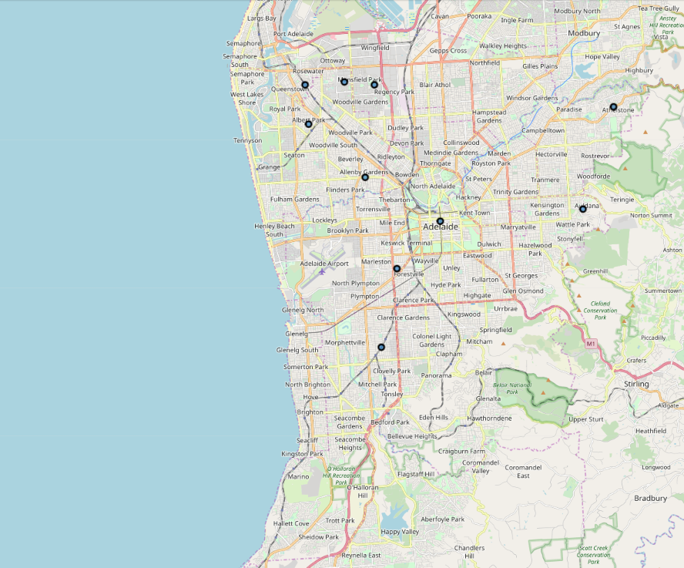

Boroughs of Adelaide differ in terms of area size, population density, and income. Therefore, I first had a look on some descriptive statistics about the boroughs.
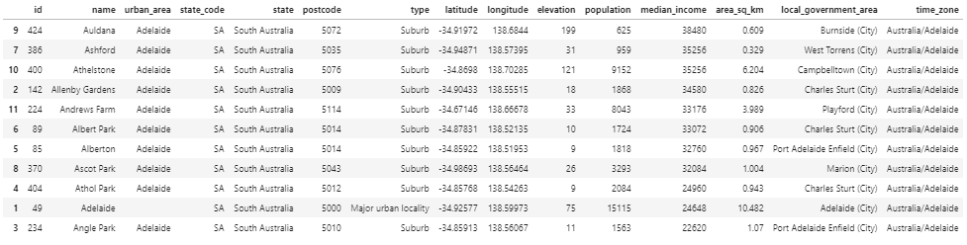
The most populated borough is the city center, called Adelaide. Athelstone follows. Considering financial wealth, Auldana, Ashford and Athelstone are the top 3 boroughs with the highest average income.

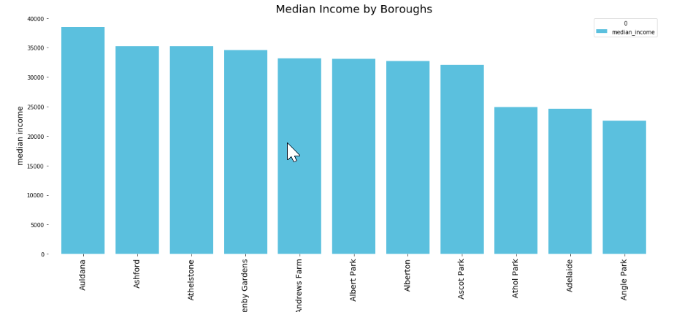

I have used Foursquare data with radius equals to 1,000 meter and limited the results with 100 venues. A sample of venues is shown below:
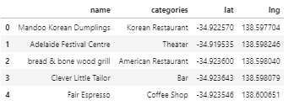
Then, I merged foursquare venue data with borough data. The shape of resulting table is 215x7.
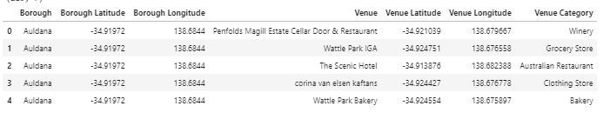

The number of venues for each borough are shown below:
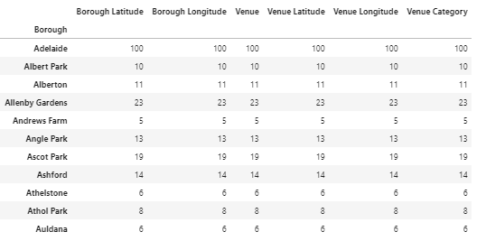
As it can be seen in the table, the number of venues in Adelaide (city center) reached the limit of 100 venues whereas the others not. It is revealed that there is a big difference between boroughs in terms of social facilities. This does not provide enough information to solve the defined problem. Do these venues are mainly business centers, restaurants or something else? Foursquare data returns 102 categories for venues in Adelaide. On the one hand, the green categories might provide an opportunity for a good restaurant business nearby, on the other hand yellow categories mean direct competitors in oriental restaurant business.
['African Restaurant', 'American Restaurant', 'Argentinian Restaurant', 'Arts & Crafts Store', 'Asian Restaurant', 'Athletics & Sports', 'Australian Restaurant', 'Bagel Shop', 'Bakery', 'Bar', 'Basketball Stadium', 'Brewery', 'Burger Joint', 'Burrito Place', 'Bus Station', 'Business Service', 'Café', 'Candy Store', 'Chinese Restaurant', 'Chocolate Shop', 'Clothing Store', 'Cocktail Bar', 'Coffee Shop', 'Convenience Store', 'Cupcake Shop', 'Deli / Bodega', 'Dessert Shop', 'Diner', 'Discount Store', 'Electronics Store', 'Farmers Market', 'Fast Food Restaurant', 'Fish & Chips Shop', 'Fishing Store', 'Food', 'Food & Drink Shop', 'Food Court', 'Football Stadium', 'French Restaurant', 'Furniture / Home Store', 'Gas Station', 'Golf Course', 'Grocery Store', 'Gym', 'Gym / Fitness Center', 'Health Food Store', 'History Museum', 'Hospital', 'Hostel', 'Hotel', 'Ice Cream Shop', 'Indian Restaurant', 'Indonesian Restaurant', 'Italian Restaurant', 'Japanese Restaurant', 'Juice Bar', 'Korean Restaurant', 'Liquor Store', 'Malay Restaurant', 'Mattress Store', 'Mediterranean Restaurant', 'Mexican Restaurant', 'Modern European Restaurant', 'Music Store', 'Noodle House', 'Paper / Office Supplies Store', 'Park', 'Pedestrian Plaza', 'Pet Store', 'Pharmacy', 'Pizza Place', 'Playground', 'Plaza', 'Pool', 'Pub', 'Racetrack', 'Restaurant', 'Sandwich Place', 'Sculpture Garden', 'Seafood Restaurant', 'Shopping Mall', 'Snack Place', 'Soccer Field', 'Spanish Restaurant', 'Sporting Goods Shop', 'Sports Bar', 'Supermarket', 'Sushi Restaurant', 'Tanning Salon', 'Tapas Restaurant', 'Tea Room', 'Thai Restaurant', 'Theater', 'Trail', 'Train Station', 'Tram Station', 'Vegetarian / Vegan Restaurant', 'Video Store', 'Vietnamese Restaurant', 'Wine Bar', 'Winery']

In order to understand which borough is more attractive for opening a new restaurant, it is a good way to calculate frequencies of each venue categories by boroughs. The resulting table is as follows:
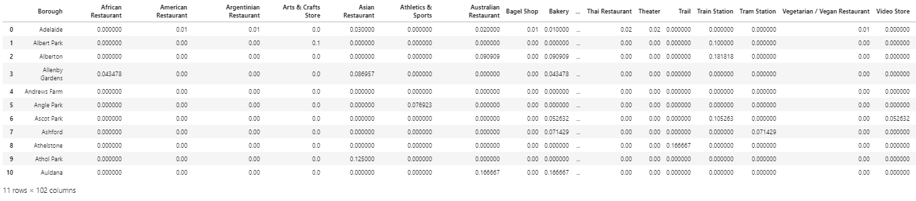
- Results
When I list top 10 most frequent venue categories for each borough, I obtain the following table:
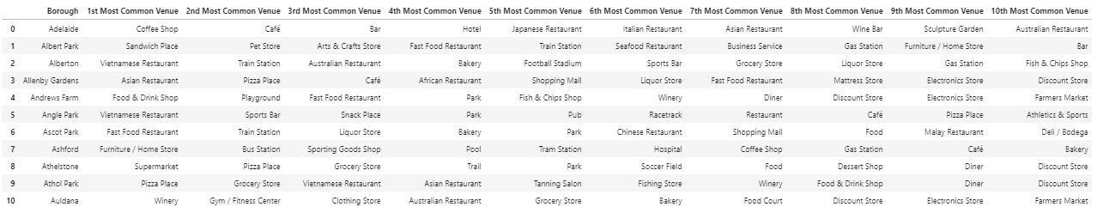
It shows that Alberton and Angle Park is dominated by Vietnamese restaurants while coffee shops dominate the city center. All boroughs but Ashford have plenty of restaurants and cafes compared to other venue categories. As shown before, Ashford is also the second wealthiest borough in Adelaide.
Based on the data analysis explained in chapter 3, I would recommend my friend Ebru to open her new restaurant in Ashford since it apparently has many small stores with employees who cannot find a decent restaurant nearby for their lunch.
- Discussion
Because of data limitations, I used data of 11 boroughs only. For more detailed and accurate guidance, the data set can be expanded to all boroughs. Moreover, identifying Ashford might be a good starting point but if neighborhood data is available, then a more specific location information can be provided.
- Conclusion
This study provides a comprehensive data analysis for deciding the most appropriate spot to open a restaurant in Adelaide, Australia. Data from Foursquare API and Geoscape.com.au is analyzed through Python 3. As a conclusion, Ashford is chosen as the most appropriate borough in Adelaide to open a restaurant.

