The Interface Design for Administration Web Development of GKPI Sipoholon

**Mutiara Enjelina1, Aldo Darel Silaen2, Yenita CH Sidabutar2**

**,Handika S.H.Harahap2 , Kevin Hutajulu3**

**,Nicolas J.Simanjuntak3**

(* for corresponding author)

1,2,3 Institut Teknologi Del, Engineering and Software Technology

Jl. Sisingamangaraja Sitoluama, Sumatera Utara, Indonesia

Corresponding e-mail: if422008@del.ac.id

| Article Information | Received: 00-00-2024 | Revised: 00-00-2024 | Accepted: 00-00-2024 |
| --- | --- | --- | --- |

**Abstrak**

Penelitian ini menjawab kebutuhan modernisasi pengelolaan data dan komunikasi di lingkungan GKPI Sipoholon melalui pengembangan sistem administrasi berbasis web. Proyek ini bertujuan untuk menyederhanakan proses administrasi dan meningkatkan transparansi dan aksesibilitas dalam komunitas gereja. Gereja GKPI Sipoholon memiliki akses yang tidak efisien dan terbatas terhadap data administrasi dan keuangan karena ketergantungannya pada aplikasi Microsoft Word. Diperlukan sistem yang lebih baik dan inklusif untuk mengatasi tantangan pembatasan akses informasi hanya pada pengurus harian dan pendeta, padahal data tertentu harus mampu memberikan aksesibilitas informasi kepada jemaat dan masyarakat umum. Melalui wawancara terbuka dan tertutup, metodologi kualitatif digunakan untuk mengumpulkan dan mengidentifikasi persyaratan dan fitur khusus yang akan memandu pengembangan sistem administrasi berbasis web untuk Gereja GKPI Sipoholon. Platform digital Gereja GKPI Sipoholon menawarkan beragam fitur untuk meningkatkan keterlibatan jemaat dan mengefektifkan pengelolaan gereja. Mulai dari fitur Jadwal Kegiatan yang memudahkan partisipasi jemaah dalam acara gereja, hingga fitur Aksesibilitas Publik yang memperluas akses informasi baik bagi jemaah maupun masyarakat umum. Dengan fitur-fitur seperti Pengelolaan Keuangan, Pengelolaan Data Anggota, Pengumuman Gereja, dan Tampilan Struktur Organisasi, gereja dapat mengelola kegiatan dan sumber daya secara lebih terstruktur dan transparan. Penelitian ini memberikan dampak luas bagi gereja-gereja lain yang menghadapi tantangan serupa, dengan memberikan wawasan dan solusi terhadap praktik administrasi gereja melalui pemanfaatan teknologi untuk memenuhi kebutuhan komunitas agama yang terus berkembang.

**Kata Kunci**: sistem administrasi berbasis web, administrasi gereja, manajemen data,

***Abstract***

*This research addresses the need for modernized data management and communication within the GKPI Sipoholon through the development of a web-based administration system. This project aims to simplify administrative processes and increase transparency and accessibility within the church community. GKPI Sipoholon Church has inefficient and limited access to administrative and financial data due to its reliance on Microsoft Word applications. A better and more inclusive system is needed to overcome the challenge of limiting access to information only to daily administrators and pastors, even though certain data must be able to provide information accessibility to congregations and the general public. Through open and closed interviews, qualitative methodology was used to collect and identify specific requirements and features that would guide the development of a web-based administration system for the GKPI Sipoholon Church. The digital platform of GKPI Sipoholon Church offers a variety of features to enhance congregation engagement and streamline church management. From the Schedule Activities feature, which facilitates congregation participation in church events, to the Public Accessibility feature, which broadens access to information for both congregants and the general public. With features like Financial Management, Member Data Management, Church Announcements, and Organizational Structure Display, the church can manage activities and resources in a more structured and transparent manner. This research has a broad impact on other churches facing similar challenges, by providing insight and solutions into church administration practices through the use of technology to meet the needs of the growing religious community.*

***Keywords****: web-based administration system, church administration, data management,*

**1. Introduction**

In today's digitally driven world, the use of information technology by various organizations, from governments to churches, is essential. One example is the use of websites. With the rapid development of information technology, churches face challenges in conveying information about their activities and ministries. Therefore, building a web-based information system is important for the church to help manage data and communicate information to the congregation, thereby supporting the achievement of the church's vision and mission (Septiani, et al.2022). Especially in the use of technology in religious institutions to simplify administrative processes and increase access to information. This research centers on developing and implementing a web-based administration system tailored to meet the specific needs of the GKPI Sipoholon Church located in North Sumatra, Indonesia.

The GKPI Sipoholon Church is a group of Protestant churches that was founded in 1995 and was legalized in 2017. The GKPI Sipoholon Church has a congregation of approximately 125 people with congregation members consisting of pastors, church administrators, administrative staff, elders, congregation members and visitors. ,

the need for an efficient and inclusive system has become abundantly clear. The community targeted by this project includes individuals who are deeply involved in the day-to-day operational activities of the church, demonstrating the importance of meeting the needs and challenges they face. In managing administrative data and financial data, the daily management of GKPI Sipoholon has used technological devices in the form of computers, especially Microsoft Word applications. The data owned by the church and stored in the computer can only be accessed by the daily management of the congregation and the pastor, while there is some information that needs to be accessed by the congregation and the general public. Some of the data that can be accessed in general include congregational statistics, church financial reports, church reports, weekly worship arrangements and activities carried out routinely and non-routine by the church. In the development of this project, there is potential to change the way congregational data is managed and improve information accessibility in the GKPI Sipoholon Church community.

At the core of this initiative is the recognition of major issues plaguing the GKPI Sipoholon Church, including irregular updates to congregational data, manual dissemination of event schedules, and the lack of comprehensive records of worship services. These challenges stem from decentralized data management practices, hindering effective communication and information dissemination within the church community. By addressing these issues through the development of a web-based administration system, this research aims to enhance efficiency, transparency, and accessibility for church officials, congregation members, and the general public alike.

The User Interface is a science that studies the order of the location of graphic design on a display website or application. The UI is more focused on the beauty of the appearance of a website or application. A UI designer is responsible for arranging text elements, colors, lines, buttons, images, and all elements within the view website or application (Muhyidin, et al. 2020).

Interface design has several goals and functions. The main goal of interface design is to facilitate interaction between users and websites. By using an intuitive and responsive design, users can easily navigate, search for information, and interact with interactive elements on the website. The effectiveness of using interface design helps create a satisfying user experience. With an intuitive design, easy navigation, and an organized layout, users will be able to quickly find the information they are looking for and interact with the website smoothly.

In a study conducted by Wiratama and Desanti (2022) on the development of the BNKP Pewarta Church website, limitations were identified regarding the lack of emphasis on church data management and specific internal administrative communication. They focused on managing congregation data without encompassing other aspects of church administration. On the other hand, this research aims to address these limitations by designing and implementing a more comprehensive administrative system that includes not only congregation data management but also other aspects of church administration, such as service data, worship data, and financial data. Thus, this research strives to provide a more holistic and comprehensive solution to enhance the efficiency of church administration.

Another literature review conducted by Bagindo (2016) highlights previous research on church information system development but does not specifically address the potential advantages of web-based solutions in addressing the challenges faced by the HKBP Kamal Raya Church, Resort Cengkareng. The proposed web-based church administration information system offers several advantages, including broader accessibility and the ability to disseminate information to the congregation, enhancing transparency, participation, and engagement within the church community. Additionally, this solution enables church information to be accessible not only to church officials but also to the general public, potentially expanding the church's mission outreach and promoting church activities to a wider audience, thereby addressing specific needs while offering broader benefits for increasing the church's visibility and impact.

Furthermore, the previous study by Purba et al. (2019) focused on addressing manual data management at the HKBP Kebon Jeruk Church. While it provided valuable contributions, the study still has some shortcomings. One of the main issues is the lack of a comprehensive solution in church data management, resulting in inadequate emphasis on optimal church information management design and solutions that are not fully integrated. In other words, although solutions were implemented for certain aspects such as member data and church events schedule, there were no solutions provided for other aspects such as baptism records, marriage records, and others. In this approach, the aim is to bridge this gap by presenting a superior system, that includes optimal information management design and fully integrated solutions to ensure smooth utilization of church information. Thus, the goal is to provide a more effective solution in addressing the challenges of church data management at the HKBP Kebon Jeruk Church.

Moreover, by drawing on the insights from Olipas et al.'s (2021) study, which focused on the specific needs and challenges faced by a particular church community, it becomes clear that the general nature of the research creates a gap between their findings and the unique needs of individual churches. The lack of specificity regarding the target community as a source of needs inhibits the direct applicability of the proposed solutions to other churches, as each church has different data management processes. To address this gap, the current study implements a customized web-based administration system tailored to the specific needs of the church. This involves a deep understanding of the unique data requirements, event schedules, and worship services of GKPI Sipoholon. Furthermore, an intuitive and responsive user interface (UI) has been designed to ensure smooth and easy usability for all users, including church officials, congregation members, and the general public.

This paper focuses on addressing the challenges faced by the GKPI Sipoholon Church in North Sumatra, Indonesia, through the development and implementation of a tailored web-based administration system. In today's digital age, the integration of technology is paramount for streamlining administrative processes and enhancing information accessibility, especially within religious institutions. By recognizing the specific needs of the GKPI Sipoholon Church community, including pastors, administrators, staff, elders, congregants, and visitors, this research endeavors to modernize congregation data management and bolster communication channels.

The purpose of this study is to describe and examine the effectiveness of the developed web-based administration system in improving efficiency, transparency, and accessibility within the GKPI Sipoholon Church community. With a comprehensive review of existing literature on church administration systems and web-based platforms, the study aims to construct a robust methodology for system development. This methodology encompasses data collection methods, system design approaches, and evaluation criteria to ensure the efficacy of the implemented solution. By detailing the process of system development and highlighting key design considerations, the research aims to provide insights into how technology integration can address challenges and enhance organizational efficiency within religious institutions.

The approach taken in this study aims to leverage web-based technologies tailored to meet the specific needs of the GKPI Sipoholon community, ultimately revolutionizing congregation data management and communication channels. Through a rigorous evaluation process, the study will assess the impact of the web-based administration system on enhancing efficiency and transparency within the church community. The findings will be presented and discussed to demonstrate how technology can address challenges and improve organizational efficiency within religious institutions. This study ultimately seeks to contribute to the advancement of church administration practices by harnessing the power of technology to meet the evolving needs of religious communities.

**2. Research Methods**

In this research, the process of gathering requirements for developing a web-based administration system for the GKPI Sipoholon Church was presented in detail. An interview with the GKPI Sipoholon pastor was conducted on February 10, 2024, via the Zoom platform, forming the core of this process. Open questions were used to explore church history, routine activities, organizational structure, and challenges in the administrative system. Meanwhile, closed questions provided direct information regarding the identity of the person in charge of the church and the presence of the church's social media. Qualitative were utilized to analyze the gathered data descriptively. The collected data was meticulously analyzed to extract specific requirements that would guide system development. Thus, this article played an important role in outlining and understanding how church administration challenges were addressed through relevant and effective integration of information technology.

After the data collection phase, this reseach proceeded to analyze the gathered information. During the data analysis process, descriptive analysis methods were employed to examine the data obtained from interviews. This research team utilized qualitative methods to delve into relevant aspects and conducted a comprehensive analysis of the data. The aim was to identify specific requirements and features that would serve as guidelines for the development of the system.

**3. Results and Discussion**

The interview findings have been meticulously organized in the report. Presented below are the comprehensive results:

Inquiry 1: Could you provide an overview of the weekly and yearly activities at GKPI Sipoholon Church, along with insights into the specific activities within each event?

Answer: schedule of weekly activities at GKPI Sipoholon Church:

Weekly Activities:

1. Organ Music Lessons: Mondays & Tuesdays, 16:00, at the church.
2. Sector Meeting: Wednesdays, 19:30, at the sector.
3. Elder's Sermon: Thursdays, 19:00, at the church.
4. Ina Debora Choir Practice: Thursdays, 17:00, at the church.
5. Gemende Choir Practice: Fridays, 19:30, at the church.
6. Sunday School Teacher's Sermon: Saturdays, 18:00, at the church.
7. PP and Youth Choir Practice: Saturdays, 19:00, at the church.

Yearly Activities:

1. Baptisms
2. Confirmation Services
3. Christmas Celebration
4. Easter Services

Inquiry 2: How is the administrative framework structured at GKPI Sipoholon Church?

Answer: The administrative system involves managing three offering collections directly, with financial data manually recorded using Excel and Microsoft Word.

Inquiry 3: Are there any challenges within the administrative system at GKPI Church?

Answer: Yes, there are some challenges faced by the church regarding data management. These include irregular updates or additions to member data, manual dissemination of event schedules, processing data into reports or information, and recording each worship service throughout the year. This may occur due to decentralized data (stored on individual computers in separate files and manually managed).

Inquiry 4: How are church procedures like confirmations, baptisms, blessings, congregation transfers, and bereavement records managed? Are they still done manually, and who handles these tasks?

Answer: Yes, these procedures still rely on manual methods and are typically handled by pastors or elders.

Inquiry 5: could you delineate the organizational structure of GKPI Sipoholon Church and delineate the roles and responsibilities of each leadership position?

Answer: The organizational structure includes the pastor as the leader, daily church officers (secretary and treasurer) who act as section heads and advisors, responsible for managing assets and finances. Elders handle member data and are divided into three sectors.

I'll be presenting a literature review of our research, focusing on addresing gaps identified in each study

In a study conducted by Wiratama and Desanti (2022) on the development of the BNKP Pewarta Church website, They focused solely on managing congregation data, leaving out other crucial aspects of church administration. Our research aims to address these limitations by designing and implementing a more comprehensive administrative system, including congregation data management, ministers data, worship data, and financial data.

Another literature review conducted by Bagindo (2016) highlighted previous research on church system development but only provided information accessibility for church officials (HKBP Kamal Raya Church secretariat, Ressort Cengkareng). Our proposed web-based church administration solution offers several advantages, such as broader accessibility and increased transparency and engagement within the church community. Additionally, this solution enables access to church information not only for church officials but also for the general public, potentially expanding the reach of the church's mission and promoting church activities to a wider audience.

Furthermore, research by Purba et al. (2019) focused on the data management manual at the HKBP Kebon Jeruk Church. However, this research lacks a comprehensive solution for managing church data, resulting in solutions that are not fully integrated. Our approach aims to bridge this gap by presenting an integrated system that meets the needs of GKPI Sipoholon Church administration, including optimal church information management design and fully integrated solutions, to ensure smooth use of church information and provide more effective solutions to prevent church data management at the GKPI Sipoholon Church

Additionally, by leveraging insights from the study of Olipas et al. (2021), which focuses on the specific needs and challenges faced by certain church communities, this research does not specifically mention the target community as a source of needs that hinder the direct application of the proposed solution to other churches, because each church has its own data management process. different . To overcome this, this research implemented a web-based administration system tailored to the specific needs of the church. This involved a deep understanding of the unique data needs of GKPI Sipoholon.

The findings from the interview with GKPI Sipoholon Church reveal a structured schedule of weekly and yearly activities to foster community engagement and spiritual growth. The dashboard displays the schedule of activities at the GKPI Sipoholon Church.

.

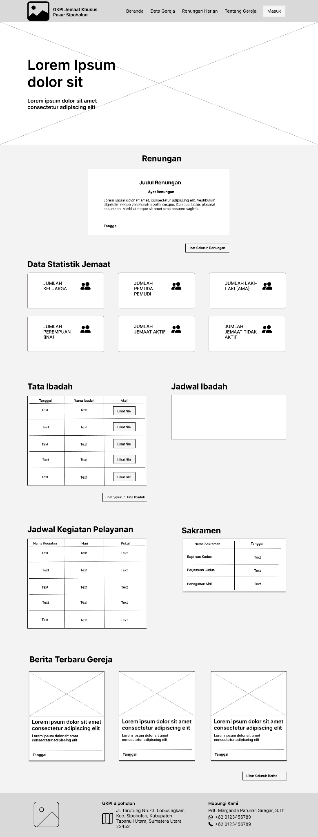

Figure 1. *Dashboard*

Then, the admin side can do the job to manage announcements, schedule of activities, and worship schedule like below.

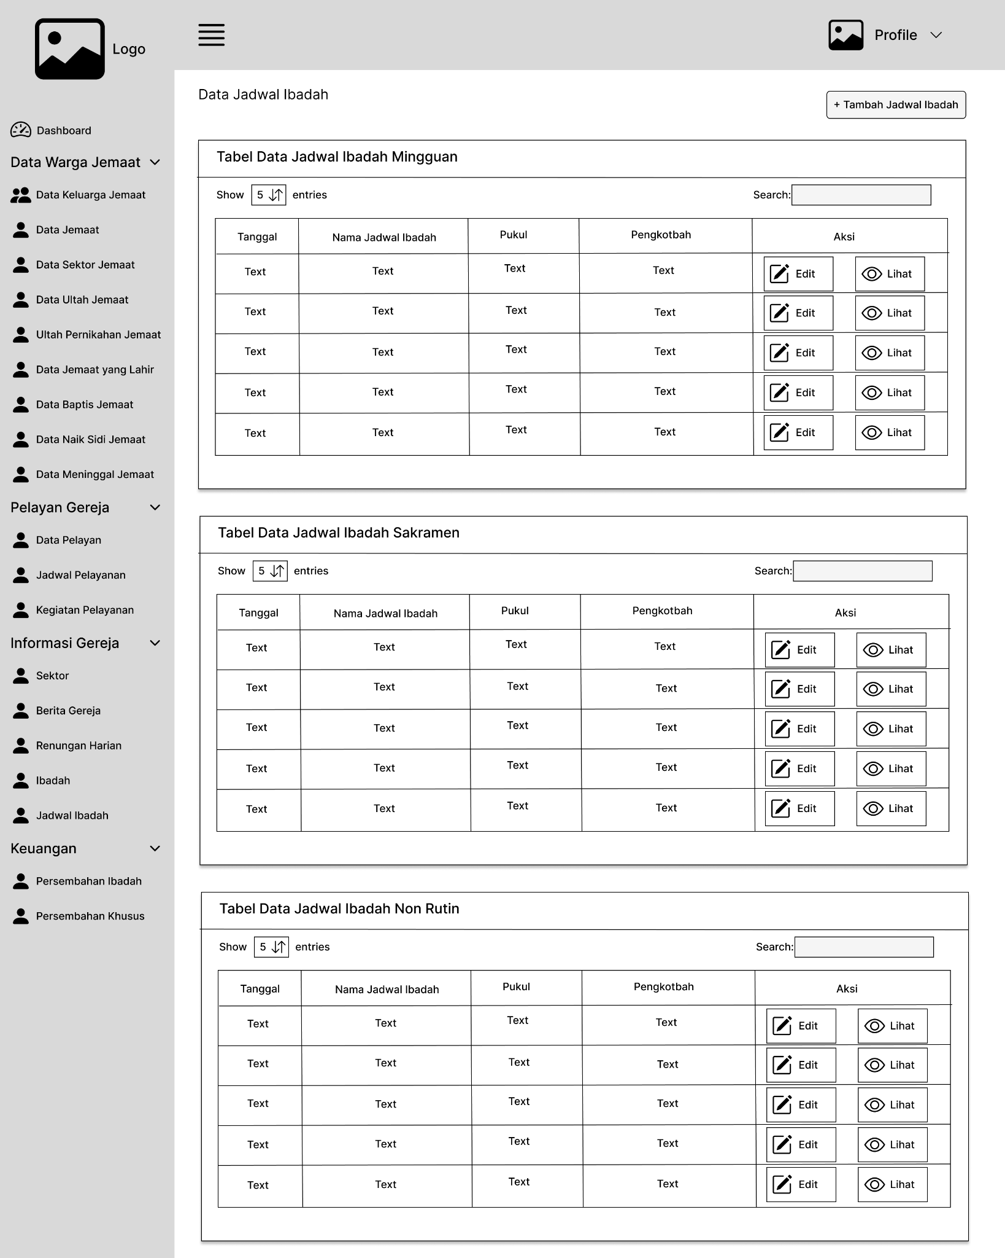Figure 2. *Worship schedule*

However, the church’s administrative framework heavily relies on manual processes, leading to challenges in data management, irregular updates, and decentralized storage. Traditional procedures like confirmations and baptisms are still managed manually by pastors or elders. To solve this problem admin can develop the system for management and church procedures in GKPI Sipoholon Church. For example, in managing church announcements as below. We can add church announcement data.

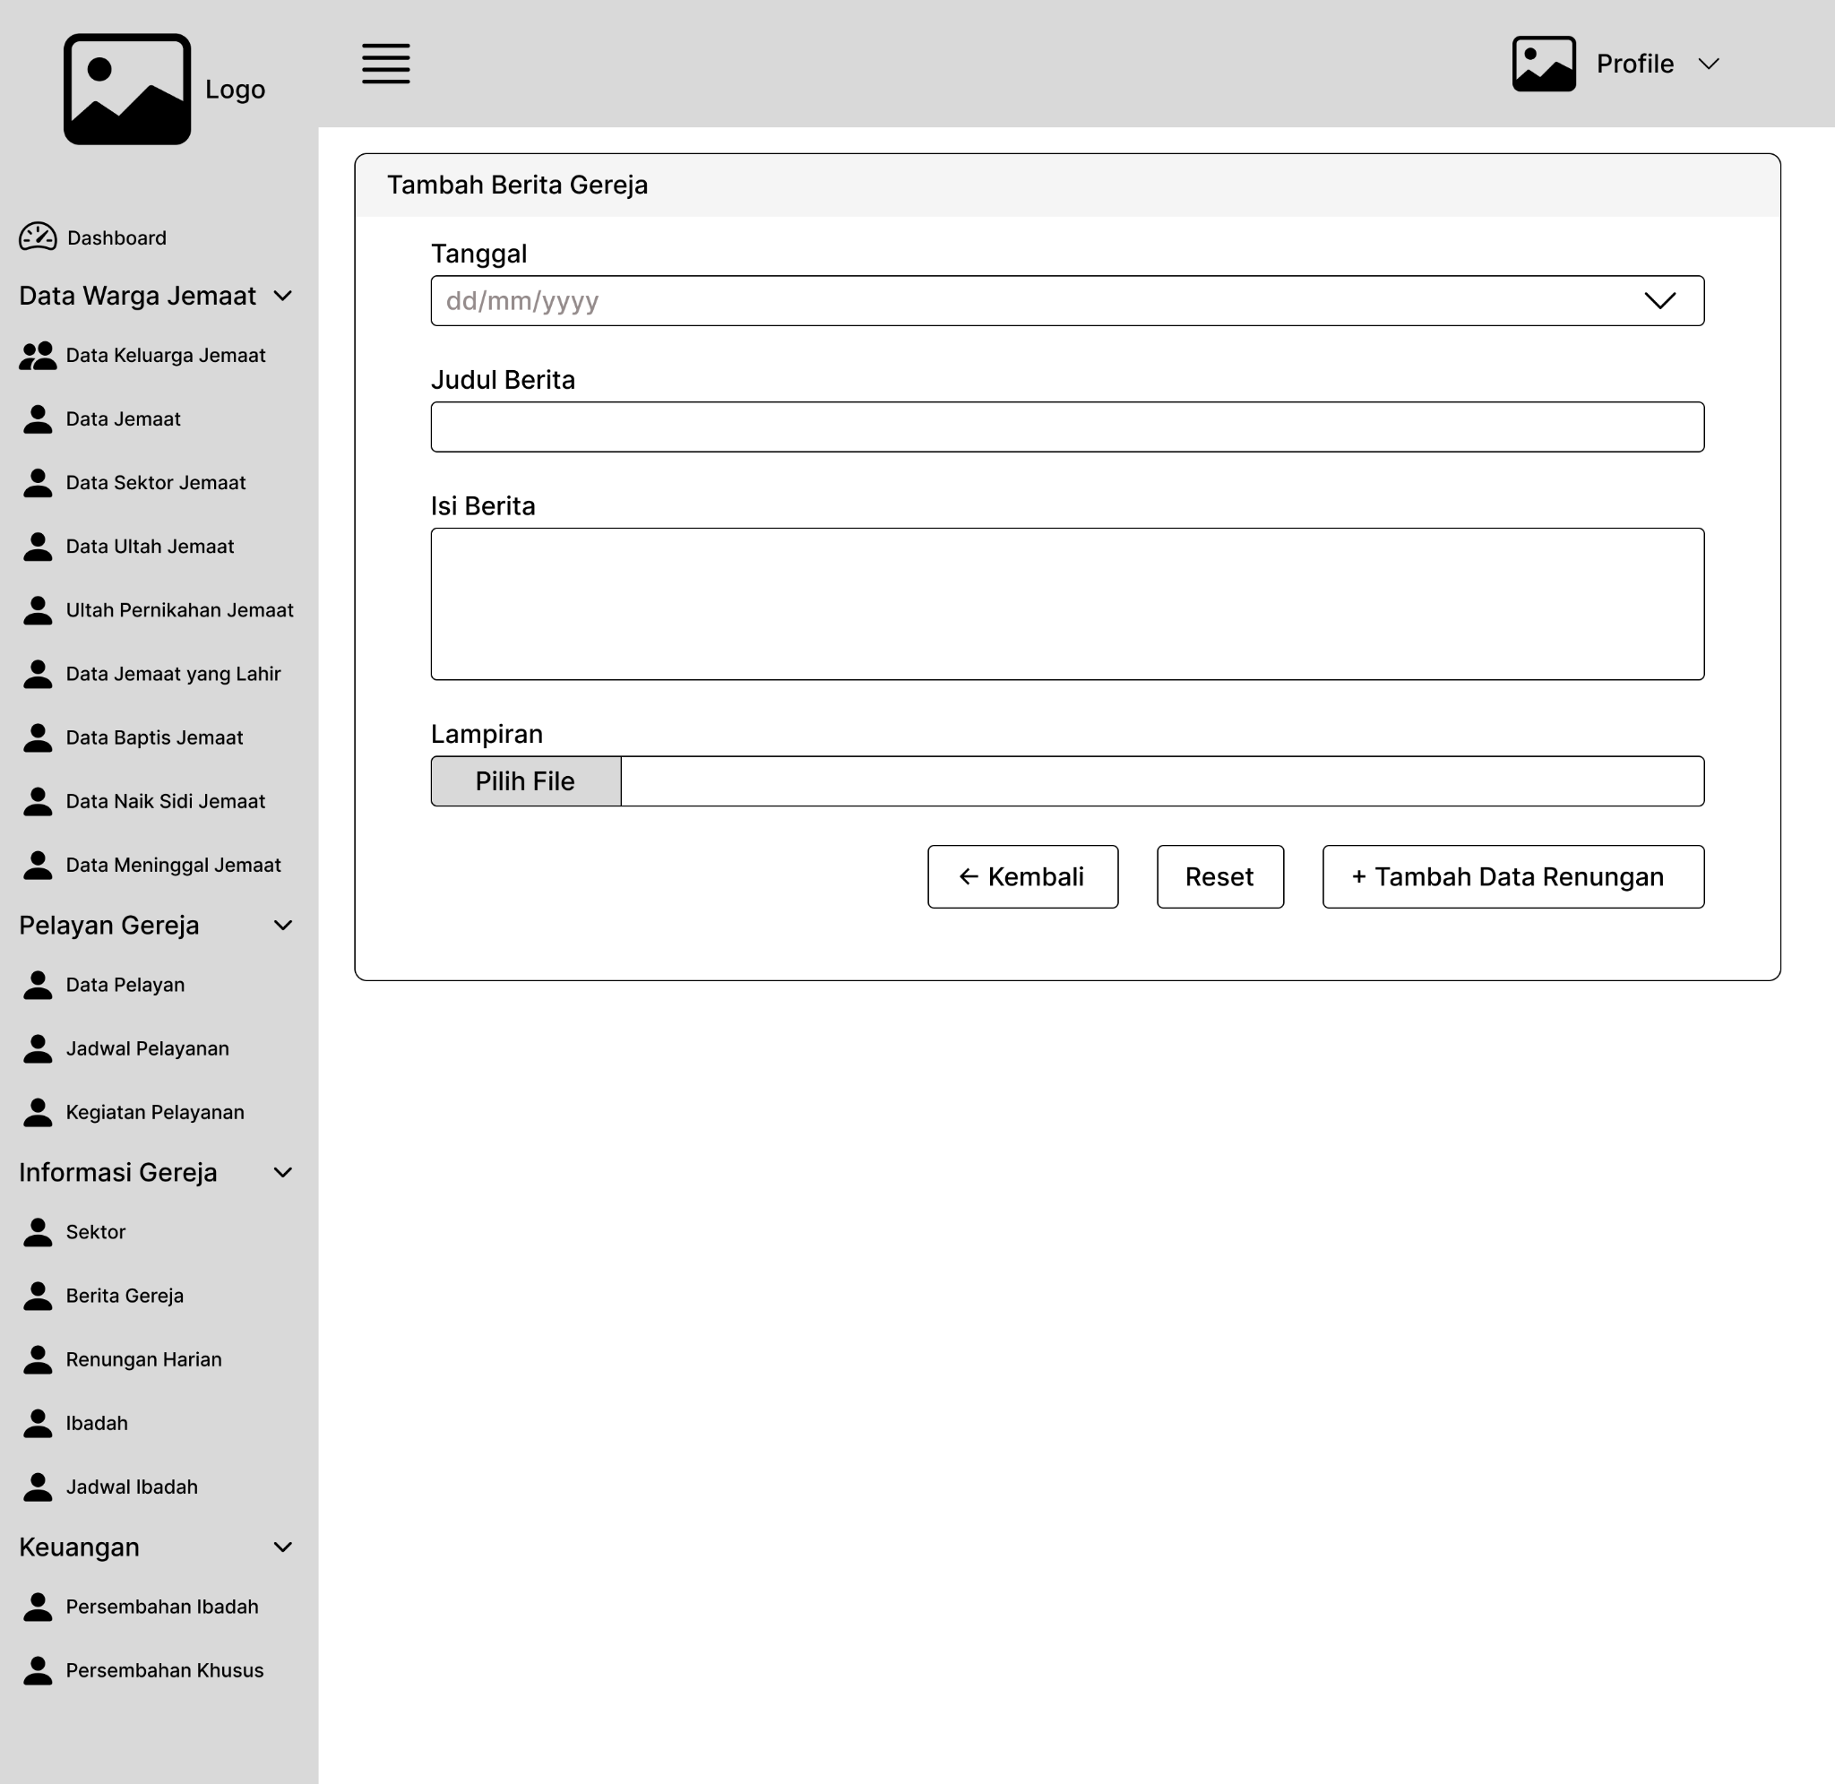

Figure 3. *Church announcement*

This research also developed a system to help show the church organization's structure on the website so all congregations can see it publicly. So the hope is to empower the church to more effectively fulfill its mission and meet the needs of its members. These features will be integrated into the website.

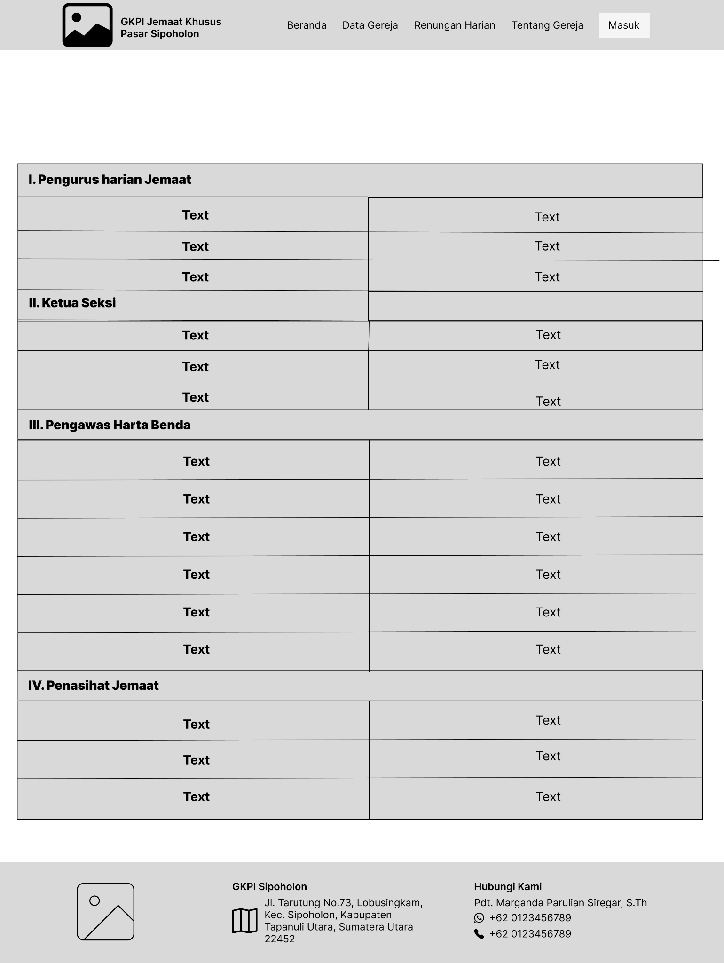

Figure 4. *Church organization's structure*

**4. Conclusion**

This study represents a concerted effort to address the operational hurdles faced by the GKPI Sipoholon Church through the creation and implementation of a tailored web-based administration system. By meticulously discerning the church community's unique needs and integrating advanced technological solutions, this research aims to modernize data management and communication within the church.

Through a thorough review of existing literature and the application of a rigorous methodology, this study not only identifies critical gaps in current understanding but also provides practical solutions to bridge these gaps. By articulating clear objectives and employing a systematic approach to system development, this research fills a crucial void in the scholarly discourse, offering insights poised to significantly impact church management practices.

The significance of this study lies in its potential to streamline administrative processes and enhance transparency and accessibility within religious institutions. By leveraging technology tailored to the specific needs of the GKPI Sipoholon Church, this research serves as a model for other religious organizations grappling with similar challenges.

Furthermore, this study introduces fresh perspectives on the role of technology in facilitating effective church management, emphasizing the importance of customized solutions and innovative approaches. By showcasing the transformative power of technology in improving organizational efficiency and fostering community engagement, this research underscores the importance of embracing technological advancements to meet the evolving demands of the modern world while staying true to core religious values.

Based on the conclusions drawn, the researches came up with the following recommendations:

1. Continuous Evaluation and Adaptation

Regularly assessing the effectiveness of the web-based administration system ensures it meets evolving church needs, guiding necessary improvements and updates.

1. Training and Capacity Building

Investing in training programs empowers staff and members to utilize the system effectively, maximizing its benefits and adoption rates.

1. Ethical Considerations

Upholding ethical standards regarding data privacy, security, and inclusivity maintains the integrity and trustworthiness of the church's administration processes amidst technological advancements.

**Reference**

Bagindo, F. S. N. (2016). Analisis dan Perancangan Sistem Informasi Administrasi Gereja Pada Gereja HKBP Kamal Raya Ressort Cengkareng. *Jurnal Informatika Dan Bisnis*, *5*(1), 30–39.

Indah Septiani, N., Sediyono, A., & Rochman, A. (2022). Perancangan Web Defacement Monitoring Dengan Menggunakan Metode Komparasi Nilai Hash1. *JIKO (Jurnal Informatika Dan Komputer)*, *5*(2), 150–155. https://doi.org/10.33387/jiko.v5i2.4852

Olipas, C. N., Norman, C., Olipas, P., Cheline, R., Sawit, M., & Esperon, R. M. (2021). The Design and Assessment of a Church Records and Information Management System. *International Journal of Research and Innovation in Applied Science (IJRIAS) |*, *VI*(I), 2454–6194. www.rsisinternational.org

Purba, A. O. K., Supardi, Dewi, E., Porrie, M. A., & Syafrullah, M. (2019). Design and implementation of web-based church information systems (Case study: HKBP Kebon Jeruk). *International Conference on Electrical Engineering, Computer Science and Informatics (EECSI)*, 264–269. https://doi.org/10.23919/EECSI48112.2019.8977094

Wiratama, J., & Desanti, R. I. (2022). Analysis and Design of Web-Based Information System for Church Congregations Case Study: Church BNKP Pewarta. *Ultima InfoSys : Jurnal Ilmu Sistem Informasi*, *12*(2), 115–120. https://doi.org/10.31937/si.v12i2.2403