<https://algs4.cs.princeton.edu/lectures/>

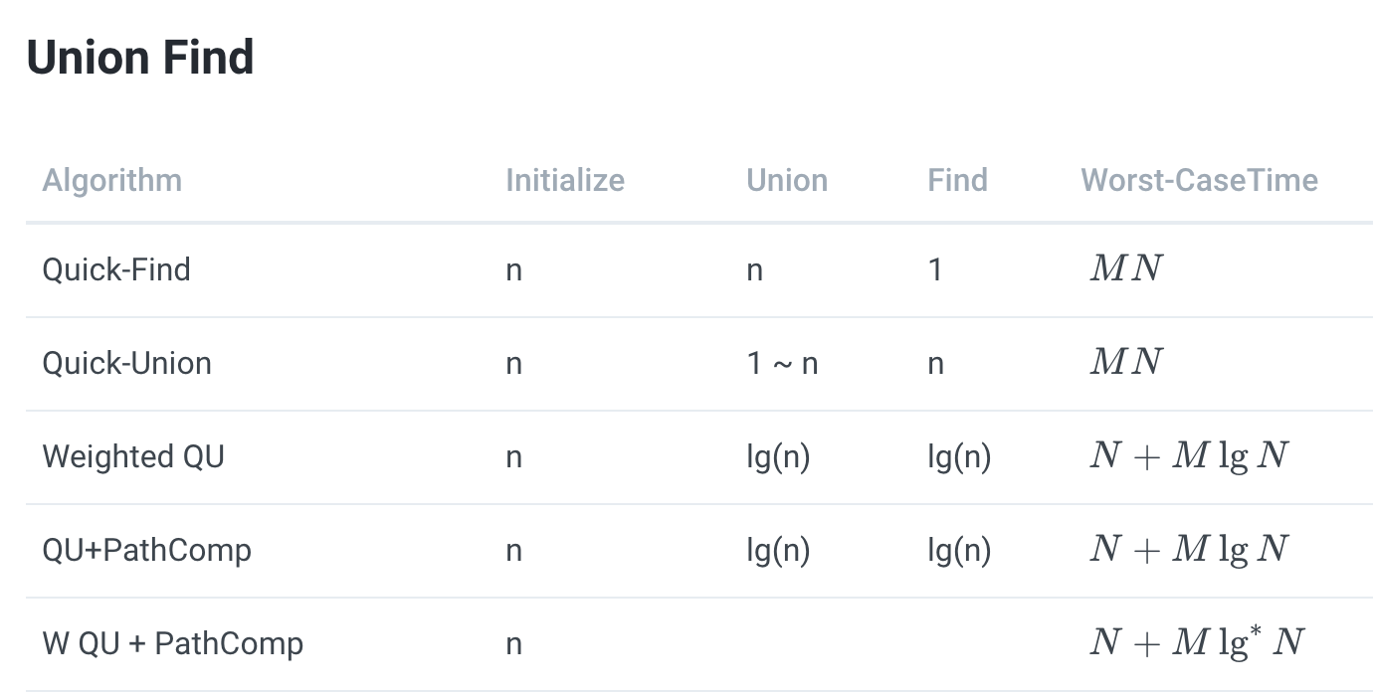

QUICK FIND

1. What is Quick Find?

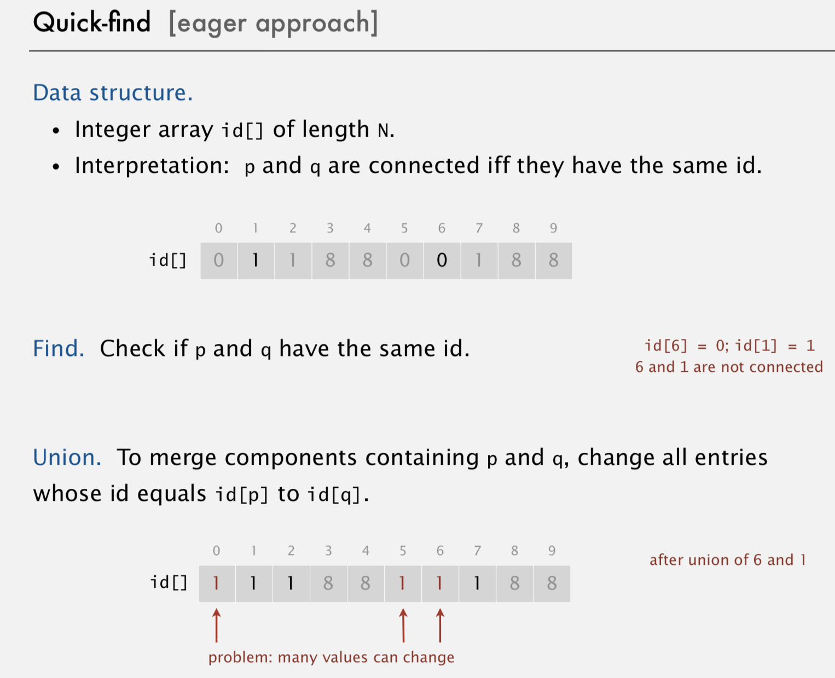

2. How is Quick Find fast? bigO = O(N)

3. When we use Quick Find?

4. Quick-find defect.

・Union too expensive (N array accesses).

・Trees are flat, but too expensive to keep them flat.

QUICK UNION

UNION FIND