|  |  |  |  |
| --- | --- | --- | --- |
| Sorting/case | Best Case | Average | Worst case |
| Bubble sort | O(n) | O(n^2) | O(n^2) |
| Insertion sort | O(n) | O(n^2) | O(n^2) |
| Merge sort | O(nlogn) | O(nlogn) | O(nlogn) |
| Iterative merge sort | O(nlogn) | O(nlogn) | O(nlogn) |
| Quick sort | O(nlogn) | O(nlogn) | O(n^2) |
| Shell sort | O(nlogn) | O(nlogn) | O(n^2) |

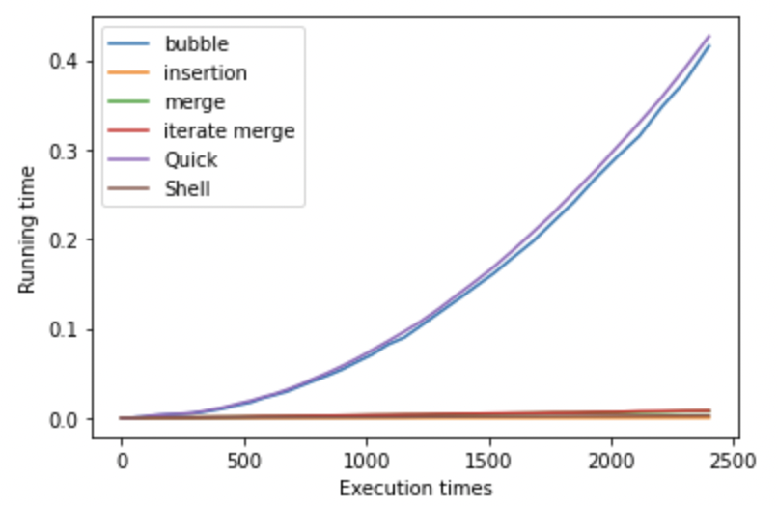

Graph1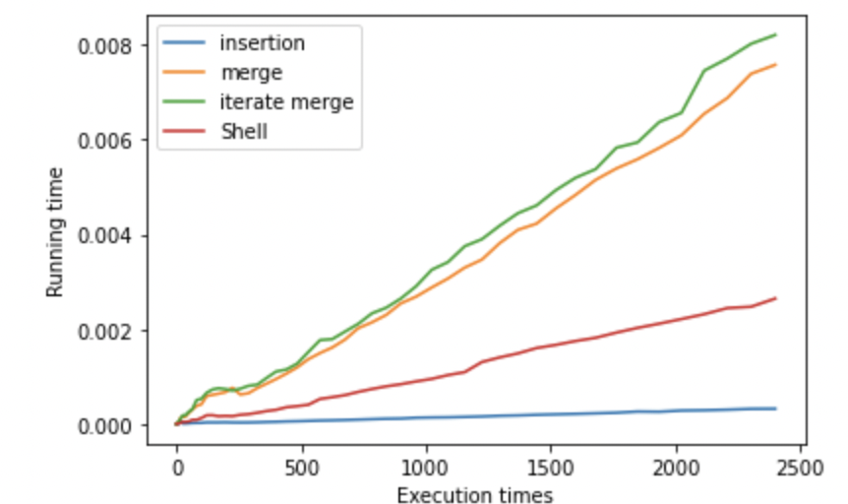

Graph2

In the graph 1 we can see that the running time for bubble sort and quick sort is exponential to execution time, compared to other sorting method these two indicates the higher running times, so in the graph 2, I delete these two methods to have a clear view on the performance of other sorting methods.

In the graph2, the two merge method is higher than shell and insertion sorting. Insertion sorting has the best performance in this sample size. If the sample size increase and gets harder, the best performance will be iterative merge sort.