**LAB 05**

**Write webpage to display the screens below when opened in a browser**

**Ex1:**

You are given a HTML file. Create a Web page like the screenshot on the right

Constraints: You are NOT allowed to change the HTML file, Just write the missing CSS.

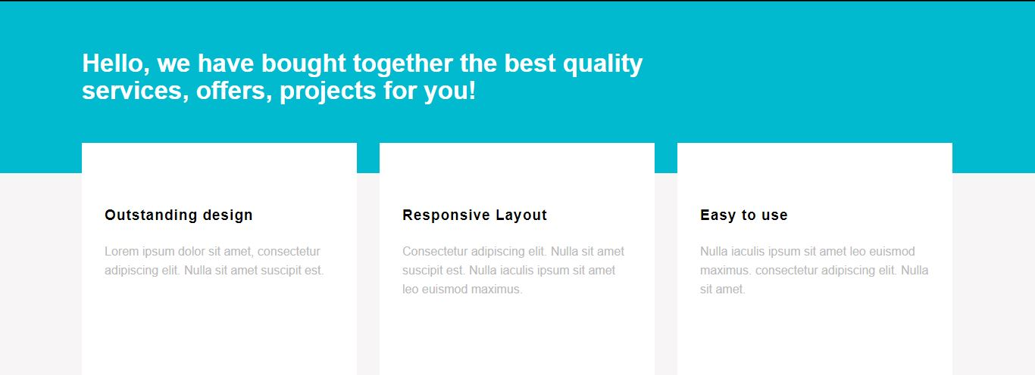

**Ex2:**

You are given a HTML file. Create a Web page like the screenshot on the right

Constraints: You are NOT allowed to change the HTML file, Just write the missing CSS.

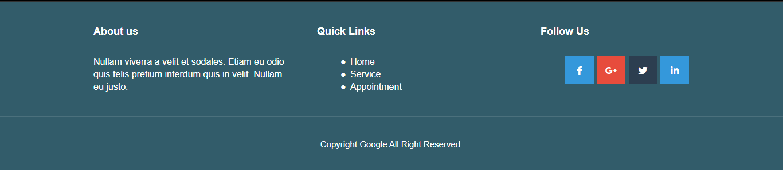

**Ex3:**

You are given a HTML file. Create a Web page like the screenshot on the right

Constraints: You are NOT allowed to change the HTML file, Just write the missing CSS.

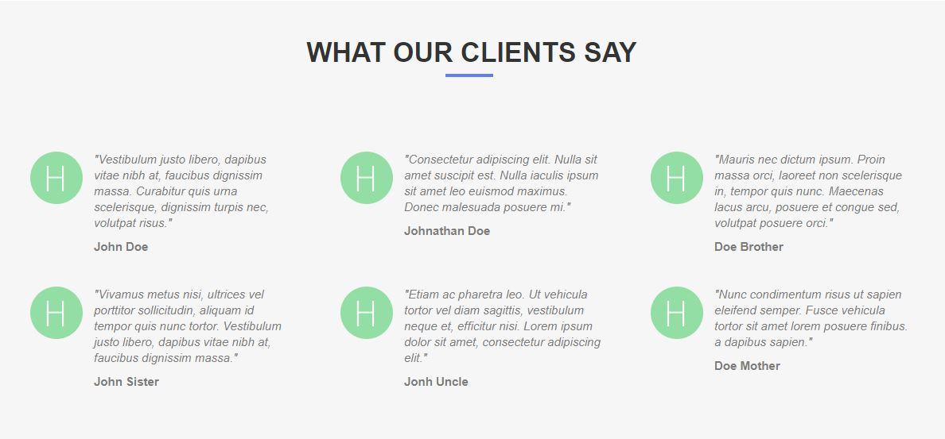

**Ex4:**

Create a Web page like the screenshot on the right

Constraints: You are NOT allowed to change the HTML file, Just write the missing CSS.

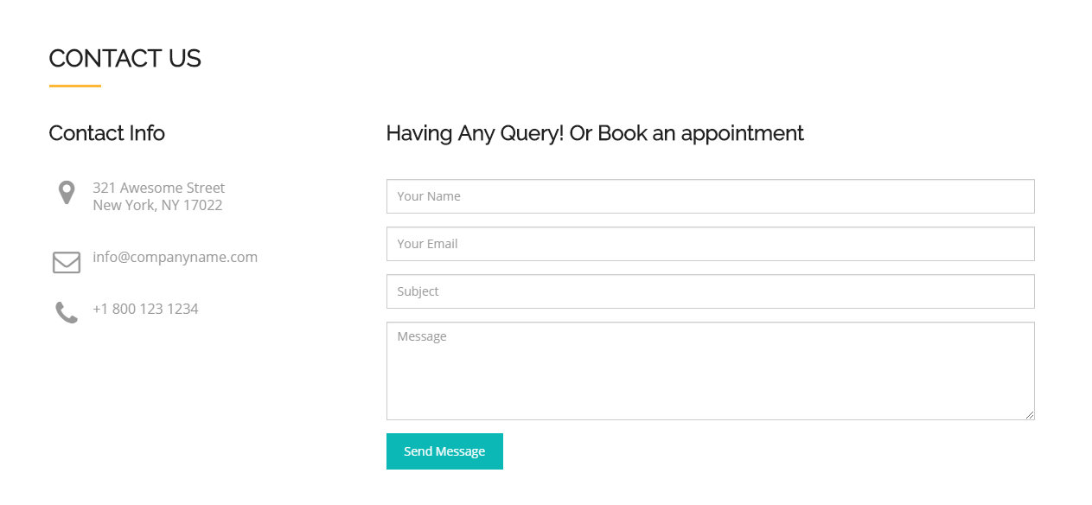

**Ex5:**

Create a Web page like the screenshot on the right

Constraints: You are NOT allowed to change the HTML file, Just write the missing CSS.

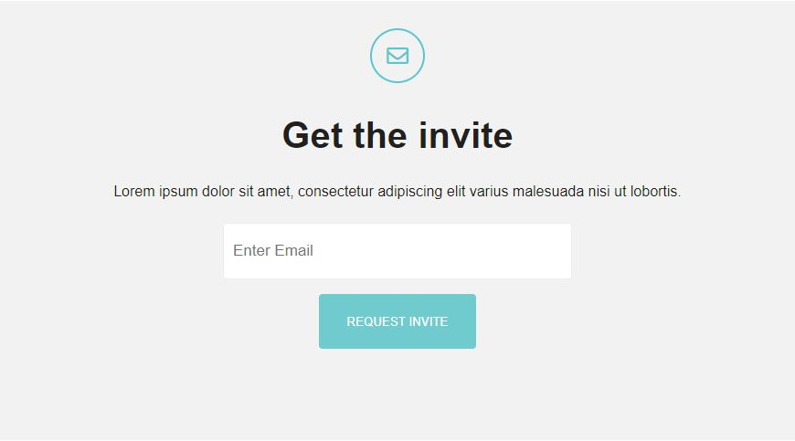

**Ex6:**

Create a Web page like the screenshot on the right

Constraints: You are NOT allowed to change the HTML file, Just write the missing CSS.

