Experiment 1

***Control two LEDs to blink with 1Hz and 2Hz using  
NI USB DAC-6009 card***

Ng Yen Aeng (15WLU09632)

October 23rd, 2017

***Objective:***

The objective of the practical is to learn to program NI USB DAQ-6009 card and DAQmx. Besides that, this experiment also learn to use NI USB DAQ-6009 card to output digital signals to control two physical LEDs to blink for 1Hz and 2Hz alternatively.

***Introduction:***

National Instrument LabVIEW is a graphical programming language. LabVIEW software is ideal for any measurement or control system, and the heart of the NI design platform. LabVIEW is one of the very first programming languages that is non-structural and compile as the code is designed and written. LabVIEW also is one of the first few languages that uses and runs on multi threads and real time. Integrating all the tools that engineers and scientists need to build a wide range of applications in dramatically less time, LabVIEW is a development environment for problem solving, accelerated productivity and continual innovation.

LabVIEW is a graphical programming platform that helps engineers scale from design to test and from small to large systems. It offers unprecedented integration with existing legacy software, IP, and hardware while capitalizing on the latest computing technologies. LabVIEW provides tools to solve today’s problems – and the capacity for future innovation – faster and more effectively.

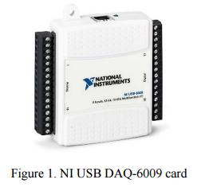

LabVIEW system design software is at the centre of the all National Instruments platform (hardware and real-time RTOS). LabVIEW is providing students a comprehensive tool that engineering and applied physics students need to build any measurement or control application in dramatically less time. LabView is the ideal development environment for innovation, discovery, with accelerated results. National Instrument or any reconfigurable third party hardware combines with the power of LabVIEW modular software can overcome the ever-increasing complexity involved in delivering measurement and control systems on time and below budget.

LabVIEW is a flexible programming environment that can help students successfully build any unique application, whether the students are taking simple measurements or prototyping with FPGA technology. LabVIEW areas of applications includes but not limit to data acquisition and data processing; instrument control; prototyping; embedded monitoring; control system; automation testing and validation systems. In data acquisition and data processing, students can learn to measure any sensors input on any bus, perform advance analysis and signal processing, display the data on custom user front-panel display as well as data logging and reports generation. For prototyping SDP algorithm is used and LTE and 802.11 development frameworks is also explored. Embedded monitoring and control systems reuse ANSIC and HDL code learnt before in graphical programming. It will integrate off the shelf hardware and extend prototyping with FPGA technology and accessing specialized tools for medical physics, robotics and much more. Finally, in automated testing and validation systems, students would automate the validation or manufacturing test of any product, control multiple scientific instruments and equipment. Additionally, student can analyze and display test results with customizable user interfaces.

NI USB DAQ-6009 card is a very versatile data acquisition card with 8 analog inputs at 14-bit, and sampling rates of 48kS/s. These analog input ports can be configured differentially or as single ended input. The NI USB DAQ-6009 has 2 analog outputs operating at 12-bit with refreshing rates of 150S/s as well as 12 reconfigurable digital I/O and a 32-bit counter. The NI USB DAQ-6009 is bus-powered for high mobility besides built-in signal connectivity. The NI USB DAQ-6009 is compatible with LabVIEW, LabWindowsTM/CVI, and Measurement Studio for Visual Studio. NET.

***Experimental setup:***

**Apparatus:**

National Instrument LabVIEW, computer, NI USB DAQ-6009, one red LED, one green LED, two 1kΩ resistors and wire

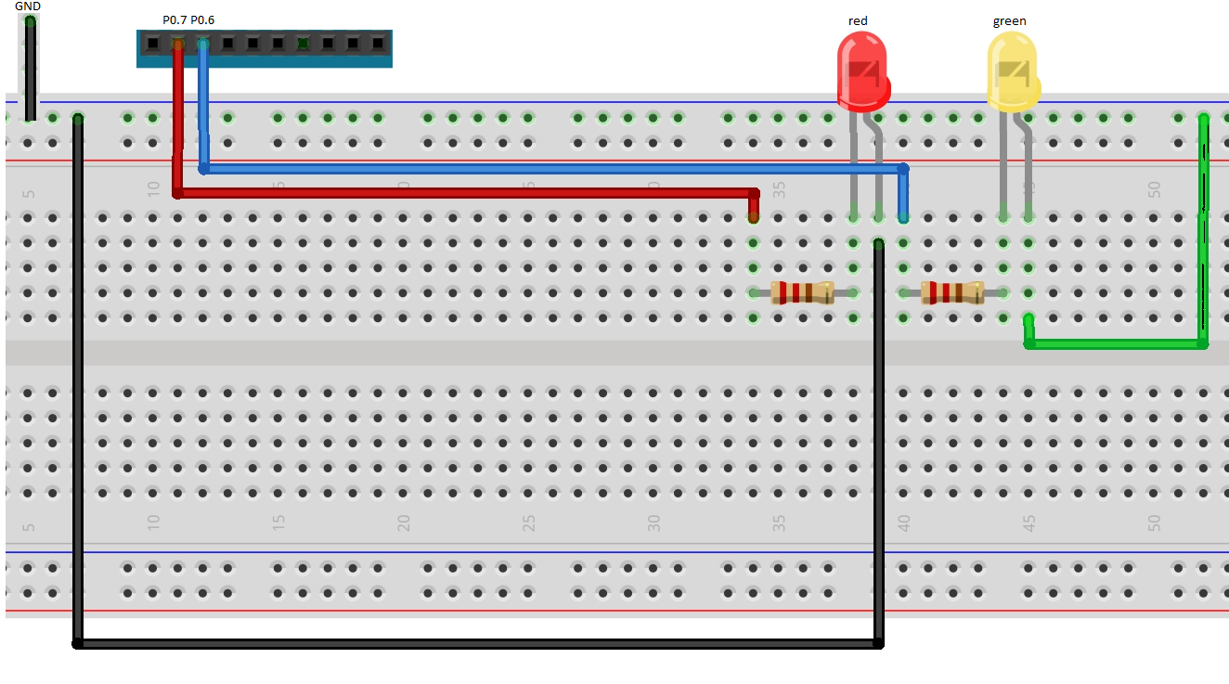

Figure 2: Setup of Circuit

***Procedure:***

1. The minimum voltages to switch on the LEDs were found by tuning the input voltage.
2. The limiting resistor was calculated by using the minimum switch on voltage.
3. Construct the circuit that shown in Figure 2.
4. The DAQ card is connected to the PC by using USB cable.
5. NI-MAX was used to create two tasks named “LED\_GREEN” and “LED\_RED\_1Hz” for generating analog output.
6. Port 0 pin7 and pin6 was configured as digital output pin for Red LED and Green LED respectively.
7. The two tasks that created were loaded in LabVIEW to control the LEDs through LabVIEW program.
8. Case structure was used to perform 2Hz green LED followed by 1Hz red LED.
9. A while loop was used to make the blinking effects continue until “STOP” button was pressed.

***Data:***

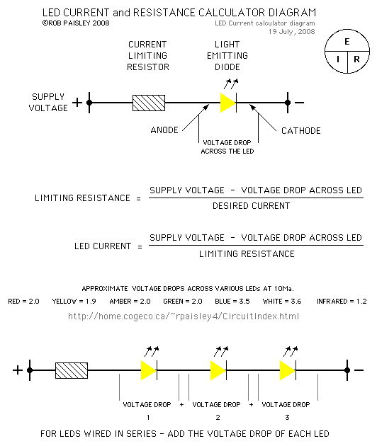

Figure 3: Formula to calculate the limiting resistance.

As shown in step 1 of the procedure, minimum switch on voltages for LEDs were measure and tabulated in table 1 as shown below.

Table 1: minimum voltage to switch on LED.

|  |  |
| --- | --- |
| **LED** | **Minimum switch on voltage** |
| Green | 1.71 V |
| Red | 1.49 V |

According to the data sheet of NI USB DAQ-6009, value of current is 30mA and output voltage is 5V. The value of current and voltage after measurement is 30mA and 5.06V respectively. The measured value was used to calculate the value of limiting resistor.

$$For Red LED Limiting Resistor = 119 ohm$$

$$For Green LED Limiting Resistor = 111.7 ohm$$

Figure 4: Block diagram of this experiment.

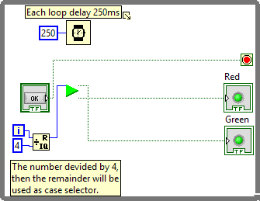

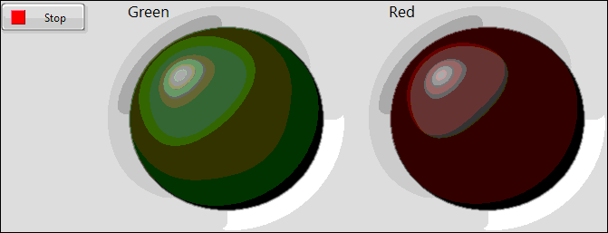  
Figure 5: Front panel of this experiment.

C:\Users\user3\Desktop\LabView\Lab1_new\BlinkingLEDc.png

Figure 6: Icon of Sub vi that used in Figure 4.

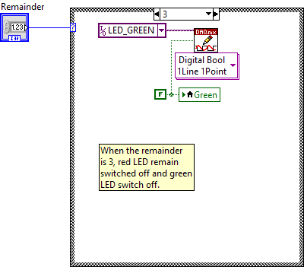

Figure 7: Block diagram of sub vi.

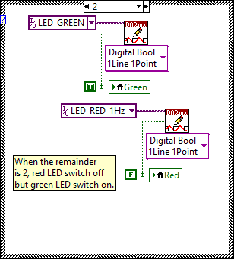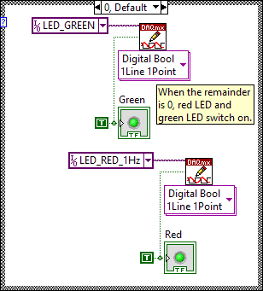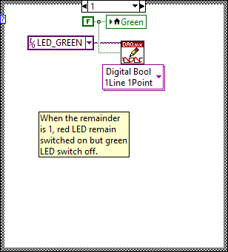

Figure 8: Other case for the block diagram shown in Figure 7.

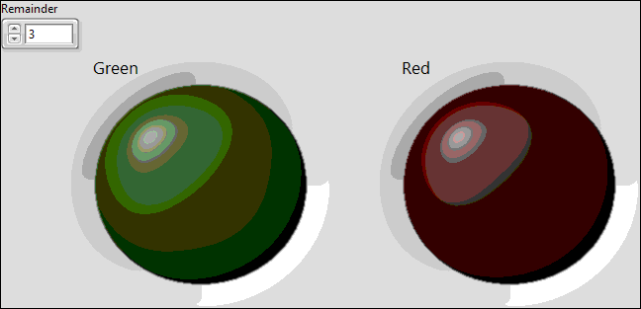

Figure 9: Front panel of sub vi

Figure 4 shows the block diagram of this experiment which can perform the blinking of 2Hz of green LED follow by 1Hz of red LED blinks. In a while loop, the number ***i*** will start at ‘0’ and keep on increasing. To create 2Hz and 1Hz blinking LEDs, which means the experiment need 4 cycles and each cycle delayed for 250 ms. If ***i*** divided by 4 and the value of the remainder can be used to represent the 4 cycles. Therefore a sub vi was created to determine the operation for each cycle.

Figure 7 and 8 show the case structure of the sub vi that determined the blinking of LEDs on the front panel and also the LEDs in the real hardware. In short, the green LED need 500ms to blink 1 time (finish 1 cycle) while red LED need 1s to blink 1 time (finish 1 cycle). This sub vi will take a remainder as input and output 2 LEDs which is red and green.

In Figure 5 and 9 there are two LEDs with red and green color, they are used to make sure the hardware LEDs blink according to the software.

***Discussion:***

In this experiment, the experimental minimum switch on voltage of the LED was not accurate as the state of LED (“on” or “off”) was observed by experimentor’s eye, which is not accurate. This result may be more accurate if a more precise tool is used to determine the state of the LEDs.

Besides that, the LabVIEW program will have problem when running the program if the NI-MAX is still switched on as they are sharing the same LED therefore when LabVIEW trying to control the LED, it will be blocked and could run the program successfully.

***Conclusion:***

As conclusion, DAQ card can generate digital output through the output pin to create a state which represent ‘on’ or ‘off’.