Weight Initialization Block (Block 1) is a module used to initialize the value of weight that will be used by the Hidden Layer Block. For Artificial Neural Network, every inputs must have their own weight respect to every neuron in the hidden layer. In this system, one hidden layer with five neurons is used, therefore 50 weights are needed. Besides that, there will have three neurons in output layer, thus 15 more weights are needed. In total, there are 65 weights for the whole system.

There are two modules in this block, the first module is LFSR. This module is a linear-feedback shift register that generate a 10 bits random number by combining the exclusive-OR configuration to form a feedback mechanism. The second module is WeightInitialize which initialize all 65 weights that needed with random number that generated by LFSR. Besides that, this module also act as RAM to store the weights’ value so that other modules can get the weights’ value in the future.

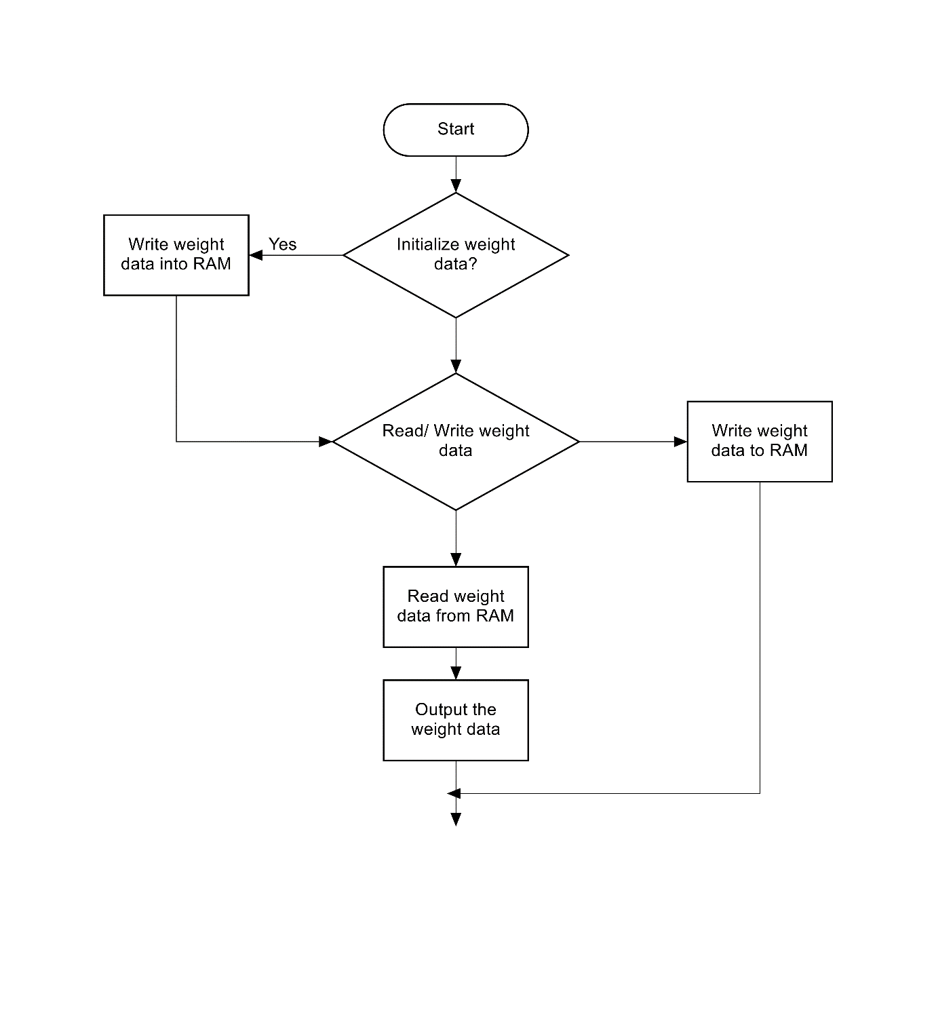

This is the first module and its testbench of block 1.

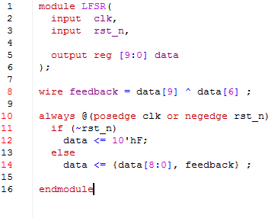

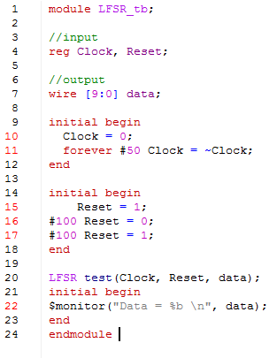

This is the console result. The first data is unknown as no value was added to the data. The first valid data is 0000001111 which is the initial value when reset the module.

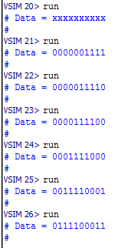

This is the second module for block 1.

