Weight Initialization Block (Block 1) is a module used to initialize the value of weight that will be used by the Hidden Layer Block. For Artificial Neural Network, every inputs must have their own weight respect to every neuron in the hidden layer. In this system, one hidden layer with five neurons is used, therefore 50 weights are needed. Besides that, there will have three neurons in output layer, thus 15 more weights are needed. In total, there are 65 weights for the whole system.

There are three modules in this block, the first module is LFSR. This module is a linear-feedback shift register that generate a 10 bits random number by combining the exclusive-OR configuration to form a feedback mechanism. The second module is WeightRAM which initialize all 65 weights that needed with random number that generated by LFSR. Besides that, this module also acts as RAM to store the weights’ value so that other modules can get the weights’ value in the future. The last module is a clk_div which used to create a slower clock. The faster clock will be used to initialize the weight data while the slower clock will be used for write/ read weight data by given address.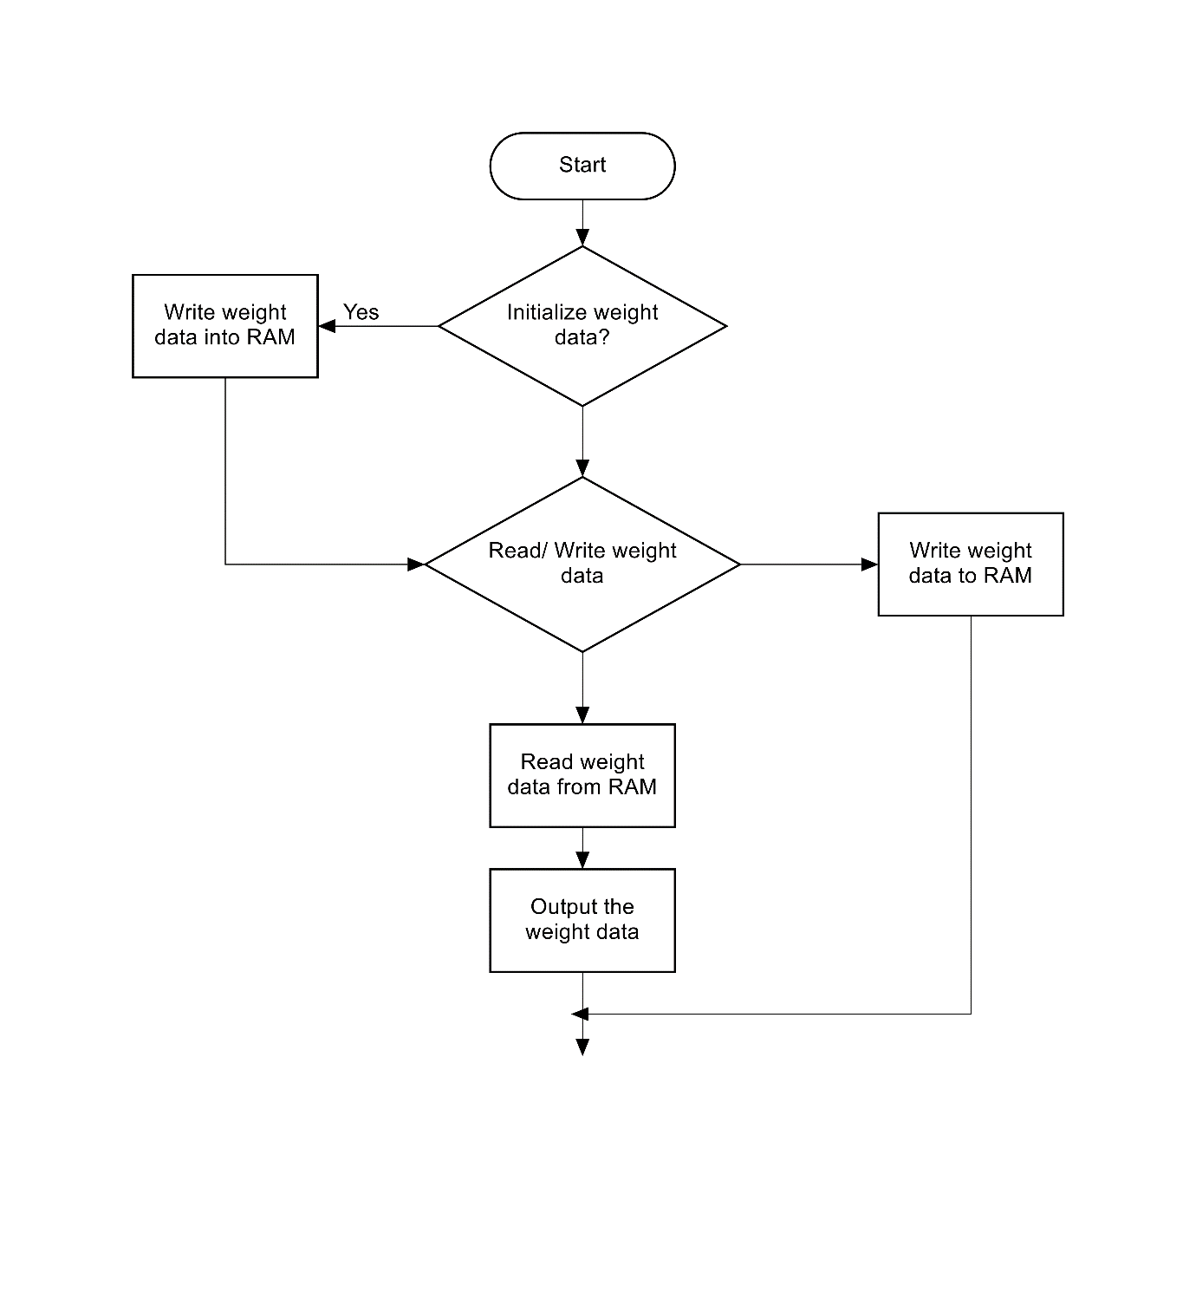

This is the first module and its testbench of block 1.

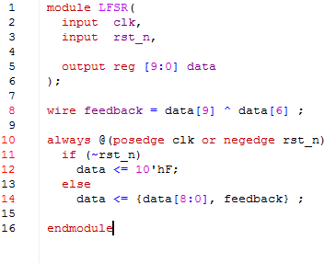

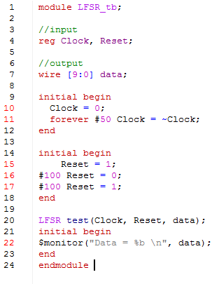

This is the console result. The first data is unknown as no value was added to the data. The first valid data is 0000001111 which is the initial value when reset the module.

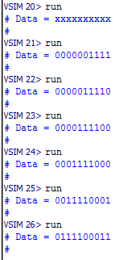

The following figures show the code of the clk_div. By default, the slower clock is 10 times slower than the original clock.

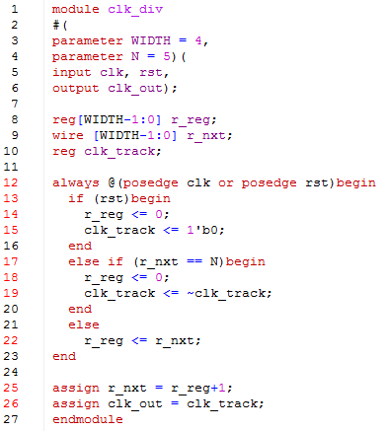

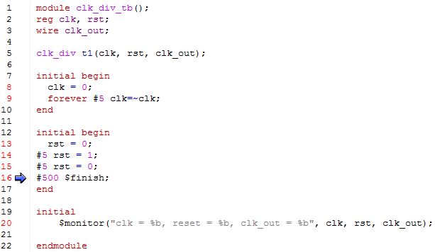

This is the wave result of clk_div_tb. From the figure, the slower clock takes 100ps for one cycle and the original clock takes 10ps. Thus, the result matches the expected result that stated above.

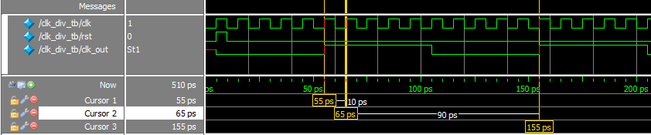

This is the code for WeightRAM module. When reset, all the output result will be set as 0. There are two clocks in this design, one is a faster slow which used to call LFSR to initialize weight data with random numbers, the other clock is the clock is the slower clock which used to write the weight value to RAM or read the weight value from RAM.

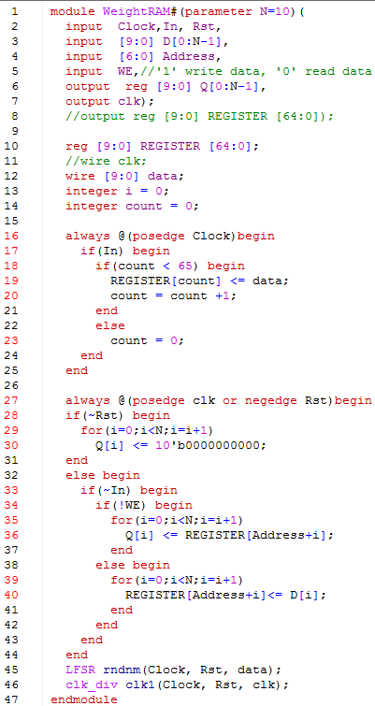

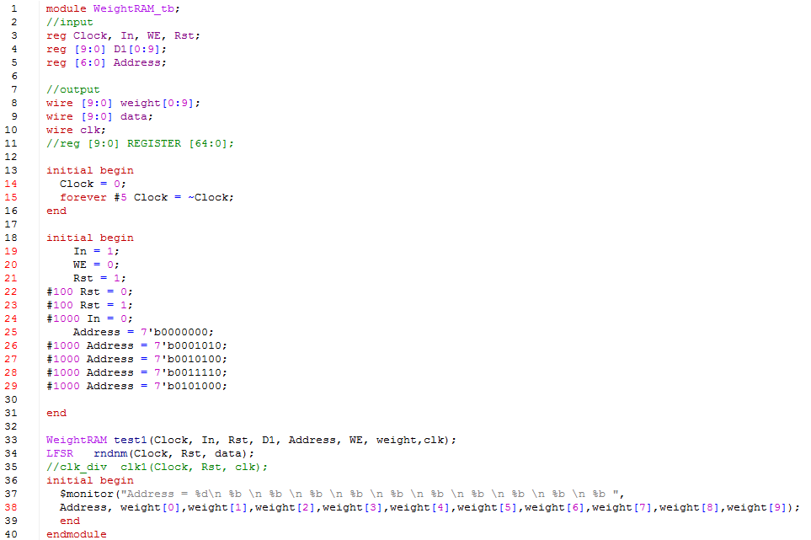

This is the output value when reset. All the output data reset to 0.

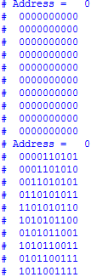

The following results are the weight values that read from the RAM with different address. All the data are auto initialize with random number.

