|  |  |  |  |  |
| --- | --- | --- | --- | --- |
| Parameter  Researcher (Year) | Accuracy (%) | Algorithm | Advantages | Disadvantages |
| Salvatore, Alessandra and Filippo (2011) | 80 | Perclos | Can be used in low light condition | Get distract easily when driver look other side. |
| Yap Ken Mun, Jason, Lee Shyan Feng (2015) | 71 | ANN |  |  |
| Wang Fei, Cheng Huiyao, Guan Xueming*.* (2005) | 67 | Self-develop algorithm | Higher accuracy during night time. |  |
| Ying-Che Kuo and Wen-Ling Hsu |  | Fuzzy logic |  | Will have error when the skin color of the user is dark. |

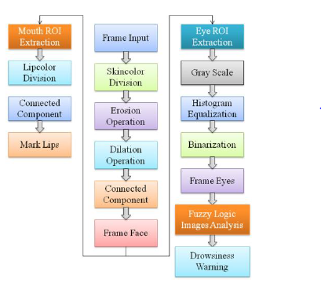

Figure 1: conventional block from YCK and WLH

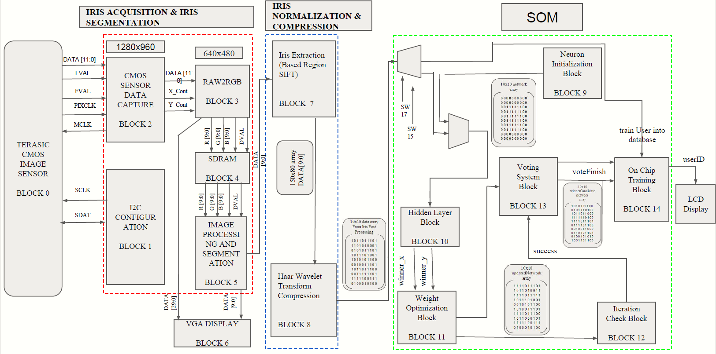Figure 2: Conventional block from Jason, LSY and YKM

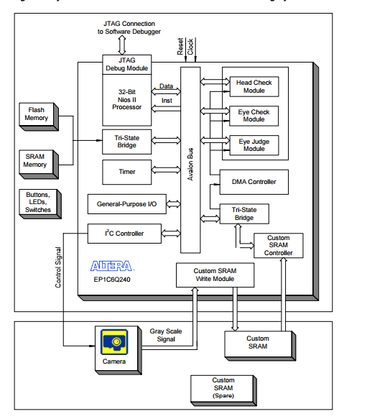

Figure 3: conventional block from WF, CHY, GXM

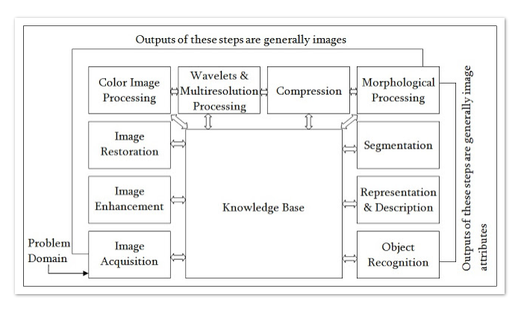

Gradient Descent:

1. Good solution
2. Solution in X iterations
3. Solution at all