# CHAPTER 1 HOMEWORK

**PROBLEM 1:**

$$f\left(n\right)= \frac{n^{5}}{5}-10n^{4}-\frac{n}{2}+300 → g\left(n\right)= n^{5}$$

* We can choose $c=\frac{1}{2}; n_{0}=3$

$\text{∀}\text{ n ≥ 3 ⟹ f(n) < }\frac{1}{2}g(n)$

**PROBLEM 2:**

$O\left(n^{2}\right)$ provide an upper-bound

$$\text{f(n) = }O\left(n^{2}\right)⟺ ∃c, n_{0} : \text{∀}\text{ n > }n_{0}\text{ ⟹ f(n) ≤ }c n^{2}$$

We have $\text{T(n)}$: running time of algorithm A. According to the topic: $\text{T(n) ≥ }O\left(n^{2}\right)$

But “at least” in the statement “The running time of algorithm 𝐴 is at least 𝑂( $n^{2}$)” gives a lower – bound. So, this statement is meaningless.

**PROBLEM 3:**















$f\left(x\right)= 2x^{2}-x+30 is O(x^{2})$

$g\left(x\right)=$ $x^{2}$

$Choose c=3; x_{0}=6$

$∃ c, x_{0} :\text{∀}\text{ x ≥ 6 ⟹ f(x) < 3}g\left(x\right) ⟺\text{f(x) = }O\left(x^{2}\right)$

$f\left(x\right)={(3x+2)log}_{2}{(x^{2}+5)} is O({xlog}_{2}{x})$

$g\left(x\right)=$ ${xlog}_{2}{x}$

$Choose c=7; x_{0}=6$

$∃ c, x_{0} :\text{∀}\text{ x ≥ 6 ⟹ f(x) < 7}g\left(x\right) ⟺\text{f(x) = }O\left({xlog}_{2}{x}\right)$

$f\left(x\right)=(x^{2}+{4log}_{2}{x})/(x+1) is O(x)$

* $g\left(x\right)=$ x

$Choose c=2; x_{0}=1$

$∃ c, x_{0} :\text{∀}\text{ x ≥ 1 ⟹ f(x) < 2}g\left(x\right) ⟺\text{f(x) = }O\left(x\right)$

**PROBLEM 4:**

1. $f\left(x\right)= 10 is O(x)$ Explain:

* $g\left(x\right)=$ x

$Choose c=2; x_{0}=6$

$∃ c, x_{0} :\text{∀}\text{ x ≥ 6 ⟹ f(x) < 2}g\left(x\right) ⟺\text{f(x) = }O\left(x\right)$

1. $f\left(x\right)= 3x+7 is O(x)$ Explain:

* $g\left(x\right)=$ x

$Choose c=4; x_{0}=8$

$∃ c, x_{0} :\text{∀}\text{ x ≥ 8 ⟹ f(x) < 4}g\left(x\right) ⟺\text{f(x) = }O\left(x\right)$

1. $f\left(x\right)= 2x^{2}+2 is not O(x)$ Explain:

* $g\left(x\right)=$ x

$∄ c, x_{0} :\text{∀}\text{ x ≥ }x_{0}\text{ / f(x) < c }g\left(x\right) ⟺\text{f(x) ≠ }O\left(x\right)$

**PROBLEM 5:**

1. $f\left(x\right)= 3^{n+3} is correct$ Explain:



$g\left(x\right)=$ $3^{n}$

$Choose c=28; x_{0}=1$

$∃ c, x_{0} :\text{∀}\text{ x ≥ 1 ⟹ f(x) < 28 }g\left(x\right) ⟺\text{f(x) = }O\left(3^{n}\right)$

1. $f\left(x\right)= 3^{3n} is incorrect$ Explain:



$g\left(x\right)=$ $3^{n}$

$∄ c, x_{0} :\text{∀}\text{ x ≥ }x_{0}\text{ / f(x) < c }g\left(x\right) ⟺\text{f(x) ≠ }O\left(3^{n}\right)$

**PROBLEM 6:**

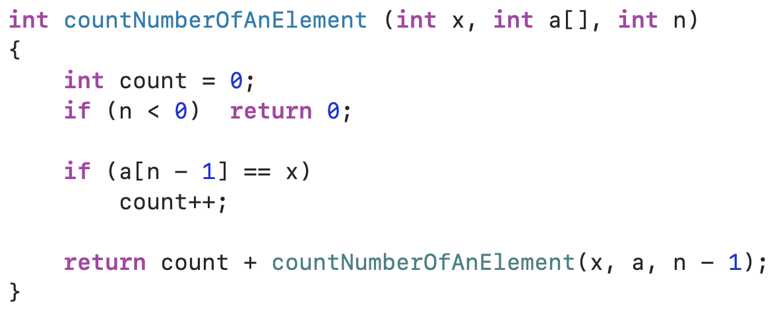

1. 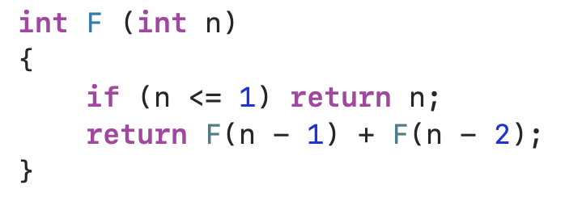

**PROBLEM 7:**

In real life applications, these are more important than performance:

* Simplicity
* Extensibility
* Robustness
* User-friendliness
* Reliability
* Modularity
* Correctness
* Maintainability
* Functionality
* Programmer time

**PROBLEM 8:**

We need to study algorithms and performance to ensure that my code solves the problem and uses resources appropriately. And make sure that my code will always be correct and with optimum performance in every case.

**PROBLEM 9:**

$$S= 1+2+3+4+…+ n$$

* Recursion

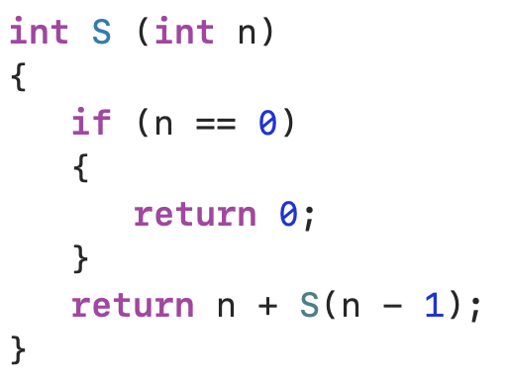

**PROBLEM 10:**

* Iteration

