|  |  |  |  |  |  |  |
| --- | --- | --- | --- | --- | --- | --- |
| **Ujian Akhir Praktikum - Semester Genap 2019/2020**  *Practicum Final Exam - Even Semester Year 2019/2020* | | | | | | |
| **Matakuliah**  *Subject* | | | **COMP6175 - Object Oriented Programming**  **MOBI6002 - Mobile Object Oriented Programming** | | |  |
| **Kelas**  *Class* | **:** | **B001 / B201 / B601 / B901 / BA01 / BA03 / BA26 / BC01 / BE01 / BG01 / BI01 / BL01 / BM01 / BT01 / BU01 / BX01 / BY01 / SB01** | | **Tanggal Mulai**  *Start Date* | **: 18 June 2020** |
| **Waktu Mulai**  *Start Time* | **: 11:20** |
| **Dosen**  *Lecturer* | **:** | **D0208 - Drs. Agus Prahono, M.Eng.Sc.**  **D1828 - Hendra, S.Kom., M.T.**  **D2425 - Ir. Yasri, M.T.**  **D3174 - Dr. Budi Yulianto, S.Kom., M.M., CBA.**  **D3757 - Tegar Aryo Sulthon Musthofa, S.Kom, M.MSI**  **D4653 - Eka Cahyadi, S.Kom., M.TI**  **D5094 - Aswin Wibisurya, S.Kom, M.TI**  **D5358 - Livia Ashianti, S.Kom., M.TI** | | **Tanggal Selesai**  *End Date* | **: 19 June 2020** |
| **Waktu Selesai**  *End Time* | **: 11:20** |

**PERATURAN UJIAN:**

*Exam Regulations:*

* Mahasiswa tidak diperbolehkan berdiskusi dan/atau bekerja sama dengan peserta ujian lainnya

*Student is not allowed to discuss and/or work together with other exam participants*

* Mahasiswa tidak diperbolehkan menyalin jawaban dari intenet

*Student is not allowed to copy answer from the intenet*

* Asisten **BERHAK** memberi nilai 0 **(NOL)** bagi peserta ujian yang melakukan segala bentuk kecurangan

*Assistant is able to give 0 (ZERO) score for exam participant who does any cheating actions*

* Kumpulkan jawaban tepat pada waktunya di <https://laboratory.binus.ac.id/lab>

*Submit the answer on time at* [*https://laboratory.binus.ac.id/lab*](https://laboratory.binus.ac.id/lab)

* Bila Anda tidak membaca peraturan ini, maka Anda dianggap telah membaca dan menyetujuinya

*If you have missed to read these regulations, so you are considered to have read and agreed on it*

**SOFTWARE YANG DIGUNAKAN:**

*Software will be used:*

* Java 8
* Eclipse Neon 3

**FILE YANG DIKUMPULKAN:**

*File must be collected:*

* Folder Project:
* Bin Folder (.CLASS)
* Src Folder (.JAVA)

**PERHATIAN!**

*Attention!*

* Bagi yang mengerjakan tidak sesuai dengan soal, maka akan diberikan nilai **NOL (0)**

*For those who do not work in accordance with the exam case will be marked as* ***ZERO (0)***

* Bagi yang mengerjakan tidak sesuai dengan software dan versi yang telah ditetapkan, maka akan tetap dikoreksi dengan software dan versi yang telah ditetapkan

*For those who do not work in accordance with the software and specific version will be corrected by the predefined software and version*

* Kompres semua jawaban yang akan diunggah. Pastikan format pengumpulan nama file dan ekstensi sesuai dengan format berikut: **[NIM]-[NAMA].zip**

*Compress all file that will be uploaded. Make sure the format for collecting file name and extension according to the following format:* ***[NIM]-[NAME].zip***

**Soal**

*Case*

**Danbam**

**Criteria**:

1. Abstract Class

You need to design at least **three** classes, **one abstract** class, and **two concrete** classes. The abstract class consists of all **common** **attributes** and **behavior** that both concrete classes had. The concrete class consist of **specific** attribute and behavior that is not common between the two concrete classes.

1. Encapsulation

To **hide** the data of a class from **illegal** direct access, all the attributes of the class must be **encapsulated** and will be accessed using an **accessor** and **mutator** that may perform validation before accessing the encapsulated attribute.

1. Inheritance

All the concrete class **must inherit all** attribute and behavior from the abstract class

1. Polymorphism

If the concrete class has **a specific implementation** of the inherited behavior (method) that **differ** from the abstract class, the concrete class can **override** or **overload** the behavior from the abstract class

1. Composition

The composition concept in OOP is a strong relationship between objects that means some object must coexist together and cannot exist independently. The type of relationship with the composition concept is ‘**part-of**’. If any of the class contains other classes, then **composition** concept should be used to implement the feature

1. Multi-Threading

Some of the processes must use **multi-threading** to make sure the process requirement runs smoothly. The multi-threading allows the program to run with different process timeline or simply run in the background

**Danbam** is a new successful korean restaurant opened in Itaewon, South Korea. You are asked to create a simulation game of Danbam’s daily transaction process using **Java Base Programming**. Danbam did not have any waiter as the customer is free to take any food provided in **queue of menu** made by the chef . The following criteria for the application are:

* Danbam’s **initial process**:
* Each object in the program have their own **ID** in the form of **UUID** (syntax: **UUID.randomUUID()**). In the beginning of the program, danbam has **1 chef**, and **10 menus** with **the total money** of **10000**
* Chef Dummy Data

|  |  |  |  |
| --- | --- | --- | --- |
| Chef Id | Username | Salary | Professional Status |
| UUID.randomUUID() | Park Sae Royi | 3000 | True |

* Menu Dummy Data

|  |  |  |
| --- | --- | --- |
| Menu Id | Name | Price |
| UUID.randomUUID() | Kimchi Jjigae 김치찌개 | Random (500 - 1000) |
| UUID.randomUUID() | Jjinmandu 찐만두 | Random (500 - 1000) |
| UUID.randomUUID() | Daeji Bulgogi 불고기 | Random (500 - 1000) |
| UUID.randomUUID() | Gogigui 고기구이 | Random (500 - 1000) |
| UUID.randomUUID() | Haejangguk 해장국 | Random (500 - 1000) |
| UUID.randomUUID() | Sundubu Jjigae 순두부찌게 | Random (500 - 1000) |
| UUID.randomUUID() | Saengseon Jjigae 생선찌개 | Random (500 - 1000) |
| UUID.randomUUID() | Nakji Bokkeum 낙지볶음 | Random (500 - 1000) |
| UUID.randomUUID() | Seolleongtang 설렁탕 | Random (500 - 1000) |
| UUID.randomUUID() | Dolsot Bibimbap 돌솥 비빔밥 | Random (500 - 1000) |

* Danbam’s **background process** using threading:
* Danbam has a **queue of menu** provided in the restaurant:
  + The queue of menu is **empty** at the beginning when the program starts, so, chef has to **cook randomly from the menu** in restaurant and add it into the **queue**
  + Each chef will add menu to the **queue** for every 1 or 2 seconds depending on their professionality
* Danbam only has a maximum of **5 seats** in the restaurant and the customer will come until the seat full
  + Customers are free to choose **randomly** which menu in the **queue** that they want to enjoy. After the customer take a menu from the queue, **remove** that menu from the queue
  + Customers will enjoy the meal in **3 seconds** and rest for **a second** while deciding whether they want to leave the restaurant or not (the percentage of leaving the restaurant is **10%**)
  + If a customer **not leaving** the restaurant, they will choose another menu from the **queue** and keep eating
  + If a customer **leaves** the restaurant, they will **pay** for all the menu(s) in the **queue** that they have eaten (the payment will **increase** the total money of danbam and their **history orders** will be saved by the program **for each customer**) and **another customer will come** to the restaurant and enjoy the meal from the menu in the **queue**
* In the beginning, the program will **show the menus** and also the **total money** in Danbam. Remember, don't focus on designing the logo, just print “Danbam” it's enough

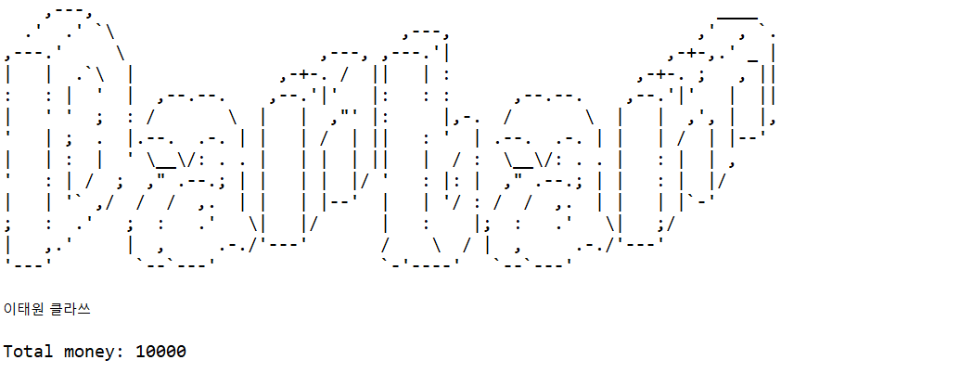

**Figure 1. Main Menu Header**

* The program will show **4 menus**:

1. **Add danbam’s chef**
2. **View danbam’s information**
3. **View customers in danbam**
4. **Quit**

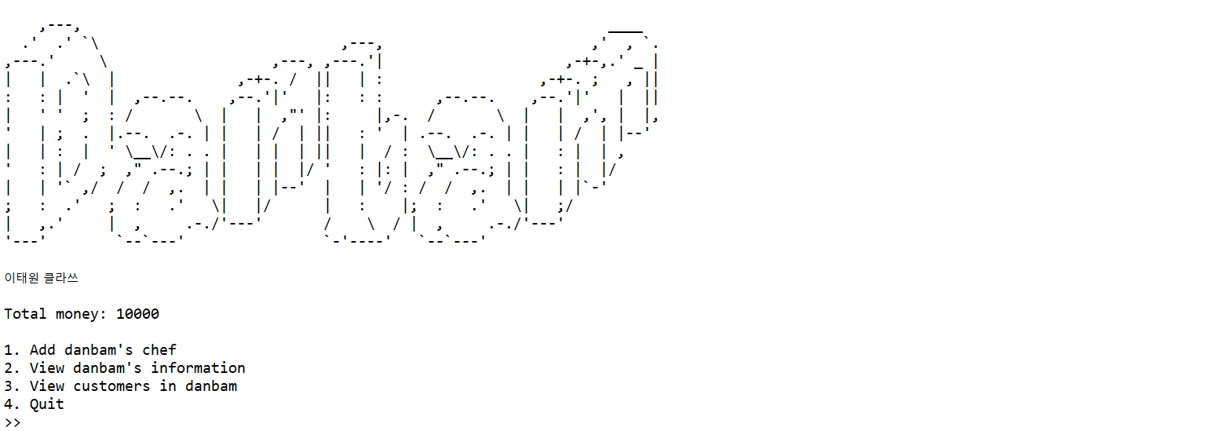

**Figure 2. Main Menu**

* If the user chooses **menu 1** ‘**Add danbam’s chef**’, then:
* The program will ask the user to input the details of the chef:
* **Chef’s name**, which must consist of **exact 3 words**
* **Chef’s username**, which must be **unique**
* **Chef’s gender**, which must be **between** **Female** and **Male** (**case sensitive**)
* **Chef’s age**, which must be **between 17** and **40**
* After the details of the chef has been filled:
* **Initialize** the chef’s salary with **3000**
* **Random**  whether the chef is **professional** or **not**
* **Generate** Chef ID in the format of **UUID** (syntax: **UUID.randomUUID()**)
* Then, **add** the **new chef** into the **chef lists** in danbam
* Every chef in danbam has a **responsibility** to cook and the **right** to get salary:
* For every **2 minutes** after the chef registration, the chef in danbam will be paid with the amount of their salary, danbam’s total money will be reduced to pay for the chef
* If the chef hired is **professional**, then the chef will be able to cook and **add the menu queue** in restaurant for every **second**. Otherwise, it is for every **2 seconds**

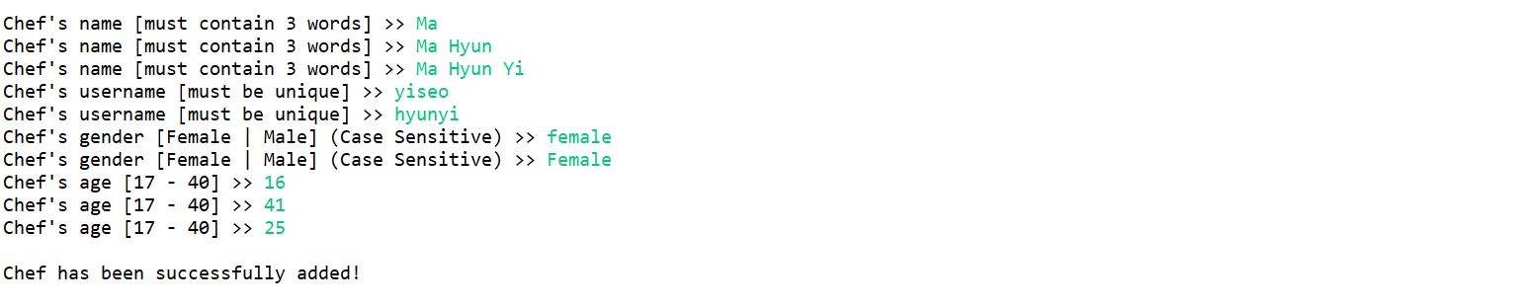

**Figure 3. Add Chef**

* If the user chooses **menu 2** ‘**View danbam’s information’**, then the program will display the **options menu** of which information the user want to view:

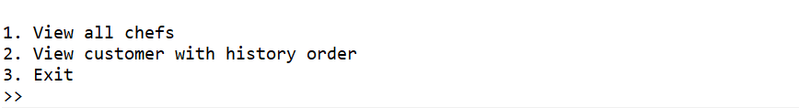

**Figure 4. Options Menu**

* If the user chooses **option 1** ‘**View all chefs**’ :
* Show **all chefs in danbam**, with the details of each chef:
* Chef Id
* Chef’s Name
* Chef’s Username
* Chef’s Age
* Chef’s Gender

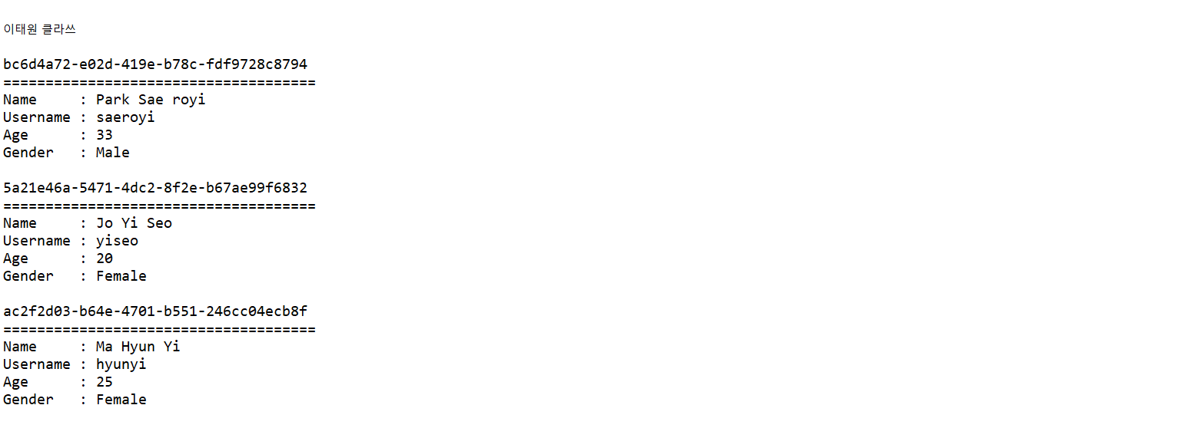

**Figure 5. View All Chefs**

* User must press enter to exit this view
* If the user chooses **option 2 ‘View customer with history order’** :
* If there are none of customers with history order, then view this following message



**Figure 6. No Order Messages**

* Otherwise **display all the customers with history order** that ever eat in danbam (This view **will be refreshed** in every second):
* Customer Id
* Customer’s Name
* Customer’s Age
* Customer’s Gender
* Menu details, with the details of:
* Menu Id
* Menu’s Name
* Total Price (obtained from the **sum of menu’s price** of the **customer’s history orders** while eating in danbam

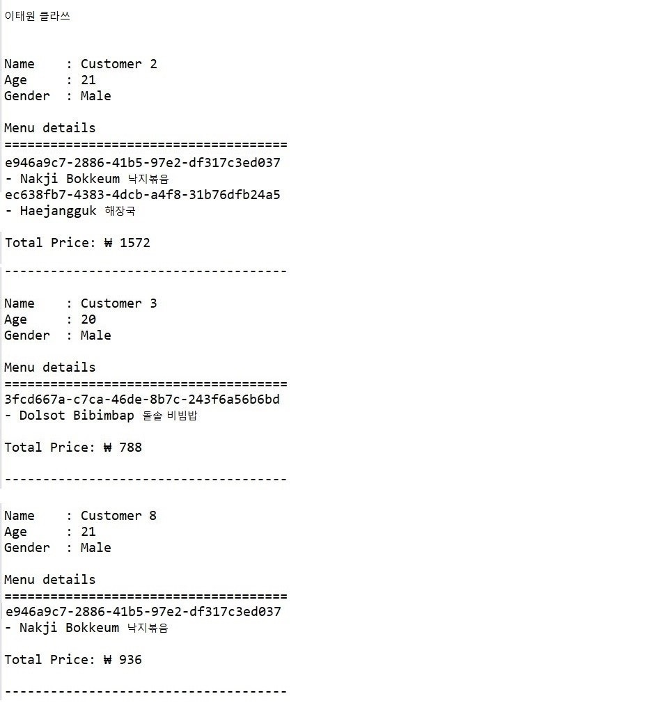

**Figure 7. View Customers with History Orders**

* User must press enter to exit this view
* If the user chooses **option 3 ‘Exit’** :
* Exit the following options and back to the main menu
* If the user chooses **menu 3** ‘**View customers in danbam**’, then:
* Show all the customers (Customer’s Name) in danbam right now:

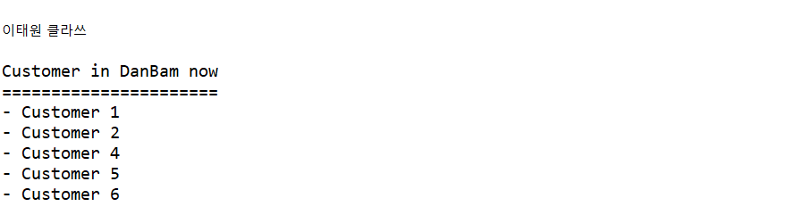

**Figure 8. Customer in Danbam**

* If the user chooses **menu 4** ‘**Exit**’, then the program will be closed

**If there is something you do not understand, feel free to ask your Assistant!**