Predicting Engagement and Sentiment Surges in Stock-Related Social Media Discussions
A Leakage-Aware Approach to Early Surge Prediction in Reddit Stock Discussions

Abstract
We study early prediction of short-term surges in stock-related social media discussions. Using a pre-collected Reddit dataset from the subreddit communities, we define a 24-hour binary surge target that combines posting-volume growth with sentiment change while restricting predictors to information available at observation time to avoid temporal leakage. Our pipeline covers ticker extraction, temporal windowing, sentiment estimation, feature engineering, temporal cross-validation, and held-out evaluation. On a temporally held-out test set, a logistic regression baseline achieves an AUC-ROC of 0.733, showing that early temporal, textual, and sentiment signals contain useful ranking information for surge detection. However, threshold-based performance remains weak, with very low precision under severe class imbalance and high per-ticker sparsity. These results suggest that early surge prediction is feasible as a ranking problem, but practical deployment will require improved calibration, denser data, and broader model comparison.

Keywords
social media analytics; surge prediction; stock discussions; sentiment analysis; temporal machine learning; Reddit; computational finance

1. Introduction
Online discussion around individual stocks can intensify within hours, creating short-lived periods of unusually high attention and sentiment change. Detecting such episodes early is useful for market monitoring, social-media analysis, and downstream decision support, but the task is difficult because surge events are rare, platform activity is sparse at the ticker level, and naïve features can leak future information.

Contributions
This paper makes three contributions:

- We formalize early surge prediction for stock-related discussions as a 24-hour binary classification task defined per ticker.
- We design a leakage-aware pipeline that combines temporal, textual, and sentiment features using only information available at prediction time.
- We present baseline evidence that the task is learnable as a ranking problem (AUC-ROC 0.733), while identifying class imbalance and ticker sparsity as the main barriers to practical precision.

Task Definition and Main Result
For a record mentioning ticker X at time t, the task is to predict whether discussion of X will surge within the next 24 hours. We define surge using a composite of normalized posting-volume growth and sentiment change, and we exclude snapshot engagement features such as score and comment count because they would contaminate the prediction setting with future information.
Empirically, the prototype achieves an AUC-ROC of 0.733 on a temporally held-out test set, indicating meaningful ranking ability. However, performance at the default decision threshold remains weak, largely because surge events are rare and the resulting class imbalance produces many false positives.
Existing research has largely focused on predicting overall popularity [1, 3] or examining relationships between sentiment and market outcomes [4], rather than forecasting whether discussion of a specific stock is about to surge. High-profile episodes such as the 2021 GameStop short squeeze illustrate that rapidly escalating online discussion can coincide with substantial market attention [5], motivating the development of early detection systems.

Prediction Scope and Surge Definition
The prediction operates at the record level but measures surges at the ticker level. For a record mentioning ticker X at time t, the system asks: "Will discussion of X surge within the next 24 hours?"

A surge is defined using a composite metric that combines z-score-normalized posting-volume growth and sentiment change:

composite = (w₁ × z_volume) + (w₂ × z_sentiment)

Here, z-scores are computed using training-partition statistics only to prevent leakage, and a record is labelled as a surge (1) if the composite exceeds the threshold τ. The target uses posting volume (that is, timestamp-derived record counts) rather than engagement scores, which are snapshot values contaminated by future information. The default configuration sets w₁ = w₂ = 0.5 and τ = 1.5 standard deviations.

A two-phase experimental design validates the composite target. Phase 1 uses volume only (w₂ = 0) as a baseline, and Phase 2 uses an equal-weight composite (w₂ = 0.5) to test whether sentiment adds predictive value.

Scope
In scope: a pre-collected static Reddit dataset selected through repository search and manual exploratory screening (pennystocks subreddit, 54,785 records, 2,912 tickers), feature engineering, binary classification, traditional machine learning models, and a reproducible pipeline with fixed random seeds.
Out of scope: real-time ingestion, production deployment, trading signals, multi-class targets, and cross-platform fusion.

Dataset Source and Selection Rationale
The study uses a pre-collected Reddit submissions dataset centred on the r/pennystocks community, stored as r_pennystocks_submissions_reddit.csv. Rather than relying on live collection, we deliberately use a static dataset sourced from public dataset repositories such as Kaggle or Hugging Face, where Reddit discussion datasets are already packaged, documented, and easier to validate before modelling. This choice reflects a practical research trade-off: Reddit data access has become more constrained by API usage limits and policy restrictions, while public dataset hubs provide a large supply of reusable collections that can be screened efficiently for relevance and quality. For this project, a static dataset is also preferable because it supports reproducible experiments, stable temporal splits, and direct comparison across modelling choices without changes in the underlying source data.
Dataset selection followed a hybrid process. In the first round, platform search and metadata filtering on dataset repositories were used to narrow a large candidate pool by source, topic, file structure, and likely relevance to stock discussions. In the second round, shortlisted datasets were inspected manually through a lightweight exploratory data analysis pipeline to assess coverage, timestamp quality, text completeness, ticker density, and suitability for surge-labelling. This two-stage approach balances efficiency with data quality control: repository search reduces the search space quickly, while manual checking ensures that the final dataset matches the modelling requirements of a leakage-aware surge prediction task.

2. Related Work

Prior Work and Research Gap
Prior work suggests that early online behaviour contains useful predictive signal. Research on popularity prediction shows that early activity can forecast later attention [1, 2], while content-based models demonstrate that textual and metadata features can improve prediction before engagement fully accumulates [3]. In parallel, studies in financial natural language processing indicate that sentiment may carry predictive value, although general-purpose sentiment tools remain imperfect for domain-specific language [4]. Work on information diffusion further shows that early temporal dynamics often distinguish content that later grows rapidly from content that does not [5–8].
However, most existing studies target eventual popularity, cascade size, or market movement rather than the onset of a short-term surge in discussion around a specific stock. They also typically focus on general social-media platforms rather than finance-oriented forums, and many do not explicitly address leakage risks that arise when snapshot engagement variables are used as predictors. These differences matter because stock-related discussions are sparse, event-driven, and highly imbalanced at the ticker level.
This paper addresses that gap by formulating a 24-hour surge prediction task for stock-related discussions under realistic temporal constraints and evaluating a baseline model that combines temporal, textual, and sentiment information. The contribution is therefore a clear problem formulation and an initial benchmark rather than a claim of deployment-ready performance.

3. System Design

System Architecture and Pipeline Stages
The system uses a staged pipeline that transforms raw Reddit submissions into ticker-level prediction instances, derives leakage-safe features and labels, and then trains and evaluates a baseline classifier under temporal holdout conditions. Figure 1 summarises the overall workflow and highlights the main design principle: every predictor is restricted to information available at observation time.
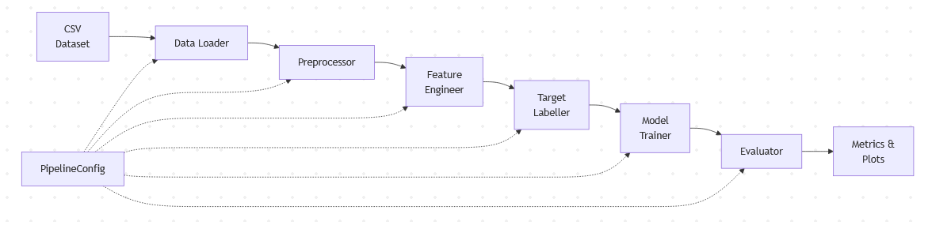
Figure 1: Data Pipeline Architecture.

Exploratory Data Analysis Phase
Exploratory Data Analysis (EDA) is the data-understanding phase of the project. Its purpose is to inspect the Reddit dataset before modelling, identify whether the data is suitable for a 24-hour surge prediction task, and reveal practical issues such as sparse ticker activity, uneven posting frequency, missing or short text fields, and class imbalance. This phase is important because the quality of the surge labels and features depends directly on the temporal coverage, ticker density, and sentiment behaviour observed in the raw data.
The EDA phase works by loading the processed record–ticker dataset, grouping records by time and ticker, and summarising key distributions before model training begins. It examines posting frequency over time, the concentration of mentions among popular tickers, the long-tail sparsity of less frequent tickers, the effect of the minimum forward-window count, and the behaviour of volume-growth and sentiment-change variables. These checks guide later design choices, including the exclusion rules for sparse forward windows, the surge threshold τ, and the comparison between volume-only and volume-plus-sentiment labelling.
In this report, EDA therefore acts as a bridge between dataset selection and predictive modelling: it confirms what the dataset contains, explains why some records must be excluded, and provides visual evidence for the modelling assumptions used later in the prototype.

Feature Design
Table 1 summarises the backward-looking feature set used by the model. Each feature is constructed only from information available at observation time t, which prevents temporal leakage.

Feature | Type | Rationale
sentiment_score | Continuous [-1, 1] | Emotional tone may precede surges [4]
hour_of_day | Discrete [0–23] | Trading hours show different patterns
day_of_week | Discrete [0–6] | Weekend vs weekday dynamics differ
time_since_previous | Continuous ≥ 0 | Rapid posting signals emerging activity [1]
ticker_post_rate_24h | Continuous ≥ 0 | Current per-ticker discussion intensity
ticker_post_acceleration | Continuous | Whether frequency is already increasing
word_count | Discrete ≥ 0 | Longer posts may carry more content [3]
title_length | Discrete ≥ 0 | Short vs detailed titles signal type
num_tickers_mentioned | Discrete ≥ 1 | Broad vs focused discussion

Excluded: score and num_comments, because these snapshot values are contaminated by future engagement and would introduce temporal leakage.

Composite Target Design
The binary surge target is computed from a forward-looking 24-hour ticker window by combining posting-volume growth with sentiment change, after standardising both components using statistics from the training partition only. Records are labelled as surges when the resulting composite exceeds a preset threshold, allowing the target to capture both unusually rapid discussion growth and marked sentiment movement without introducing leakage.
Records with fewer than three posts in the forward ticker window are excluded because they do not provide enough data for stable metric computation. This addresses Risk #6 (per-ticker sparsity) but produces a high exclusion rate on sparse datasets.

Evaluation Strategy
Table 2 lists the evaluation metrics used on the temporally held-out test set. Together, these metrics distinguish ranking performance from threshold-dependent decision quality.

Metric | Purpose
AUC-ROC | Primary metric; threshold-independent discriminative ability
Precision | Proportion of predicted surges that are actual surges
Recall | Proportion of actual surges correctly detected
F1-Score | Harmonic mean balancing precision and recall

Evaluation uses a temporally held-out test set, with model selection performed through temporal cross-validation inside the training partition. Because surges are rare, threshold-independent discrimination is prioritised over raw accuracy, while precision, recall, and F1 are reported to show the practical consequences of class imbalance.

Performance is compared with a random baseline (AUC = 0.5), a majority-class baseline, and single-feature baselines. The success criteria are a minimum AUC-ROC above 0.60, a target above 0.70, and a stretch goal above 0.80.

Additional sensitivity analyses examine how the surge threshold and the weight placed on sentiment affect class balance and predictive performance. These checks are intended to show whether the baseline behaviour is robust to reasonable alternative target settings.

To improve reliability, the analysis also considers uncertainty estimates and repeated runs, although these are primarily intended as robustness checks rather than the central contribution of the prototype.

Risk Register
# | Risk | Likelihood | Impact | Mitigation | Status
1 | Class imbalance (few surge events) | High | High | Balanced class weighting, AUC-ROC evaluation, report precision-recall curves | Open
2 | TextBlob sentiment limitations | Medium | Medium | Document limitations; configurable component weight; FinBERT as future alternative | Open
3 | Data quality issues | Medium | Medium | Robust preprocessing with logging; document exclusion criteria | Open
4 | Temporal data leakage | Medium | High | Strict temporal split; 9 backward-only features; engagement scores excluded | Mitigated
5 | Overfitting on small effective dataset | Medium | High | Temporal CV, L1/L2 regularisation, report train-test gaps | Open
6 | Per-ticker sparsity | High | High | Min window count (N≥3); report exclusion rate; test with larger datasets | Open
7 | Snapshot engagement as features | High | Critical | Eliminated — features use only timestamps and text | Mitigated
8 | Circular labelling from snapshot scores | High | Critical | Target uses posting volume growth from timestamps only | Mitigated
9 | Temporal concept drift | Medium | Medium | Report train/test rate differences; acknowledge as limitation | Open

Project Timeline
Id | Phase | Key Activities | Deliverables
Phase 1 | Business Understanding & Scoping | Define problem, users, research question, scope and success criteria | Project definition and requirements
Phase 2 | Literature Review | Review trend prediction, engagement prediction and sentiment analysis research | Literature review and research gap
Phase 3 | Data Understanding | Dataset investigation, exploratory analysis and quality assessment | Dataset profile and EDA results
Phase 4 | System Design | Design prediction pipeline, feature set, surge definition and evaluation strategy | System architecture and design specification
Phase 5 | Prototype Development | Implement baseline pipeline and Logistic Regression model | Feasibility prototype
Phase 6 | Full Pipeline Implementation | Preprocessing, feature engineering and advanced models | Complete predictive system
Phase 7 | Evaluation & Analysis | Model comparison, cross-validation, error analysis and feature importance analysis | Evaluation results
Phase 8 | Refinement | Improve models and address identified weaknesses | Refined prototype
Phase 9 | Final Report & Demonstration | Final documentation and demonstration video | Final report and video

The project follows an iterative predictive modelling process. Initial phases focus on defining the problem, reviewing related research and understanding the dataset. These activities inform the system design, including the surge definition, feature engineering strategy and evaluation methodology. A feasibility prototype is developed to validate the proposed approach before implementing the complete prediction pipeline. The final stages focus on comparative evaluation, refinement and preparation of the final report and demonstration.

Figure 2: Project Gantt Chart

4. Prototype and Results
We next evaluate the end-to-end prototype on a temporally held-out test set. The baseline Logistic Regression model attains moderate ranking performance, but the section also shows that this does not translate into useful precision at the default operating point because surge events are extremely rare.

Prototype Implementation
The prototype operationalises the proposed pipeline in Python, covering data preparation, temporal window construction, sentiment estimation, target labelling, feature generation, model training, and evaluation. In this report, it serves mainly to demonstrate that the proposed design can be executed reproducibly and assessed end to end on the available dataset.
Module | Responsibility | Key Challenge
eda_pipeline.py | Automated exploratory analysis and figure generation | Reproducible publication-ready figures across five focus areas
loader.py | CSV ingestion, ticker extraction, record explosion | Filtering 200+ false-positive stopwords from ticker regex
windowing.py | Per-ticker temporal windowing | Vectorised searchsorted across 2,912 tickers
sentiment.py | TextBlob polarity + mean future sentiment | 80,212 records with title-fallback handling
labelling.py | Temporal split, z-score normalisation, labelling | Training-only statistics to prevent leakage
features.py | Nine backward-only features | Strict temporal isolation
training.py | Logistic Regression + temporal CV | Grid search (10 configs) with k=4 expanding-window folds
evaluation.py | Metrics computation and visualisation | Handling 50.9:1 class imbalance

Reproducibility
The prototype is implemented as a modular Python pipeline with fixed configurations and consistent temporal splitting to prevent leakage. All preprocessing, feature engineering, labelling, and model evaluation steps are executed via a single script, ensuring results can be regenerated from the original dataset. Fixed random seeds are used to maintain consistency across runs, supporting reliable and repeatable experimentation.

Exploratory Data Analysis Pipeline
The prototype implements the EDA phase through an automated module (src/eda/eda_pipeline.py). This module translates the methodology-level EDA checks into reproducible code by reading the processed dataset, computing descriptive statistics, and generating publication-ready figures (Figures 3–11). Unlike the training pipeline, it does not fit a predictive model; instead, it diagnoses the dataset and produces evidence used to justify the later feature, target, and evaluation choices. The EDA pipeline covers five focus areas:

1. Dataset overview — temporal coverage, posting frequency, and ticker frequency distribution (Figures 3–5)
2. Sparsity analysis — per-ticker exclusion rates and the impact of the min_window_count parameter on dataset coverage (Figures 6–7)
3. Feature distributions — posting volume growth and absolute sentiment change histograms split by surge vs non-surge labels (Figures 8–9)
4. Phase 1 vs Phase 2 comparison — label agreement between volume-only and composite labelling, quantifying sentiment's marginal contribution (Figure 10)
5. Threshold sensitivity — surge rate curve across τ values with viable region identification (Figure 11)

Operationally, the module runs after run_pipeline.py has produced the cleaned and labelled intermediate data. It is invoked separately from model training so that exploratory findings remain deterministic, reproducible, and consistent with the exact dataset used for modelling. The resulting figures satisfy requirement R2 (Exploratory Data Analysis) and inform key design decisions documented in this chapter, including the choice of τ=1.5, the high exclusion rate caused by per-ticker sparsity, and the observation that sentiment adds only marginal discriminative value beyond volume alone.
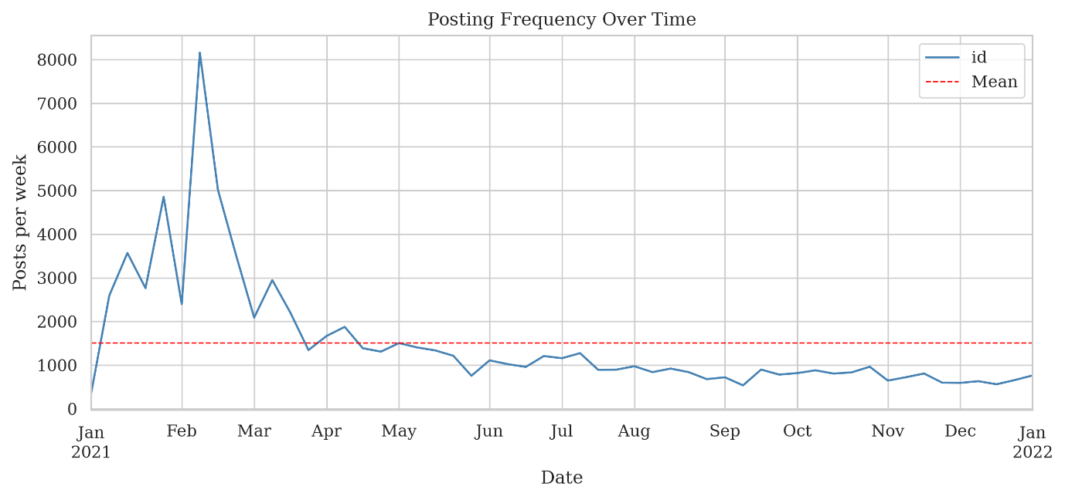
Figure 3: Posting frequency over time showing weekly activity patterns across the dataset period.

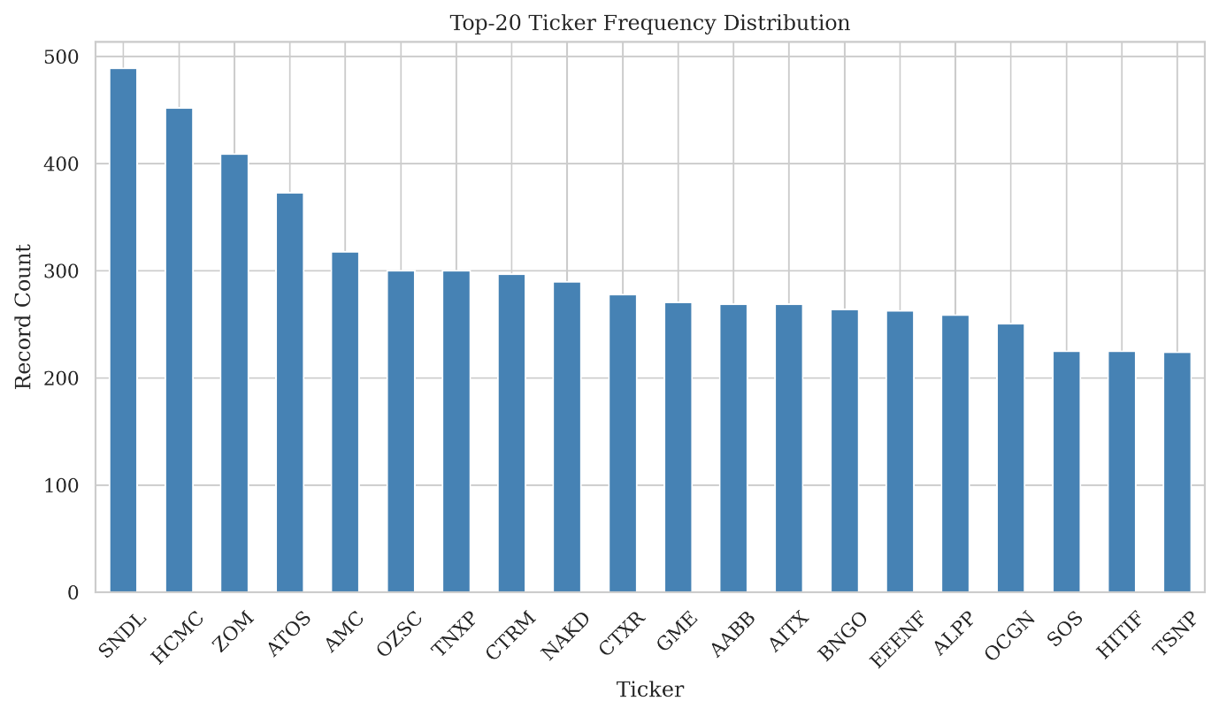
Figure 4: Top-20 most frequently mentioned tickers, demonstrating heavy concentration in a few symbols.
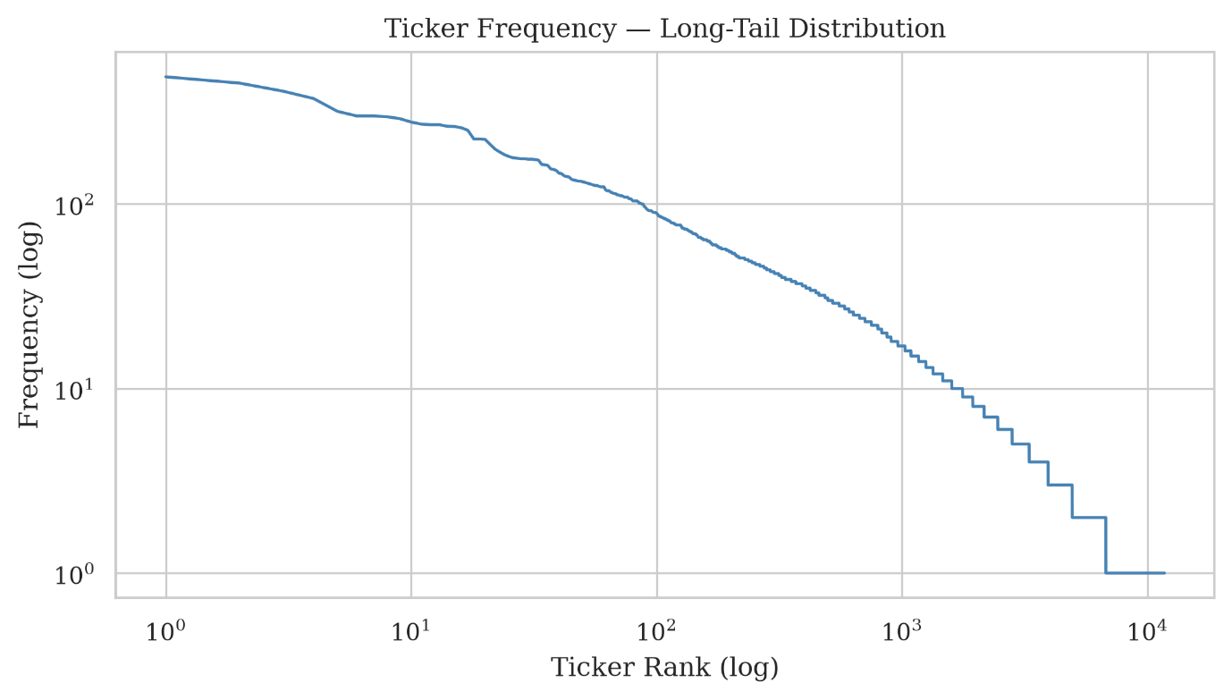
Figure 5: Ticker frequency long-tail distribution (log-log scale) — most tickers have very few mentions, driving the high exclusion rate.
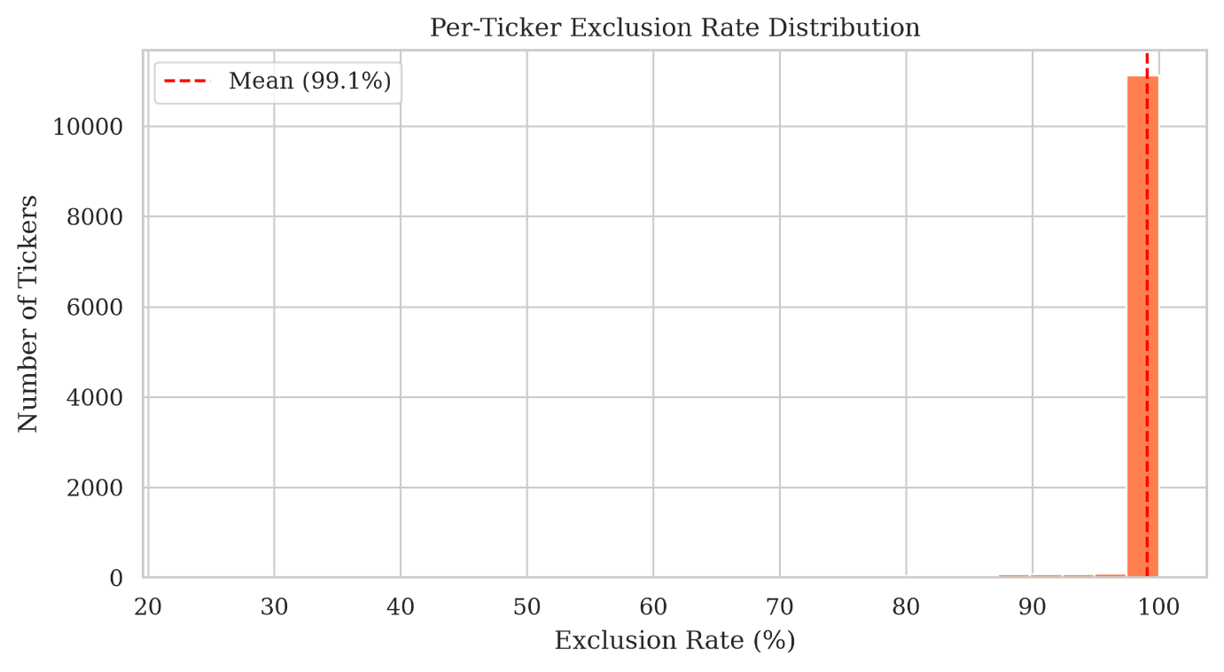
Figure 6: Per-ticker exclusion rate distribution — the majority of tickers have high exclusion rates due to sparse forward windows (min_window_count=3).
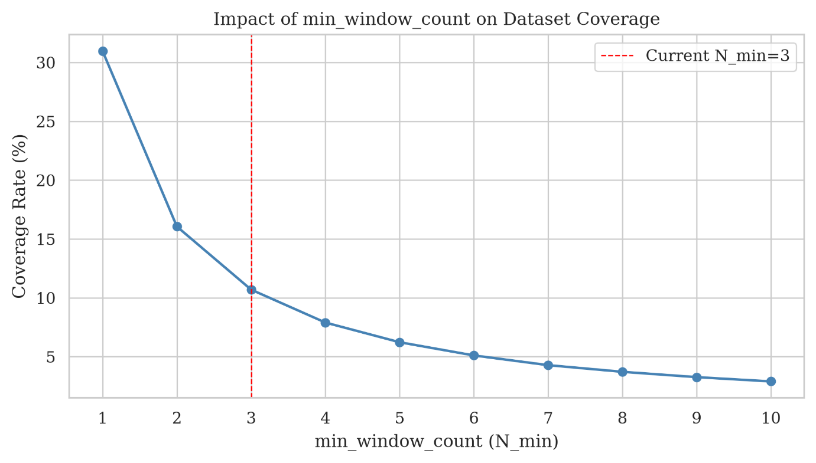
Figure 7: Impact of min_window_count parameter on dataset coverage — lower thresholds retain more data but risk unstable labels.
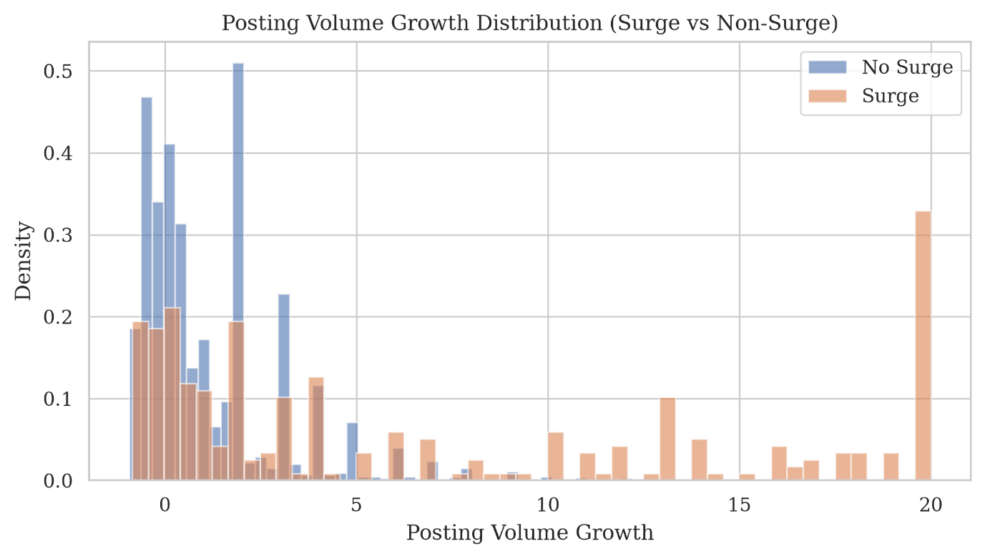
Figure 8: Posting volume growth distribution split by surge vs non-surge labels — surge events exhibit higher growth values, confirming feature discriminative power.
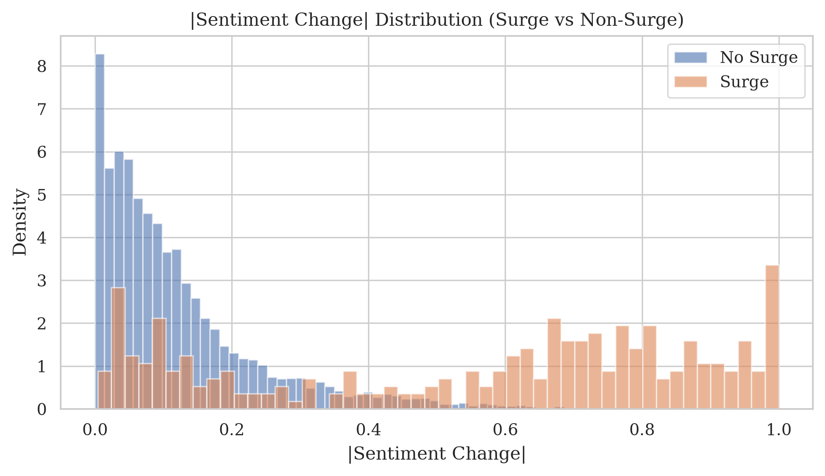
Figure 9: Absolute sentiment change distribution by label — surge events show slightly elevated sentiment shifts, though overlap is substantial.
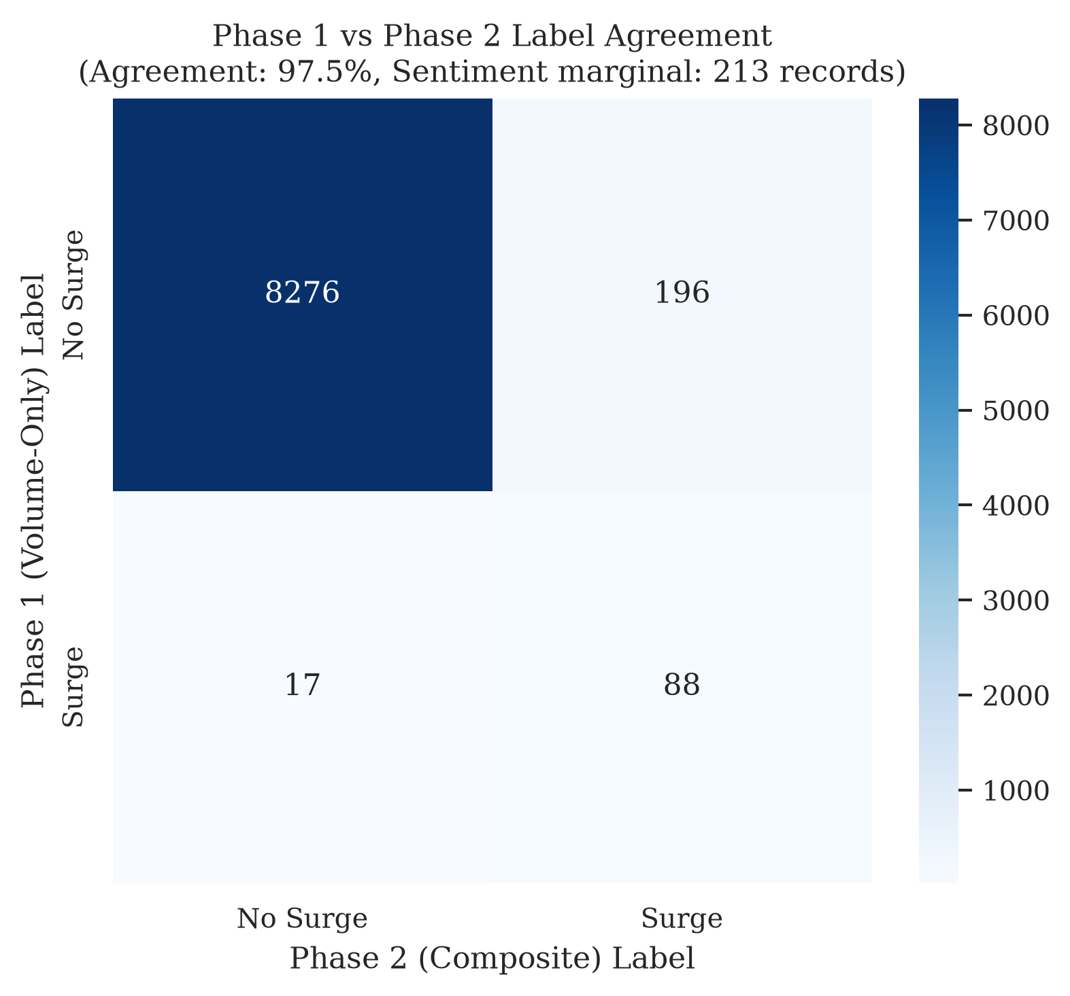
Figure 10: Phase 1 (volume-only) vs Phase 2 (composite) label agreement — quantifies sentiment's marginal contribution to the surge definition.

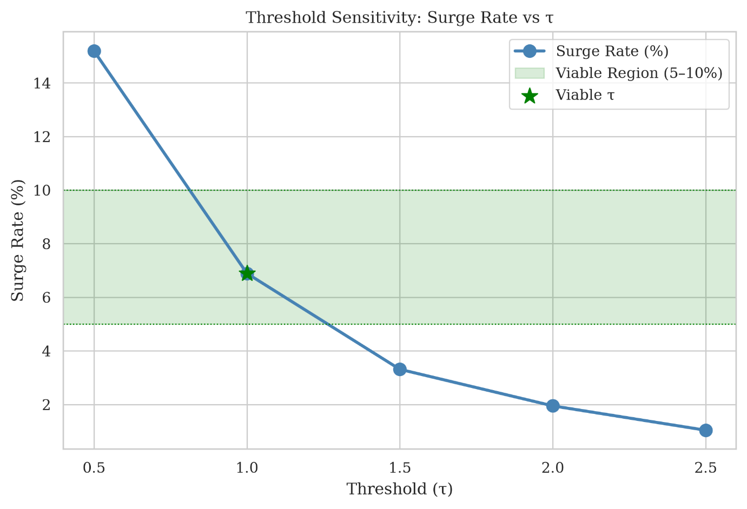
Figure 11: Labelling threshold sensitivity — surge rate across τ values with viable region (5–10%) highlighted. Only τ=1.0 falls within the viable range.

Execution Results
Dataset: r_pennystocks_submissions_reddit.csv (54,785 records). Configuration: τ=1.5, w₁=w₂=0.5, 80/20 temporal split, min_window_count=3.

Data flow: 54,785 raw records expand to 80,212 record–ticker pairs, of which 71,635 (89.3%) are excluded because of ticker sparsity, leaving 8,577 included instances (8,058 train; 519 test).
Partition | Surge | No-Surge | Surge Rate | Imbalance
Training | 274 | 7,784 | 3.40% | 28.4:1
Test | 10 | 509 | 1.93% | 50.9:1
The lower surge rate in the test partition is consistent with temporal concept drift (Risk #9), suggesting that later months of 2021 contain less surge activity than the earlier meme-stock period.

Model Performance

Metric | Value | Interpretation
ROC-AUC | 0.733 | Exceeds target (>0.70); moderate discriminative ability
Precision | 0.028 | Most predicted surges are false positives
Recall | 0.900 | Detects 9 of 10 actual surges
F1 | 0.054 | Low due to precision-recall imbalance

Confusion Matrix:

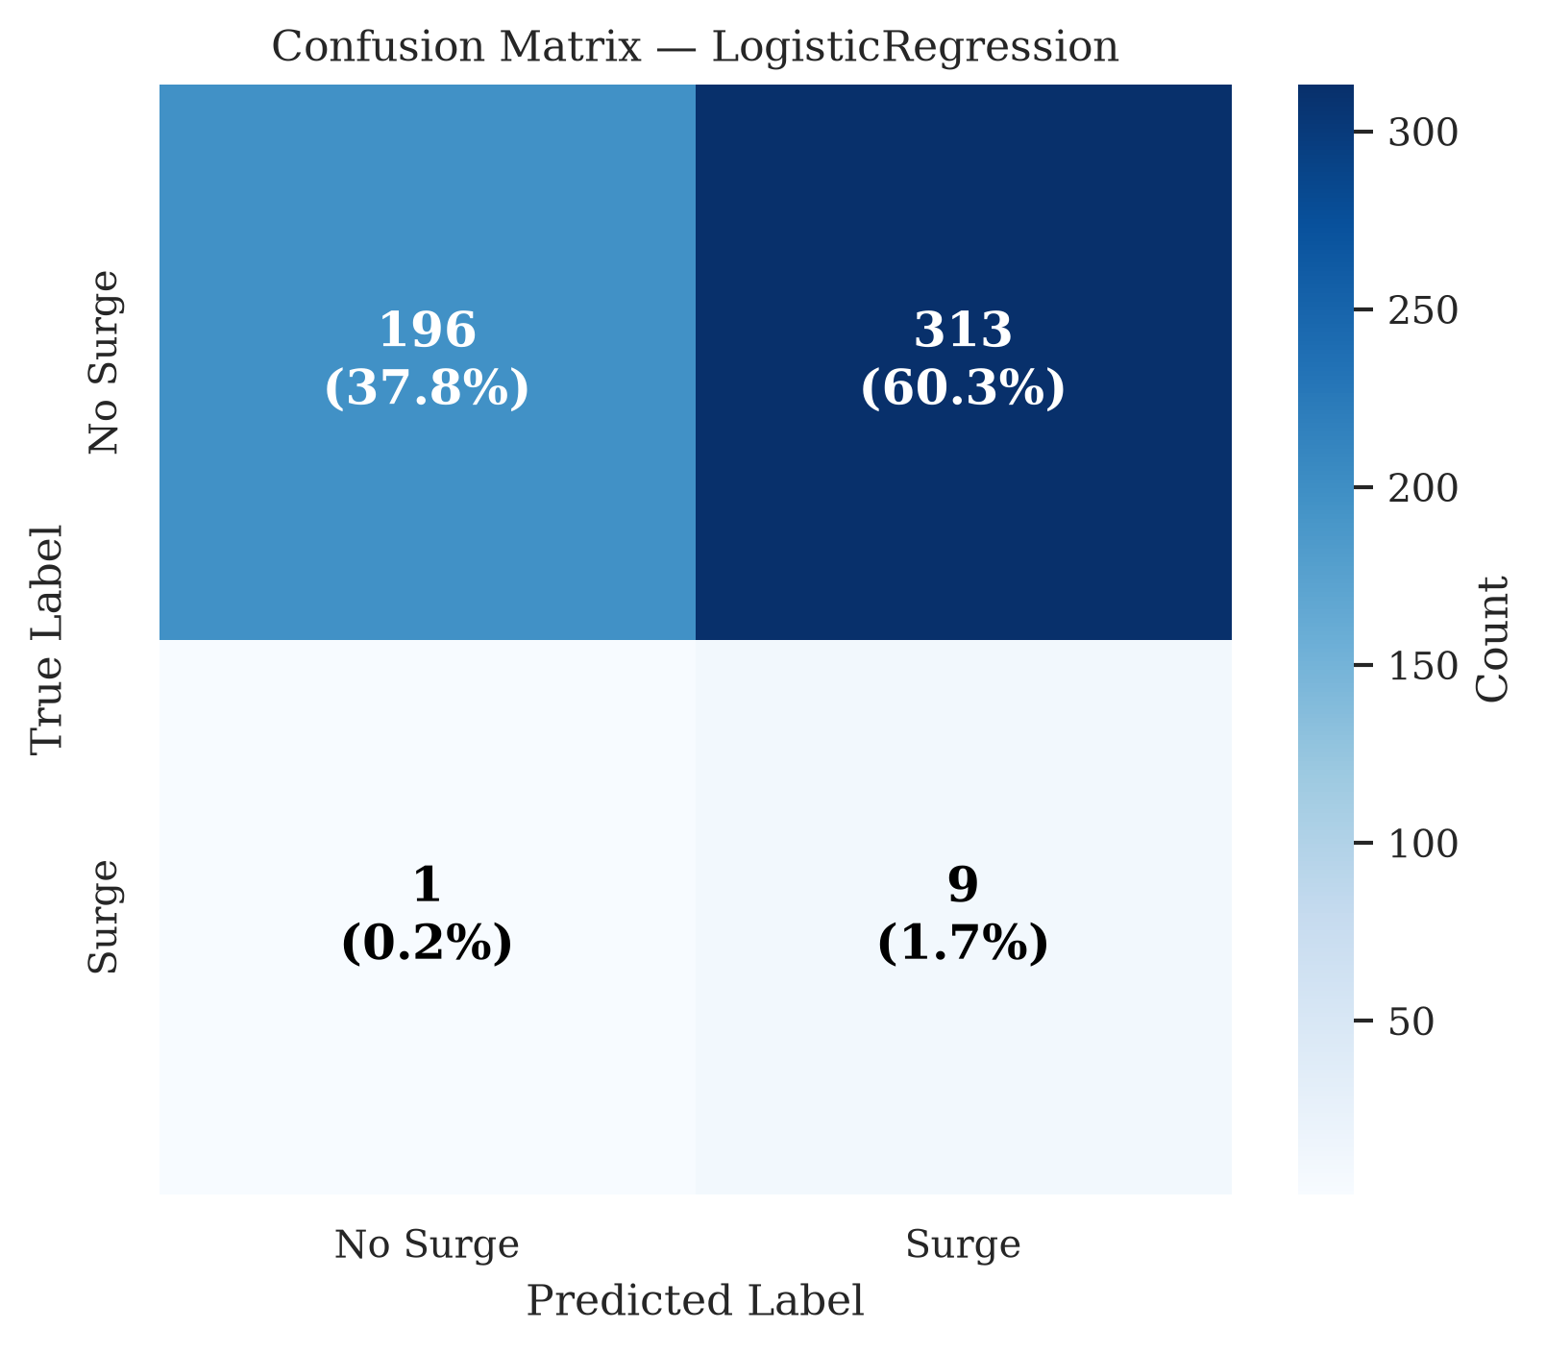
Figure 12: Confusion matrix for Logistic Regression baseline on the held-out test set (519 records).
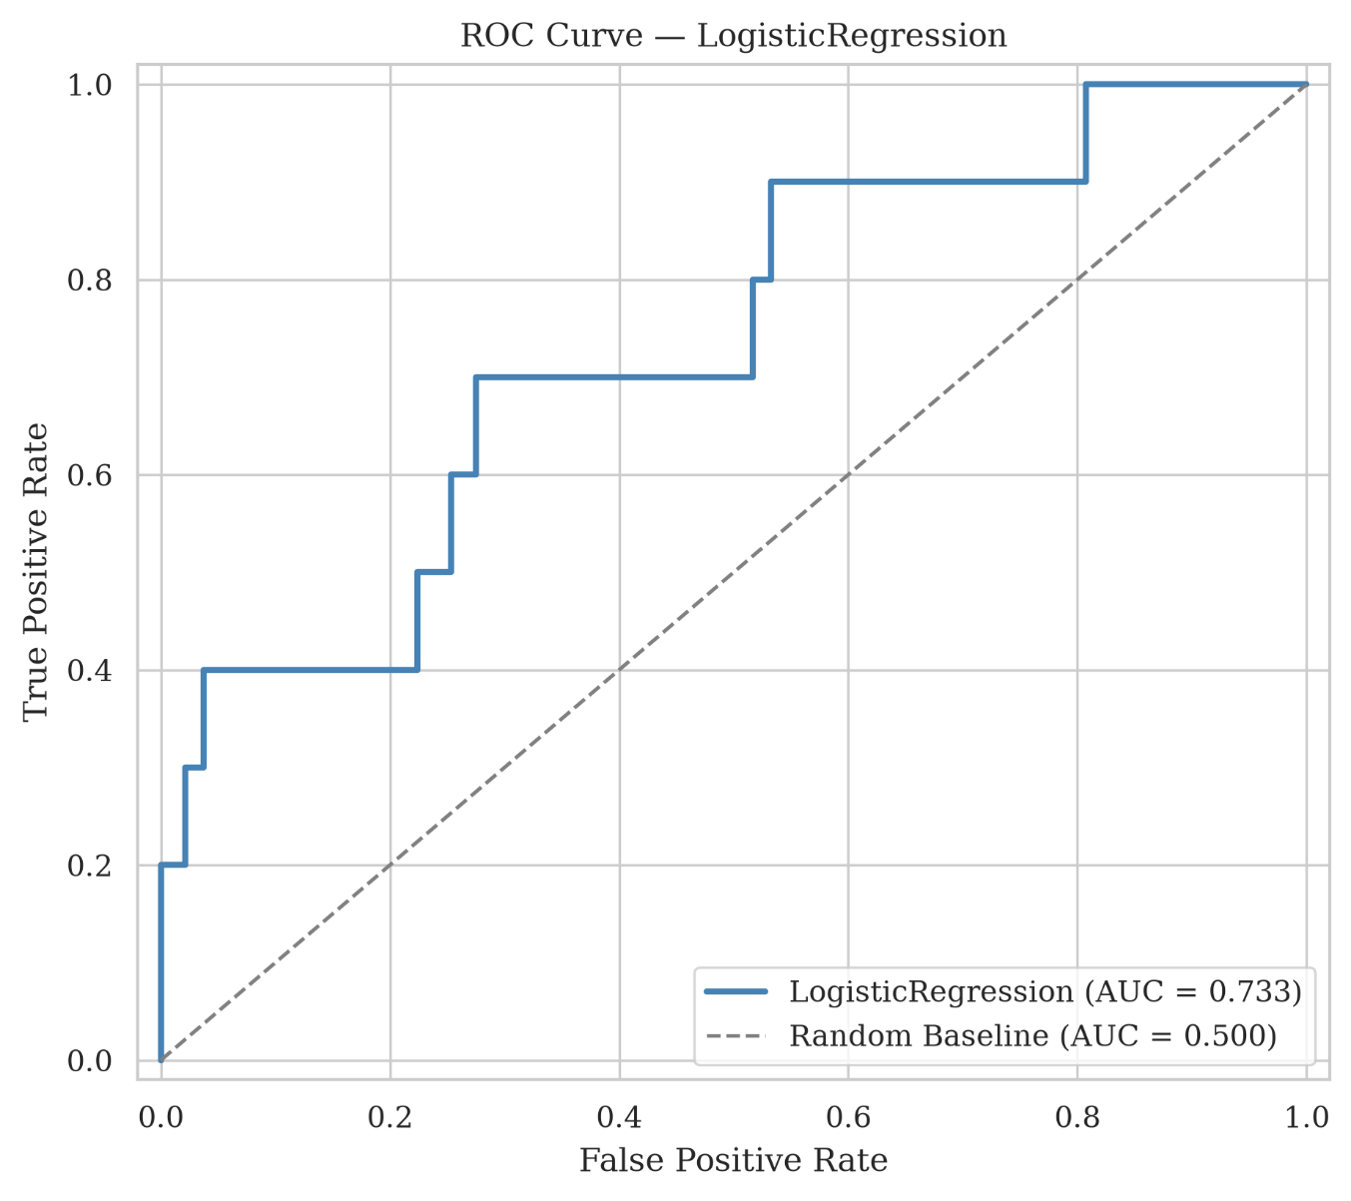
Figure 13: ROC curve for Logistic Regression (AUC = 0.733) versus random baseline.

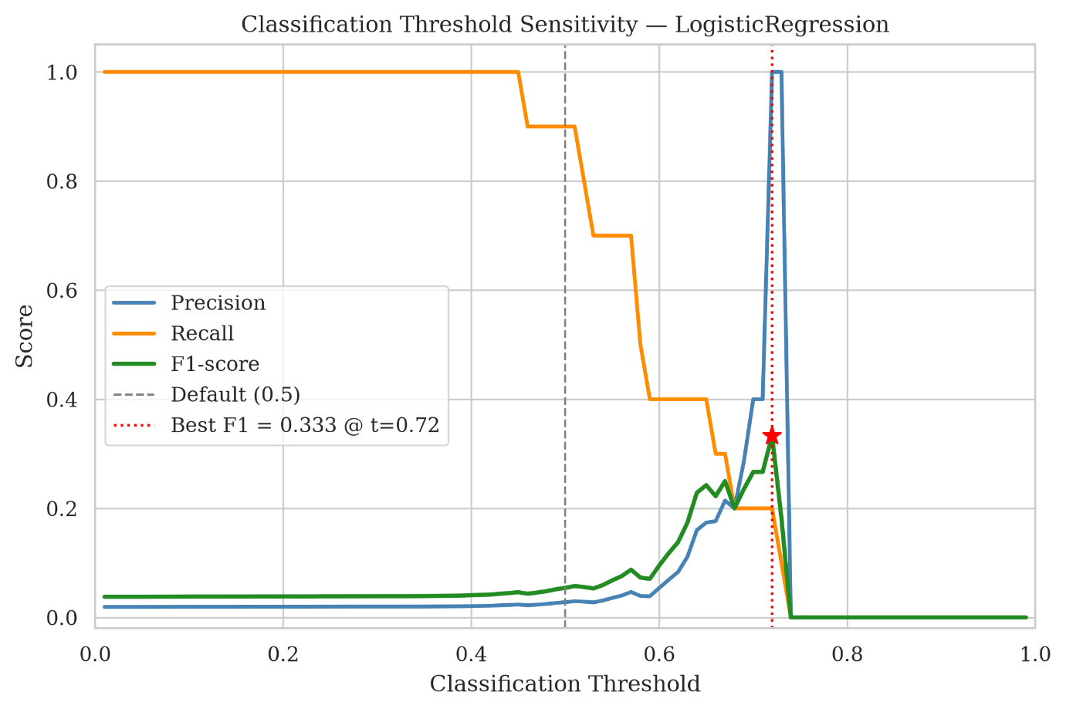
Figure 14: Classification threshold sensitivity — precision, recall, and F1.
Overall, the model separates surge from non-surge cases better than chance, but its default operating point is not yet suitable for practical alerting. The main challenge is therefore not whether predictive signal exists, but how to turn that signal into reliable decisions under extreme imbalance.

Threshold Sensitivity
τ | Surge Count | Surge Rate | Imbalance | Viable (5–10%)
0.5 | 1,303 | 15.19% | 5.6:1 | No
1.0 | 591 | 6.89% | 13.5:1 | Yes
1.5 | 284 | 3.31% | 29.2:1 | No
2.0 | 167 | 1.95% | 50.4:1 | No
2.5 | 89 | 1.04% | 95.4:1 | No
Only τ = 1.0 produces a viable surge rate (6.89%). The prototype setting of τ = 1.5 creates extreme imbalance that challenges the model, motivating a re-run at τ = 1.0 in the full project.

Limitations and Further Improvements
The prototype establishes a credible baseline for early surge prediction under realistic temporal constraints. Its value lies in showing that the task contains learnable signal while also making clear that stronger decision performance will require improvements beyond the current baseline.

The main limitations are the low precision at the chosen threshold, the high exclusion rate caused by sparse ticker activity, evaluation on only one model family, and the very small number of positive test examples. The next step is to test whether these issues can be reduced through a less extreme surge threshold, probability calibration, stronger model comparison, and evaluation on a denser dataset.

Limitation | Improvement
Low precision (0.028) | Re-run at τ=1.0; probability calibration; tune classification threshold
High exclusion rate (89.3%) | Test with wallstreetbets dataset (775K records, denser tickers)
Single model type | Add Random Forest and XGBoost
Small test positive class (n=10) | Lower threshold; bootstrap confidence intervals
Limited Phase 1 vs Phase 2 modelling comparison | EDA-level label agreement has been assessed; next, train and evaluate models under both w₂=0 and w₂=0.5, then compare AUC-ROC and classification errors statistically.
Single seed | 5-seed evaluation with mean±std reporting

5. Conclusion
This project developed a leakage-aware prototype for predicting 24-hour surges in stock-related Reddit discussions. The Logistic Regression baseline achieved an AUC-ROC of 0.733 on a temporally held-out test set, showing that early temporal, textual, and sentiment-derived features contain useful ranking signal.
However, the prototype is not yet suitable for practical alerting. Precision remains very low because surge events are rare, the test set contains only 10 positive cases, and many ticker windows are excluded because of sparse activity.
Future work should therefore focus on precision–recall evaluation, a less extreme surge threshold such as τ=1.0, denser datasets, calibrated probabilities, and comparison with stronger models such as Random Forest and XGBoost.
Overall, the study should be interpreted as a feasibility study rather than a deployment-ready system: it demonstrates that early surge prediction is learnable as a ranking problem, but reliable decision-making will require improved target design, data coverage, calibration, and precision-focused evaluation.

6. References
[1] Gabor Szabo and Bernardo A. Huberman. 2010. Predicting the popularity of online content. Communications of the ACM 53, 8 (2010), 80–88. https://doi.org/10.1145/1787234.1787254

[2] Kristina Lerman and Tad Hogg. 2010. Using a model of social dynamics to predict popularity of news. In Proceedings of the 19th International Conference on World Wide Web (WWW '10). ACM, New York, NY, USA, 621–630. https://doi.org/10.1145/1772690.1772758

[3] Roja Bandari, Sitaram Asur, and Bernardo A. Huberman. 2012. The pulse of news in social media: Forecasting popularity. In Proceedings of the International AAAI Conference on Web and Social Media 6, 1 (2012), 26–33. https://doi.org/10.1609/icwsm.v6i1.14261

[4] Johan Bollen, Huina Mao, and Xiao-Jun Zeng. 2011. Twitter mood predicts the stock market. Journal of Computational Science 2, 1 (2011), 1–8. https://doi.org/10.1016/j.jocs.2010.12.007

[5] Justin Cheng, Lada A. Adamic, P. Alex Dow, Jon Kleinberg, and Jure Leskovec. 2014. Can cascades be predicted? In Proceedings of the 23rd International Conference on World Wide Web (WWW '14). ACM, New York, NY, USA, 925–936. https://doi.org/10.1145/2566486.2567997

[6] Chunyan Wang and Bernardo A. Huberman. 2012. Long trend dynamics in social media. EPJ Data Science 1, 1, Article 2 (2012). https://doi.org/10.1140/epjds2

[7] Qingchao Kong, Wenji Mao, Guandan Chen, and Daniel Zeng. 2020. Exploring trends and patterns of popularity stage evolution in social media. IEEE Transactions on Systems, Man, and Cybernetics: Systems 50, 10 (2020), 3817–3827. https://doi.org/10.1109/TSMC.2018.2855806

[8] Delin Yuan and Yang Li. Discovering and early predicting popularity evolution patterns of social media emergency information. Aslib Journal of Information Management 77, 6 (2025), 1129–1151. https://doi.org/10.1108/AJIM-10-2023-0450

