**Tools Used**: Visual Studio 2015.

**Summary:** This application helps the user to select either xml or json file and after selecting the file it file is parsed, and Fiber Name is displayed in the textbox to edit the fiber name if needed.

It also displays the Depths values in the list box and if user selects any value from the list box then the corresponding Temperature, Stokes and Anti-Stokes values are displayed on a chart.

If the user selects file other than xml or json then it displays error message saying to open only xml and json files. Similarly, if there is any parse error occurred during the parsing of the file then an error message will be displayed to the user on the screen and the error details are logged to a file on the user desktop.

Note: Instead of Storing the Error Logs to a file on the user machine we can store the Logs on to the Event Viewer

**Screenshots:**

**Initial Form when application starts:**

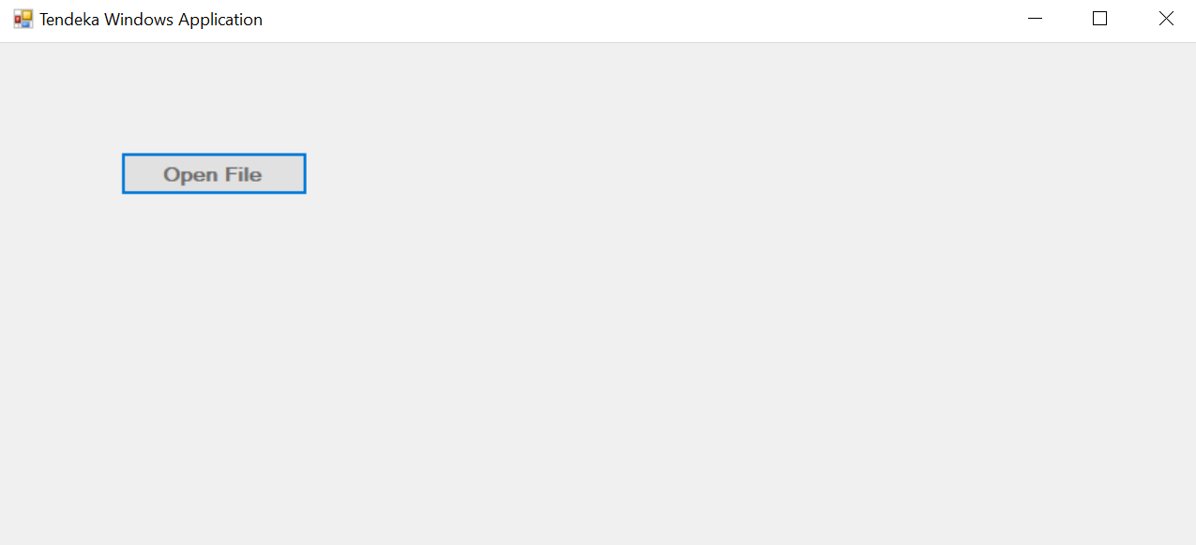

**Open File**

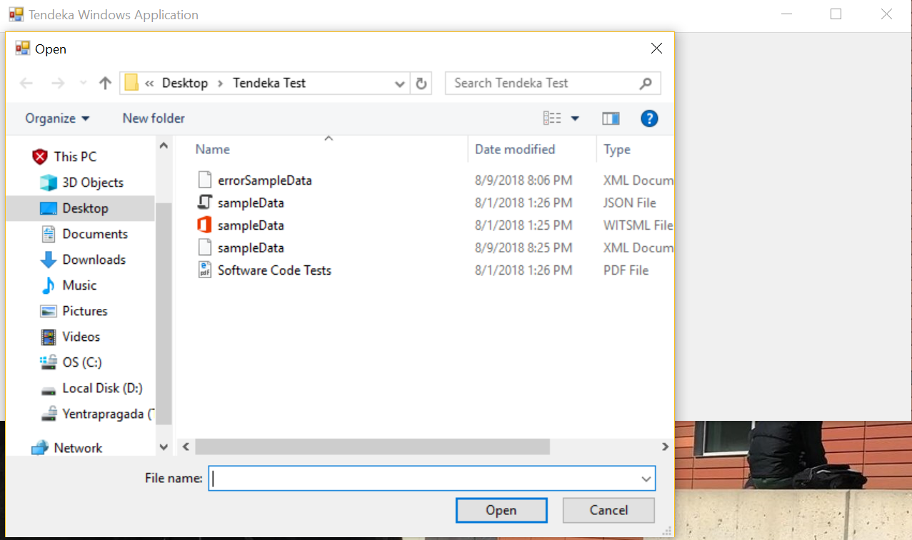

**Parsing Exception:**

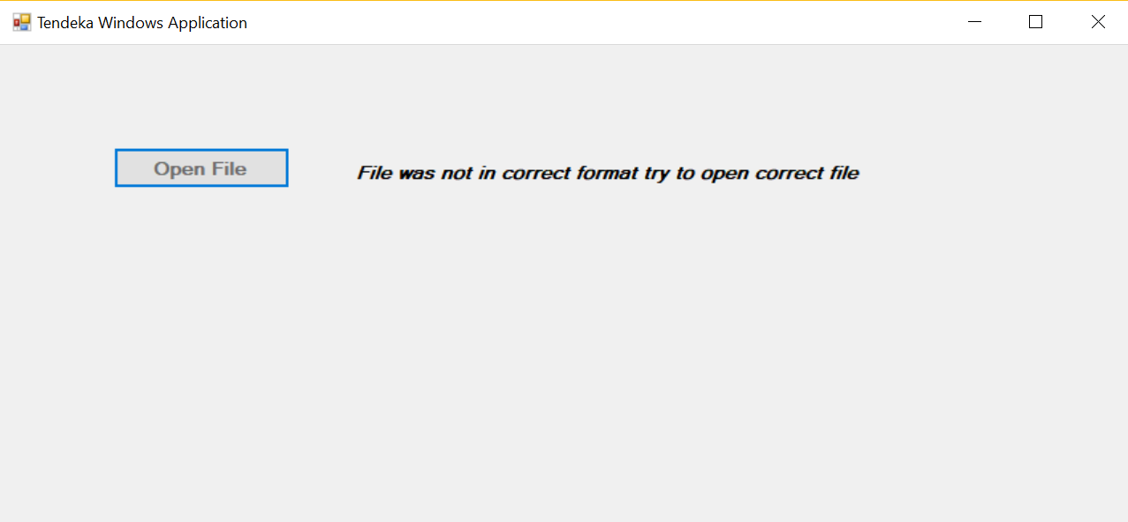

**Error Logging to file on desktop**

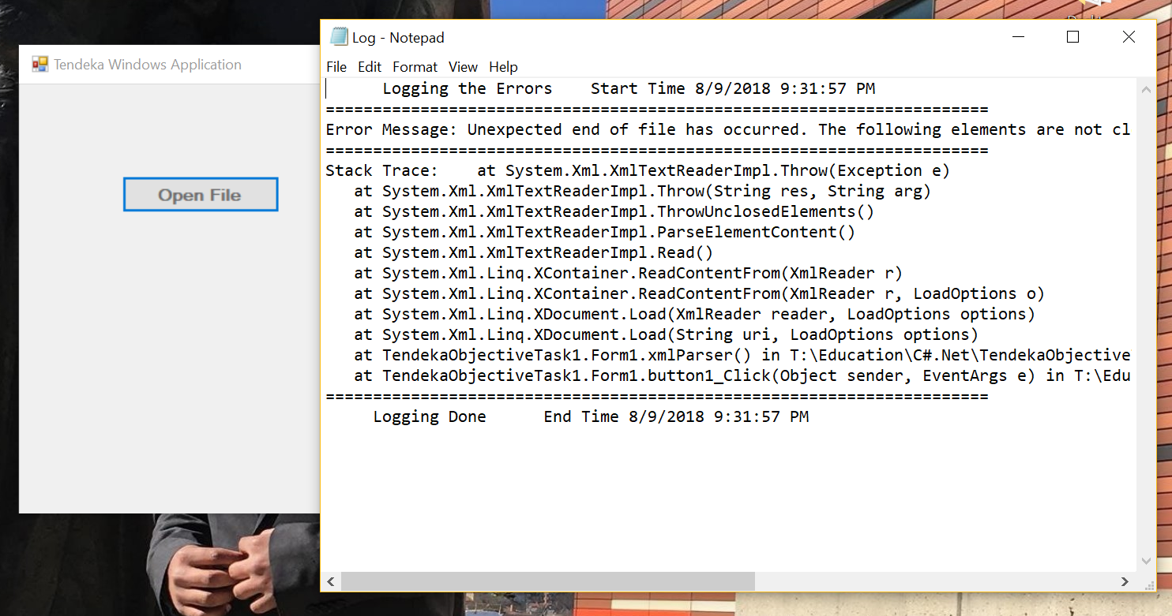

**After Parsing the File**

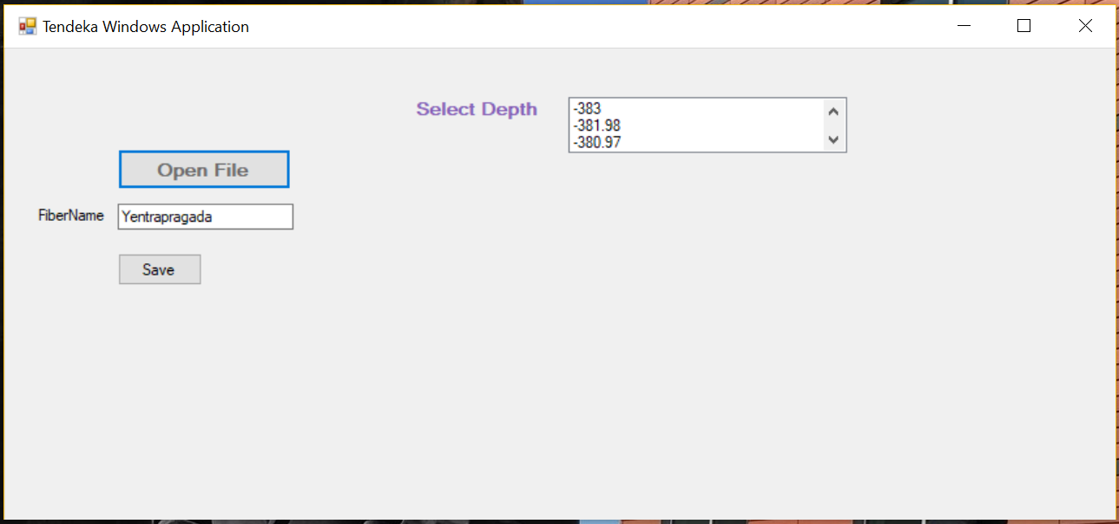

**Saving the file with new Fiber Name**

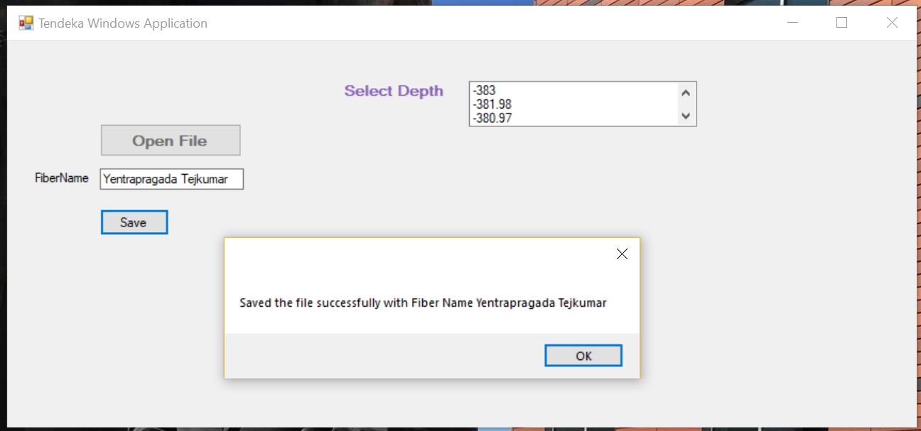

**Selecting the Depth and Generated info based on selected Depth**

