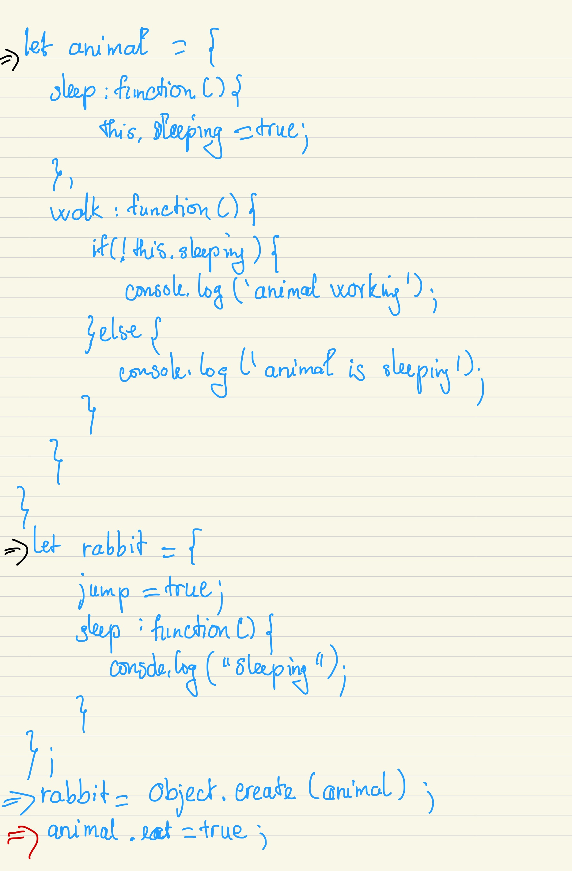

I will draw the diagram step by step. I use => with different colors for demo different object in the below diagram.

