1. Design TM using simulator to accept the input string ww.

OUTPUT:

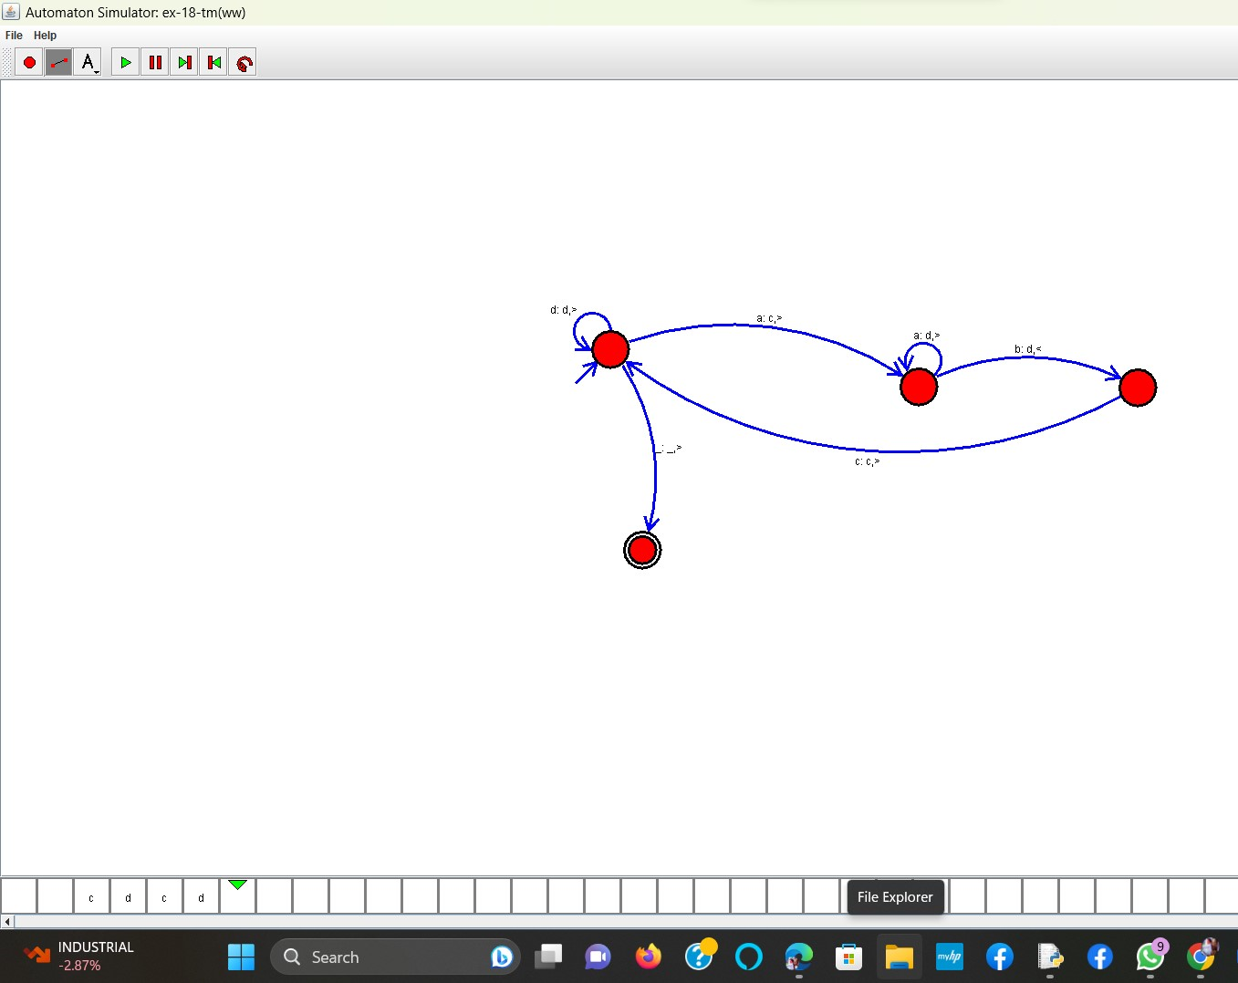

**RESULT:** THE TM RUN SUCCESFULLY USING SIMULATOR BASED ON GIVEN STRINGS