19. Design TM using simulator to perform addition of ‘aa’ and ‘aaa’

OUTPUT:

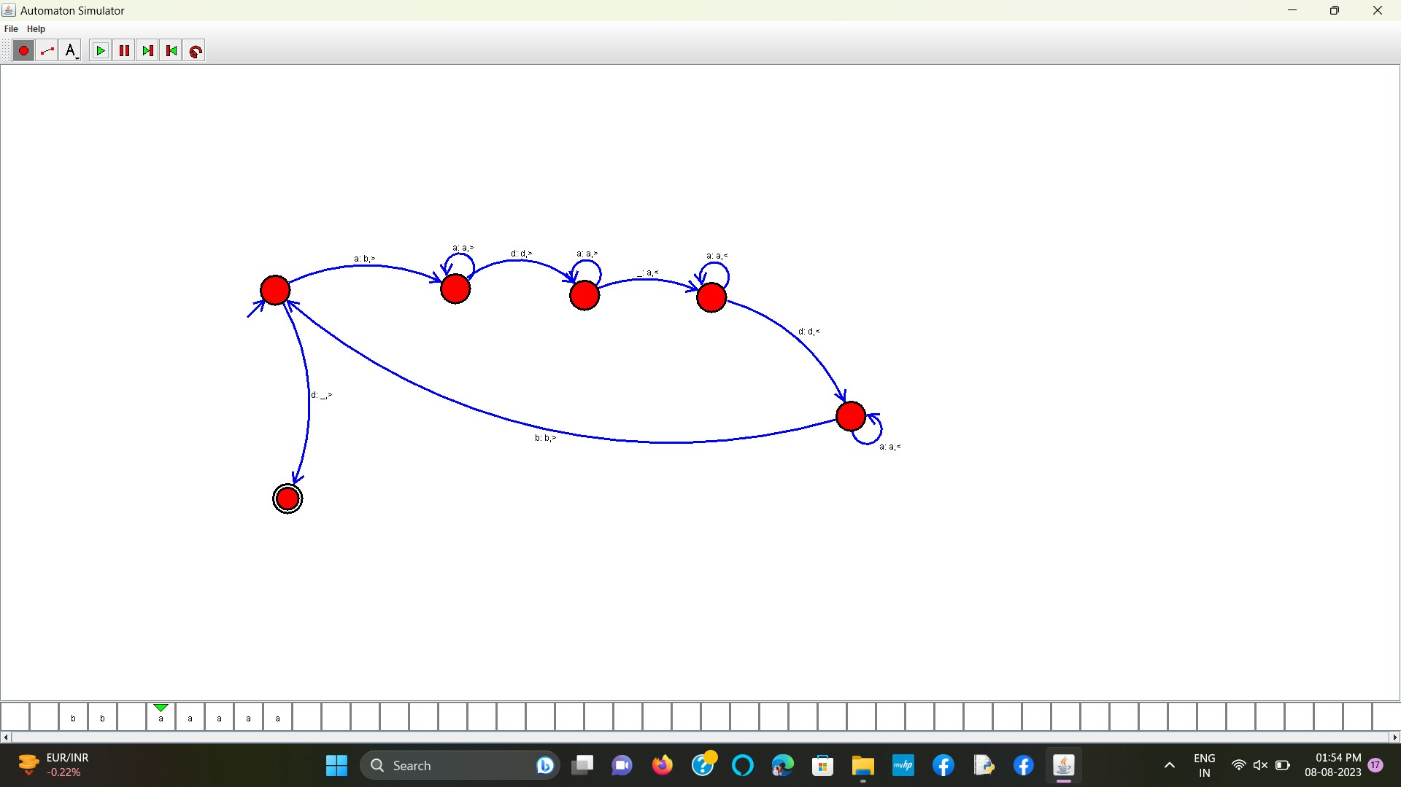

**RESULT:** THE TM RUN SUCCESFULLY USING SIMULATOR BASED ON GIVEN STRINGS