1. Design TM using simulator to perform subtraction of aaa-aa

OUTPUT;

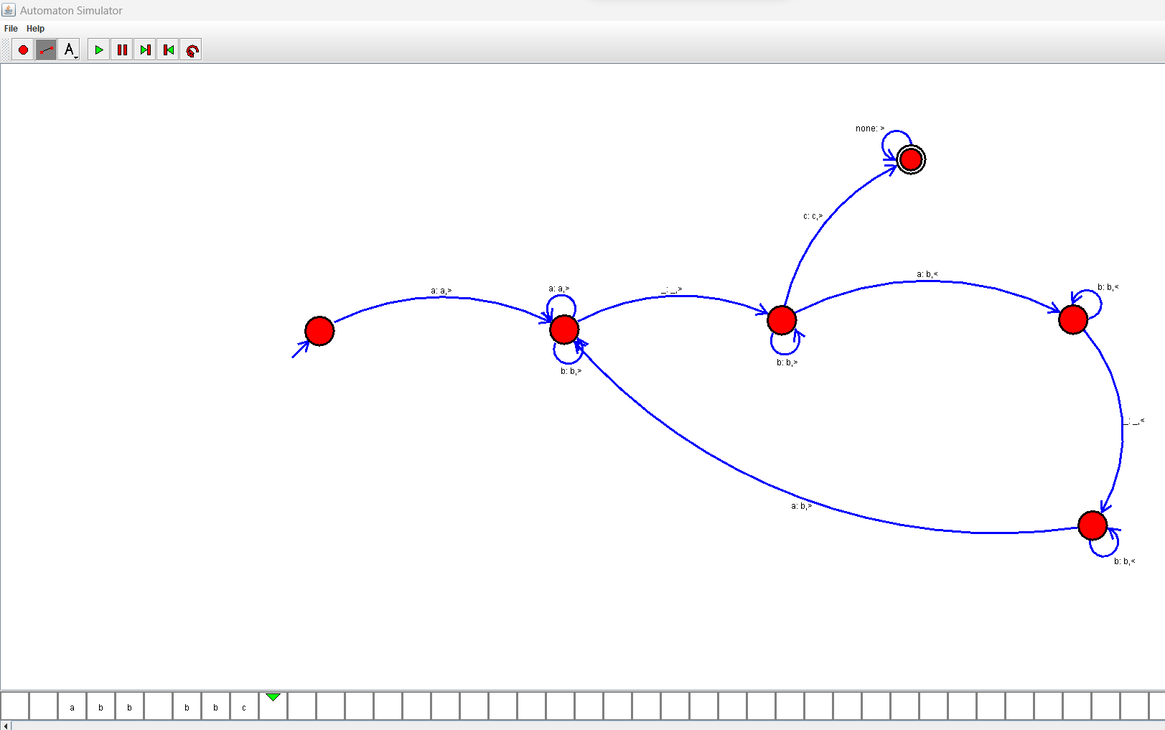

RESULT:Sucessfully run TM using simulator perform subtraction of aaa-aa