1. Design DFA using simulator to accept odd number of a’s.

OUTPUT:-

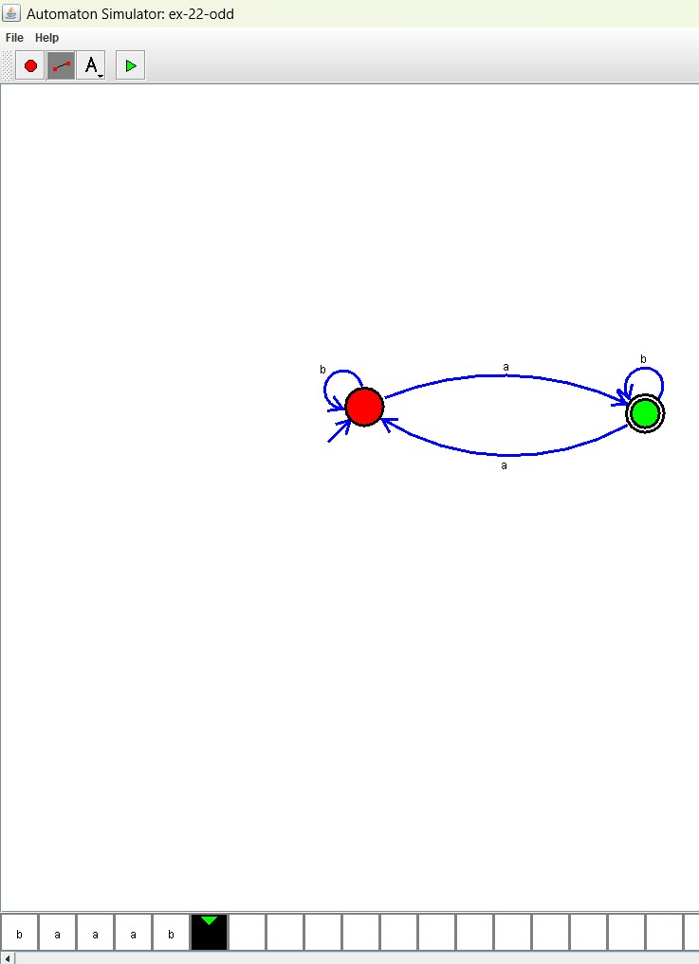

**RESULT**: THE DFA RUN SUCCESFULLY USING SIMULATOR BASED ON GIVEN STRINGS