29. Design DFA using simulator to accept the input string “bc” ,”c”,and ”bcaaa”.

OUTPUT:

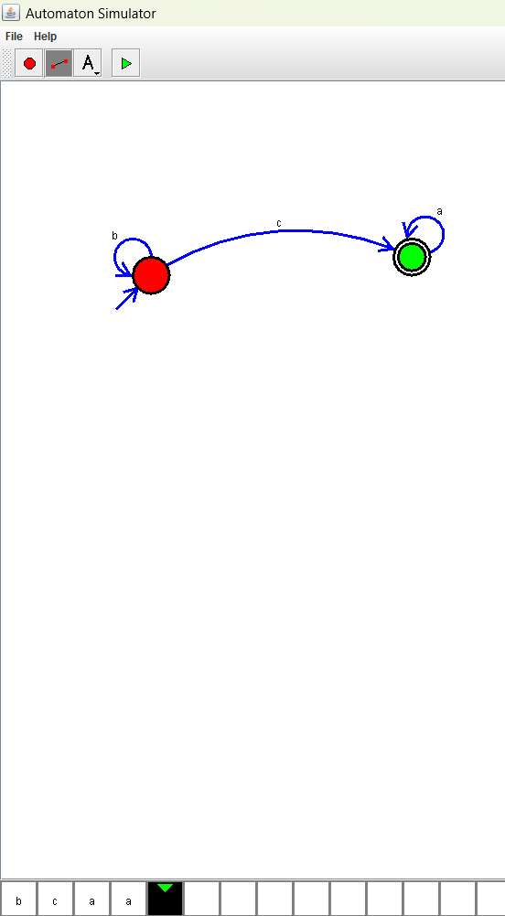

**RESULT**: THE DFA RUN SUCCESFULLY USING SIMULATOR BASED ON GIVEN STRINGS.