1. Design NFA to accept any number of b’s where input={a,b}.

OUTPUT:

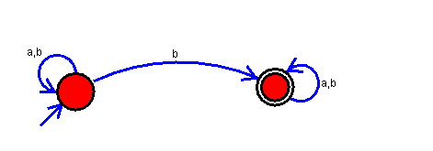

RESULT:The NFA is accepting any number of b’s where input={a,b}.