1. Design PDA using simulator to accept the input string aabb

OUTPUT

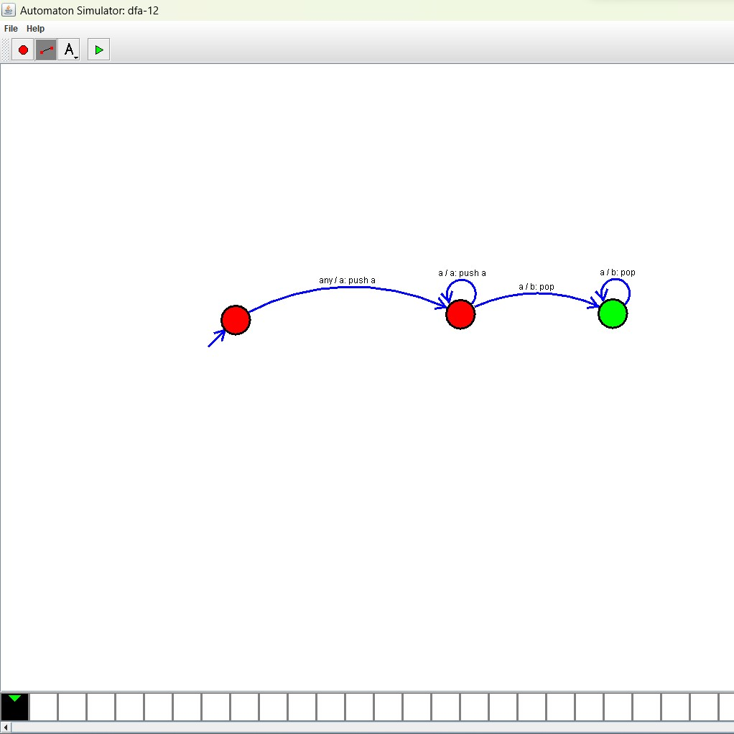

**RESULT**: THE PDA RUN SUCCESFULLY USING SIMULATOR BASED ON GIVEN STRINGS.