1. Design TM using simulator to accept the input string anbn

**OUTPUT**

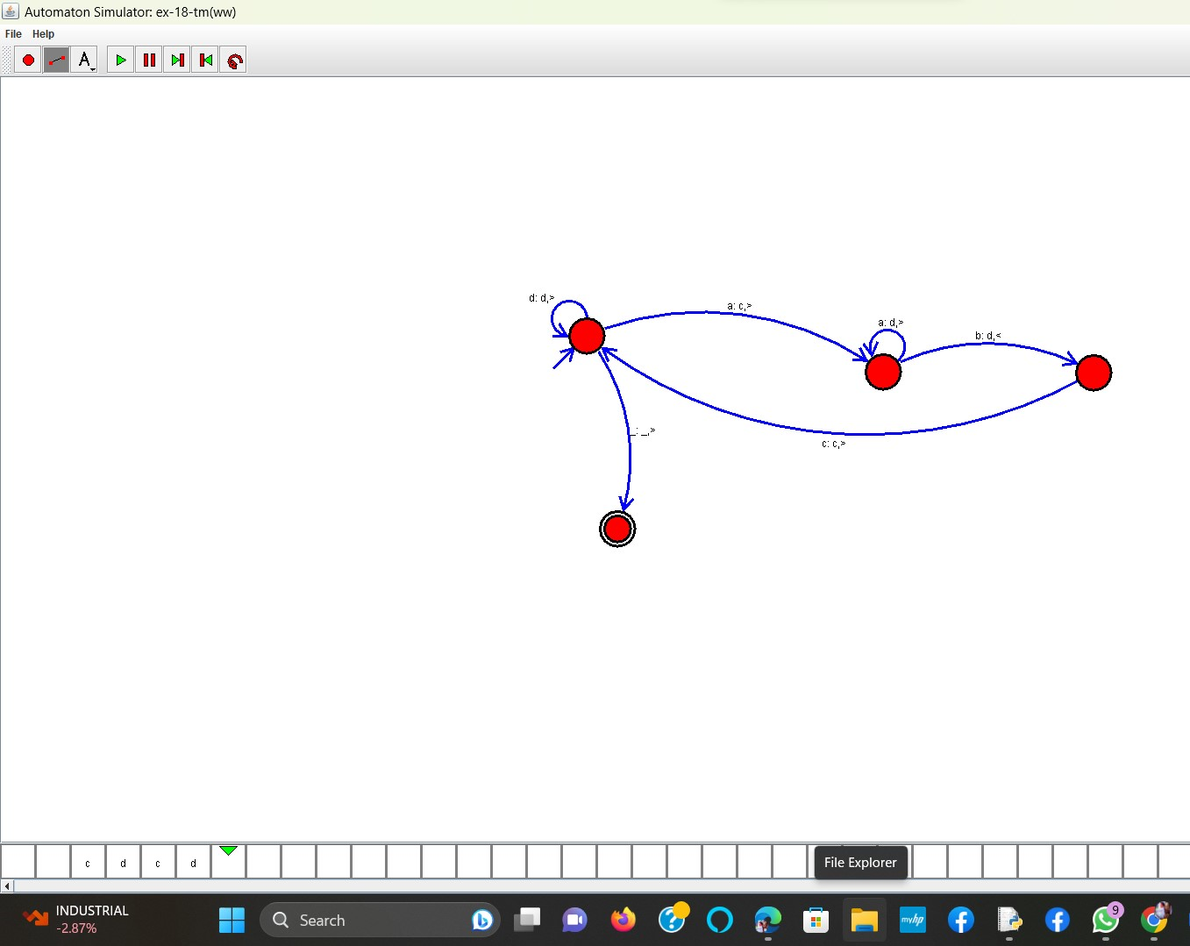

**RESULT**: THE TM RUN SUCCESFULLY USING SIMULATOR BASED ON GIVEN STRINGS