1. Design TM using simulator to accept the input string anb2n

**output**

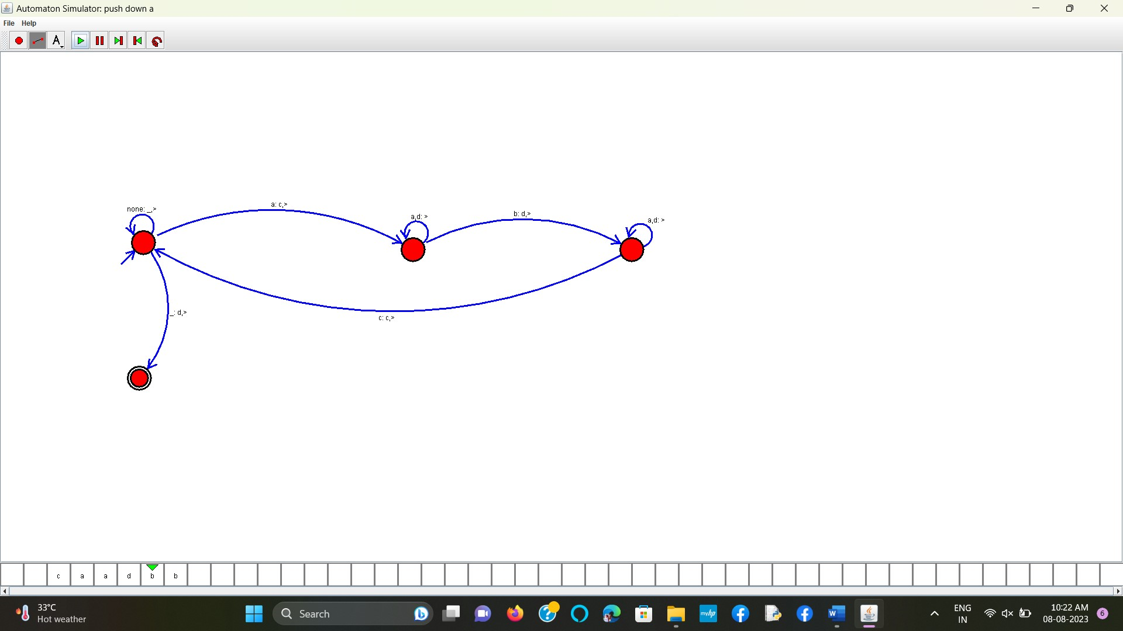

**RESULT:** THE TM RUN SUCCESFULLY USING SIMULATOR BASED ON GIVEN STRINGS