1. Design DFA using simulator to accept even number of a’s.

OUTPUT:

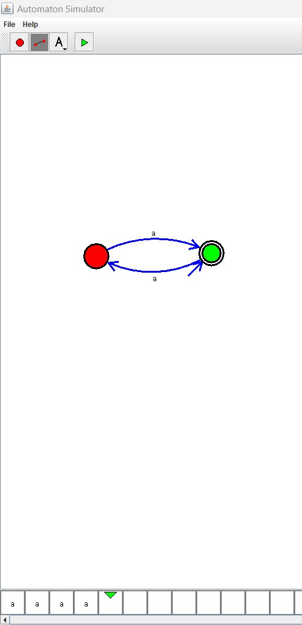

RESULT: THE DFA RUN SUCCESFULLY USING SIMULATOR BASED ON GIVEN STRINGS