Duolingo XR — Immersive Chinese Learning
Design Report Concept
DECO7230 Digital Prototyping and Extended Reality
YINING ZHU 49053881

1. Application Redesign & Concept
Application: Duolingo — an interactive and game-based language learning application.
Concept: Duolingo XR creates virtual everyday environments where learners practise language through seeing, speaking, selecting, grabbing and moving objects in context. Compared with learning on a phone screen, XR allows learners to connect Chinese words with virtual objects and physical actions. For example, instead of remembering that “书” means “book”, learners see a virtual book, hear and read “书”, and follow an instruction such as “请拿起书” (Pick up the book). The wider concept spans everyday scenes (bedroom/study, kitchen, restaurant, supermarket, airport); this prototype focuses on a virtual Bedroom/Study Room to test object-based vocabulary learning and physical interaction.
Design principle: Language + Object + Action + Context → Better Understanding
2. User Tasks & Goals

Task 1 — Learn Vocabulary
Learners explore virtual objects such as 书 (book), 笔 (pen), 桌子 (desk), 椅子 (chair) and拿起（pick up） with Chinese, pinyin and English labels.
Goal: Connect new vocabulary with visual objects and context.

Task 2 — Object Recognition
After learning the words, English support is gradually removed. Learners see a virtual object and choose the correct Chinese word.
Goal: Recall and recognise vocabulary with reduced support.

Task 3 — Understand Instructions Through Action
Learners follow simple Chinese instructions using physical XR interactions. Examples: 请拿起书。— Pick up the book.
Goal: Understand nouns, verbs and spatial language through physical action.
3. XR Environment & Interactions
The concept uses a fully virtual Bedroom / Study environment. A virtual environment avoids the limitations of real locations and allows learners to switch between controlled everyday scenarios.
Main interactions:
- Look / gaze — explore objects and labels
- Point / select — choose the correct object or word
- Grab — pick up virtual objects
- Move / place — reposition objects according to instructions
- Speak — pronounce words or short sentences
- Spatial interaction — understand words such as 上 (on) and 旁边 (next to)
These interactions use the learner’s body and the surrounding space rather than relying only on virtual buttons.
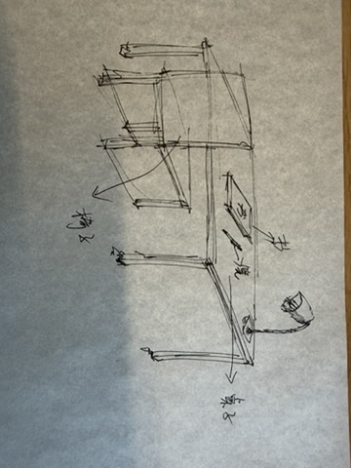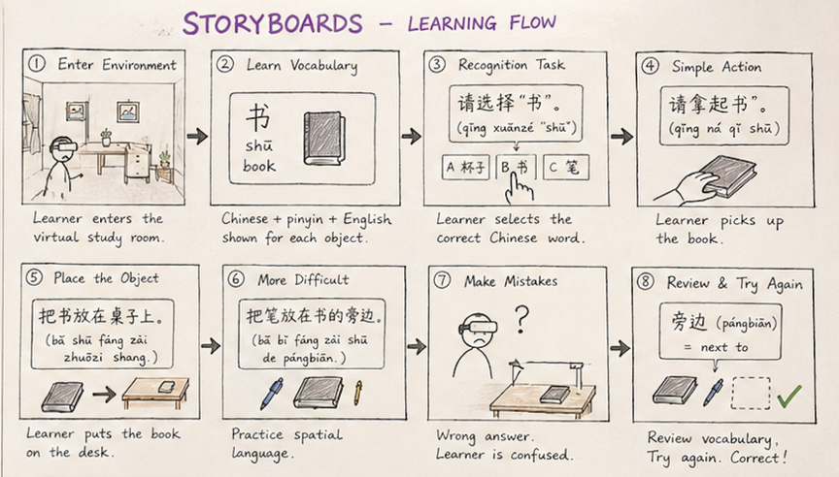
[Figure 1: Sketch] [Figure 2: Storyboard]
4. Ideation & Prototype Development
The initial idea was to use XR in the learner’s real physical environment. However, this was limited because users may not have the same objects or access to suitable locations.
The concept was therefore refined into multiple virtual everyday environments, providing consistent learning content while keeping contextual and embodied interaction.
A low-fidelity paper prototype was created for the Bedroom / Study scene using vocabulary cards, object cards and instruction cards.
Learning flow: Learn → Remove English Support → Recognise → Act → Review Mistakes → Try Again
A Wizard-of-Oz and Think-Aloud method was used, with the tester acting as the XR system and manually presenting instructions, hints and feedback.
5. Testing Plan & Results

Assumption: Learners will understand Chinese vocabulary and simple instructions more easily when language is connected with visual objects, physical actions and meaningful context.

Participants: Two foreign participants with little or no previous Chinese-learning experience.

Tasks Tested:
- Learning Vocabulary — learn 书 (book), 笔 (pen), 桌子 (desk), 椅子 (chair) and拿起（pick up）Object Recognition — identify the correct Chinese word after English support is removed.
- Simple Action — understand and perform “请拿起书”.
If incorrect: Wrong → Hint → Review → Try Again

Results:
Participant | Vocabulary | Recognition | “请拿起书” | Total Hints
P1 | 2 min | 20 sec ✕, 3 hints | 15 sec ✕, 1 hint | 4
P2 | 1 min 35 sec | 15 sec ✕, 1 hint | 7 sec ✓ | 1
6. Design Refinement
Based on testing, the next iteration will:
- remove English support more gradually;
- keep pinyin visible for longer;
- use visual arrows or highlights for new actions and spatial words;
- demonstrate unfamiliar verbs through animation;
- automatically review incorrect vocabulary before progressing.
The refined concept keeps immersive interaction while providing adaptive language support that decreases as learners become more confident.

