NANYANG POLYTECHNIC

EGR204 Microcontroller Applications

Assignment

Course: Diploma in Robotics and Mechatronics

Module: EGR204 Microcontroller Applications

Weightage: 20%

Instruction (***Please Read Instruction Carefully***):

* This assignment has two parts. Each part is 10% of total assessment.
* The first part consists of three Python program. The objective is to convert these Python program to equivalent C code. You may compare outputs of Python program and C program using replit.com, a web-based IDE.
* The second part is on unit conversion (temperature, currency, and mass) using C program. A template C program with comments is provided for you to work on. The objective is to complete the C code to achieve the outcome. Screenshot of sample outputs are provided for your reference. You may use replit.com web-based IDE for the task. Use Google exchange rate for currency conversion.
* Save your work as *.C file ONLY. For example, for the first Python code of part 1, your C code should be saved as Q1.C file. You may use notepad to save the file. However, you should not save it as *.txt file, one common mistake is that the file is saved as Q1.c.txt file.
* In your submission, you should have four files, namely Q1.C, Q2.C, Q3.C and unit_converter.C files. Put these four files into a folder and zip it. Rename the zip folder as RX_adm_number, for example, if you are from class R1 and your admission number is 20000X, the zip folder should be named as R1_20000X.
* Upload your submission to NYP LMS.

PART 1

Convert the following three Python programs to equivalent C program.

Q1

#Q1: Convert the following Python program into C code

a = 1

b = a

print(a,b)

if a==b and b==1:

print("True, a=%d, b=%d." %(a,b))

else:

print("False, a=%d, b=%d." %(a,b))

print("Completed checking")

c = 2

if a==1 or c >= 2:

print("True, a=%d, c=%d." %(a,c))

c -= 1

else:

print("False, a=%d, c=%d." %(a,c))

if a==1 or c >= 2:

print("True, a=%d, c=%d." %(a,c))

c -= 1

else:

print("False, a=%d, c=%d." %(a,c))

if not (a==1) or c >= 2:

print("True, a=%d, c=%d." %(a,c))

c -= 1

else:

print("False, a=%d, c=%d." %(a,c))

Q2

#Q2: Convert the following Python program into C code

a = 100

for i in range(10):

print ("i = %d" %(i))

print ("a = %d" %(a))

a -= 10

print("for loop completed")

print("the final value of i = %d and a = %d" %(i,a))

# point_x and point_y are the (x,y) coordinates of a point in 2D space

point_x = []

point_y = []

for i in range(5):

for j in range (6):

print("i = %d and j = %d" %(i,j))

point_x = i

point_y = j

print("point coordinate is (%d, %d)" %(point_x, point_y))

if(point_x == 4 and point_y == 5):

print("exit the for loop")

break

print("the final value of i = %d and j = %d" %(i,j))

print("the final value of point_x = %d and point_y = %d" %(point_x,point_y))

Q3

#Q3: Convert the following Python program into C code

a = 0

while(a<100):

print("a = %d" %(a))

a += 1

if(a >= 50 and a < 60):

print("a is between [50 and 60)")

elif(a>=60 and a < 70):

print("a is between [60 and 70)")

elif(a>=70 and a < 80):

print("a is between [70 and 80)")

elif(a>=80 and a < 90):

print("a is between [80 and 90)")

elif(a>=90 and a <= 100):

print("a is between [90 and 100)")

else:

print("a is less than 50")

print("while loop completed")

PART 2

Complete the following unit conversion program with reference to the sample output.

Hint:

* You will need to declare some variables in the program. You may use existing variables as reference.
* Refer to sample output to complete the code.
* The sample output only shows the expected outcome of the program partially.

#include <stdio.h>

int main()

{

char category;

int tempChoice;

int userinputF; // User inputted Fahreinheit;

int userinputUSDtoEuro; // User inputted for USD to EURO;

int userinputOunce; // User inputted for Ounce;

int fahrenheitToCelcius; // variable that stores the converted F->C;

float USDtoEURO ; // variable that stores the converted USD->EURO;

float ounceToPounds; // stores the converted Ounce->Pounds;

printf("Welcome to Unit Converter! \n");

scanf("%c",&category); // this code reads in user input from keyboard

if(category == 'T'){

scanf("%d",&tempChoice);

if(tempChoice == 1){

printf("Please enter the Fahrenheit degree: \n");

scanf("%d",&userinputF);

fahrenheitToCelcius = ((userinputF-32) * (5.0/9.0));

printf("Celcius: %d",fahrenheitToCelcius);

}

else if(tempChoice == 2){

}

else

printf("Please enter the correct choice. \n");

}

else if(category == 'C')

{

// implement your code here

}

else if(category == 'M')

{

// implement your code here

}

return 0;

}

**Sample output for temperature conversion**

1. At the start of the program:

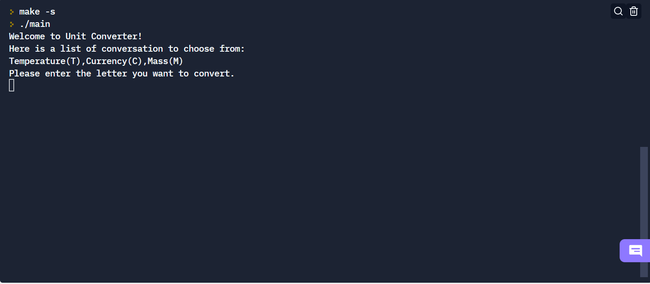

1. User entered input “ T ”

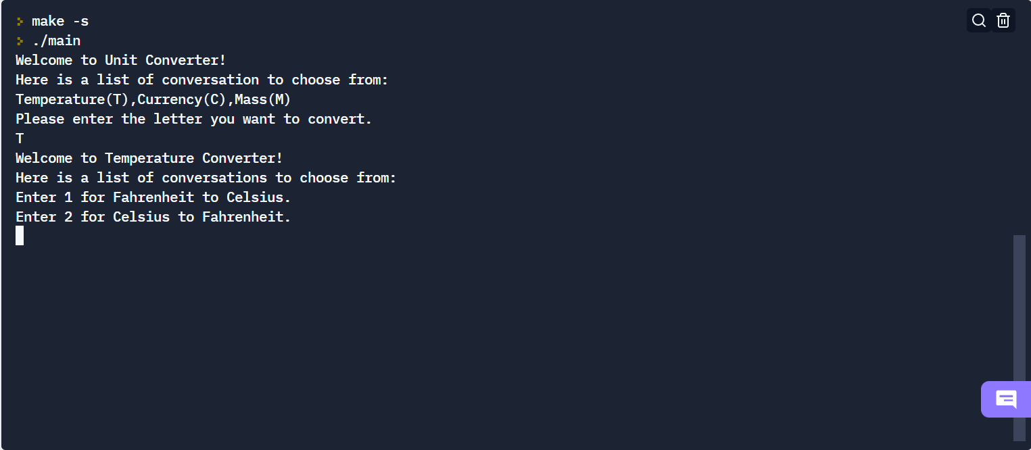

1. User entered input “ 1 ”

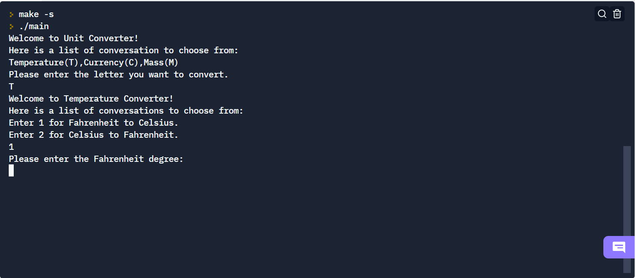

1. User entered input Fahrenheit degree “81”

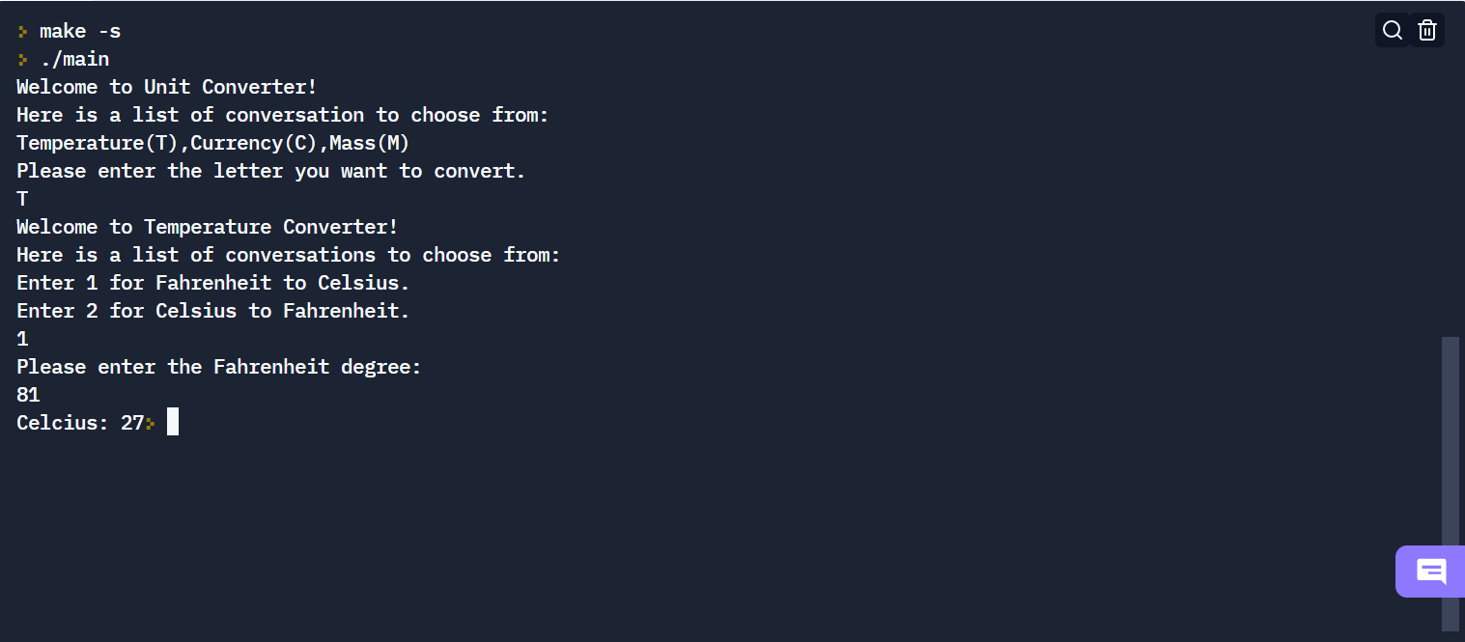

**Sample output for currency conversion**

1. At the start of the program:



1. User entered input “ C ”:

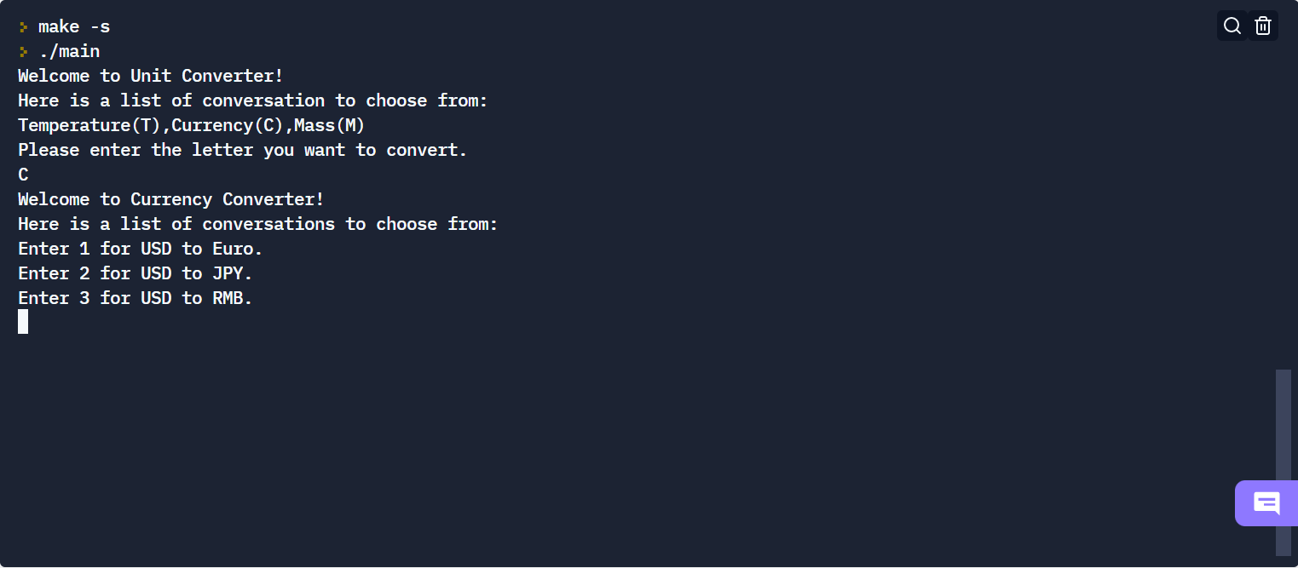

1. User entered input “ 1 ”:

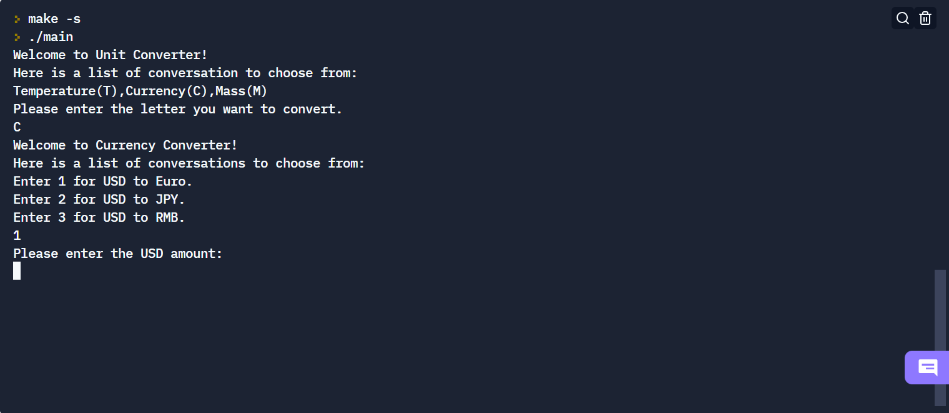

1. User entered input amount “ 80 ”:

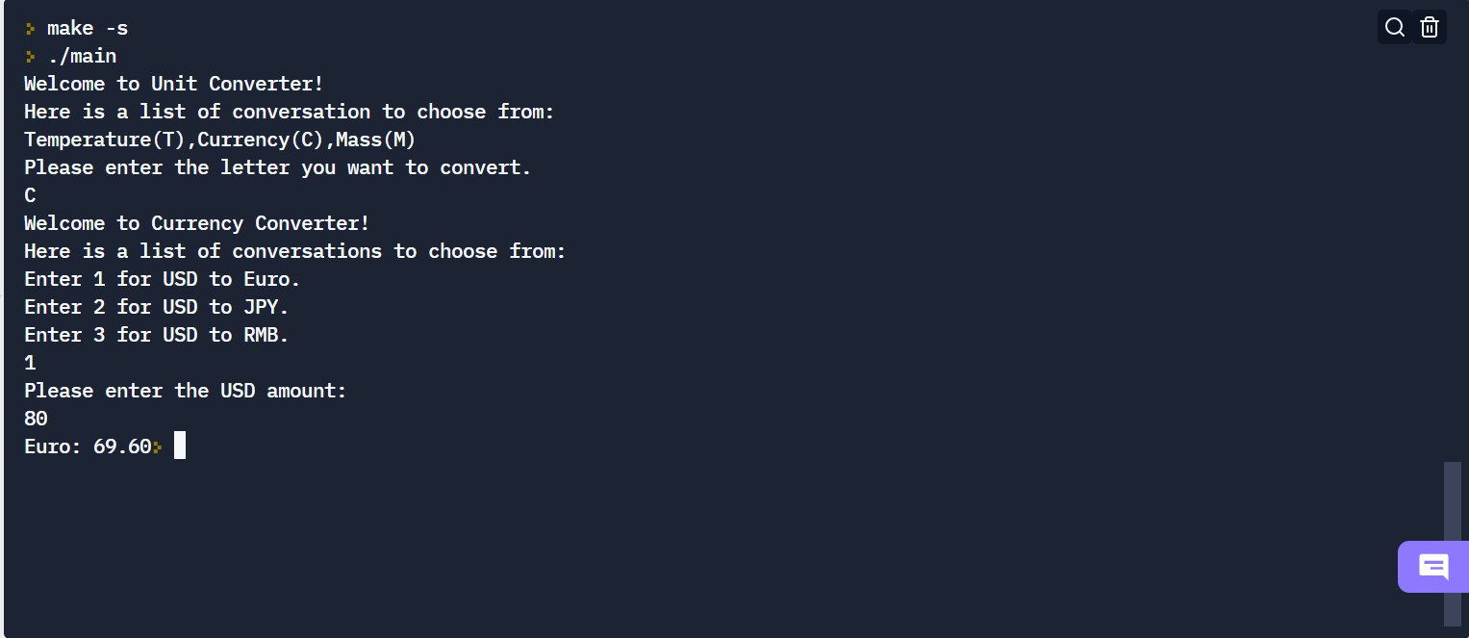

**Sample output for mass conversion**

1. At the start of the program:



1. User entered input “ M ”:

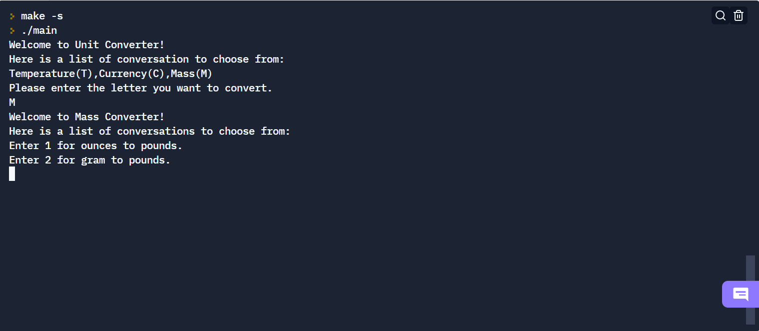

1. User entered input “ 1 ”:

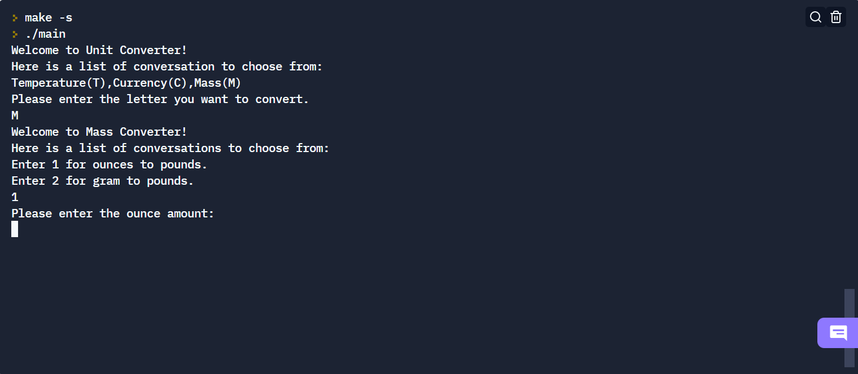

1. User entered input “ 80 ” ounce:

