电脑键盘

**Book8088**

**User’s Guide**

Document Revision 2.0

1. **USER INFORMATION**
   1. ***About This Manual***

This document provides information about the Book8088

**1.2 *Trademarks***

**The following lists the trademarks of components used in this manual.**

* IBM, XT, AT, PS/2 and Personal System/2 are trademarks of International Business Machines Corp.
* Microsoft is a registered trademark of Microsoft Corp.
* Intel is a registered trademark of Intel Corp.
* All other products and trademarks mentioned in this manual are trademarks of their respective owners.

1. **INTRODUCTION**

The Book8088 is an XT clone computer, It is 100% compatible with IBM PC.

* 8088 processor
* 8087 math processor (optional)
* 640KiB RAM
* IBM CGA (Color Graghic Adapter) 6845 CRT controller
* XT-CF Adapter
* USB controller (CH375B)
* OPL3(YAMAHA YMF262-M) Audio Adapter
* ISA Bus Extension

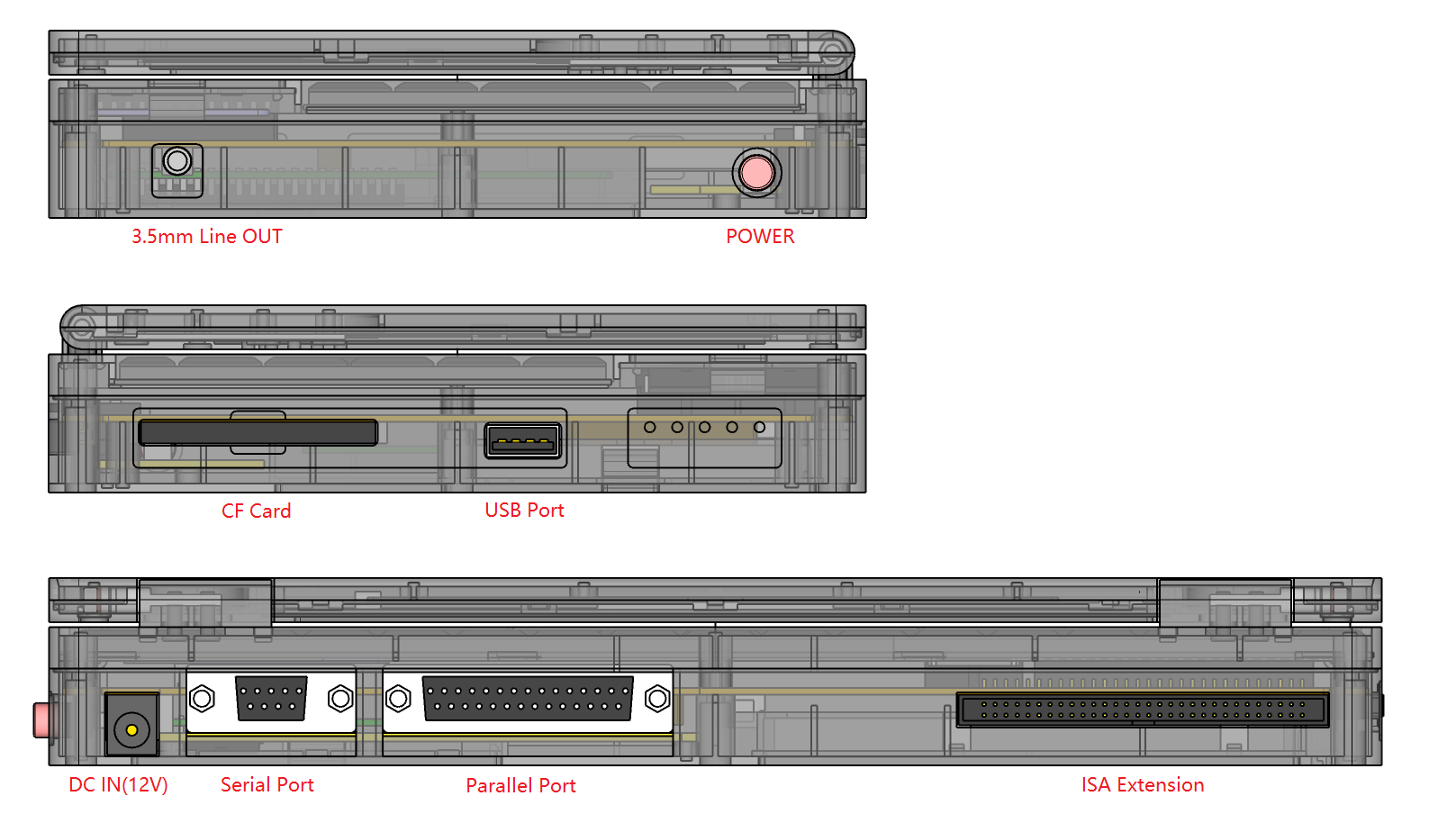

1. **System Hotkeys**

* **Fn+F1:** Turn off the audio system
* **Fn+F2:** Turn on the audio system
* **Fn+F6:** Turbo XT switching

**Off(default):** CPU frequency = 4.7MHz

**On :** CPU frequency = 8MHz

* **Fn+F7:** Mode 80 instruction

Used to refresh and adjust screen alignment.

* **Ctrl+Alt+Del:** Reset

1. **Introduction to External Interfaces**

**4-1. ISA Extension Port.** (All lines are TTL-compatible.)

The I/O channel contains an 8-bit, bidirectional data bus, 20 address lines, 6 levels of interrupt, control lines for memory and I/O read or write, clock and timing lines, 3 channels of DMA control lines, and power and ground for the adapters. Two voltage levels are provided for External I/O cards: +5 Vdc, +12 Vdc.

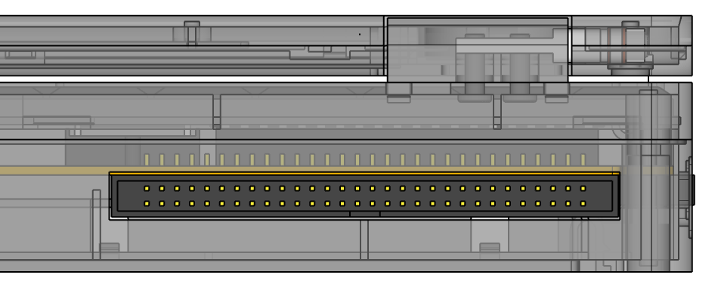

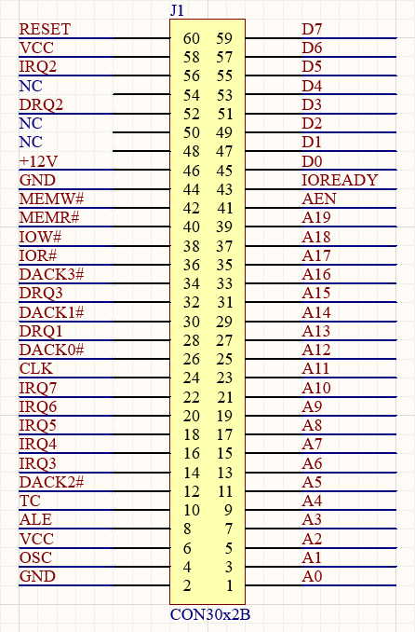

(More IO information, please refer to “IBM PC_XT_Technical_Reference”)

**4-2. USB Port**

USB port supports disks in FAT16 format up to 2GB.

When the DOS system starts, the USB disk is treated as a hard disk partition after loading the "CH375. sys" driver file. And assign a drive letter.

After inserting a USB disk, enter the corresponding drive letter to access the USB disk.

**4-3. LED status indicator.**

* + **CF :** CF card is being accessed
  + **TBO :** Turbo XT Mode
  + **CHG :** Red – Charging / Blue – full
  +  **:** LED1 on - 99%

LED1 flash - 75%

LED2 on - 50%

LED2 flash - 25%

Other statuses – Charging or lower.

1. **Introduction to Internal Interfaces.**

**5-1. Internal ISA-AUDIO**

表格

|  |  |  |  |
| --- | --- | --- | --- |
| **A0-A19** | (ISA) Address signal | **ADLIBCS#** | IO 388h Address select |
| **D0-D19** | (ISA) Data signal | **MUTE#** | Power amplifier off |
| **AEN** | (ISA) Address Enable | **SPKL+** | Left channel output |
| **OSC** | (ISA) Oscillator 14.318MHz | **SPKL-** | Left channel output |
| **MEMW#** | (ISA) Memory Write | **SPKR+** | Right channel output |
| **MEMR#** | (ISA) Memory Read | **SPKR-** | Right channel output |
| **IOREADY** | (ISA) I/O Channel Ready | **AR** | Right channel line output |
| **IOW#** | (ISA) -I/O Write | **AL** | Left channel line output |
| **IOR#** | (ISA) -I/O Read | **VCC** | Digital+5V power supply |
| **RESET#** | (ISA) RESETDRV Inversion | **GND** | DGND |

**5-2. Internal ISA-VIDEO**

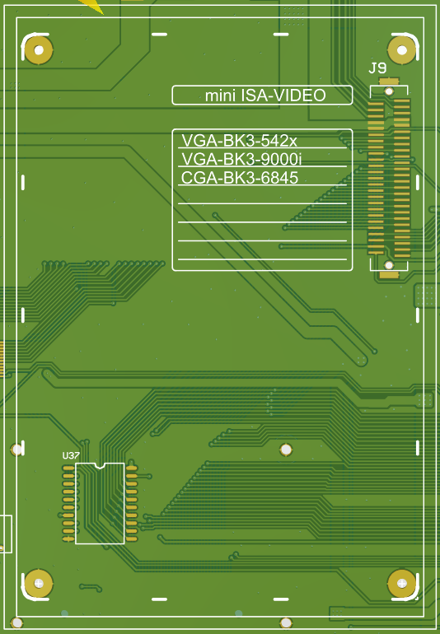 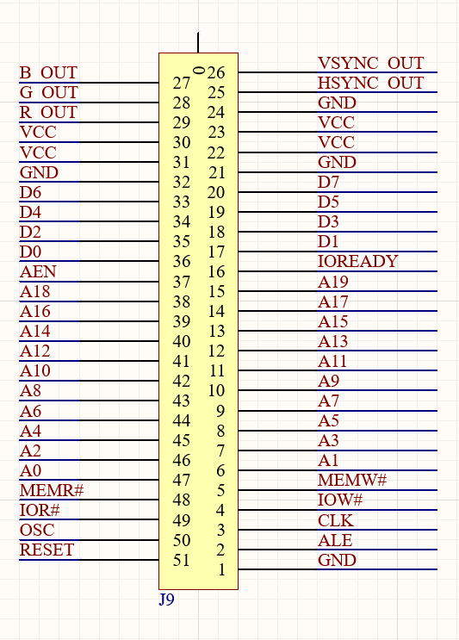

|  |  |  |  |
| --- | --- | --- | --- |
| **A0-A19** | (ISA) Address signal | **CLK** | (ISA) System clock |
| **D0-D19** | (ISA) Data signal | **ALE** | (ISA) Address Latch Enable |
| **AEN** | (ISA) Address Enable |  |  |
| **OSC** | (ISA) Oscillator 14.318MHz | **B_OUT** | blue channel |
| **MEMW#** | (ISA) Memory Write | **G_OUT** | green channel |
| **MEMR#** | (ISA) Memory Read | **R_OUT** | red channel |
| **IOREADY** | (ISA) I/O Channel Ready | **VSYNC_OUT** | vertical sync signal |
| **IOW#** | (ISA) -I/O Write | **HSYNC_OUT** | Horizontal sync signal |
| **IOR#** | (ISA) -I/O Read | **VCC** | Digital+5V power supply |
| **RESET** | (ISA) RESETDRV | **GND** | DGND |

1. **LCD Alignment adjustment**

Switching between graphic and text modes may cause screen characters to shift to the left. You can type “mode 80”(Fn+F7) to adjust the screen alignment, sometimes it may need to be repeated 4-5 times to adjust it properly.

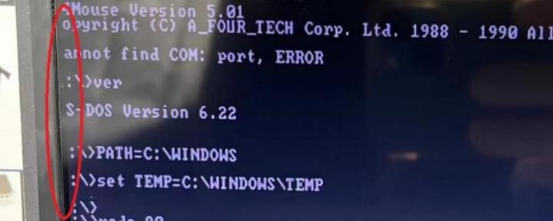

**If you have any questions or suggestions, please contact us!**

**Email: [460511929@qq.com](mailto:460511929@qq.com)**