**Assignment 5 – Android Data Storage**

**Name : Snehal Yeole**

**SJSU ID : 012548471**

**Home Screen:**

The Main Activity screen (Home Screen) is shown as below with three buttons, Preferences, SQLite and Close. Clicking on preferences navigate to the preferences screen, SQLite navigates to the SQLlite screen and Close button closes the application.

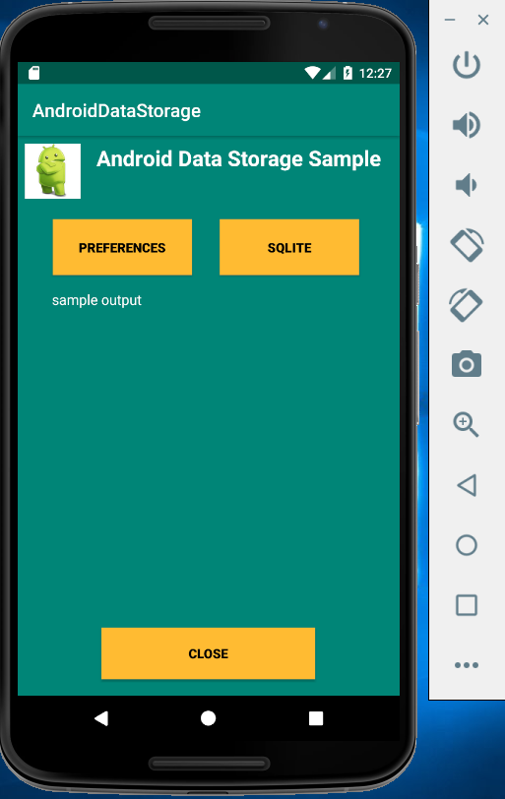

**Preferences Screen:**

The Preference view consist of the book details such as Book Name, Author Name and Description. When user clicks on Save button, the user entered details are stored in the shared preference storage. The limit on number of characters for each field is mentioned in the text box below. The cancel button navigates back to the home screen.

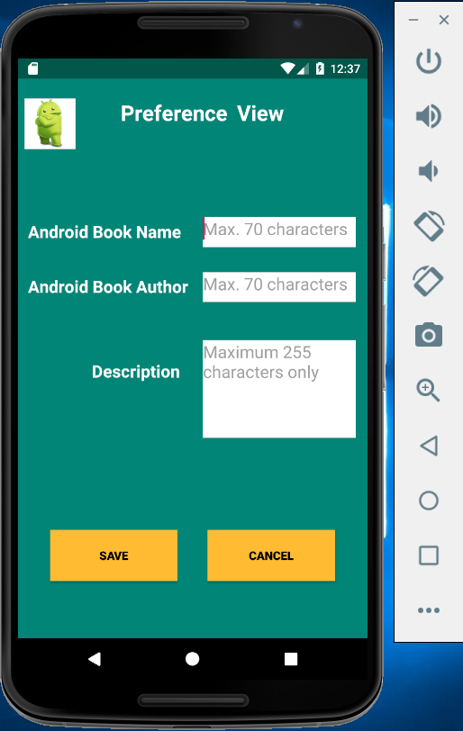

**SQLite Screen:**

The SQLite home screen consists of the Blog Message with limit of maximum 255 characters. When user enters the Blog Message and click on Save button, the message gets stored in the SQLite database storage. On clicking Cancel button, the user is navigated back to the home screen.

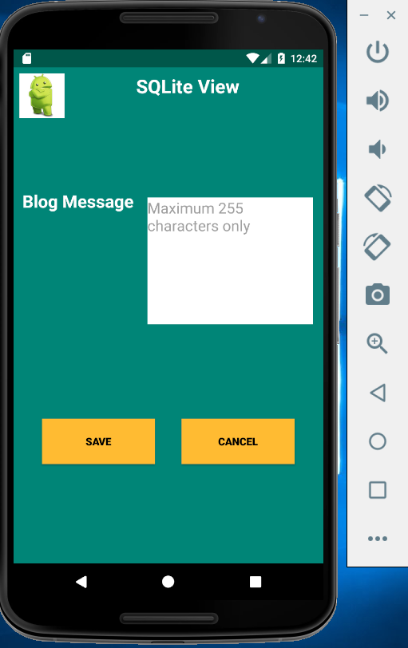

**Preference View Demo:**

On clicking Save button, the user entered details are displayed on the main activity screen along with the timestamp.

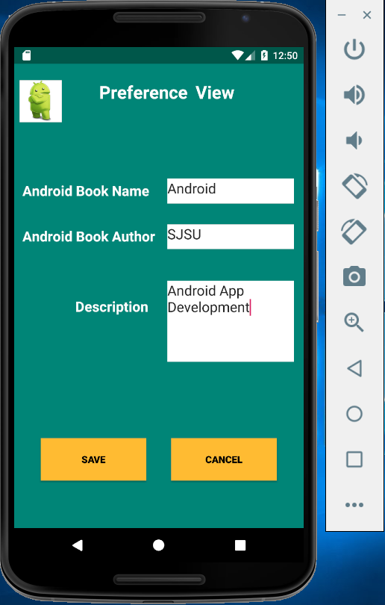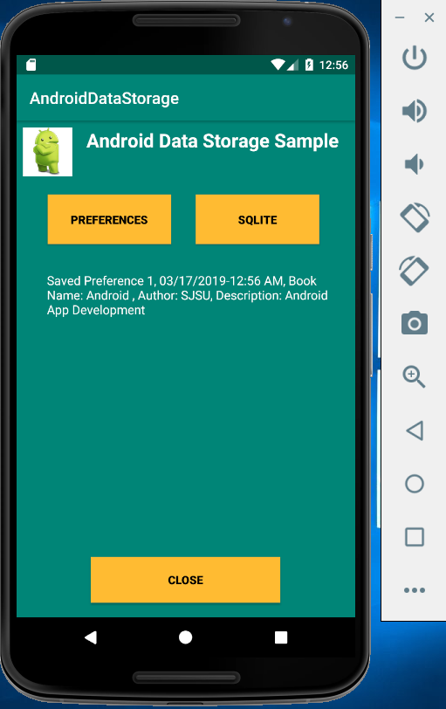

The code in SetPreferencesActivity.java is modified as below in order to add the user entered details in shared preference storage.

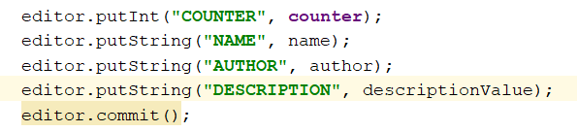

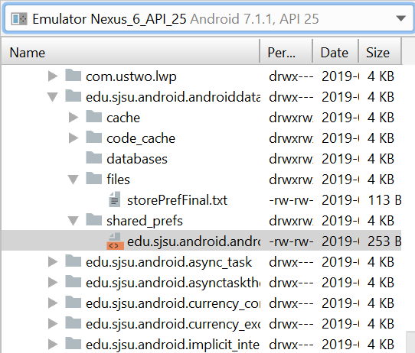

Preferences xml file that stores the user entered details

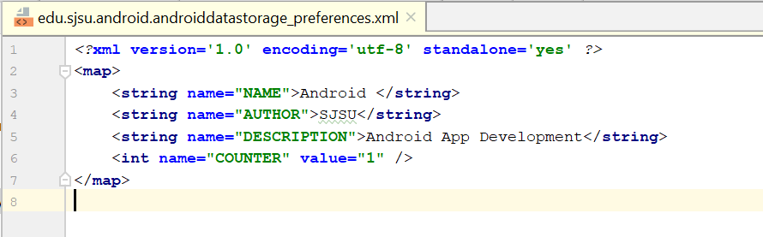

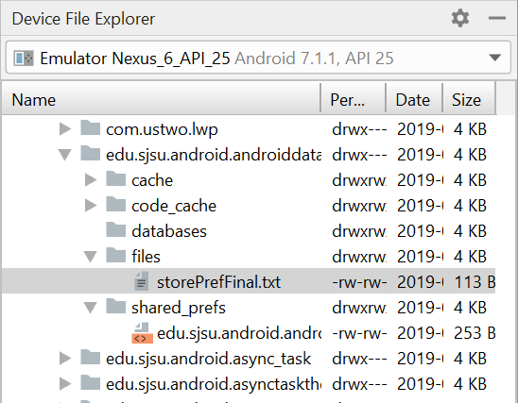

The user entered details are also stored in storePrefFinal text file and retrieved on the main activity screen.

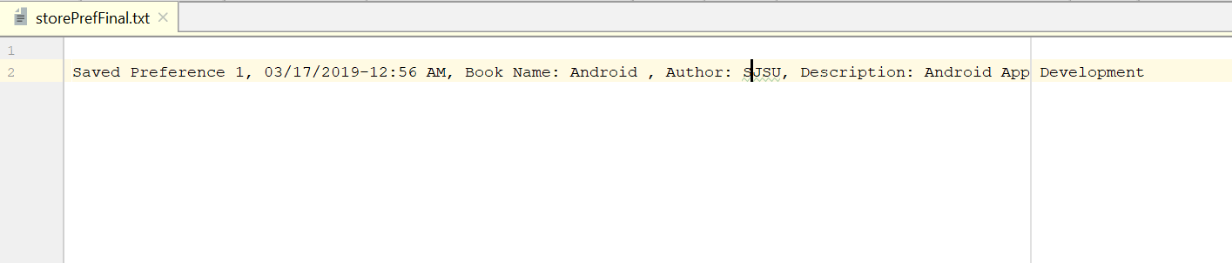

**Onclick Cancel button:**

On clicking the Cancel button, the control is navigated back to the Main Activity screen.

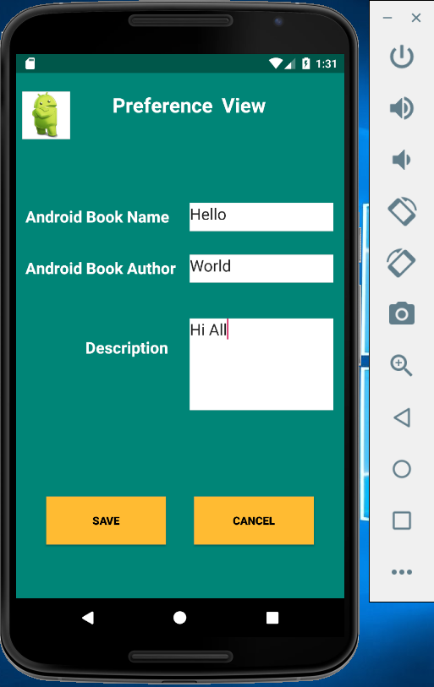

**SQLite View Demo:**

Let’s add some blog message and save it. The blog message gets stored in the SQLite database storage and the counter value and timestamp for SQLite are displayed on main activity screen.

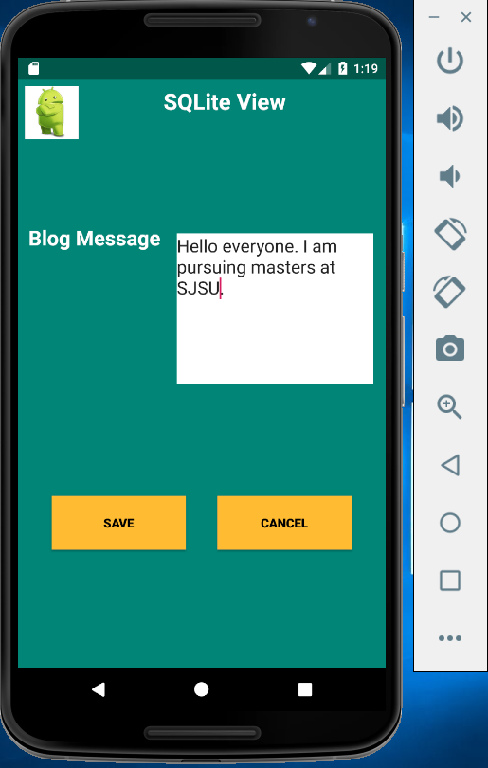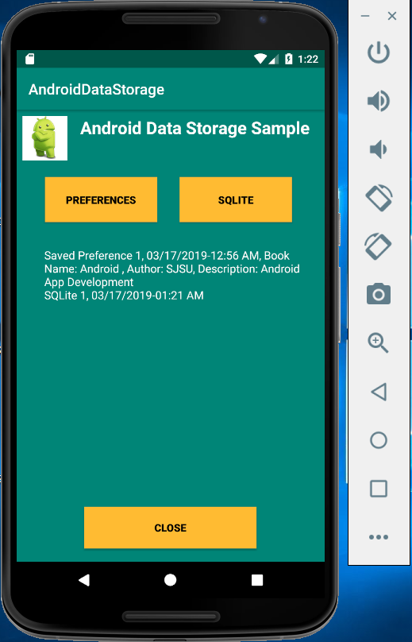

Let’s check the blog message stored in database. Below is the location to check the database storage.

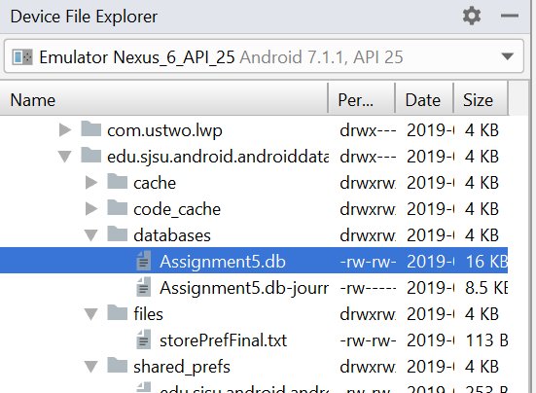

The message highlighted below in blue color is the blog message getting stored in database.

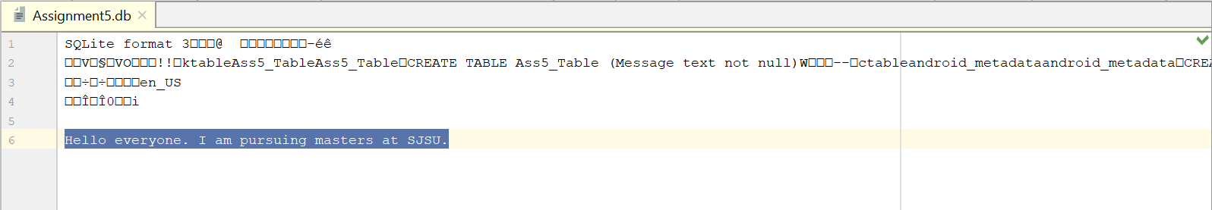

**OnClick Cancel button:**

On clicking the Cancel button, the control is navigated back to the Main Activity screen from the SQLite view.

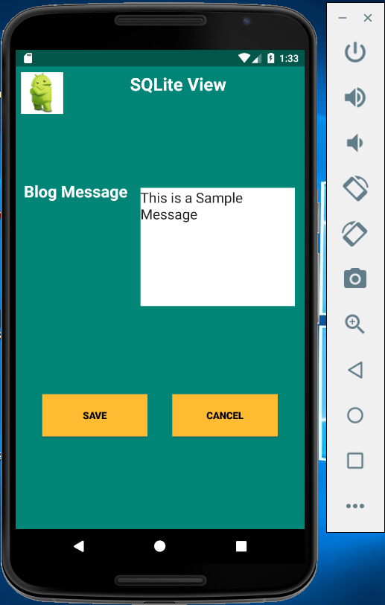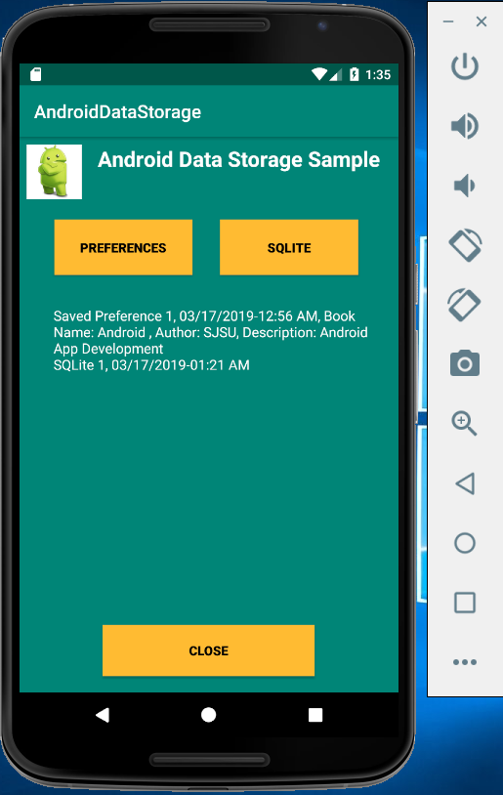

**Onclick Close button:**

On clicking the close button on Main Activity screen, the application is closed.

