**Assignment 4 : Temperature Humidity Sensor Driver Using Async Task**

**Name : Snehal Yeole**

**SJSU ID : 012548471**

The home screen for Async Task Application with three TextViews to display all the values of Temperature, Humidity and Activity generated in the background by Async Task, one EditText to accept the sensor readings count from the user, Generate button that starts the Async Task and generates random values of the fields in the background when user clicks on it, Cancel button that reverts the content on screen and starts the activity again and the result textview at the bottom that displays the values for N number of times (number of sensor readings ). I have used random function for generation of random values.

**Range for Temperature : 25 F to 100 F**

**Range for Humidity : 40% to 100%**

**Range for Activity : 1 to 500**

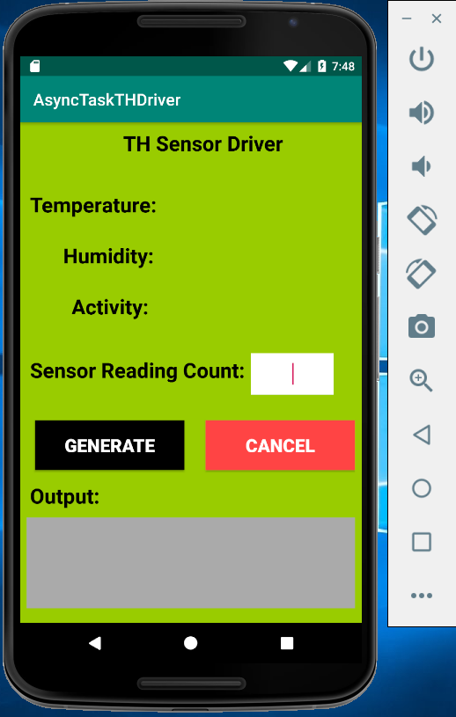

Let’s input some value (say 2) in the “number of sensor readings” field and click generate button. Async Task will run in background and calculate the values for temperature, humidity and activity for ‘N’ number of times and display the values in the text views for each iteration. It also displays the output values at the bottom of the screen. We can see output for each iteration by scrolling down the text view as shown below:

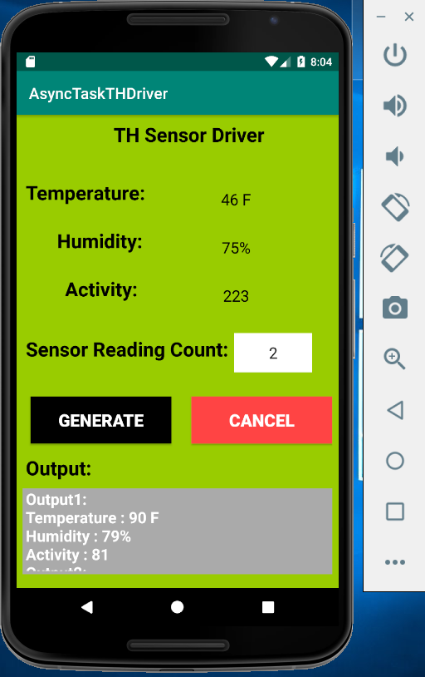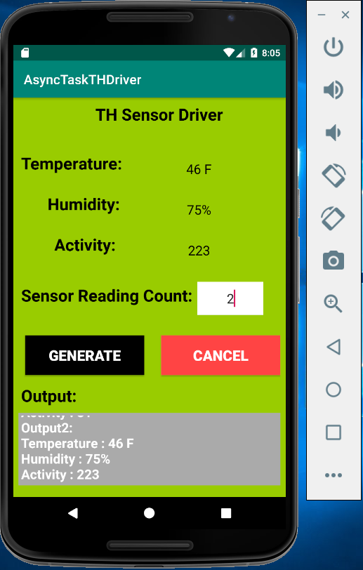

Now let’s try with some different input value (say 9)

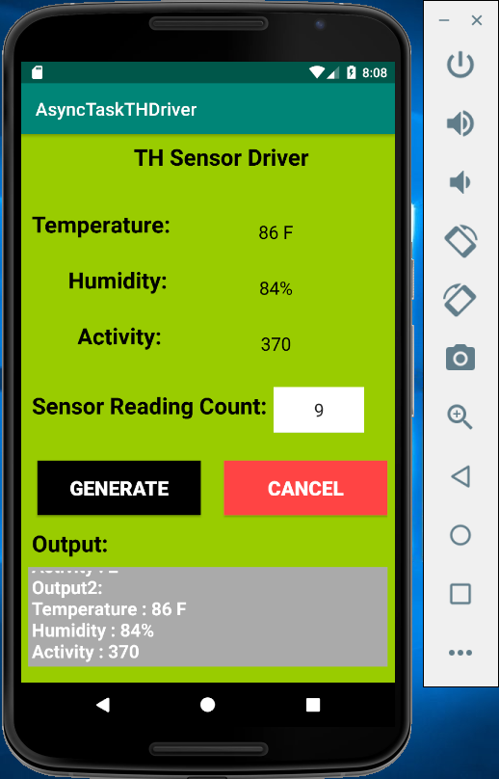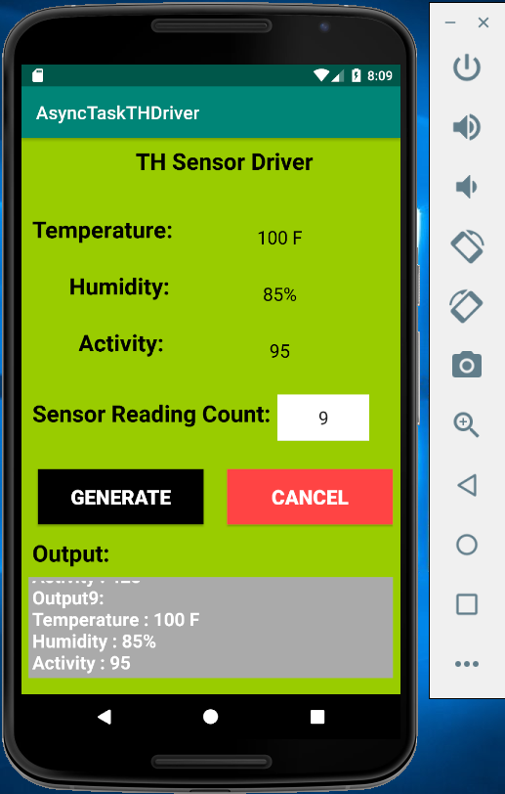

First screenshot displays the output from second iteration and the second image displays the output from last I.e; 9th iteration

Now let’s run for 20 sensor readings

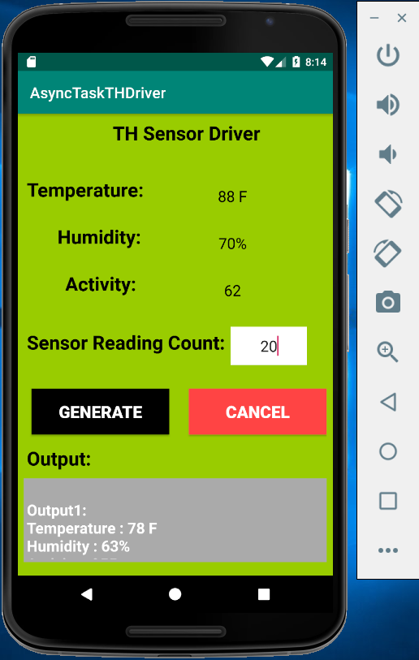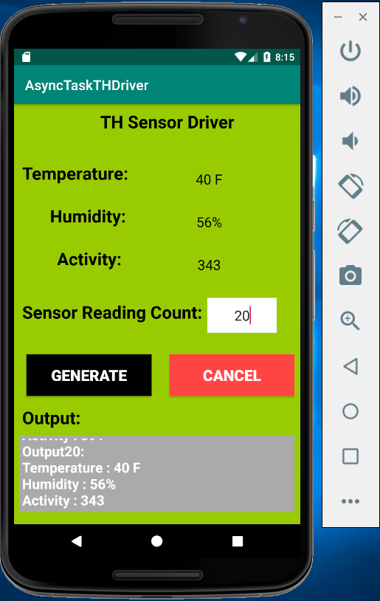

From the screenshots, we can see the output for first and last iteration. The values are displayed every second on the screen till it reaches the value of sensor readings input by the user.

When the user clicks on the cancel button, the values on the home screen are cleared and the activity is started again as shown below

