**Assignment 3 – Broadcast Receiver**

**Name : Snehal Yeole**

**SJSU ID : 012548471**

The home screen for Currency Converter Application with Dollar Amount and Convert To fields. Convert to text field displays three type of currencies using spinner. Screen also includes two buttons one for broadcasting values to second application and other for closing the application. Simple text is displayed at the bottom of the screen.

The values for Dollar Amount and Convert to fields are stored in a parameter and passed in an intent which is broadcasted to the currency conversion exchange application.

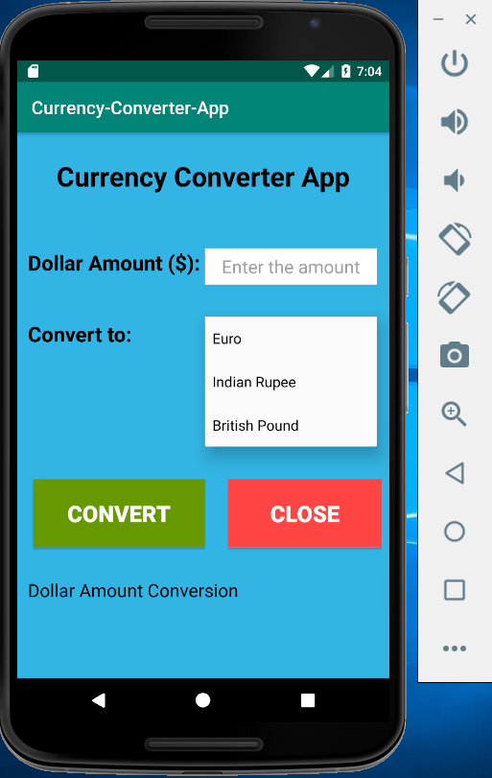

Home screen for Currency Conversion Exchange Application displaying two fields Dollar Amount and Convert to which will be broadcasted from the Currency Converter Application. It also displays two buttons Apply and Close. Apply button is used for currency conversion, whenever the user clicks on Apply button, the values of Dollar Amount and Convert to are passed to the backend currency conversion function that fetches the live currency exchange rates from a central server and calculate the converted amount. Close button is used to close the application.

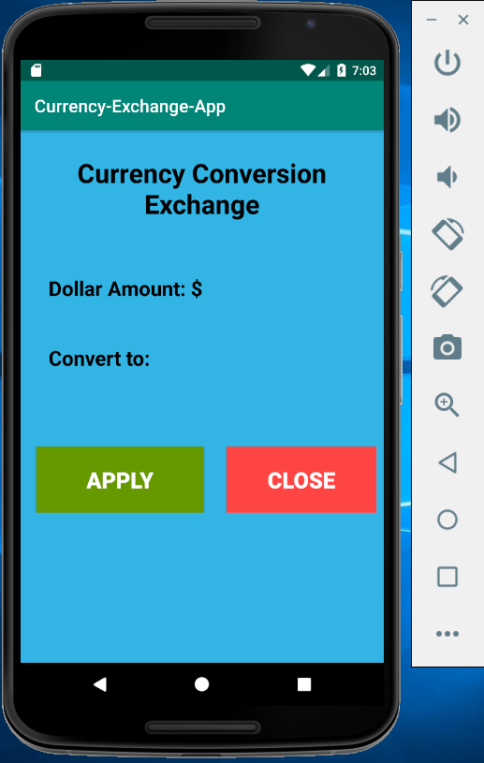

Enter the Dollar amount as $ 1000 and select the currency as British Pound. When the user clicks on Convert button, the values are broadcasted to the currency exchange application and a toast is displayed on screen with the information of package name, dollar amount and currency type.

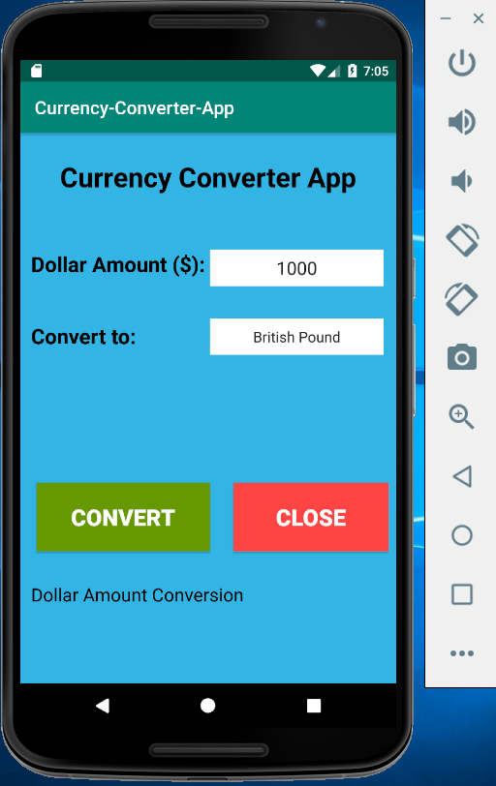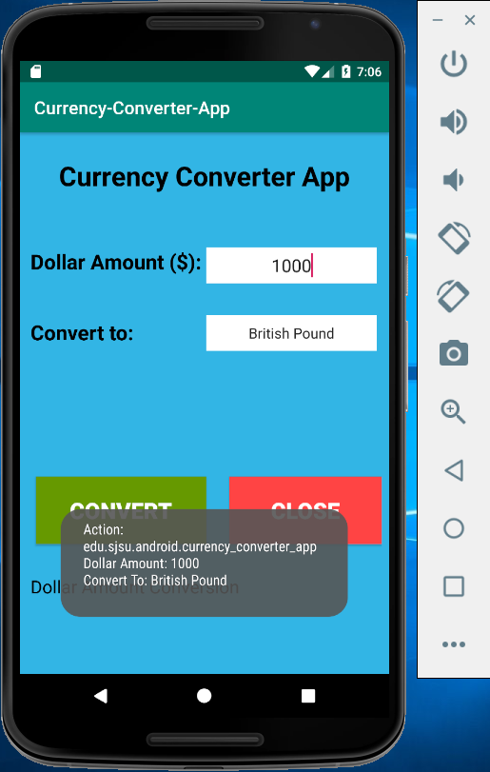

Open the conversion exchange application and you should see the values of Dollar amount and currency type on home screen populated from the converter application. When the user clicks on Apply button, the dollar amount is converted to British Pound and a toast message is displayed on screen with information of package name and converted currency.

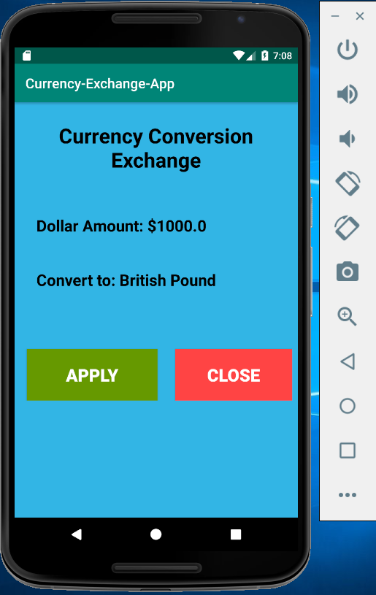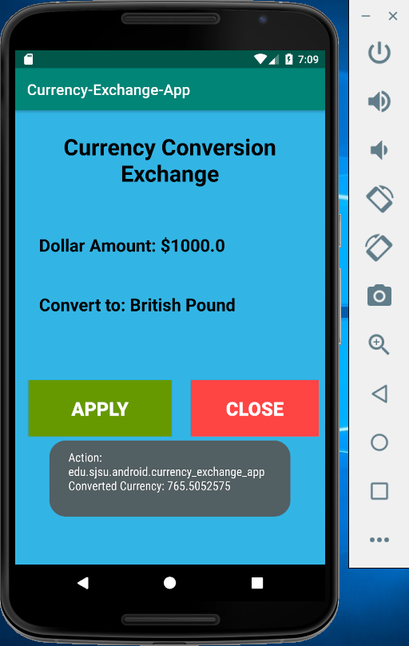

Now, switch to the currency converter application and you should see the message displayed at the bottom of the screen with Dollar amount converted to British Pound.

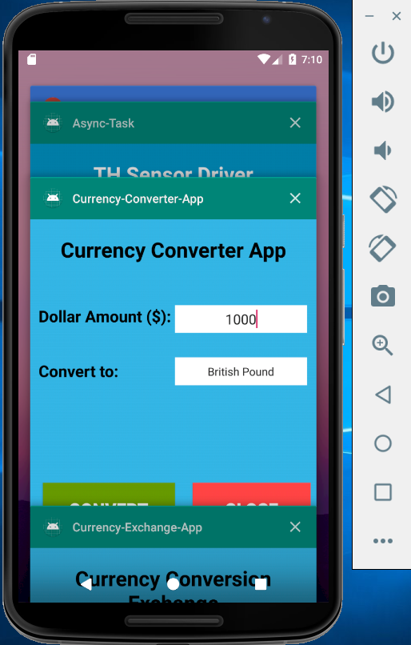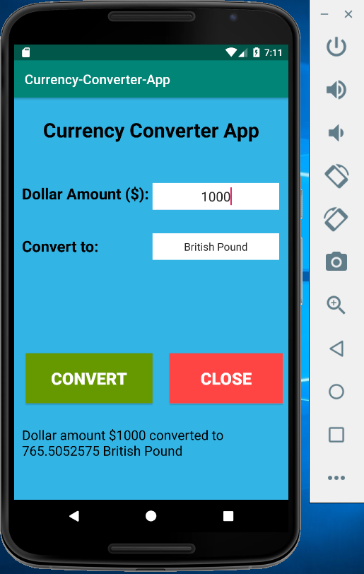

Enter the Dollar amount as $ 299 and select the currency as Indian Rupee. When the user clicks on Convert button, the values are broadcasted to the currency exchange application and a toast message is displayed on screen with the information of package name, dollar amount and currency type.

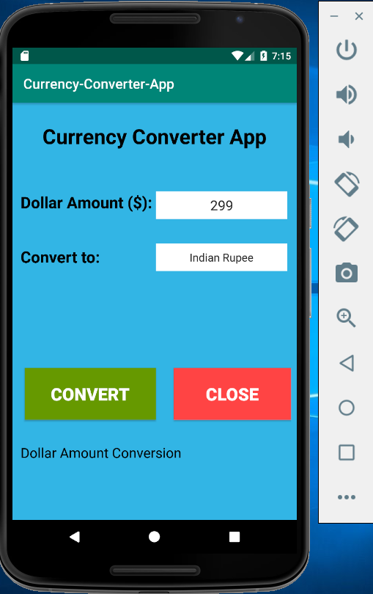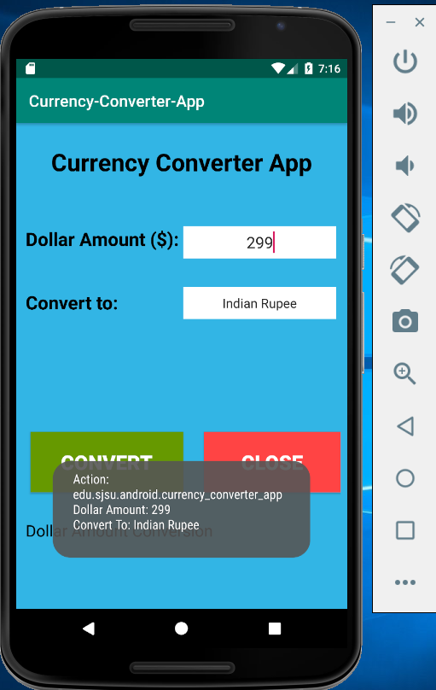

Open the conversion exchange application and you should see the values of Dollar amount and currency type on home screen populated from the converter application. When the user clicks on Apply button, the dollar amount is converted to Indian Rupee and a toast message is displayed on screen with information of package name and converted currency.

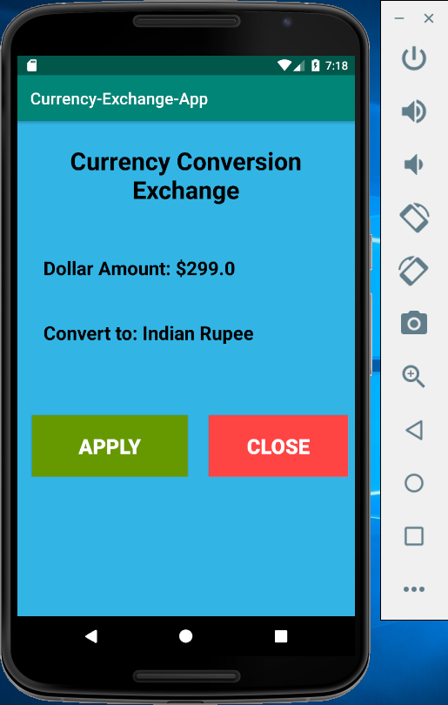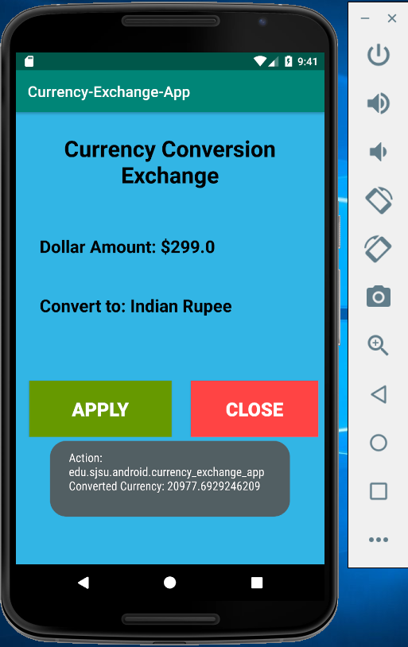

Now, switch to the currency converter application and you should see the message displayed at the bottom of the screen with Dollar amount converted to Indian Rupee.

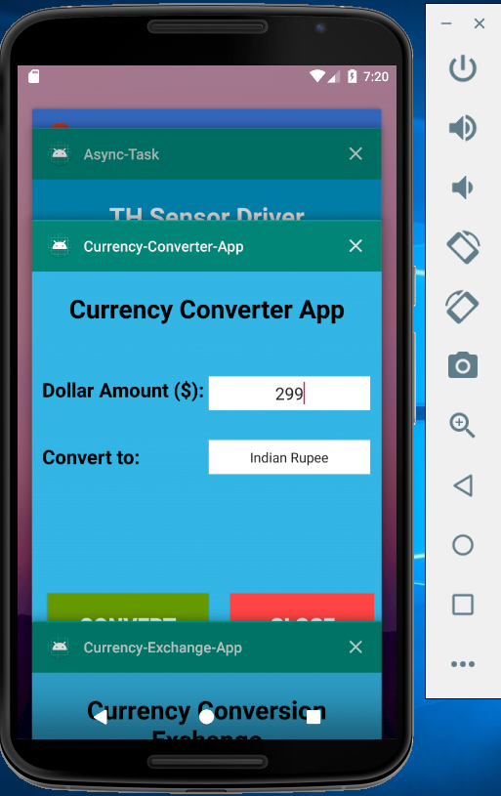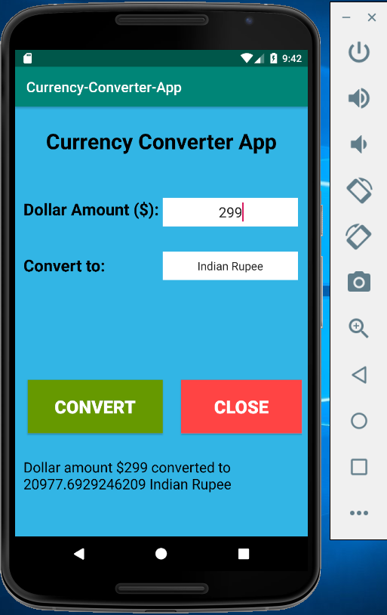

Enter the Dollar amount as $ 2500 and select the currency type as Euro. When the user clicks on Convert button, values are broadcasted to the currency exchange application and a toast message is displayed on screen with the information of package name, dollar amount and currency type.

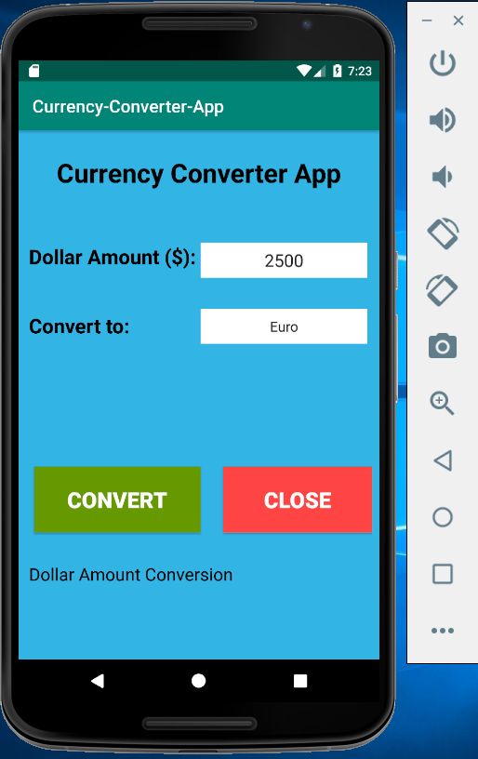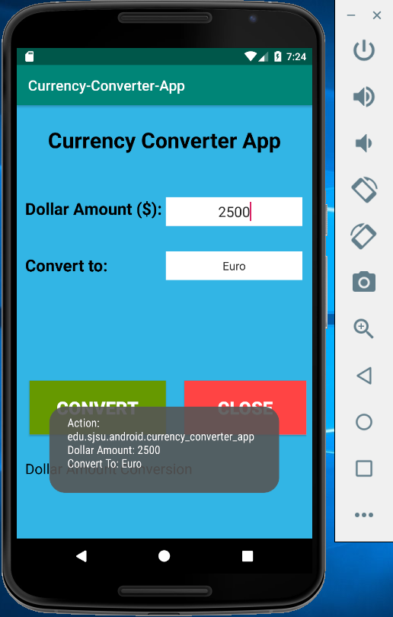

Open the conversion exchange application and you should see the values of Dollar amount and currency type on home screen populated from the converter application. When the user clicks on Apply button, the dollar amount is converted to Euro and a toast message is displayed on screen with information of package name and converted currency.

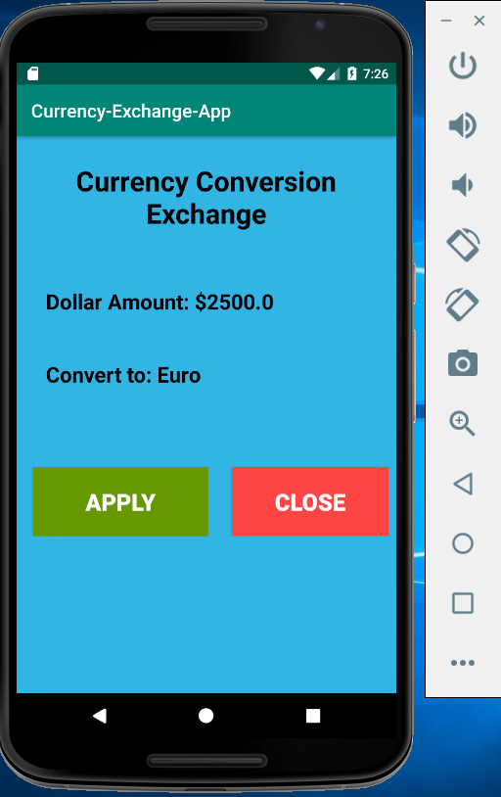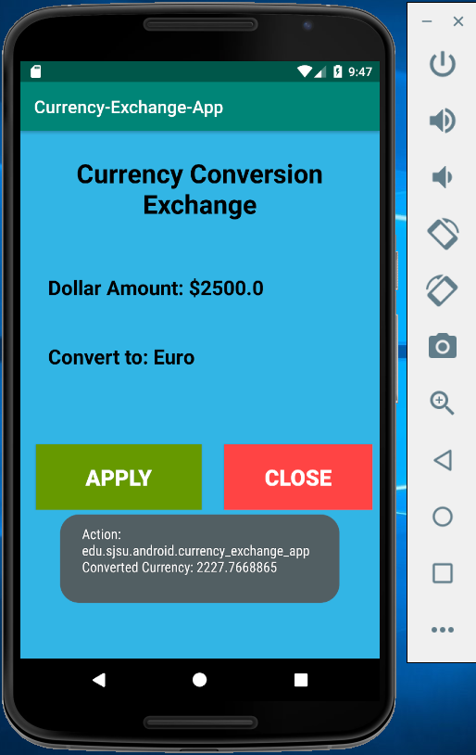

Now, switch to the currency converter application and you should see the message displayed at the bottom of the screen with Dollar amount converted to the Euro.

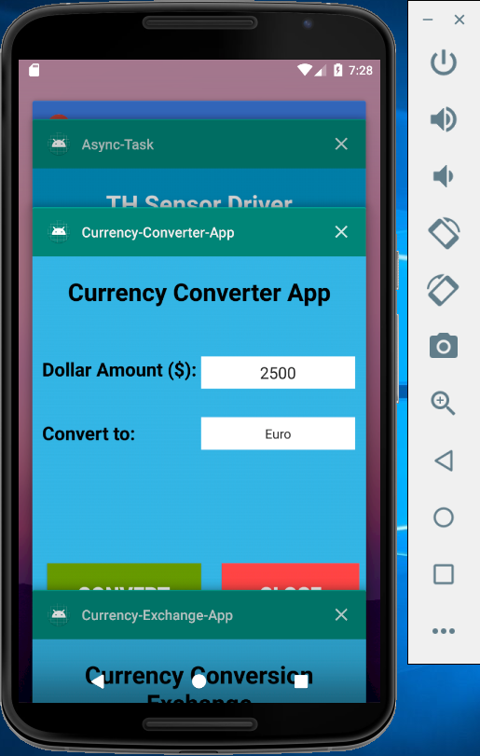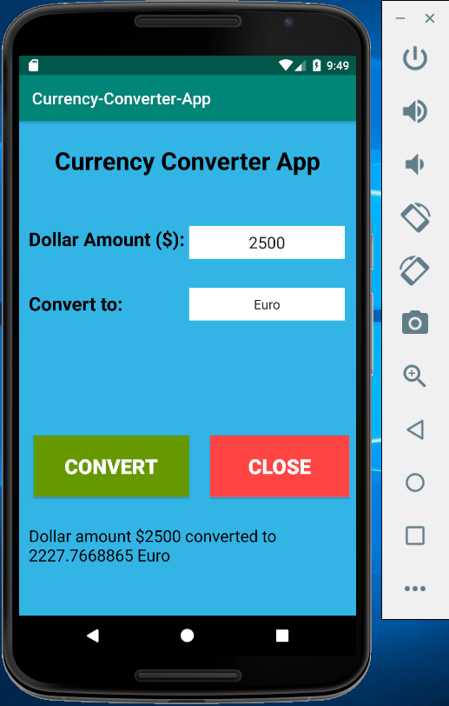

When user clicks on the Close button in Currency Converter application, the application is closed and home screen of android is displayed.

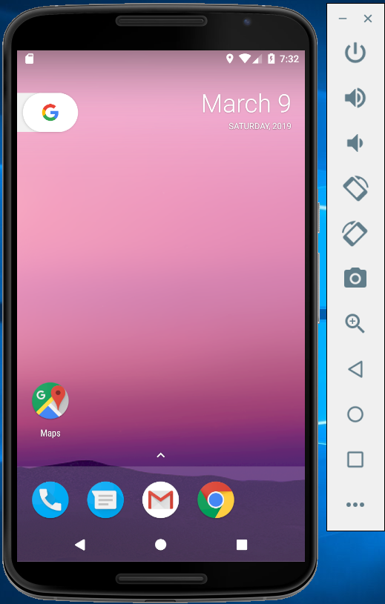

When user clicks on the Close button in Currency Conversion Exchange application, the application is closed and home screen of android is displayed.

