**Assignment 7 – Clap App**

**Name : Snehal Yeole**

**SJSU ID : 012548471**

**Home Screen:**

The Home Screen for the Mobile Clap Application is as shown below. It has the message displayed on screen “Bring your palms closer to the phone!!”. This application is to simulate clapping using mobile phone and hand. Whenever user brings palms closer to the phone, the clapping sound is played and stopped when the user takes palms away from the phone. This is implemented using PROXIMITY_SENSOR. The text “output” is changed to **Near** or **Away** based on the distance of palms from the phone. The application is closed on clicking the **Close** button.

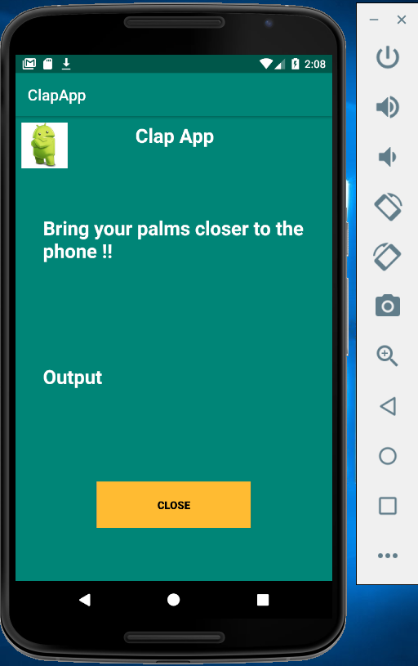

The **clapsound.mp3** file is stored under raw folder inside the res folder

res -> raw -> clapsound.mp3

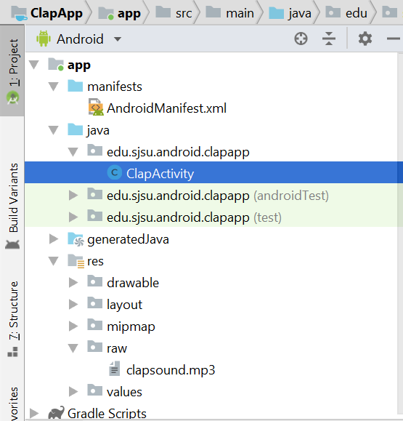

Now, under Extended controls -> Virtual sensors -> Additional sensors, change the proximity to any value below 3 and the output text on main activity screen changes to **Near** indicating that the palms are closer to the phone and clap sound is played.

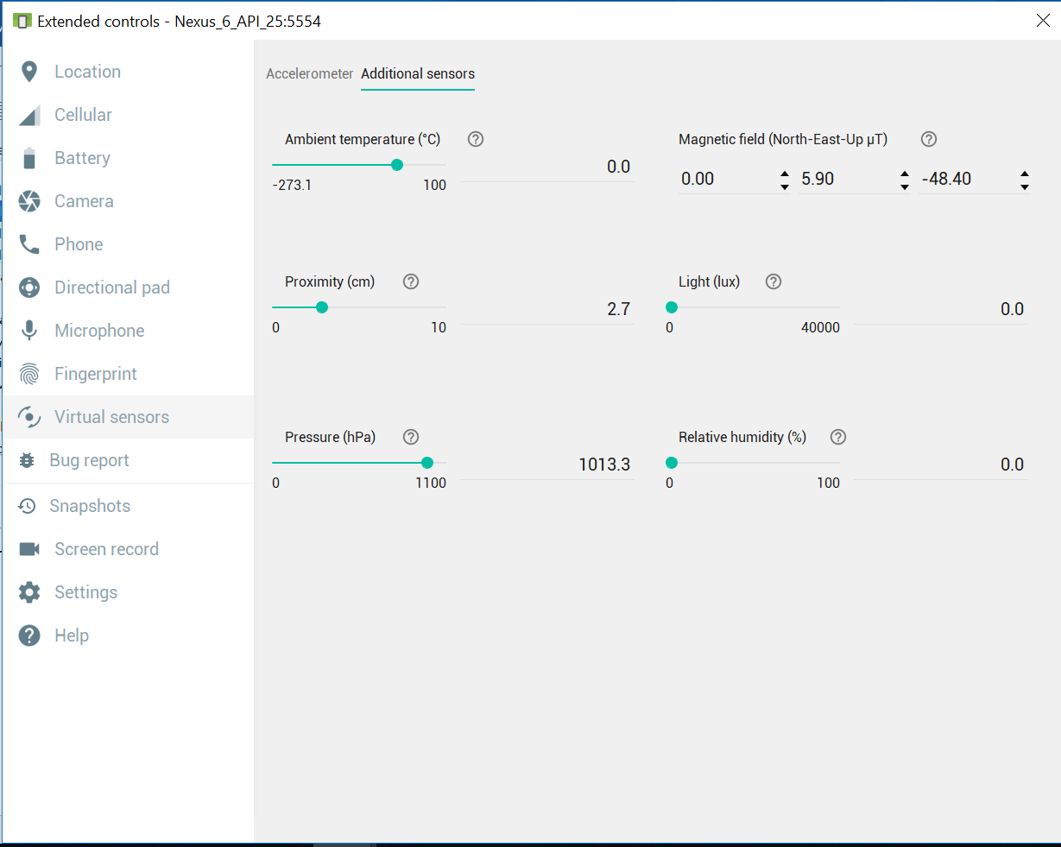

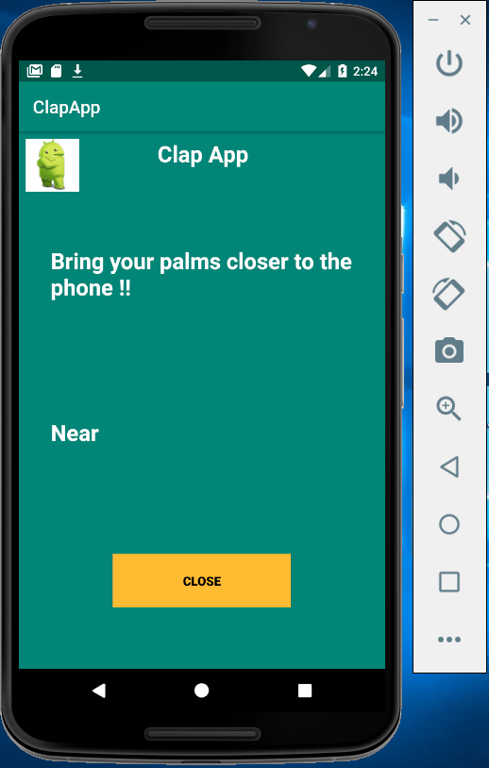

Now, change the proximity to any value above 3 and the output text on main activity screen changes to **Away** indicating that the palms are away from the phone and clap sound is stopped.

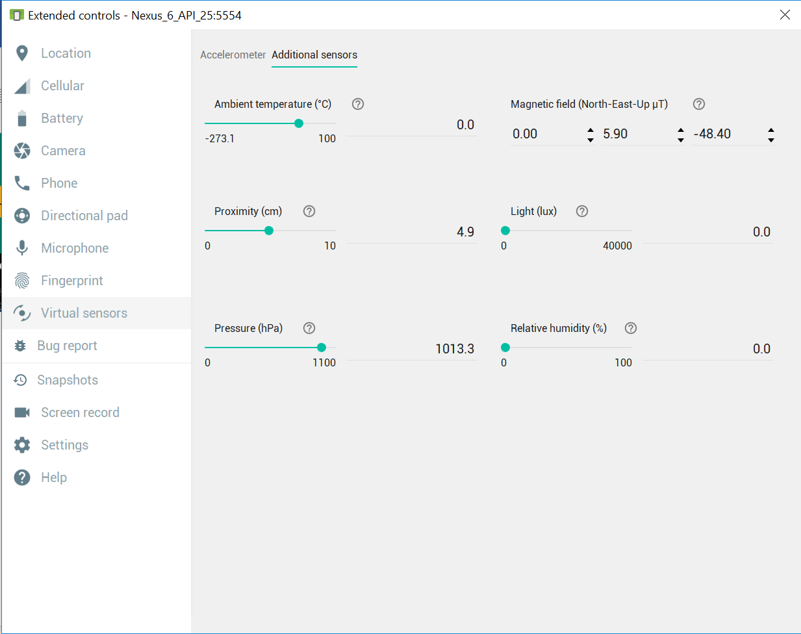

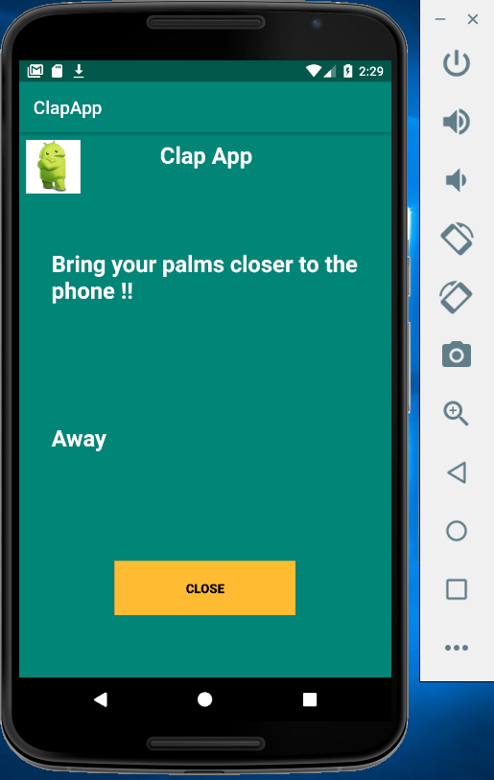

**onClick Close button:**

The application is closed on clicking the **Close** button.

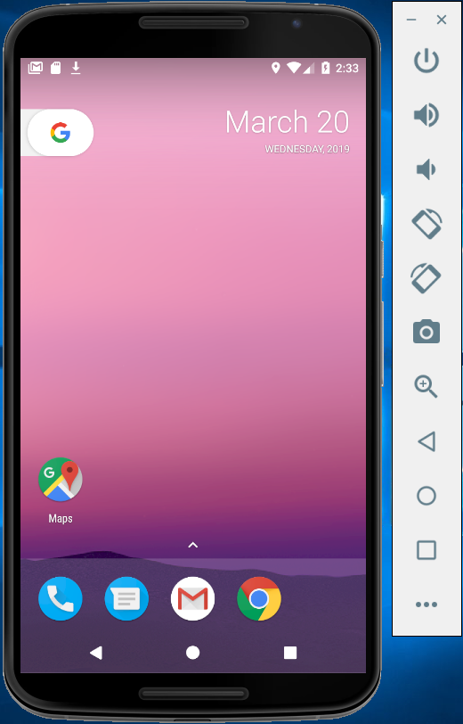

**Demo Link:**

<https://drive.google.com/file/d/1H6cmrsUOBVXYCW4ATc778f6ggiD0QyWE/view?usp=sharing>