**Assignment 8 – Torch App**

**Name : Snehal Yeole**

**SJSU ID : 012548471**

**Learning Objective:**  Using Mobile Camera & LIGHT Sensors, develop torch App that turns on automatically based on low luminous ambient environments and turns off high luminous ambient environments.

The flash light turns on/off based on the luminous values

The flash light turns On when the light sensor value is less than 10, otherwise the flash light is turned Off.

**Screenshot for flashlight turned On:**

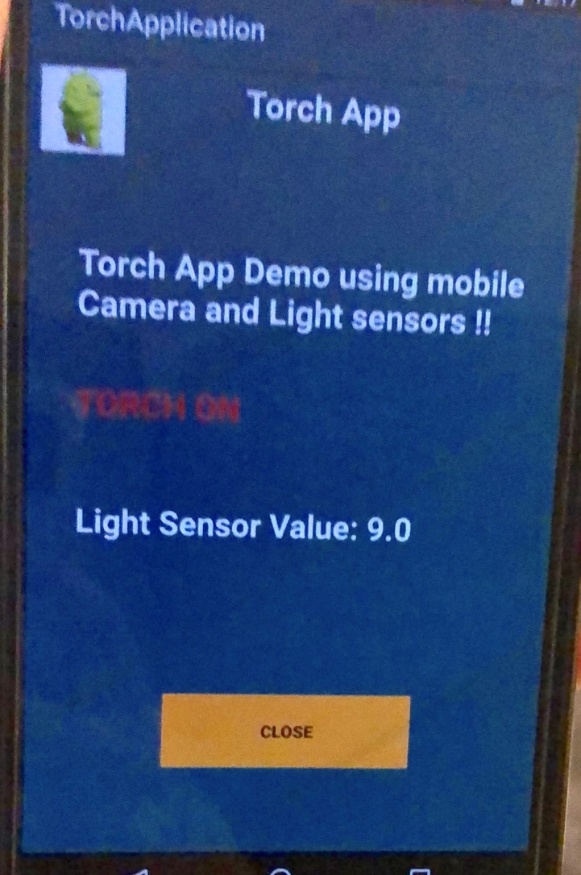

**Note:** The color difference is because the image was not captured properly.

**Screenshot for flash light turned Off:**

