Standard Scores
This chart has title 'Shaded area = 68.27 %'.
It has x-axis 'Score' with labels μ-4σ, μ-3σ, μ-2σ, μ-1σ, μ, μ+1σ, μ+2σ, μ+3σ and μ+4σ.
It has y-axis '' with labels 0.0, 0.1, 0.2 and 0.3.
It has 3 layers.
Layer 1 is a ribbon which is bound on the y axis, with non constant widths: 0.24, 0.35, 0.4, 0.35 and 0.24 with centers at: 0.12, 0.18, 0.2, 0.18 and 0.12. The ribbon takes up 21% of the graph.
Layer 1 has colour set to light gray.
Layer 1 has fill set to brilliant blue.
Layer 1 has alpha set to 0.8.
Layer 2 is a function graph that VI cannot process.
Layer 2 has colour set to light gray.
Layer 2 has linewidth set to 1.
Layer 3 is a vline graph that VI cannot process.
Layer 3 has colour set to light gray.
This chart has title 'Shaded area = 95.45 %'.
It has x-axis 'Score' with labels μ-4σ, μ-3σ, μ-2σ, μ-1σ, μ, μ+1σ, μ+2σ, μ+3σ and μ+4σ.
It has y-axis '' with labels 0.0, 0.1, 0.2 and 0.3.
It has 3 layers.
Layer 1 is a ribbon which is bound on the y axis, with non constant widths: 0.05, 0.24, 0.4, 0.24 and 0.05 with centers at: 0.03, 0.12, 0.2, 0.12 and 0.03. The ribbon takes up 30% of the graph.
Layer 1 has colour set to light gray.
Layer 1 has fill set to brilliant blue.
Layer 1 has alpha set to 0.8.
Layer 2 is a function graph that VI cannot process.
Layer 2 has colour set to light gray.
Layer 2 has linewidth set to 1.
Layer 3 is a vline graph that VI cannot process.
Layer 3 has colour set to light gray.
This chart has title 'Shaded area = 99.73 %'.
It has x-axis 'Score' with labels μ-4σ, μ-3σ, μ-2σ, μ-1σ, μ, μ+1σ, μ+2σ, μ+3σ and μ+4σ.
It has y-axis '' with labels 0.0, 0.1, 0.2 and 0.3.
It has 3 layers.
Layer 1 is a ribbon which is bound on the y axis, with non constant widths: 0, 0.13, 0.4, 0.13 and 0 with centers at: 0, 0.06, 0.2, 0.07 and 0. The ribbon takes up 31% of the graph.
Layer 1 has colour set to light gray.
Layer 1 has fill set to brilliant blue.
Layer 1 has alpha set to 0.8.
Layer 2 is a function graph that VI cannot process.
Layer 2 has colour set to light gray.
Layer 2 has linewidth set to 1.
Layer 3 is a vline graph that VI cannot process.
Layer 3 has colour set to light gray.
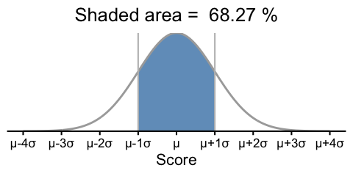
(a) An interval from $−1$ σ to $1$ σ from μ covers 68.27% of the data

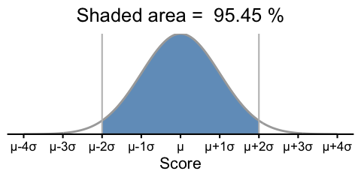
(b) An interval from $−2$ σ to $2$ σ from μ covers 95.45% of the data

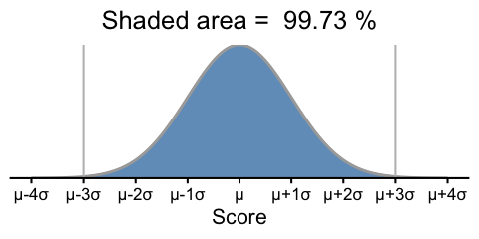
(c) An interval from $−3$ σ to $3$ σ from μ covers 99.73% of the data

Figure 1: Normal Distributions and the 68-95-99.7 Rule
This chart has title 'Shaded area = 68.27 %'.
It has x-axis 'z' with labels -4, -3, -2, -1, 0, 1, 2, 3 and 4.
It has y-axis '' with labels 0.0, 0.1, 0.2 and 0.3.
It has 3 layers.
Layer 1 is a ribbon which is bound on the y axis, with non constant widths: 0.24, 0.35, 0.4, 0.35 and 0.24 with centers at: 0.12, 0.18, 0.2, 0.18 and 0.12. The ribbon takes up 21% of the graph.
Layer 1 has colour set to light gray.
Layer 1 has fill set to brilliant blue.
Layer 1 has alpha set to 0.8.
Layer 2 is a function graph that VI cannot process.
Layer 2 has colour set to light gray.
Layer 2 has linewidth set to 1.
Layer 3 is a vline graph that VI cannot process.
Layer 3 has colour set to light gray.
This chart has title 'Shaded area = 95.45 %'.
It has x-axis 'z' with labels -4, -3, -2, -1, 0, 1, 2, 3 and 4.
It has y-axis '' with labels 0.0, 0.1, 0.2 and 0.3.
It has 3 layers.
Layer 1 is a ribbon which is bound on the y axis, with non constant widths: 0.05, 0.24, 0.4, 0.24 and 0.05 with centers at: 0.03, 0.12, 0.2, 0.12 and 0.03. The ribbon takes up 30% of the graph.
Layer 1 has colour set to light gray.
Layer 1 has fill set to brilliant blue.
Layer 1 has alpha set to 0.8.
Layer 2 is a function graph that VI cannot process.
Layer 2 has colour set to light gray.
Layer 2 has linewidth set to 1.
Layer 3 is a vline graph that VI cannot process.
Layer 3 has colour set to light gray.
This chart has title 'Shaded area = 99.73 %'.
It has x-axis 'z' with labels -4, -3, -2, -1, 0, 1, 2, 3 and 4.
It has y-axis '' with labels 0.0, 0.1, 0.2 and 0.3.
It has 3 layers.
Layer 1 is a ribbon which is bound on the y axis, with non constant widths: 0, 0.13, 0.4, 0.13 and 0 with centers at: 0, 0.06, 0.2, 0.07 and 0. The ribbon takes up 31% of the graph.
Layer 1 has colour set to light gray.
Layer 1 has fill set to brilliant blue.
Layer 1 has alpha set to 0.8.
Layer 2 is a function graph that VI cannot process.
Layer 2 has colour set to light gray.
Layer 2 has linewidth set to 1.
Layer 3 is a vline graph that VI cannot process.
Layer 3 has colour set to light gray.
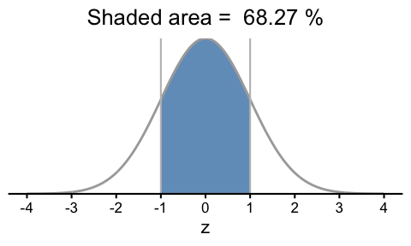
(a) z score interval from $−1$ to $1$ covers 68.27% of the data

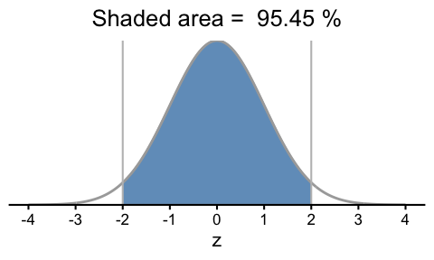
(b) z score interval from $−2$ to $2$ covers 95.45% of the data

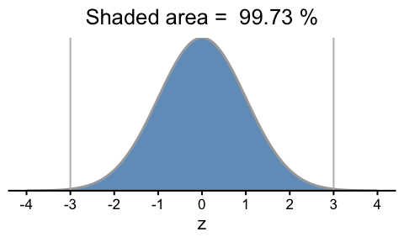
(c) z score interval from $−3$ to $3$ covers 99.73% of the data

Figure 2: The Standard Normal Distribution and the 68-95-99.7 Rule
This chart has title 'Standard Normal Distribution'.
It has x-axis 'Score' with labels -5, -4, -3, -2, -1, 0, 1, 2, 3, 4 and 5.
It has y-axis 'Density' with labels 0.0, 0.1, 0.2, 0.3 and 0.4.
It has 11 layers.
Layer 1 is a set of 1 line.
Line 1 connects 101 points.
Layer 2 is a vline graph that VI cannot process.
Layer 3 is a vline graph that VI cannot process.
Layer 4 is a label graph that VI cannot process.
Layer 5 is a label graph that VI cannot process.
Layer 6 is a label graph that VI cannot process.
Layer 7 is a label graph that VI cannot process.
Layer 8 is a label graph that VI cannot process.
Layer 9 is a label graph that VI cannot process.
Layer 10 is a label graph that VI cannot process.
Layer 11 is a label graph that VI cannot process.
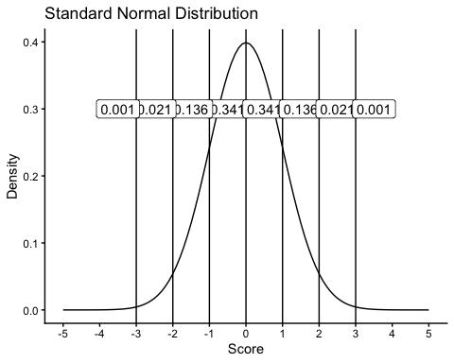
Figure 3: The Standard Normal Distribution

