Standard Scores
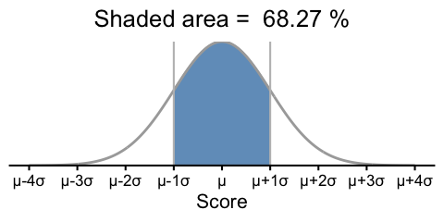
(a) An interval from $−1$ σ to $1$ σ from μ covers 68.27% of the data

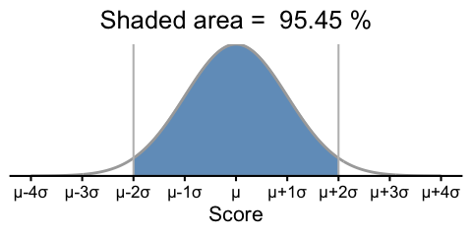
(b) An interval from $−2$ σ to $2$ σ from μ covers 95.45% of the data

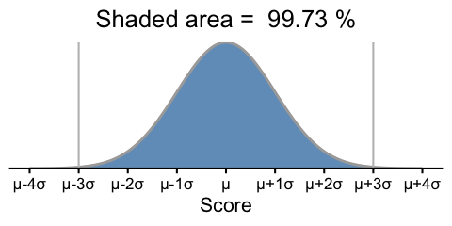
(c) An interval from $−3$ σ to $3$ σ from μ covers 99.73% of the data

Figure 1: Normal Distributions and the 68-95-99.7 Rule
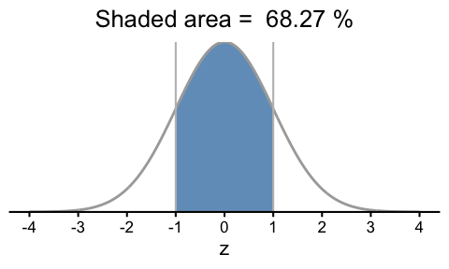
(a) z score interval from $−1$ to $1$ covers 68.27% of the data

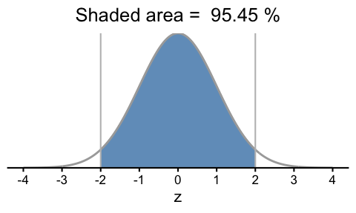
(b) z score interval from $−2$ to $2$ covers 95.45% of the data

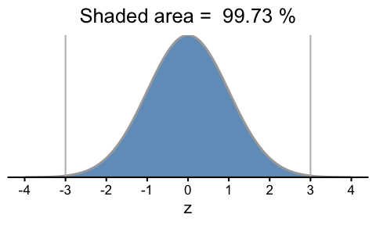
(c) z score interval from $−3$ to $3$ covers 99.73% of the data

Figure 2: The Standard Normal Distribution and the 68-95-99.7 Rule
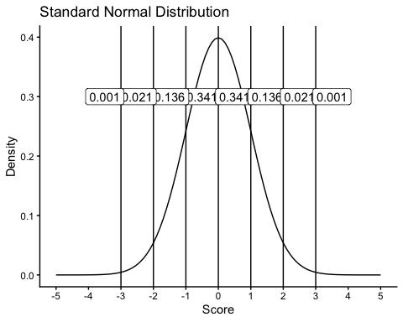
Figure 3: The Standard Normal Distribution

