Presenting Your Work in APA Style
Yeon Soon Shin
Anjali Thapar
Dustin Albert
Matthew J. C. Crump
Paul C. Price
Rajiv Jhangiani
I-Chant A. Chiang
Dana C. Leighton
Imagine that you have identified an interesting research question, reviewed the relevant literature, designed and conducted an empirical study, analyzed the data, and drawn your conclusions. There is still one more step in the process of conducting scientific research. It is time to add your research to the literature so that others can learn from it and build on it. Remember that science is a social and cumulative process—a large-scale collaboration among many researchers distributed across space and time. For this reason, it could be argued that unless you make your research public in some form, you are not really engaged in science at all.
In this chapter, we look at how to present your research effectively in the American Psychological Association (APA) style—the primary approach to writing taken by researchers in psychology and related fields.

American Psychological Association (APA) Style

What Is APA Style?
APA style is a set of guidelines for writing in psychology and related fields. These guidelines are set down in the Publication Manual of the American Psychological Association (APA, 2006). The Publication Manual originated in 1929 as a short journal article that provided basic standards for preparing manuscripts to be submitted for publication (Bentley et al. 1929). It was later expanded and published as a book by the association and is now in its sixth edition. The primary purpose of APA style is to facilitate scientific communication by promoting clarity of expression and by standardizing the organization and content of research articles and book chapters. It is easier to write about research when you know what information to present, the order in which to present it, and even the style in which to present it. Likewise, it is easier to read about research when it is presented in familiar and expected ways.
APA style is best thought of as a “genre” of writing that is appropriate for presenting the results of psychological research—especially in academic and professional contexts. It is not synonymous with “good writing” in general. You would not write a literary analysis for an English class, even if it were based on psychoanalytic concepts, in APA style. You would write it in Modern Language Association (MLA) style instead. And you would not write a newspaper article, even if it were about a new breakthrough in behavioral neuroscience, in APA style. You would write it in Associated Press (AP) style instead. At the same time, you would not write an empirical research report in MLA style, in AP style, or in the style of a romance novel, an e-mail to a friend, or a shopping list. You would write it in APA style. Part of being a good writer in general is adopting a style that is appropriate to the writing task at hand, and for writing about psychological research, this is APA style.

Overall Organization of an APA-Style Article
The first level of APA style is the overall organization of an article (which is covered in Chapter 2 “Manuscript Structure and Content” of the Publication Manual). Empirical research reports, in particular, have several distinct sections that always appear in the same order. Table 1 summarizes the purpose of each section and the guiding question that it answers. The sections are as follows:
Table 1: Sections and Their Functions
Section | Function | Guiding Questions
Title page | Presents the article title and author names and affiliations. | What did you study?
Abstract | Summarizes the research in a short paragraph. | What did you study? what was done and found? What are the implications?
Introduction | Describes previous research and the rationale for the current study. | Why did you do your study? what is your hypothesis?
Method | Describes how the study was conducted. | How did you do your study?
Results | Describes the results of the study. | What did you find?
Discussion | Summarizes the study and discusses its implications. | What do your results mean?
References | Lists the references cited throughout the article. | What are the sources that you refer to in your article?

High-Level Style of APA: Clear Expression of Ideas
The second level of APA style can be referred to as high-level style (covered in Chapter 3 “Writing Clearly and Concisely” of the Publication Manual), which includes guidelines for the clear expression of ideas. There are two important themes here. One is that APA-style writing is formal rather than informal. It adopts a tone that is appropriate for communicating with professional colleagues—other researchers and practitioners—who share an interest in the topic. Beyond this shared interest, however, these colleagues are not necessarily similar to the writer or to each other. A graduate student in British Columbia might be writing an article that will be read by a young psychotherapist in Toronto and a respected professor of psychology in Tokyo. Thus formal writing avoids slang, contractions, pop culture references, humor, and other elements that would be acceptable in talking with a friend or in writing informally.
The second theme of high-level APA style is that it is straightforward. This means that it communicates ideas as simply and clearly as possible, putting the focus on the ideas themselves and not on how they are communicated. Thus APA-style writing minimizes literary devices such as metaphor, imagery, irony, suspense, and so on. Again, humor is kept to a minimum. Sentences are short and direct. Technical terms must be used, but they are used to improve communication, not simply to make the writing sound more “scientific.” For example, if participants immersed their hands in a bucket of ice water, it is better just to write this than to write that they “were subjected to a pain-inducement apparatus.”
At the same time, however, there is no better way to communicate that a between- subjects design was used than to use the term “between-subjects design.” Some terms are widely understood in psychology and are assumed to be understood by the audience without further explanation. They help communicate ideas more concisely and efficiently. In fact, we are learning these terms in this book so we understand them in other people’s writing and can use them in our own.

APA Style and the Values of Psychology
Robert Madigan and his colleagues have argued that APA style has a purpose that often goes unrecognized (Madigan et al. 1995). Specifically, it promotes psychologists’ scientific values and assumptions. From this perspective, many features of APA style that at first seem arbitrary actually make good sense. Following are several features of APA-style writing and the scientific values or assumptions they reflect.
Another important element of high-level APA style is the avoidance of language that is biased against particular groups. This is not only to avoid offending people—why would you want to offend people who are interested in your work?—but also for the sake of scientific objectivity and accuracy. For example, the term sexual orientation should be used instead of sexual preference because people do not generally experience their orientation as a “preference,” nor is it as easily changeable as this term suggests (APA Committee on Lesbian, Gay, and Bisexual Concerns Joint Task Force on Guidelines for Psychotherapy With Lesbian, Gay, and Bisexual Clients, 2000).
The general principles for avoiding biased language are fairly simple. First, be sensitive to labels by avoiding terms that are offensive or have negative connotations. This includes terms that identify people with a disorder or other problem they happen to have. For example, patients with schizophrenia is better than schizophrenics. Second, use more specific terms rather than more general ones. For example, Chinese Canadians is better than Asian Canadians if everyone in the group is, in fact, Chinese Canadian. Third, avoid objectifying research participants. Instead, acknowledge their active contribution to the research. For example, “The students completed the questionnaire” is better than “The subjects were administered the questionnaire.” Note that this principle also makes for clearer, more engaging writing.
The previous edition of the Publication Manual strongly discouraged the use of the term subjects (except for nonhumans) and strongly encouraged the use of participants instead. The current edition, however, acknowledges that subjects can still be appropriate in referring to human participants in areas in which it has traditionally been used (e.g., basic memory research). But it also encourages the use of more specific terms when possible: university students, children, respondents, and so on.

APA Style and Grammar Guidelines
The third level of APA style can be referred to as low-level style (which is covered in Chapter 4 “The Mechanics of Style” through Chapter 7 “Reference Examples” of the Publication Manual.) Low-level style includes all the specific guidelines pertaining to spelling, grammar, references and reference citations, numbers and statistics, figures and tables, and so on. There are so many low-level guidelines that even experienced professionals need to consult the Publication Manual from time to time. Table 2 contains some of the most common types of APA style errors based on an analysis of manuscripts submitted to one professional journal over a 6-year period (Onwuegbuzie et al. 2010). These errors were committed by professional researchers but are probably similar to those that students commit the most too. Refer to the APA style guidelines for more information on these.
Table 2: Common APA Style Errors. Adapted from Onwuegbuzie et al. (2010).
Error Type | Principle | Error Example | Corrected Example
Use of numbers | Use numerals for numbers 10 and above, and words for numbers below 10. | “9 students were assigned to …” | “Nine students were assigned to …”
Hyphenation | Hyphenate compound adjectives. | “role playing technique” | “role-playing technique”
Use of “et al.” | Use “et al.” after a reference is cited for the first time. | “Smith, Jones, and Brown (2010) found that … Smith, Jones, and Brown (2010) also found that …” | “Smith, Jones, and Brown (2010) found that … Smith et al. (2010) also found that …”
Headings | Title Case Heading | “Design and procedure” | “Design and Procedure”
Use of abbreviations | Spell out a term completely before introducing an abbreviation for it. | “We used BDI to measure depression. BDI scores were …” | “We used the Beck Depression Inventory (BDI) to measure depression. BDI scores were …”
Use of “&” and “and” in in-text citations | Use “&” in parentheses, and use “and” in text. | “Smith & Jones (2010) found that … (Smith and Jones, 2010).” | “Smith and Jones (2010) found that … (Smith & Jones, 2010).”

APA-Style References and Citations
Because science is a large-scale collaboration among researchers, references to the work of other researchers are extremely important. Their importance is reflected in the extensive and detailed set of rules for formatting and using them.

References
At the end of an APA-style article or book chapter is a list that contains references to all the works cited in the text (and only the works cited in the text). The reference list begins on its own page, with the heading “References,” centered in upper and lower case. The references themselves are then listed alphabetically according to the last names of the first named author for each citation. (As in the rest of an APA-style manuscript, everything is double- spaced.) Many different kinds of works might be cited in APA-style articles and book chapters, including magazine articles, websites, government documents, and even television shows. Of course, you should consult the Publication Manual or Online APA Style Resources for details on how to format them. Here we will focus on formatting references for the three most common kinds of works cited in APA style: journal articles, books, and book chapters.

Journal
Articles For journal articles, the generic format for a reference is as follows:
Author, A. A., Author, B. B., & Author, C. C. (year). Title of article. Title of Journal, xx(yy), pp–pp. doi:xx.xxxxxxxxxx
Here is a concrete example:
Adair, J. G., & Vohra, N. (2003). The explosion of knowledge, references, and citations: Psychology’s unique response to a crisis. American Psychologist, 58(1), 15–23. doi: 10.1037/0003-066X.58.1.15
There are several things to notice here. The reference includes a hanging indent. That is, the first line of the reference is not indented but all subsequent lines are. The authors’ names appear in the same order as on the article, which reflects the authors’ relative contributions to the research. Only the authors’ last names and initials appear, and the names are separated by commas with an ampersand (&) between the last two. This is true even when there are only two authors. Only the first word of the article title is capitalized. The only exceptions are for words that are proper nouns or adjectives (e.g., “Freudian”) or if there is a subtitle, in which case the first word of the subtitle is also capitalized. In the journal title, however, all the important words are capitalized. The journal title and volume number are italicized; however, the issue number (listed within parentheses) is not. At the very end of the reference is the digital object identifier (DOI), which provides a permanent link to the location of the article on the Internet. Include this if it is available. It can generally be found in the record for the item on an electronic database (e.g., PsycINFO) and is usually displayed on the first page of the published article.

Books
For a book, the generic format and a concrete example are as follows:
Author, A. A. (year). Title of book. Location: Publisher.
Kashdan, T., & Biswas-Diener, R. (2014). The upside of your dark side. New York, NY: Hudson Street Press.
Book Chapters For a chapter in an edited book, the generic format and a concrete example are as follows:
Author, A. A., Author, B. B., & Author, C. C. (year). Title of chapter. In A. A. Editor, B. B. Editor, & C. C. Editor (Eds.), Title of book (pp. xxx–xxx). Location: Publisher.
Lilienfeld, S. O., & Lynn, S. J. (2003). Dissociative identity disorder: Multiple personalities, multiple controversies. In S. O. Lilienfeld, S. J. Lynn, & J. M. Lohr (Eds.), Science and pseudoscience in clinical psychology (pp. 109–142). New York, NY: Guilford Press.
Notice that references for books and book chapters are similar to those for journal articles, but there are several differences too. For an edited book, the names of the editors appear with their first and middle initials followed by their last names (not the other way around)—with the abbreviation “Eds.” (or “Ed.,” if there is only one) appearing in parentheses immediately after the final editor’s name. Only the first word of a book title is capitalized (with the exceptions noted for article titles), and the entire title is italicized. For a chapter in an edited book, the page numbers of the chapter appear in parentheses after the book title with the abbreviation “pp.” Finally, both formats end with the location of publication and the publisher, separated by a colon.

In-Text Citations
When you refer to another researcher’s idea, you must include a reference citation (in the text) to the work in which that idea originally appeared and a full reference to that work in the reference list. What counts as an idea that must be cited? In general, this includes phenomena discovered by other researchers, theories they have developed, hypotheses they have derived, and specific methods they have used (e.g., specific questionnaires or stimulus materials). Citations should also appear for factual information that is not common knowledge so that other researchers can check that information for themselves. For example, in an article on the effect of cell phone usage on driving ability, the writer might cite official statistics on the number of cell phone–related accidents that occur each year. Among the ideas that do not need citations are widely shared methodological and statistical concepts (e.g., between-subjects design, t test) and statements that are so broad that they would be difficult for anyone to argue with (e.g., “Working memory plays a role in many daily activities.”). Be careful, though, because “common knowledge” about human behavior is often incorrect. Therefore, when in doubt, find an appropriate reference to cite or remove the questionable assertion.
When you cite a work in the text of your manuscript, there are two ways to do it. Both include only the last names of the authors and the year of publication. The first method is to use the authors’ last names in the sentence (with no first names or initials) followed immediately by the year of publication in parentheses. Here are some examples:
Burger (2008) conducted a replication of Milgram’s (1963) original obedience study.
Although many people believe that women are more talkative than men, Mehl, Vazire, Ramirez-Esparza, Slatcher, and Pennebaker (2007) found essentially no difference in the number of words spoken by male and female college students.
Notice several things. First, the authors’ names are treated grammatically as names of people, not as things. It is better to write “a replication of Milgram’s (1963) study” than “a replication of Milgram (1963).” Second, when there are two authors the names are not separated by commas, but when there are three or more authors they are. Third, the word and (rather than an ampersand) is used to join the authors’ names. Fourth, the year follows immediately after the final author’s name. An additional point, which is not illustrated in these examples but is illustrated in the sample paper in Section 11.2 “Writing a Research Report in American Psychological Association (APA) Style”, is that the year only needs to be included the first time a particular work is cited in the same paragraph.
The second way to cite an article or a book chapter is parenthetically—including the authors’ last names and the year of publication in parentheses following the idea that is being credited. Here are some examples:
People can be surprisingly obedient to authority figures (Burger, 2008; Milgram, 1963).
Recent evidence suggests that men and women are similarly talkative (Mehl, Vazire, Ramirez-Esparza, Slatcher, & Pennebaker, 2007).
One thing to notice about such parenthetical citations is that they are often placed at the end of the sentence, which minimizes their disruption to the flow of that sentence. In contrast to the first way of citing a work, this way always includes the year—even when the citation is given multiple times in the same paragraph. Notice also that when there are multiple citations in the same set of parentheses, they are organized alphabetically by the name of the first author and separated by semicolons.
There are no strict rules for deciding which of the two citation styles to use. Most articles and book chapters contain a mixture of the two. In general, however, the first approach works well when you want to emphasize the person who conducted the research—for example, if you were comparing the theories of two prominent researchers. It also works well when you are describing a particular study in detail. The second approach works well when you are discussing a general idea and especially when you want to include multiple citations for the same idea.
The third most common error in Table 2 has to do with the use of et al. This is an abbreviation for the Latin term et alia, which means “and others.” In APA style, if an article or a book chapter has more than two authors, you should include all their names when you first cite that work. After that, however, you should use the first author’s name followed by “et al.” Here are some examples:
Recall that Mehl et al. (2007) found that women and men spoke about the same number of words per day on average.
There is a strong positive correlation between the number of daily hassles and the number of symptoms people experience (Kanner et al., 1981).
Notice that there is no comma between the first author’s name and “et al.” Notice also that there is no period after “et” but there is one after “al.” This is because “et” is a complete word and “al.” is an abbreviation for the word alia.

Writing a Research Report in American Psychological Association (APA) Style
In this section, we look at how to write an APA-style empirical research report, an article that presents the results of one or more new studies. Recall that the standard sections of an empirical research report provide a kind of outline. Here we consider each of these sections in detail, including what information it contains, how that information is formatted and organized, and tips for writing each section. At the end of this section is a sample APA-style research report that illustrates many of these principles.

Title Page and Abstract
An APA-style research report begins with a title page. The title is centered in the upper half of the page, with each important word capitalized. The title should clearly and concisely (in about 12 words or fewer) communicate the primary variables and research questions. This sometimes requires a main title followed by a subtitle that elaborates on the main title, in which case the main title and subtitle are separated by a colon. Here are some titles from recent issues of professional journals published by the American Psychological Association.
- Sex Differences in Coping Styles and Implications for Depressed Mood
- Effects of Aging and Divided Attention on Memory for Items and Their Contexts
- Computer-Assisted Cognitive Behavioral Therapy for Child Anxiety: Results of a Randomized Clinical Trial
- Virtual Driving and Risk Taking: Do Racing Games Increase Risk-Taking Cognitions, Affect, and Behavior?
There are different ways to approach a title. Some titles are list of key variables, some are a research question, and some are a statement of the main finding. If it is a simple enough question and finding, it can be an effective way of communicating the research.
Below the title are the authors’ names and, on the next line, their institutional affiliation—the university or other institution where the authors worked when they conducted the research. As we have already seen, the authors are listed in an order that reflects their contribution to the research. When multiple authors have made equal contributions to the research, they often list their names alphabetically or in a randomly determined order.
For articles that are being submitted for publication, the title page also includes an author note that lists the authors’ full institutional affiliations, any acknowledgments the authors wish to make to agencies that funded the research or to colleagues who commented on it, and contact information for the authors. For student papers that are not being submitted for publication—including theses—author notes are generally not necessary.
The abstract is a summary of the study. It is the second page of the manuscript and is headed with the word Abstract. The first line is not indented. The abstract presents the research question, a summary of the method, the basic results, and the most important conclusions. Because the abstract is usually limited to about 200 words, it can be a challenge to write a good one.

Introduction
The introduction begins on the third page of the manuscript. The heading at the top of this page is the full title of the manuscript, with each important word capitalized as on the title page. The introduction includes three distinct subsections, although these are typically not identified by separate headings. The opening introduces the research question and explains why it is interesting, the literature review discusses relevant previous research, and the closing restates the research question and comments on the method used to answer it.

The Opening: General idea/topic of the problem
The opening, which is usually a paragraph or two in length, introduces the research question and explains why it is interesting. To capture the reader’s attention, researcher Daryl Bem recommends starting with general observations about the topic under study, expressed in ordinary language (not technical jargon)—observations that are about people and their behavior, not about researchers or their research (Bem 1993). Concrete examples are often very useful here. According to Bem, this would be a poor way to begin a research report:
Festinger’s theory of cognitive dissonance received a great deal of attention during the latter part of the 20th century (p. 191)
The following would be much better:
The individual who holds two beliefs that are inconsistent with one another may feel uncomfortable. For example, the person who knows that he or she enjoys smoking but believes it to be unhealthy may experience discomfort arising from the inconsistency or disharmony between these two thoughts or cognitions. This feeling of discomfort was called cognitive dissonance by social psychologist Leon Festinger (1957), who suggested that individuals will be motivated to remove this dissonance in whatever way they can (p. 191).
Researcher Larry Jacoby reported several studies showing that a word that people see or hear repeatedly can seem more familiar even when they do not recall the repetitions—and that this tendency is especially pronounced among older adults. He opened his article with the following humorous anecdote:
A friend whose mother is suffering symptoms of Alzheimer’s disease (AD) tells the story of taking her mother to visit a nursing home, preliminary to her mother’s moving there. During an orientation meeting at the nursing home, the rules and regulations were explained, one of which regarded the dining room. The dining room was described as similar to a fine restaurant except that tipping was not required. The absence of tipping was a central theme in the orientation lecture, mentioned frequently to emphasize the quality of care along with the advantages of having paid in advance. At the end of the meeting, the friend’s mother was asked whether she had any questions. She replied that she only had one question: “Should I tip?” (Jacoby, 1999, p. 3)
Although both humor and personal anecdotes are generally discouraged in APA-style writing, this example is a highly effective way to start because it both engages the reader and provides an excellent real-world example of the topic under study.
After capturing the reader’s attention, the opening should go on to introduce the research question and explain why it is interesting. Will the answer fill a gap in the literature? Will it provide a test of an important theory? Does it have practical implications? Giving readers a clear sense of what the research is about and why they should care about it will motivate them to continue reading the literature review—and will help them make sense of it.

Background: Literature review
Immediately after the opening comes the background with literature review, which describes relevant previous research on the topic and can be anywhere from several paragraphs to several pages in length. However, the literature review is not simply a list of past studies. Instead, it constitutes a kind of argument for why the research question is worth addressing. By the end of the literature review, readers should be convinced that the research question makes sense and that the present study is a logical next step in the ongoing research process.
Like any effective argument, the literature review must have some kind of structure. For example, it might begin by describing a phenomenon in a general way along with several studies that demonstrate it, then describing two or more competing theories of the phenomenon, and finally presenting a hypothesis to test one or more of the theories. Or it might describe one phenomenon, then describe another phenomenon that seems inconsistent with the first one, then propose a theory that resolves the inconsistency, and finally present a hypothesis to test that theory. In applied research, it might describe a phenomenon or theory, then describe how that phenomenon or theory applies to some important real-world situation, and finally suggest a way to test whether it does, in fact, apply to that situation.
Looking at the literature review in this way emphasizes a few things. First, it is extremely important to start with an outline of the main points that you want to make, organized in the order that you want to make them. The basic structure of your argument, then, should be apparent from the outline itself. Second, it is important to emphasize the structure of your argument in your writing. One way to do this is to begin the literature review by summarizing your argument even before you begin to make it. “In this article, I will describe two apparently contradictory phenomena, present a new theory that has the potential to resolve the apparent contradiction, and finally present a novel hypothesis to test the theory.” Another way is to open each paragraph with a sentence that summarizes the main point of the paragraph and links it to the preceding points. These opening sentences provide the “transitions” that many beginning researchers have difficulty with. Instead of beginning a paragraph by launching into a description of a previous study, such as “Williams (2004) found that…,” it is better to start byindicating something about why you are describing this particular study. Here are some simple examples:
- Another example of this phenomenon comes from the work of Williams (2004).
- Williams (2004) offers one explanation of this phenomenon.
- An alternative perspective has been provided by Williams (2004).
- We used a method based on the one used by Williams (2004).

The Gap: What is unknown? Why important?
Finally, remember that your goal is to construct an argument for why your research question is interesting and worth addressing—not necessarily why your favorite answer to it is correct. In other words, your literature review must be balanced. If you want to emphasize the generality of a phenomenon, then of course you should discuss various studies that have demonstrated it. However, if there are other studies that have failed to demonstrate it, you should discuss them too. Or if you are proposing a new theory, then of course you should discuss findings that are consistent with that theory. However, if there are other findings that are inconsistent with it, again, you should discuss them too. It is acceptable to argue that the balance of the research supports the existence of a phenomenon or is consistent with a theory (and that is usually the best that researchers in psychology can hope for), but it is not acceptable to ignore contradictory evidence. Besides, a large part of what makes a research question interesting is uncertainty about its answer.

The Closing: The specific research question and method
The closing of the introduction—typically the final paragraph or two—usually includes two important elements. The first is a clear statement of the main research question or hypothesis. This statement tends to be more formal and precise than in the opening and is often expressed in terms of operational definitions of the key variables. The second is a brief overview of the method and some comment on its appropriateness. Here, for example, is how Darley and Latané (1968) concluded the introduction to their classic article on the bystander effect:
These considerations lead to the hypothesis that the more bystanders to an emergency, the less likely, or the more slowly, any one bystander will intervene to provide aid. To test this proposition it would be necessary to create a situation in which a realistic “emergency” could plausibly occur. Each subject should also be blocked from communicating with others to prevent his getting information about their behavior during the emergency. Finally, the experimental situation should allow for the assessment of the speed and frequency of the subjects’ reaction to the emergency. The experiment reported below attempted to fulfill these conditions. (p. 378)
Thus the introduction leads smoothly into the next major section of the article—the method section.

Method
The method section is where you describe how you conducted your study. An important principle for writing a method section is that it should be clear and detailed enough that other researchers could replicate the study by following your “recipe.” This means that it must describe all the important elements of the study—basic demographic characteristics of the participants, how they were recruited, whether they were randomly assigned, how the variables were manipulated or measured, how counterbalancing was accomplished, and so on. At the same time, it should avoid irrelevant details such as the fact that the study was conducted in Classroom 37B of the Industrial Technology Building or that the questionnaire was double-sided and completed using pencils.
The method section begins immediately after the introduction ends with the heading “Method” (not “Methods”) centered on the page. Immediately after this is the subheading “Participants,” left justified and in italics. The participants subsection indicates how many participants there were, the number of women and men, some indication of their age, other demographics that may be relevant to the study, and how they were recruited, including any incentives given for participation.
Table 3: Three Ways of Organizing an APA-Style Method Section.
Simple Method | Typical Method | Complex Method
Participants  “The Participants were…” | Participants  “The Participants were…” | Participants  “The Participants were…”
Design and Procedure  “There were three conditions…” | Design  “There were three conditions…” | Materials  “The stimuli were…”
Design and Procedure  “There were three conditions…” | Design  “There were three conditions…” | Design  “There were three conditions…”
Design and Procedure  “There were three conditions…” | Procedure  “Participants viewed each stimulus on the computer screen…” | Procedure  “Participants viewed each stimulus on the computer screen…”

After the participants section, the structure can vary a bit. Table 3 shows three common approaches. In the first, the participants section is followed by a design and procedure subsection, which describes the rest of the method. This works well for methods that are relatively simple and can be described adequately in a few paragraphs. In the second approach, the participants section is followed by separate design and procedure subsections. This works well when both the design and the procedure are relatively complicated and each requires multiple paragraphs.
What is the difference between design and procedure? The design of a study is its overall structure. What were the independent and dependent variables? Was the independent variable manipulated, and if so, was it manipulated between or within subjects? How were the variables operationally defined? The procedure is how the study was carried out. It often works well to describe the procedure in terms of what the participants did rather than what the researchers did. For example, the participants gave their informed consent, read a set of instructions, completed a block of four practice trials, completed a block of 20 test trials, completed two questionnaires, and were debriefed and excused.
In the third basic way to organize a method section, the participants subsection is followed by a materials subsection before the design and procedure subsections. This works well when there are complicated materials to describe. This might mean multiple questionnaires, written vignettes that participants read and respond to, perceptual stimuli, and so on. The heading of this subsection can be modified to reflect its content. Instead of “Materials,” it can be “Questionnaires,” “Stimuli,” and so on.

Results
The results section is where you present the main results of the study, including the results of the statistical analyses. Although it does not include the raw data—individual participants’ responses or scores—researchers should save their raw data and make them available to other researchers who request them. Several journals now encourage the open sharing of raw data online.
Although there are no standard subsections, it is still important for the results section to be logically organized. Typically it begins with certain preliminary issues. One is whether any participants or responses were excluded from the analyses and why. The rationale for excluding data should be described clearly so that other researchers can decide whether it is appropriate. A second preliminary issue is how multiple responses were combined to produce the primary variables in the analyses. For example, if participants rated the attractiveness of 20 stimulus people, you might have to explain that you began by computing the mean attractiveness rating for each participant. Or if they recalled as many items as they could from study list of 20 words, did you count the number correctly recalled, compute the percentage correctly recalled, or perhaps compute the number correct minus the number incorrect? A third preliminary issue is the reliability of the measures. This is where you would present test-retest correlations, Cronbach’s $α$, or other statistics to show that the measures are consistent across time and across items. A final preliminary issue is whether the manipulation was successful. This is where you would report the results of any manipulation checks.
The results section should then tackle the primary research questions, one at a time. Again, there should be a clear organization. One approach would be to answer the most general questions and then proceed to answer more specific ones. Another would be to answer the main question first and then to answer secondary ones. Regardless, Bem suggests the following basic structure for discussing each new result:
- Remind the reader of the research question.
- Give the answer to the research question in words.
- Present the relevant statistics.
- Qualify the answer if necessary.
- Summarize the result.
Notice that only Step 3 necessarily involves numbers. The rest of the steps involve presenting the research question and the answer to it in words. In fact, the basic results should be clear even to a reader who skips over the numbers.

Discussion
The discussion is the last major section of the research report. Discussions usually consist of some combination of the following elements:
- Summary of the research in plain English without numbers
- Theoretical implications
- Practical implications
- Limitations
- Suggestions for future research
The discussion typically begins with a summary of the study that provides a clear answer to the research question. In a short report with a single study, this might require no more than a sentence. In a longer report with multiple studies, it might require a paragraph or even two. The summary is often followed by a discussion of the theoretical implications of the research. Do the results provide support for any existing theories? If not, how can they be explained? Although you do not have to provide a definitive explanation or detailed theory for your results, you at least need to outline one or more possible explanations. In applied research—and often in basic research—there is also some discussion of the practical implications of the research. How can the results be used, and by whom, to accomplish some real-world goal?
The theoretical and practical implications are often followed by a discussion of the study’s limitations. Perhaps there are problems with its internal or external validity. Perhaps the manipulation was not very effective or the measures not very reliable. Perhaps there is some evidence that participants did not fully understand their task or that they were suspicious of the intent of the researchers. Now is the time to discuss these issues and how they might have affected the results. But do not overdo it. All studies have limitations, and most readers will understand that a different sample or different measures might have produced different results. Unless there is good reason to think they would have, however, there is no reason to mention these routine issues. Instead, pick two or three limitations that seem like they could have influenced the results, explain how they could have influenced the results, and suggest ways to deal with them.
Most discussions end with some suggestions for future research. If the study did not satisfactorily answer the original research question, what will it take to do so? What new research questions has the study raised? This part of the discussion, however, is not just a list of new questions. It is a discussion of two or three of the most important unresolved issues. This means identifying and clarifying each question, suggesting some alternative answers, and even suggesting ways they could be studied.
Finally, some researchers are quite good at ending their articles with a sweeping or thought-provoking conclusion. Darley and Latané (1968), for example, ended their article on the bystander effect by discussing the idea that whether people help others may depend more on the situation than on their personalities. Their final sentence is, “If people understand the situational forces that can make them hesitate to intervene, they may better overcome them” (p. 383). However, this kind of ending can be difficult to pull off. It can sound overreaching or just banal and end up detracting from the overall impact of the article. It is often better simply to end when you have made your final point (although you should avoid ending on a limitation).

References
The references section begins on a new page with the heading “References” centered at the top of the page. All references cited in the text are then listed in the format presented earlier. They are listed alphabetically by the last name of the first author. If two sources have the same first author, they are listed alphabetically by the last name of the second author. If all the authors are the same, then they are listed chronologically by the year of publication. Everything in the reference list is double-spaced both within and between references.

Appendices, Tables, and Figures
Appendices, tables, and figures come after the references. An appendix is appropriate for supplemental material that would interrupt the flow of the research report if it were presented within any of the major sections. An appendix could be used to present lists of stimulus words, questionnaire items, detailed descriptions of special equipment or unusual statistical analyses, or references to the studies that are included in a meta-analysis. Each appendix begins on a new page. If there is only one, the heading is “Appendix,” centered at the top of the page. If there is more than one, the headings are “Appendix A,” “Appendix B,” and so on, and they appear in the order they were first mentioned in the text of the report.
After any appendices come tables and then figures. Tables and figures are both used to present results. Figures can also be used to illustrate theories (e.g., in the form of a flowchart), display stimuli, outline procedures, and present many other kinds of information. Each table and figure appears on its own page. Tables are numbered in the order that they are first mentioned in the text (“Table 1,” “Table 2,” and so on). Figures are numbered the same way (“Figure 1,” “Figure 2,” and so on). A brief explanatory title, with the important words capitalized, appears above each table. Each figure is given a brief explanatory caption, where (aside from proper nouns or names) only the first word of each sentence is capitalized. More details on preparing APA-style tables and figures are presented later in the book.

Sample APA-Style Research Report
Figure 1, Figure 2, Figure 3, and Figure 4 show some sample pages from an APA-style empirical research report originally written by undergraduate student Tomoe Suyama at California State University, Fresno. The main purpose of these figures is to illustrate the basic organization and formatting of an APA-style empirical research report, although many high-level and low-level style conventions can be seen here too. Note that this report follows an APA 6th edition style guide, which is still widely used in many psychology courses. The APA 7th edition style guide has some differences, but the basic organization and formatting is the same.
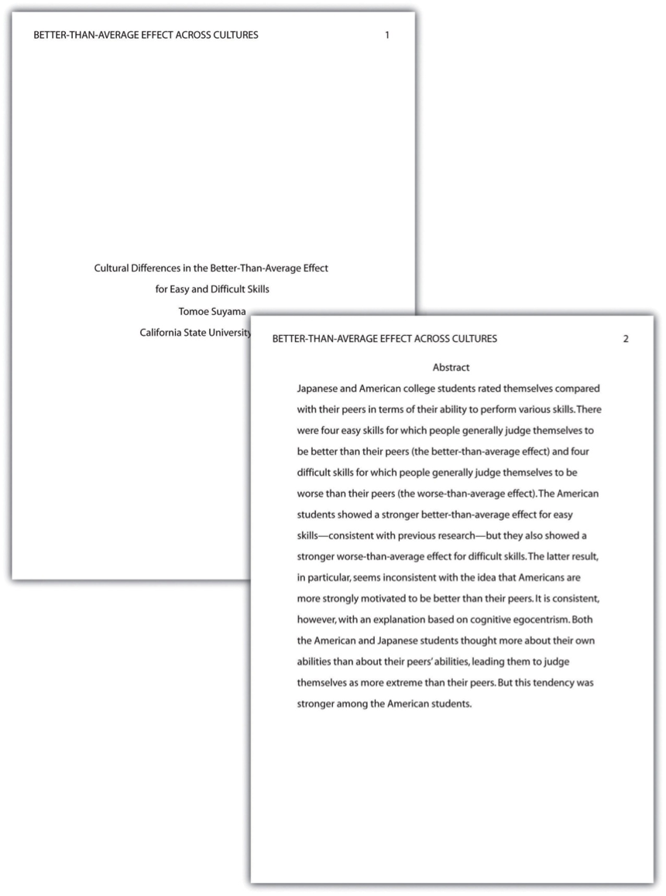
Figure 1: Title Page and Abstract. This student paper does not include the author note on the title page. The abstract appears on its own page.
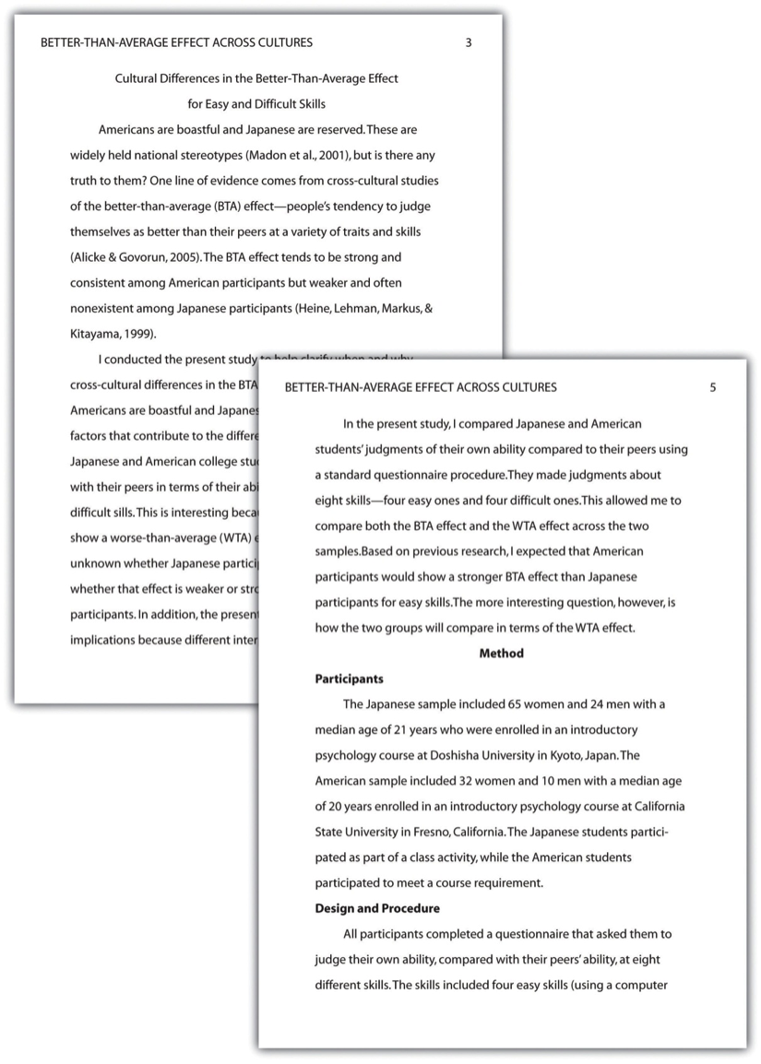
Figure 2: Introduction and Method. Note that the introduction is headed with the full title, and the method section begins immediately after the introduction ends.
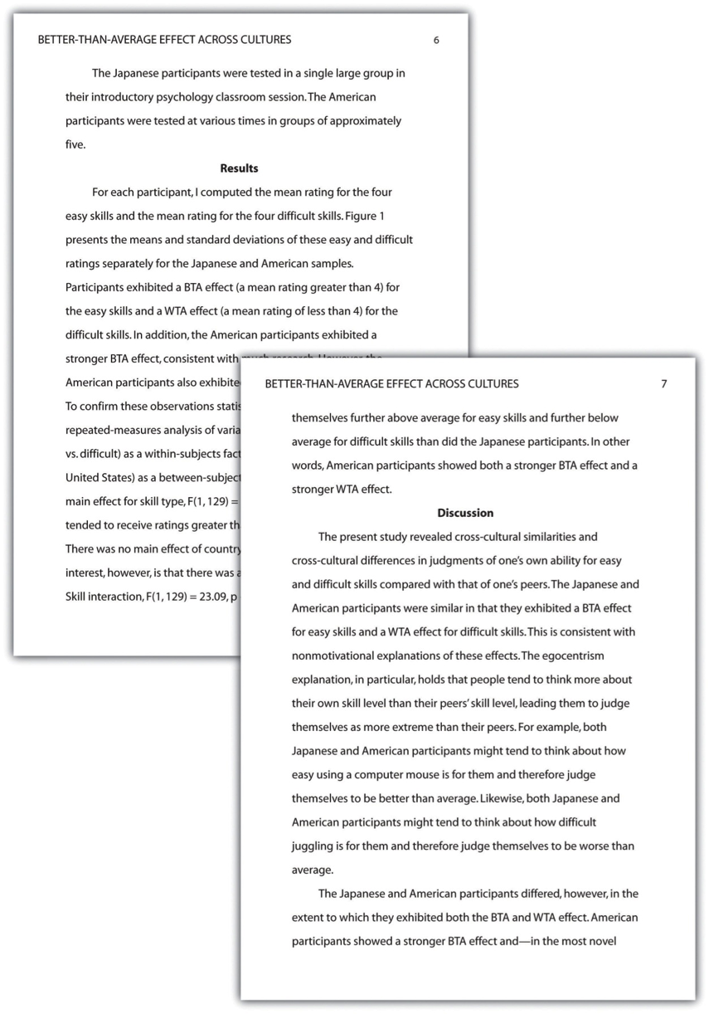
Figure 3: Results and Discussion The discussion begins immediately after the results section ends.
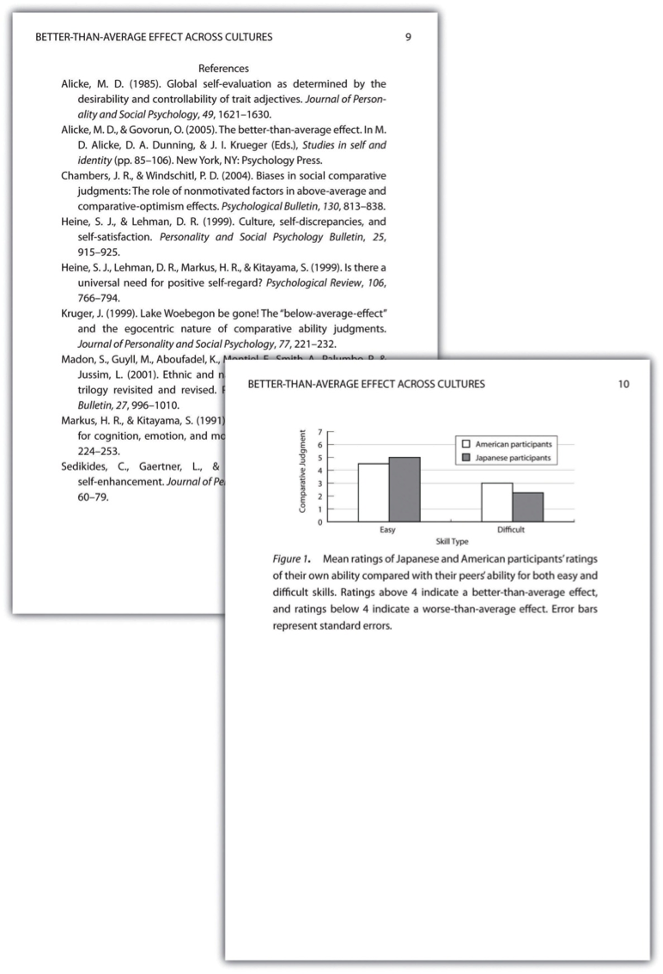
Figure 4: References and Figure. If there were appendices or tables, they would come before the figure.
Bem, Daryl. 1993. “Writing the Empirical Journal Article.” Unpublished manuscript.
Bentley, Madison, C. A. Peerenboom, F. W. Hodge, Edward B. Passano, H. C. Warren, and M. F. Washburn. 1929. “Instructions in Regard to Preparation of Manuscript.” Psychological Bulletin 26 (2): 57.
Madigan, Robert, Susan Johnson, and Patricia Linton. 1995. “The Language of Psychology: APA Style as Epistemology.” American Psychologist 50 (6): 428.
Onwuegbuzie, Anthony J., Julie P. Combs, John R. Slate, and Rebecca K. Frels. 2010. Evidence-Based Guidelines for Avoiding the Most Common APA Errors in Journal Article Submissions.

