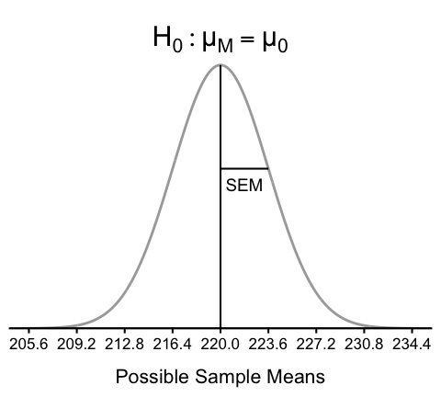
Figure 1: Distribution of Sample Means Under the Null Hypothesis
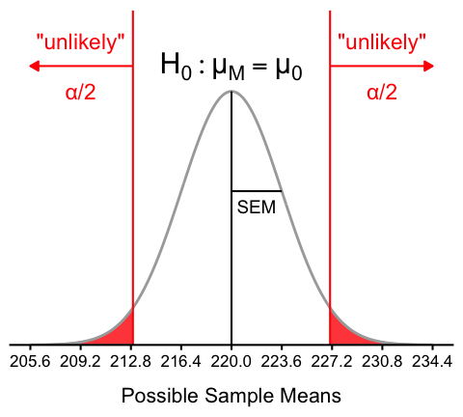
Figure 2: Two-Tailed Test. The sample means outside the cutoff values are unlikely under the null hypothesis. The area outside the cutoff values in both tails adds up to the significance level α (set to 0.05 in this example).
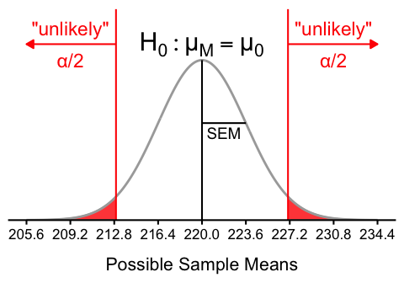
Figure 3: Two-Tailed Test. The sample means outside the cutoff values are unlikely under the null hypothesis. The area outside the cutoff values in both tails adds up to the significance level α (set to 0.05 in this example).
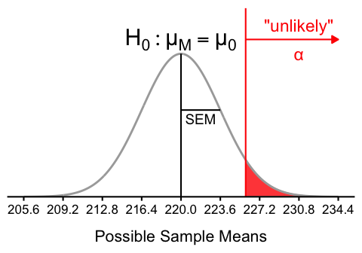
(a) $H_{1}:μ>μ_{0}$

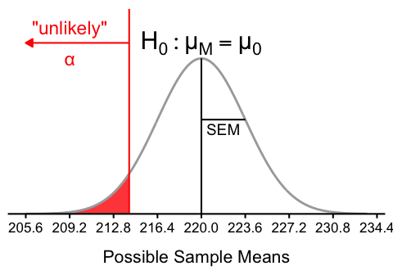
(b) $H_{1}:μ<μ_{0}$

Figure 4: One-Tailed Test. The sample mean is unlikely under the null hypothesis. The area outside the cutoff value is shaded in red.
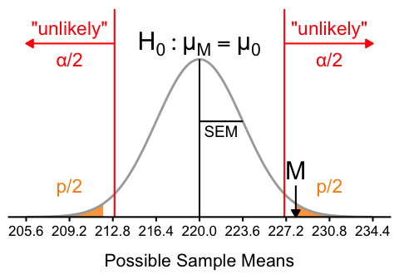
Figure 5: Two-Tailed Hypothesis Test. The sample mean M is outside of the cutoff values, and therefore unlikely under the null hypothesis. The p-value is the probability of observing a sample mean as extreme as M or more extreme if H0 is true. The shaded area in orange in both tails represents the p-value.
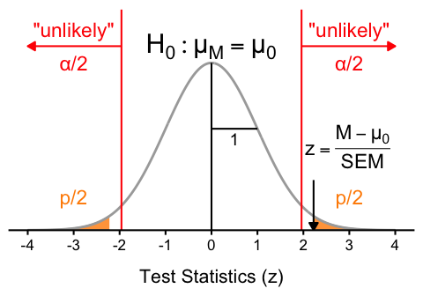
Figure 6: Two-Tailed Hypothesis Test Using Test Statistics (z). test statistic z is outside of the critical values for z, and therefore unlikely under the null hypothesis. The p-value is the probability of observing a test statistic as extreme as z or more extreme if H0 is true. The shaded area in orange in both tails represents the p-value.

