Dear Editor,
It is our honor to submit the paper entitled “A linear-complexity deep learning network with local-global attention for efficient state-of-health estimation of lithium-ion batteries using optimized multi-source health indicators” for consideration to be published in Energy.
Deep learning models are better at learning complex data patterns, but their computational resource demands are generally higher than those of traditional machine learning models, which limits their use in resource-limited battery management systems. The quality of health indicators is crucial for accurate SOH estimation. We focus on optimizing multi-source health indicators and reducing model size while improving estimation accuracy. In this paper, as illustrated in Fig. 1, a linear-complexity deep learning network, termed MS-AgentNet, is proposed. It integrates a local-global fusion attention module to capture both long-term and short-term dependencies while reducing computational complexity compared with traditional Softmax-based attention. Additionally, multi-scale depthwise separable convolutions are used to enhance feature diversity with fewer parameters than standard convolutions.
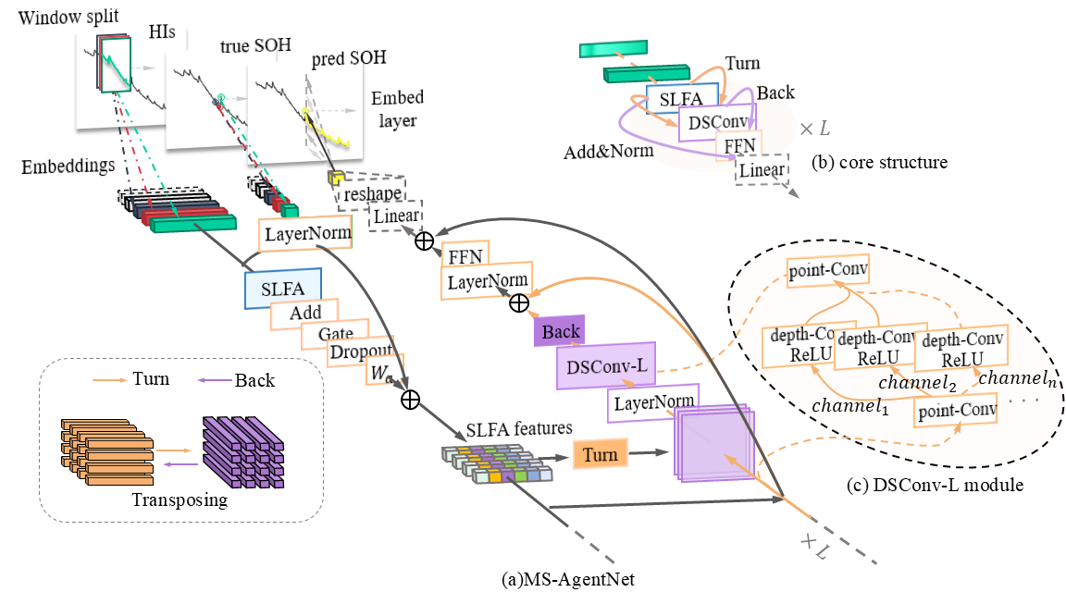
Fig. 1. Framework of MS-AgentNet. (a) MS-AgentNet, (b) core structure, (c) DSConv-L module
We appreciate your consideration of our manuscript for publication in Energy and look forward to your positive response. If you require any additional information or clarification, please do not hesitate to contact us.
Thank you for your time and consideration.
Sincerely,
On behalf of all the authors

Supplementary Note 1.
We have also prepared a figure illustrating the overall process of our SOH estimation approach. We hope this figure will be helpful to explain our approach.
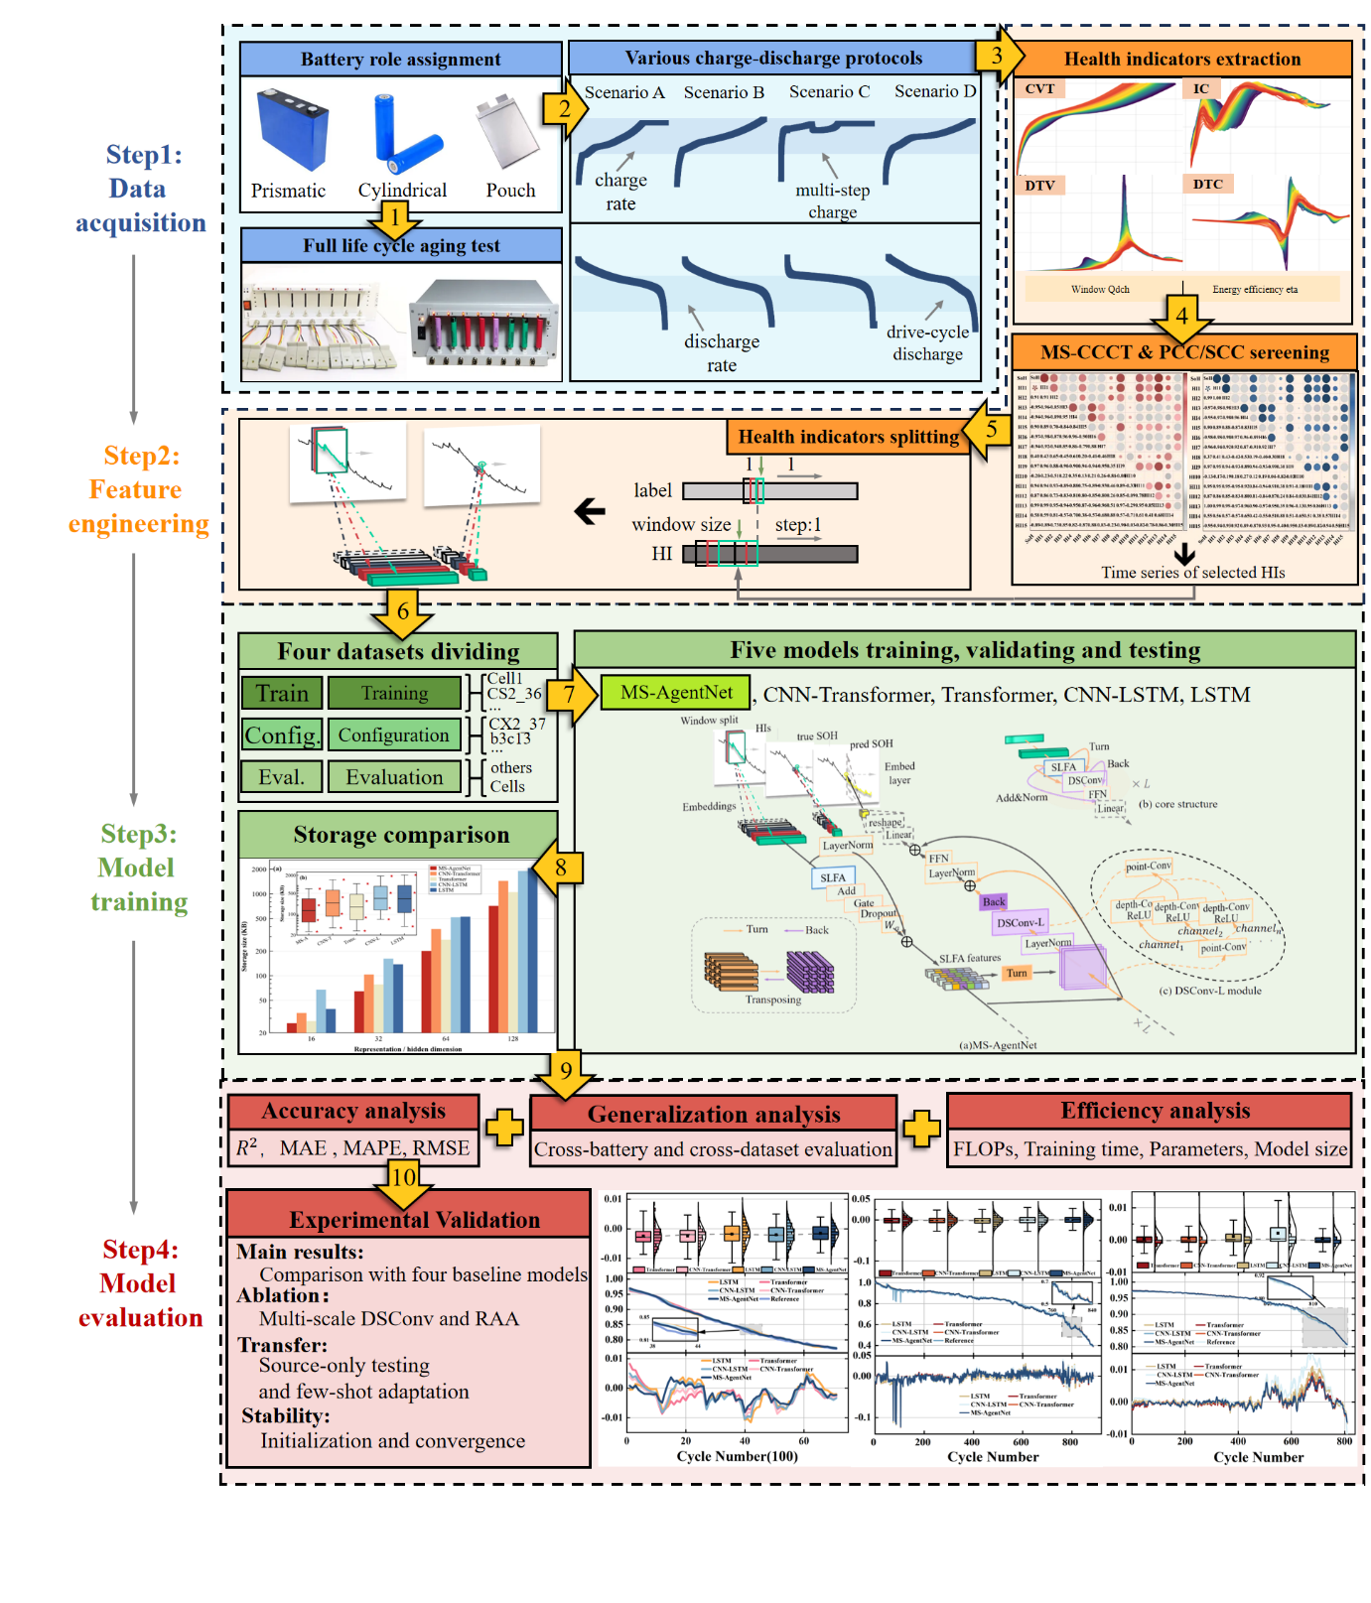
Fig 2. Flowchart of developed SOH estimation approach

