41518010056 – Yeppy Mangun Puspitajudin

**Review – Introduction to DBA**

1. What are entities, attributes, primary keys, what are symbols?

**Entities** are representation object, place, class, person or things in DBMS.

**Attributes** are the characteristic of the entity, the data to describe the entity.

**Primary keys** are the attributes that has unique value to identifies each row in a table (entity).

**Symbols** are a shape to create a diagram in DBMS. Entities use rectangle symbol, attributes use oval shape, etc.

1. What do you think is the relation and cardinality and how about the symbol?

**Cardinality** is the relation of data in the database, usually the relationships are 1 to 1, 1 to many, many to many.

1. Focus on Figure below! Then write down which ones include entities, attributes, primary keys, relations, and cardinalities! Use 5 different colors to match. Give Information

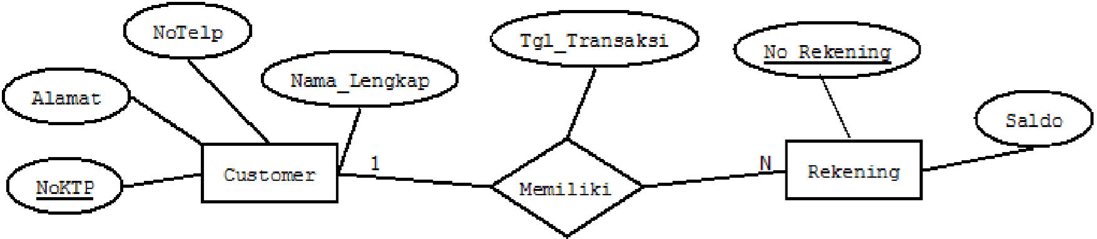



Red is the entity, there are 2 entities.

Green is the attributes, there are 4 attributes in Customer entity, and 2 attributes in Rekening entitiy, and 1 attributes in Memiliki relation.

Yellow is the primary key.

Blue is the relation between Customer and Rekening.

Purple is the cardinality between Customer and Rekening. 1 Customer may have(Memiliki) many Rekening.

1. Investigate the Figure in number 3! Convert it into a relationship scheme!

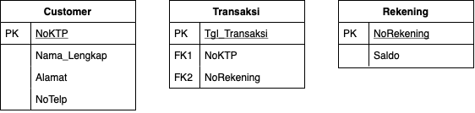

1. Convert the relation scheme to a relationship diagram! Observe the results of your relationship diagram?

