**IT Governance at Hospital Based on COBIT 5 Framework**

Information Technology (IT) Governance in Hospitals describe how to create an IT governance process that increases the number of IT projects that support the strategy of a hospital and are completed on-time and on- budget. Good IT governance aligns decisions about the use of IT with desired behaviours and organizational objectives. The existence of good IT governance at Hospitals is expected to provide improvement on quality, functionality, and ease of use of the service.

1. **Introduction**

The success of implementing effective governance in an organization associated with the right pattern or fit for the organization so that they can be a complement or supplement of organization's strategic focus. Information technology (IT) governance is not a static concept but rather processes inherent in the organization.

The development of information technology (IT) will certainly affect how hospital management in building better governance in a transparent, structured and accountable so it can increase profitability and enablement resources optimally.

The existence of the IT governance at both Hospitals are expected to:

1. Provide improved on quality, functionality, and ease of use of the service;
2. Speed up the process; and
3. On an ongoing basis can improve the level of service against all expectations through the fulfilment of the relatively low cost of realization and efficient use of resources.

COBIT 5 frameworks can be used by an organization in implementing IT governance to support the achievement of the objectives. By selecting the processes by the aims of the Organization, the frameworks COBIT 5 provides a guide how should those processes are planned, build, run, and evaluated.

1. **Research Methodology**

Our research follows the Design Science Research Methodology (DSRM).

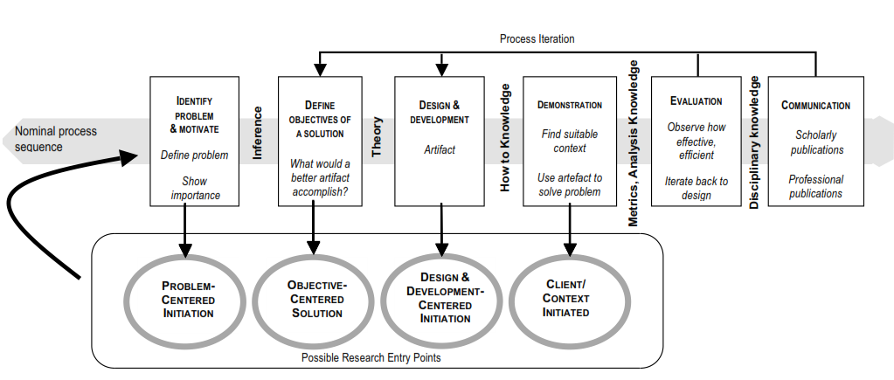

1. **Problem Definitions**The problem that focuses in this paper is how to give a guide for Hospital for implementing IT Governance.
2. **Defining Solution**The solution is defining with a literature review related to papers or research related IT governance in Hospital. Solutions build the solution are developed based on the author's experiences while working on projects related to IT governance.
3. **Design and Model Development Demonstrations**  
   Design and model IT Governance for the hospital is development base on COBIT 5 framework. In this step, describe how IT governance implemented in Hospital.
4. **Related Work**

Strong leadership becomes a success factor of IT governance in the organization. In addition, another important factor is the organizational ability to manage change. Good IT governance must be able to align IT usage decisions with desired organizational behaviour and objectives. Related Governance, top level management must make decisions about the transparency of IT such as standardization versus innovation.

Currently, IT Governance in Hospitals and Health Systems is a must. Good IT governance will support the number of IT projects that support the strategy and can clarify time and budget. Without a governance structure, IT in many hospitals and health systems are useless, the budget IT is not consistent with the results obtained and in the end many different systems that are not functioning properly.

1. **The Important of IT Governance For Organization**

A control framework for IT governance defines the reasons IT governance is needed, the stakeholders and what it needs to accomplish. IT Governance is essential for the organization because:

1. Management expects a heightened understanding of the way IT is operated and the likelihood of its being leveraged successfully for competitive advantage.
2. Successful enterprises understand the risks and exploit the benefits of IT and find ways to deal with aligning IT strategy with the business strategy, Cascading IT strategy and goals down into the enterprise, and Measuring IT performance.
3. The organization cannot deliver effectively against these business and governance requirements without adopting and implementing a governance and control framework for IT to define the management control objectives to be considered.
4. Governance and control frameworks are becoming a part of IT management good practice and are an enabler for establishing IT governance and complying with continually increasing regulatory requirements.
5. Business managers and boards demanding a better return on IT investments, i.e., that IT delivers what the business needs to enhance stakeholder value
6. **Proposed IT Governance at Hospital Base on COBIT 5 Framework**

Under the laws of the Republic of Indonesia Number 44 In 2009 About Hospital, the goals of the establishment of the hospital are:

1. Organization of health services treatment and recovery by service standards the hospital;
2. Maintenance and upgrading individual health through plenary health services second and third level corresponding medical needs;
3. Organization of the education and training of human resources to increase skills in administering health services; and
4. Organization of research and development, as well as filtering technology in the health field order, increased health services with attention to ethics in science fields health.

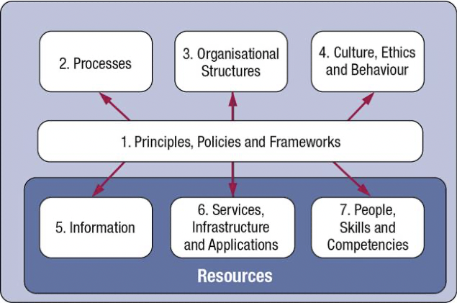

The COBIT 5 framework is described seven categories of enablers.

1. Principles, policies, and frameworks are the vehicles to translate the desired behaviour into practical guidance for day-to-day management at Hospital.

2. Processes describe a Hospital set of practices and activities to achieve the objectives and produce a set of outputs to support and achieving overall IT- related goals.

3. Organizational structures are the key decision-making entities in a Hospital.

1. Culture, ethics, and behaviour of individuals and the hospital as a success factor in governance and management activities.
2. Information is pervasive throughout any organization and includes all information produced and used by the hospital. Information is required for keeping the organization running and well governed, but at the operational level, information is very often the key product of the hospital itself.
3. Services, infrastructure, and applications include the infrastructure, technology, and applications that provide the hospital with information technology processing and services.
4. People, skills, and competencies are linked to people and are required for successful completion of all activities and for making correct decisions and taking corrective actions in a hospital.

Some IT process in COBIT 5 Process Reference Model is relevant and can be used in implementing IT governance in Hospital are as follows:

1. Align, Plan and Organize

* APO01 Manage the IT Management Framework
* APO02 Manage Strategy
* APO03 Manage Enterprise Architecture
* APO06 Manage Budget and Costs
* APO07 Manage Human Resources
* APO09 Manage Service Agreements

1. Build, Acquire and Implement

* BAI02 Manage Requirements Definition
* BAI03 Manage Solutions Identification and Build
* BAI09 Manage Assets

1. Deliver, Service, and Support

* DSS01 Manage Operations
* DSS02 Manage Service Requests and Incidents
* DSS03 Manage Problems
* DSS06 Manage Business Process Controls

4. Monitor,

* MEA01 Monitor, Evaluate and Assess Performance and Conformance
* MEA02 Monitor, Evaluate and Assess the System for Internal Control

1. **Conclusion**

The existence of good IT governance at Hospitals is expected to Provide improved on quality, functionality, and ease of use of the service. Enablers in COBIT 5 framework can be applied in practical situations and can be used to implement effective and efficient information governance and data management of IT governance for Hospital. The results contribute to give a model of IT governance for a hospital that can be used by hospitals in performing the optimization of IT services to achieve the normal vision and mission.