<https://github.com/yerabimzatov/EPAM_task>

*An AWS EC2 Ubuntu Instance was used to perform this tasks.*

**TASK1.**

1. 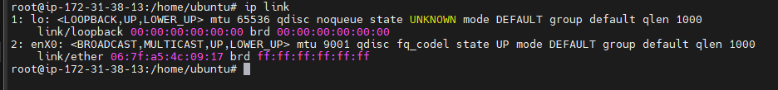
2. 
3. 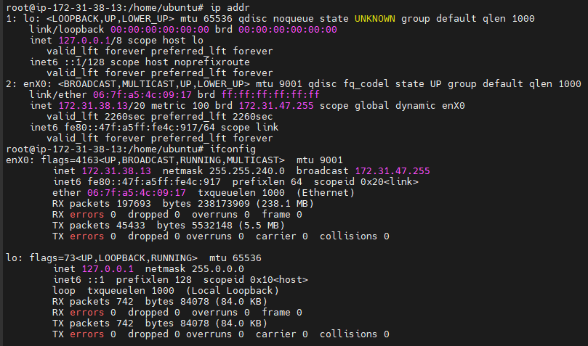
4. 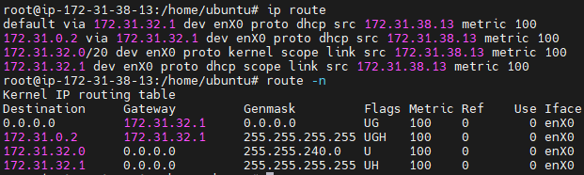
5. 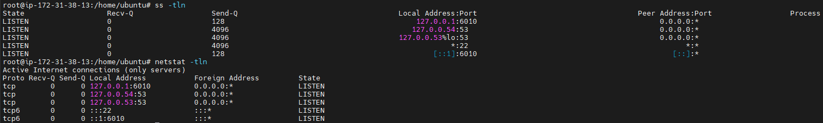

**TASK 2.**

1. 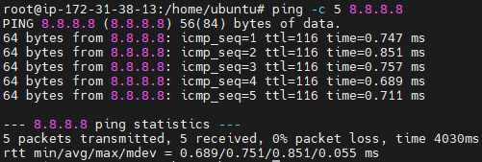
2. 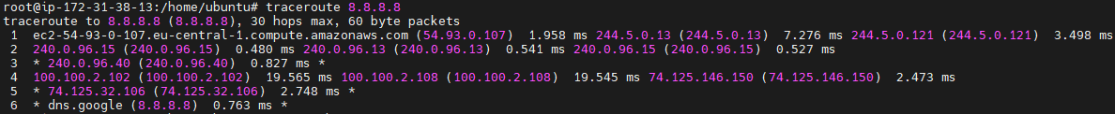

**TASK 3.**

1. The netmask is a 32-bit number where:

* The first 26 bits are 1 (network portion).
* The remaining 6 bits are 0 (host portion).

11111111.11111111.11111111.11000000

(11111111)₂ = (1 × 2⁷) + (1 × 2⁶) + (1 × 2⁵) + (1 × 2⁴) + (1 × 2³) + (1 × 2²) + (1 × 2¹) + (1 × 2⁰) = (255)10

(11111111)₂ = (1 × 2⁷) + (1 × 2⁶) + (1 × 2⁵) + (1 × 2⁴) + (1 × 2³) + (1 × 2²) + (1 × 2¹) + (1 × 2⁰) = (255)10

(11111111)₂ = (1 × 2⁷) + (1 × 2⁶) + (1 × 2⁵) + (1 × 2⁴) + (1 × 2³) + (1 × 2²) + (1 × 2¹) + (1 × 2⁰) = (255)10

(11000000)₂ = (1 × 2⁷) + (1 × 2⁶) + (0 × 2⁵) + (0 × 2⁴) + (0 × 2³) + (0 × 2²) + (0 × 2¹) + (0 × 2⁰) = (192)10

The netmask is - **255.255.255.192**

1. The network address is obtained by **bitwise ANDing** the IP address and the netmask.

11000000.10101000.00000000.00000000 (IP address)

AND

11111111.11111111.11111111.11000000 (Netmask)

=

11000000.10101000.00000000.00000000

in decimal - **192.168.0.0**

1. The broadcast address is obtained by bitwise ORing the IP address with the inverted netmask (host bits set to 1).

11000000.10101000.00000000.00000000 (IP address)

OR

00000000.00000000.00000000.00111111 (Inverted netmask)

=

11000000.10101000.00000000.00111111

in decimal - **192.168.0.63**

1. The number of hosts = 2host bits – 2 = 26 – 2 = **62**

**TASK 4.**

Defined the enX0 interface by ‘ifconfig’.

ARP:

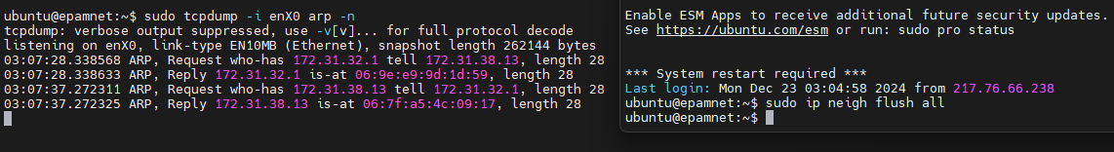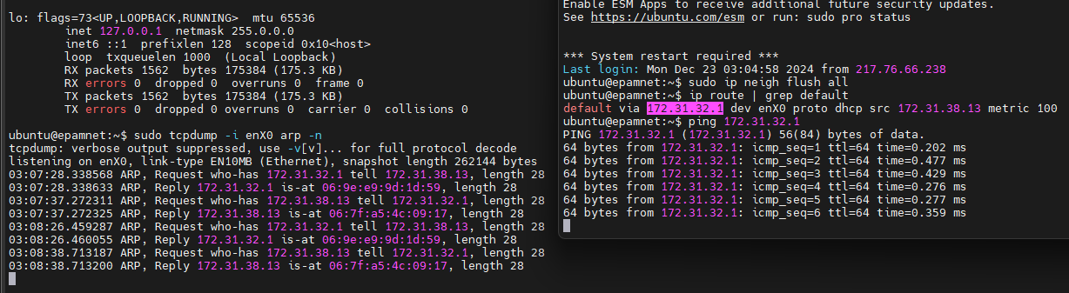

ICMP:

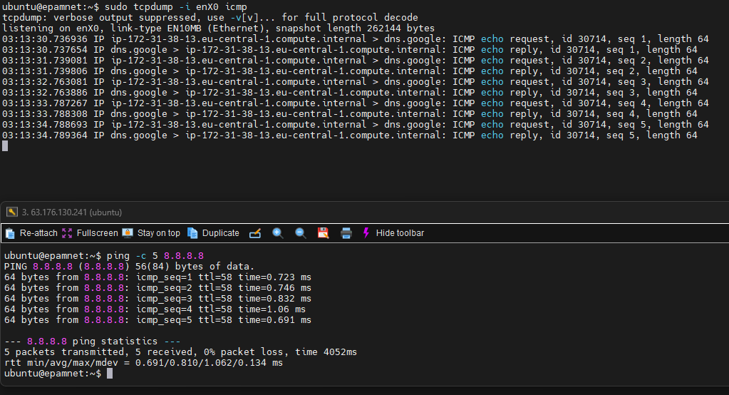

TCP, HTTP:

