<https://github.com/yerabimzatov/EPAM_task>

**Task 1:**

1. 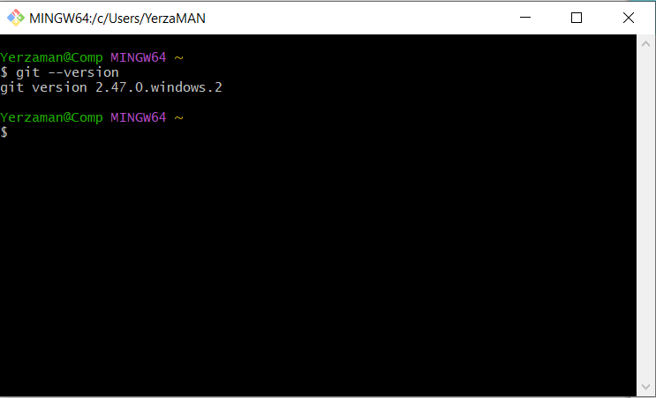
2. I had to change the core.editor to nano since I’m using Windows and mvim is for Mac.
3. 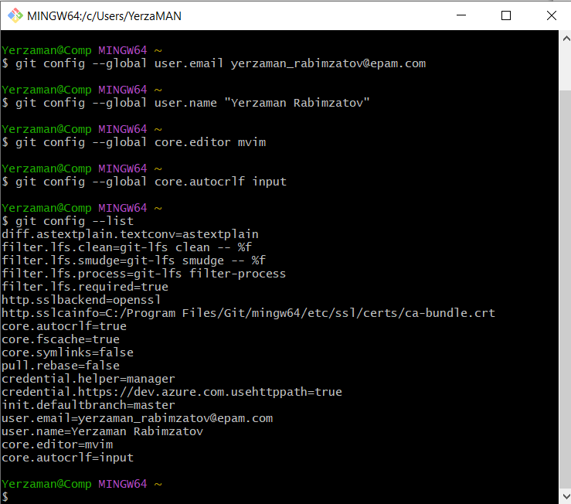
4. 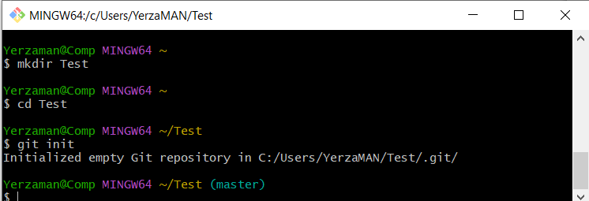
5. 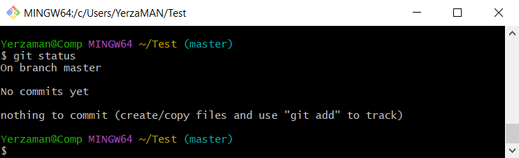
6. 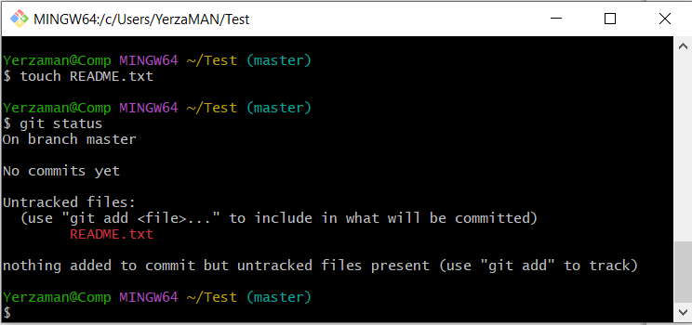
7. 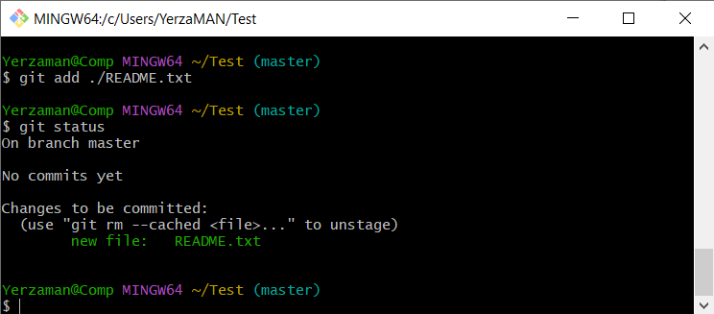
8. 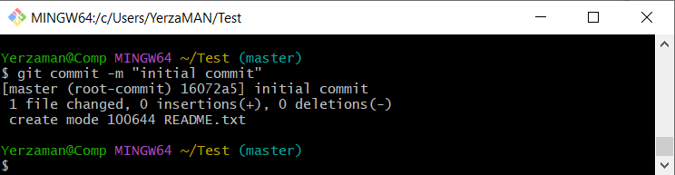
9. Yes, the first output indicates an empty repository with no commits yet. The second one indicates an existing repository with commits, and the working directory is clean (nothing to commit).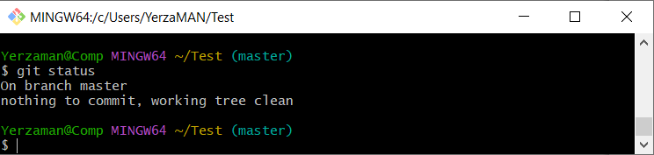
10. In the fifth step: README.txt is untracked, and the repository has no commits. This is a brand-new file in a new repository. In this step, a tracked file has been modified but the changes are not yet staged.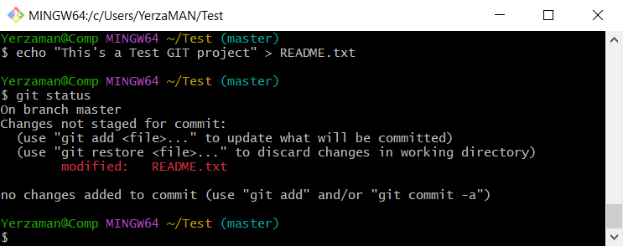
11. 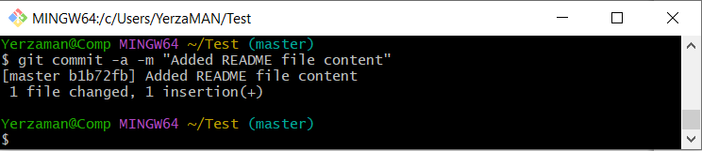
12. 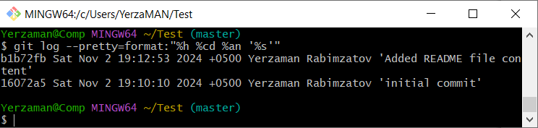
13. The commit IDs, time, message and actions differ. The second commit (16072a55aa9804d17f50ea92faba9c07c1743824) created the empty README.txt file with message “initial commit”. The first commit (b1b72fb4e29ab3f714530e6cbf7fc6625328b844) Added content "This's a Test GIT project" to README.txt file with message “Added README file content”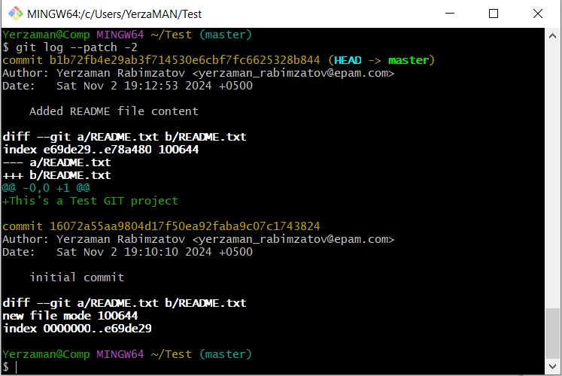

**Task 2:**

1. 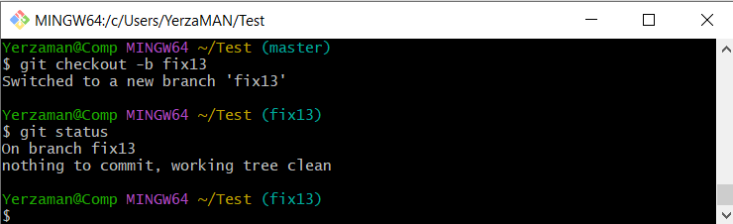
2. It seems like in the task fix13.txt file was created with a command like ‘echo "It's Fix 13 branch"> fix14.txt, since there is 1 insertion in the output and the size of the file is 19B according to the following ls outputs. But in mine there is no insertions, bc it’s empty.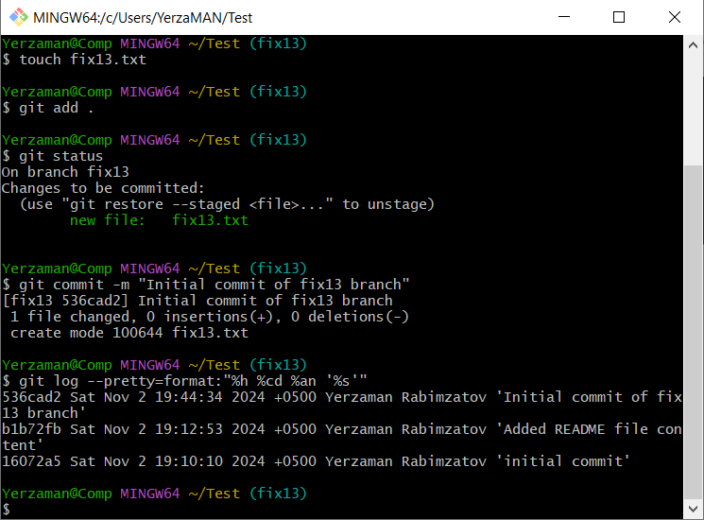
3. 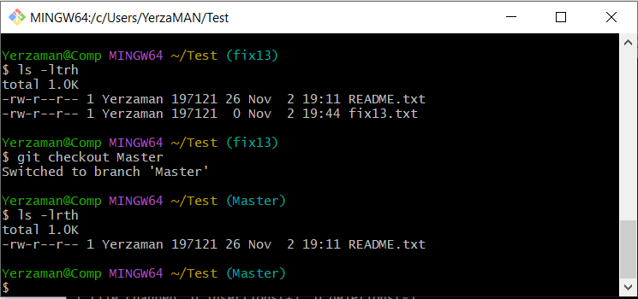
4. 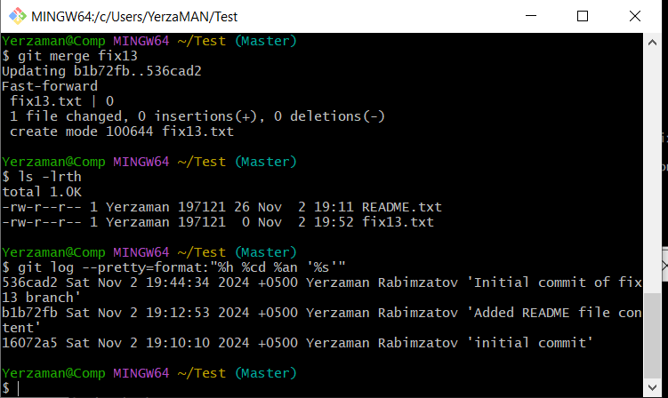
5. 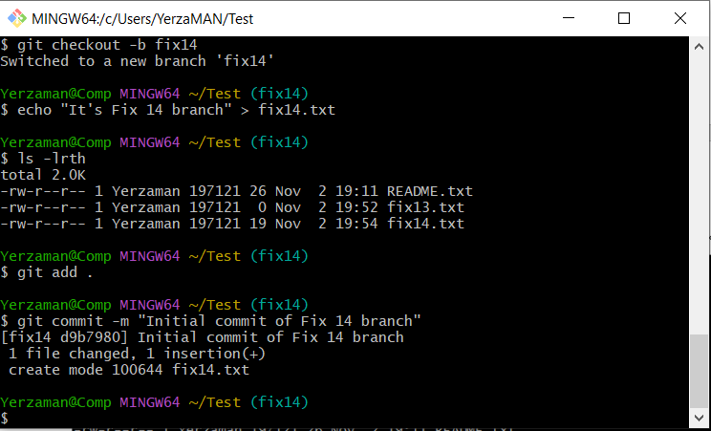
6. 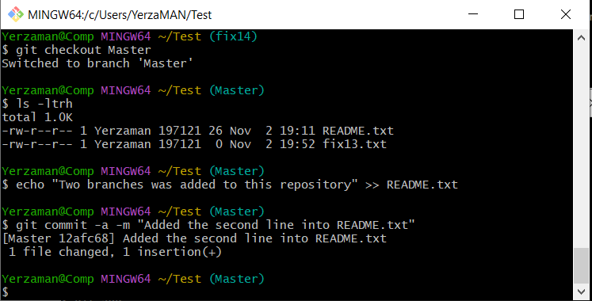
7. 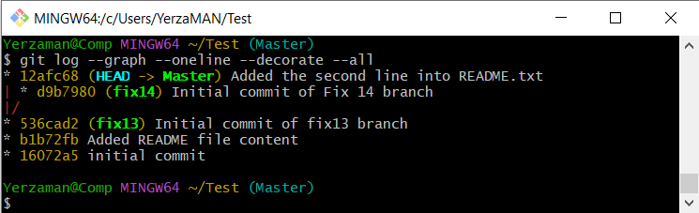
8. The difference is that my version of Git is 2.47.0, and there’s **ORT (Ostensibly Recursive Two-way)** that was introduced in Git 2.34.0 as an alternative to the traditional recursive merge strategy.  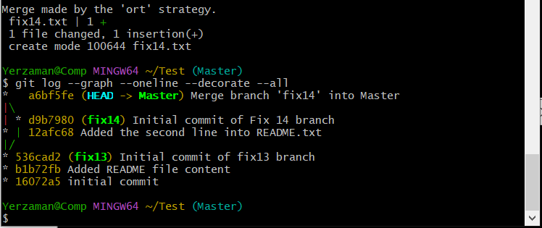
9. 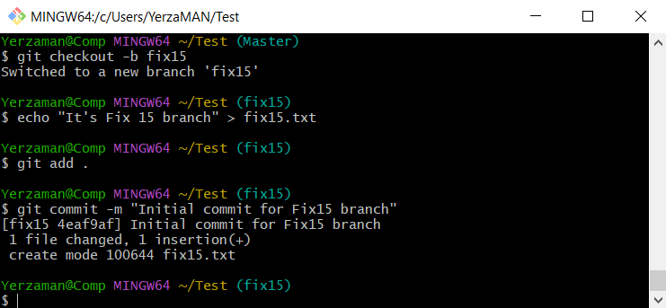
10. 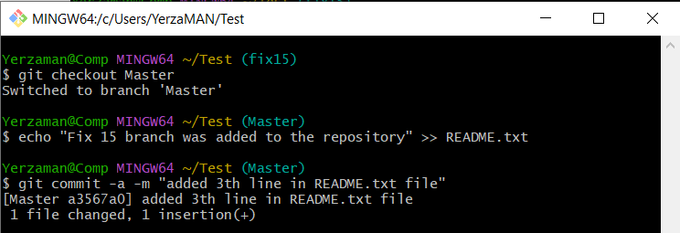
11. 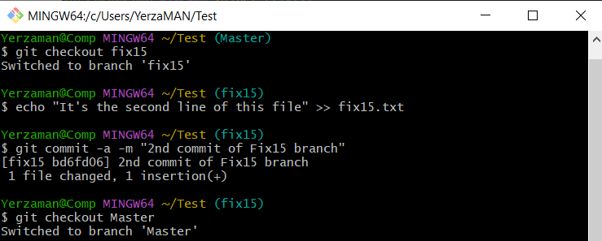
12. 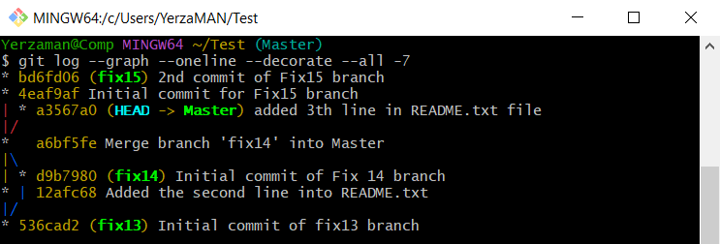
13. 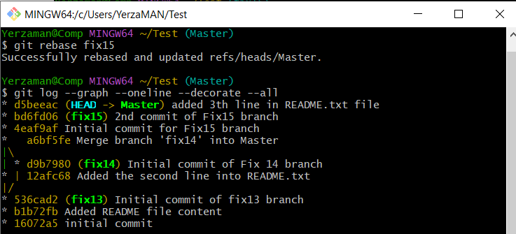
14. 