PART 1
Task 1.1
Relation A:
- {EmpID},{SSN} , {Email}, {Phone}, {EmpID, SSN},{EmpID, Phone}
- {EmplD} , {Email},{SSN}
- I would choose EmpID as the primary key because it is the most universal and unique identifier for an employee, which is unlikely to change, unlike other attributes (for example, email may change
- In the given data, phone numbers are unique for each employee. However, theoretically, if there were an employee in the database with the same phone number, it could indicate a data error. In a real situation, phone numbers would most likely need to be unique for each employee, but this is not guaranteed in the current table
Relation B:
- PK = (StudentID, CourseCode, Section, Semester, Year)
- StudentID — identifies which student is registered.
CourseCode — identifies the course (sections repeat across courses).
Section — identifies the specific section. A student can register for different sections of the same course in one semester, so it is required.
Semester — distinguishes between Fall, Spring, etc. for the same student and course.
Year — distinguishes between semesters across different years (e.g., Fall 2024 vs. Fall 2025)
3. There are no additional candidate keys. The primary key (StudentID, CourseCode, Section, Semester, Year) is the only valid and minimal key
Task 1.2
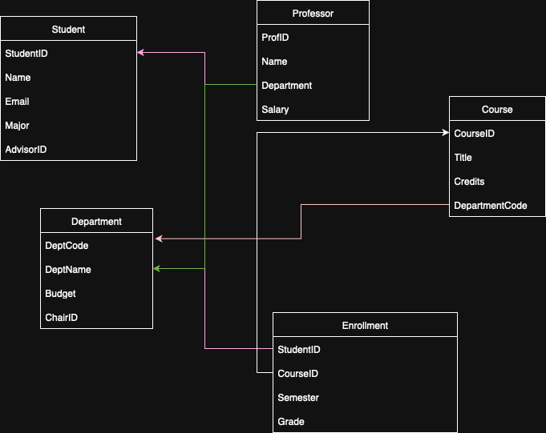

Part 2
Task 2.1
1.
Strong entities:
Patient.PatientID,Doctor.DoctorID,Department.DeptCode,Room.RoomNumber
Weak entities: Appointment.PatientID, Appointment.DoctorID, Prescription.PatientID, Prescription.DoctorID
2. 1. Patient
PatientID: Simple (single value, unique identifier)
Name: Simple (single value)
Birthdate: Simple (single value)
Address: Composite (can be broken down into Street, City, State, Zip).
Phone Numbers: Multi-valued (a patient can have multiple phone numbers).
Insurance Information: Composite (could include multiple attributes like insurance provider, policy number, etc.)
2. Doctor
DoctorID: Simple (single value, unique identifier)
Name: Simple (single value)
Specializations: Multi-valued (a doctor can have multiple specializations)
Phone Numbers: Multi-valued (a doctor can have multiple phone numbers)
Office Location: Simple (single value)
3. Department
DeptCode: Simple (single value, unique identifier)
DeptName: Simple (single value)
Budget: Simple (single value, monetary amount)
ChairID: Simple (single value, references DoctorID)
4. Appointment
AppointmentID: Simple (single value, unique identifier)
PatientID: Simple (single value, references PatientID)
DoctorID: Simple (single value, references DoctorID)
DateTime: Simple (single value, timestamp)
Purpose: Simple (single value, text)
Notes: Simple (single value, text, may be optional)
5. Prescription
PrescriptionID: Simple (single value, unique identifier)
PatientID: Simple (single value, references PatientID)
DoctorID: Simple (single value, references DoctorID)
Medication: Simple (single value, name of medication)
Dosage: Simple (single value, can be numeric, e.g., 50mg)
Instructions: Simple (single value, text)
6. Room
RoomID: Simple (single value, unique identifier)
DeptCode: Simple (single value, references DeptCode)
RoomNumber: Simple (single value, numeric or alphanumeric identifier)
Location: Simple (single value, room location within the department)
3.
Patient to Appointment (1:N) One patient can have multiple appointments with different doctors or at different times.
Doctor to Appointment (1:N) One doctor can see multiple patients at different times.
Patient to Prescription (1:N) A patient can receive multiple prescriptions from different doctors over time.
Doctor to Prescription (1:N) A doctor can prescribe multiple medications to different patients.
Department to Room (1:N) Each department (e.g., Cardiology, Neurology) can have multiple rooms.
Department to Doctor (1:N) One department (e.g., Cardiology, Neurology) can have multiple doctors working in it

4,5.
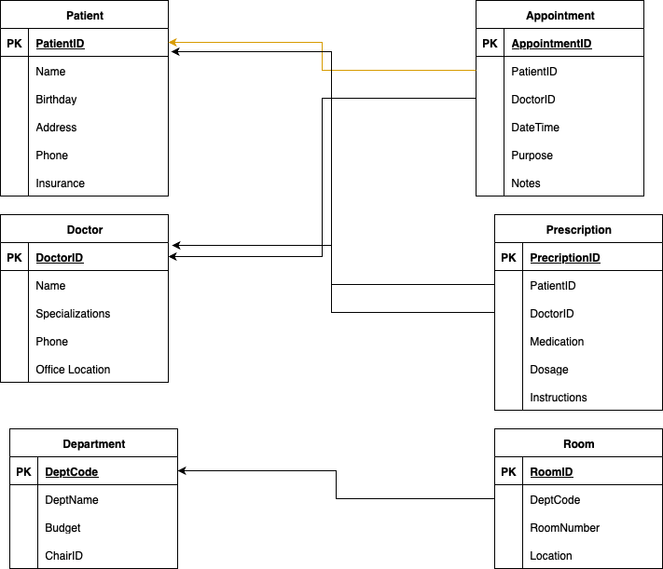

Task 2.2
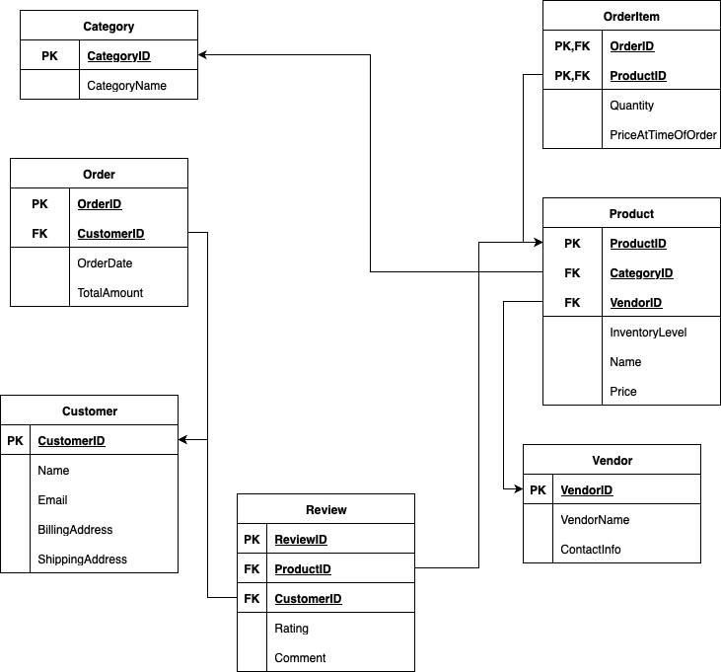

2.order_items is weak entity, because this entity can not exist without another entities
3. Customers can review multiple Products, and each Product can have multiple Customers reviewing it.
This relationship is many-to-many because:
A single customer can write multiple reviews for different products.
A single product can have reviews from multiple customers.

Task 4.1
1.
StudentID -> StudentName, StudentMajor
ProjectID -> ProjectTitle, ProjectType
SupervisorID -> SupervisorName, SupervisorDept
StudentID, ProjectID -> Role, HoursWorked, StartDate, EndDate
StudentID, ProjectID -> SupervisorID, SupervisorName, SupervisorDept
2.
- If a student participates in multiple projects, their information like name and major will be repeated for each project.
3.
The StudentProject table is already in 1NF. There are no violations, and no changes are needed for this normal form.
4.
The `StudentProject` table is decomposed into 4 smaller tables in 2NF, which removes partial dependencies and ensures that each non-prime attribute depends on the full composite primary key.
Task 4.2
1.
primary key is combination of attributes such as CourseID, InstructorID, TimeSlot
2.
CourseID -> CourseName
InstructorID -> InstructorName
Room -> Building
CourseID, InstructorID, TimeSlot, Room -> StudentID
StudentID, CourseID, TimeSlot, Room -> StudentMajor
3.
Not BCNF
4.
Courses Table:
course_id, course_name
Instructors Table:
instructor_id, instructor_name
Rooms Table:
room_id, room_number, building
StudentEnrollments Table:
student_id, course_id, time_slot, room_id, student_major
CourseSchedule Table:
course_id, instructor_id, time_slot, room_id

5.
It lose its convenience in use
Task 5.1
1.

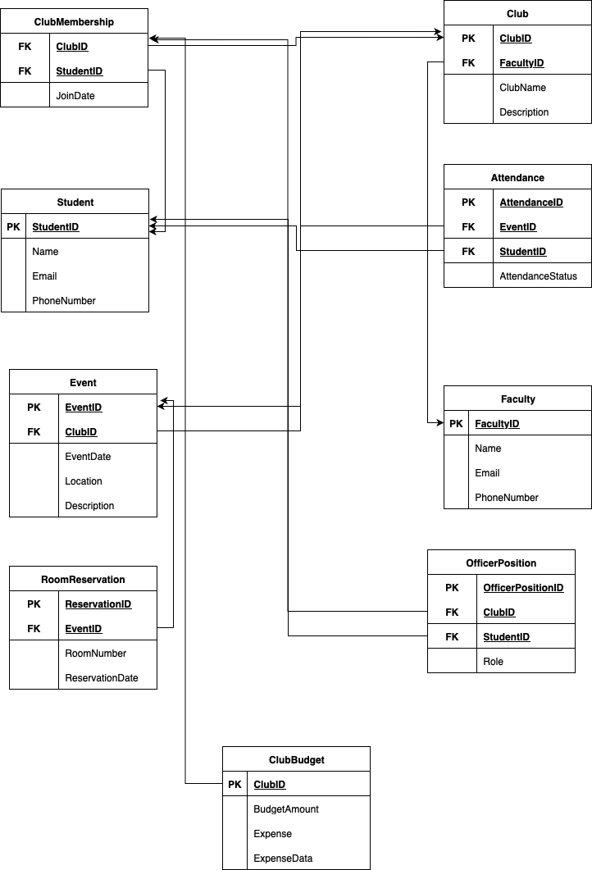

3.
I chose the many-to-many relationship table because it aligns better with normalization principles and offers more flexibility for future requirements

