ROBOT-MOPPING FLOOR
Tashtenov Daulet,Turkebay Madina, Kulseitov Yerassel
School of IT and Engineering, Kazakh-British Technical University, Almaty, Kazakhstan
d_tashtenov@kbtu.kz m_turkebay@kbtu.kz y_kulseitov@kbtu.kz
Abstract— This report presents the design and implementation of a Robot-Mopping Floor system developed to automate wet floor cleaning in a compact indoor area. The main objective of the project is to combine programmed coverage motion, water spraying, active wiping, and obstacle avoidance in one low-cost mobile robotic platform. The robot uses an ESP32 microcontroller as the central control unit, four DC motors for locomotion, an L298N motor driver for movement control, an HC-SR04 ultrasonic sensor mounted on a servo motor for environment scanning, a water pump for spraying liquid, and a rotating sponge mechanism driven by a separate DC motor to wipe the floor. The cleaning strategy is based on a predefined zigzag trajectory that allows the robot to repeatedly move through adjacent rows while spraying water and wiping it from the surface. When an obstacle is detected, the robot interrupts the planned motion, scans available directions, performs an avoidance maneuver, and then attempts to resume the intended cleaning path. Experimental observations showed that the robot was able to follow the zigzag route, operate the cleaning mechanism during motion, detect obstacles using the ultrasonic sensor, and cover a demonstration area of approximately 50 × 50 cm. Open-space distance readings were obtained up to approximately 400 cm, while shorter decision thresholds were used for practical obstacle avoidance. The prototype demonstrates the feasibility of a simple autonomous mopping robot and provides a foundation for future improvements in localization, route correction, water control, and cleaning accuracy.
Keywords— ESP32, floor cleaning robot, zigzag path, obstacle avoidance, ultrasonic sensor, water pump, rotating sponge, L298N motor driver.

I. INTRODUCTION
Household and service robotics increasingly focus on automating repetitive physical tasks. Floor cleaning is one of the most common examples because it requires repeated coverage of a surface, stable movement, and interaction with dust, water, and obstacles. A robot that can spray water and wipe the floor while moving along a defined route can reduce manual effort and demonstrate important principles of embedded control, mobile robotics, and electromechanical integration.
The Robot-Mopping Floor project was developed as a compact autonomous cleaning prototype. Unlike a simple remote-controlled vehicle, the robot is designed to execute a planned cleaning routine. Its target behavior is to move along a zigzag trajectory, apply water through a pump, and wipe the surface using a rotating sponge attached to a dedicated DC motor. This movement pattern is selected because it provides a straightforward way to cover a rectangular region row by row.
A practical floor-cleaning robot must also react to obstacles. For this purpose, the robot uses an HC-SR04 ultrasonic sensor installed on a servo motor. The distance sensor checks the front area, and the servo allows the robot to compare the free space on different sides when an obstruction is encountered. Based on the measured distances, the controller selects an avoidance direction and then continues the cleaning procedure.
The project contributes a low-cost implementation of wet-cleaning functionality using widely available components. Its main design idea is the integration of four subsystems into one prototype: mobile movement, route-based coverage, water spraying, and active wiping. The system is intended for educational demonstration and serves as a foundation for more advanced autonomous cleaning designs.

II. RELATED WORKS

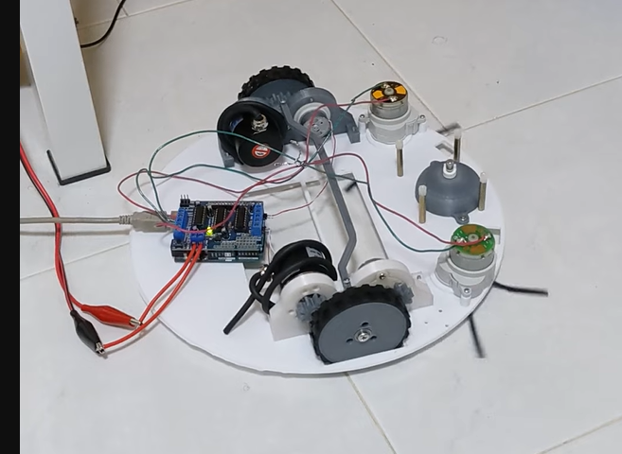
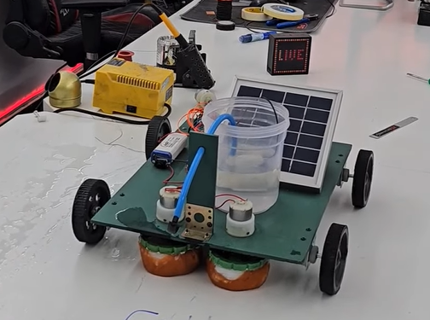

Autonomous floor-cleaning robots are commonly developed around three essential functions: surface coverage, obstacle awareness, and a physical cleaning mechanism. Recent studies and prototypes describe mobile cleaners that combine water delivery with mopping pads or rotating cleaning parts, showing that wet cleaning can be integrated into compact robotic platforms. In comparison with such systems, the present project focuses on a simplified educational design using an ESP32, a rotating sponge, and a water pump controlled as part of the cleaning cycle.
Coverage planning is especially important for cleaning robots because random motion may leave portions of a floor untouched. A zigzag or back-and-forth strategy is frequently used in basic area coverage tasks due to its simplicity and predictable behavior in rectangular spaces. In this project, the zigzag route was selected as the main cleaning trajectory to demonstrate systematic surface coverage without requiring complex mapping or localization.

III. METHODOLOGY
This section describes the overall architecture of the Robot-Mopping Floor system, including its hardware configuration, software logic, and the cleaning algorithm used during operation. The project is divided into locomotion, sensing, cleaning, water delivery, and route control subsystems.

A. Hardware architecture of this project
The robot is built as a four-wheel mobile cleaning platform. Four DC motors provide movement, while an additional DC motor rotates a sponge that is physically attached to the robot body and kept in contact with the floor surface. A small water pump supplies water during motion so that the floor can be moistened before or during wiping. The ESP32 operates as the central control unit and sends signals to the motor driver, servo, water pump control circuit, and cleaning mechanism.
No. | Component | Specifications / Role | Remarks
1 | ESP32 microcontroller | Main control unit; reads sensors and executes motion logic | Coordinates movement, cleaning, and obstacle avoidance
2 | L298N motor driver | Dual H-bridge driver used for drive motor control | Controls the four DC locomotion motors through grouped channels
3 | Four DC motors | Drive system for forward/backward motion and turning | Provide the robot's mobile platform
4 | HC-SR04 ultrasonic sensor | Distance measurement module; open-space readings observed up to ~400 cm | Used for front obstacle detection
5 | Servo motor | Rotates the ultrasonic sensor for left-center-right scanning | Powered separately from the main control block
6 | Water pump | Pumps water for wet cleaning | Powered by a dedicated 5 V source
7 | Rotating sponge DC motor | Spins the attached sponge to wipe the floor | Powered by a dedicated 5 V source
8 | Power source A | 7.2 V block | Supplies ESP32, HC-SR04, and L298N subsystem
9 | Power source B | 7.2 V block | Supplies the servo motor separately
10 | Power source C | 5 V block | Supplies the water pump and rotating sponge motor

The power architecture is separated into three supply blocks. The ESP32, HC-SR04 ultrasonic sensor, and L298N locomotion subsystem are powered from a 7.2 V block. The servo motor receives power from a separate 7.2 V block in order to reduce interference with the controller and drive circuit. The water pump and the sponge motor are powered from an independent 5 V source because they belong to the cleaning subsystem and may produce electrical noise or load changes during operation.
The rotating sponge is the main wiping element of the system. Instead of simply dragging a passive cloth, the robot uses a DC motor to generate continuous circular wiping motion. The water pump supports wet cleaning by delivering water to the working area, and the moving robot distributes the wiping action across the predefined route.

B. Software architecture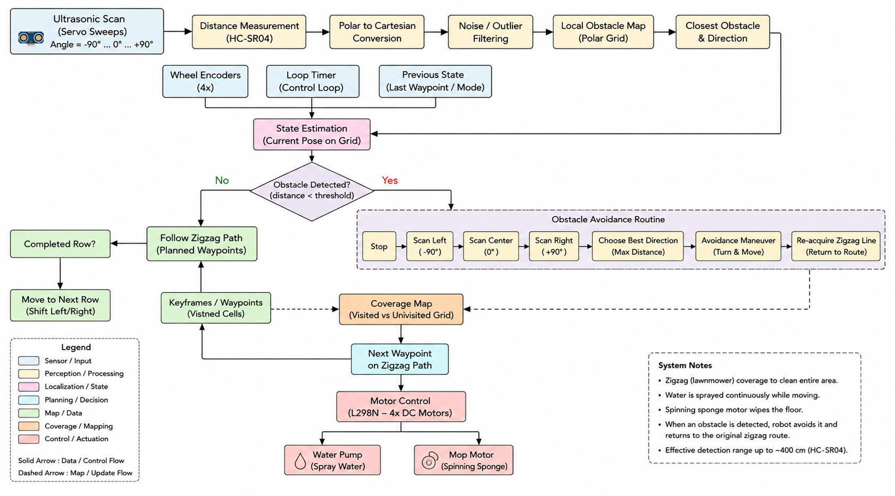

C. Operational algorithm and pseudocode
The simplified pseudocode below summarizes the intended robot behavior. It represents the cleaning motion as a repeated row-based procedure with an interrupt condition for obstacle detection.
1. Initialize ESP32, motor driver, ultrasonic sensor, servo motor, water pump, and sponge motor.
2. Start the cleaning subsystem: activate water spraying and rotating sponge mechanism.
3. Move forward along the current cleaning row.
4. Continuously measure front distance using the HC-SR04 sensor.
5. If an obstacle is detected below the configured threshold:
5.1. Stop the drive motors.
5.2. Rotate the servo sensor to inspect left and right directions.
5.3. Select the side with more available space.
5.4. Execute an avoidance maneuver.
5.5. Attempt to return to the original cleaning direction.
6. If the current row is completed:
6.1. Turn toward the next lane.
6.2. Shift sideways by the chosen row distance.
6.3. Turn again to face the opposite direction.
7. Repeat the movement to form a zigzag coverage path.
8. Continue spraying water and rotating the sponge during the cleaning sequence.
Detailed code in GitHub: github.com/yerassyl667/rp

IV. EXPERIMENTAL RESULTS

A. Experimental setup
The prototype was tested as a compact wet-cleaning robot in a demonstration workspace. The basic route evaluation used an area of approximately 50 × 50 cm, allowing the team to observe whether the robot could maintain a snake-like cleaning pattern, perform turns, shift to the next lane, and continue movement repeatedly. Water spraying and sponge rotation were considered part of the cleaning cycle rather than independent laboratory subsystems.
Obstacle handling was evaluated by placing objects in the robot's route and observing whether the ultrasonic sensor detected them, whether the servo-based scan was triggered, and whether the robot executed a detour before continuing its movement. The HC-SR04 sensor also produced open-space distance readings up to approximately 400 cm, although practical avoidance behavior depends on a shorter configured threshold selected in the control code.
Test objective | Observation | Result
Zigzag route following | Robot moved forward, turned, shifted to the next lane, and returned in the opposite direction | Works with some issues
Cleaning mechanism | Water pump sprayed water while the rotating sponge wiped the surface | Working
Obstacle detection | Ultrasonic sensor detected objects in front of the robot | Working
Directional scanning | Servo motor changed sensor orientation for left/right comparison | Working
Obstacle avoidance | Robot interrupted motion, selected a free side, and performed a detour | Working
Demonstration field coverage | Robot covered a compact area of approximately 50 × 50 cm | Achieved

Parameter | Measured / Observed value | Comment
Demonstration area | Approximately 50 × 50 cm | Used to assess route coverage
Ultrasonic open-space reading | Up to approximately 400 cm | Sensor measurement capability observed during testing
Drive architecture | 4 DC motors | Supports mobile movement and turning
Cleaning method | Water spraying + rotating sponge | Wet wiping mechanism
Route type | Zigzag / snake-like path | Selected for systematic floor coverage

B. Results and discussion

The project demonstrated that a low-cost mobile platform can combine floor coverage, wet cleaning, and obstacle avoidance in one coordinated routine. The robot successfully followed a repeating zigzag route in the test field. This result is important because the cleaning effectiveness depends not only on the sponge and water pump but also on the ability to distribute them over the surface in an organized manner.
The active cleaning mechanism performed as intended: water was supplied by the pump, while the sponge attached to a dedicated DC motor created rotational wiping action. This approach improves the functional realism of the project compared with a platform that only drives over the floor without any mechanical contact-based cleaning.
The obstacle avoidance mechanism also operated successfully. The ultrasonic sensor allowed the robot to recognize objects along its path, and the servo-mounted scan enabled a basic comparison between candidate directions. The robot could interrupt the current cleaning motion, maneuver around an obstacle, and then continue the planned route. The main practical limitation is that an avoidance maneuver may introduce route error, which means future versions would benefit from more precise localization or feedback-based path correction.
Another key observation was the importance of calibration. In earlier tuning, insufficient turning duration caused the robot to follow a more curved trajectory instead of a rectangular zigzag route. Increasing and adjusting the turn duration improved alignment with the desired lane-switching pattern. However, the drive motors turned out to be relatively weak for the robot’s weight and mechanical load. Because of this, the actual turning angle could sometimes change unexpectedly even when the same timing values were used in the code. This inconsistency was caused by hardware limitations rather than the control algorithm itself, and it could not be fully eliminated within the current prototype. This confirms that time-based motion control is workable for a basic demonstration, but stronger motors, wheel encoders, or closed-loop control would significantly improve repeatability and trajectory accuracy.

V. CONCLUSIONS
The Robot-Mopping Floor project achieved its main goal of creating a compact autonomous wet-cleaning prototype. The system integrates an ESP32 controller, a four-motor mobile base, water spraying, a motor-driven rotating sponge, and ultrasonic obstacle avoidance. The robot follows a programmed zigzag path, which allows it to cover a selected area in a structured row-by-row manner while performing the cleaning process.
Experimental evaluation confirmed that the robot could cover an approximately 50 × 50 cm test region, carry out the designed route after turning calibration, detect obstacles, scan for a free direction, and continue operation after the avoidance maneuver. The HC-SR04 sensor provided distance readings up to approximately 400 cm in open conditions, while the actual obstacle-avoidance decision was based on a shorter operational threshold.
Future work can improve the prototype in several directions: implementing wheel encoder feedback, using more accurate route recovery after obstacle avoidance, adding better control of water quantity, improving mechanical stability of the cleaning head, and introducing more advanced mapping or localization. Nevertheless, the current design already demonstrates a meaningful integration of embedded systems, autonomous motion, and practical cleaning functionality.

ACKNOWLEDGEMENT
We acknowledge the guidance and mentorship of the course and laboratory instructors who supported the development and testing of this project.

REFERENCES
https://youtu.be/wsKTmlipQOE?si=n7wt0Y1l86qwLaCC
https://youtube.com/shorts/Xb_w7ReJuDk?si=3ndGIdUANIznAsbr
https://www.youtube.com/watch?v=rSCy1_GbC0w

