Create Jenkins Master & slave , installed git,java,maven,tomcat & Jenkins on JM, installed java & tomcat on slave.
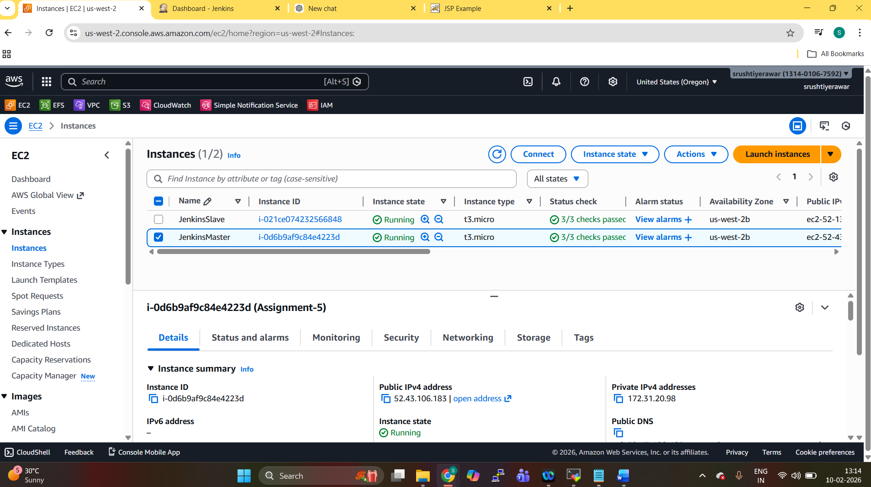

Create 3 jobs
- WarFileCreation- Created the war file in target folder using Maven
- S3 copy – Created s3 bucket using s3 cli command & copied that war file in bucket
- DeployOnSlave – Deploy that s3 bucket war file on slave machine in webapps folder.

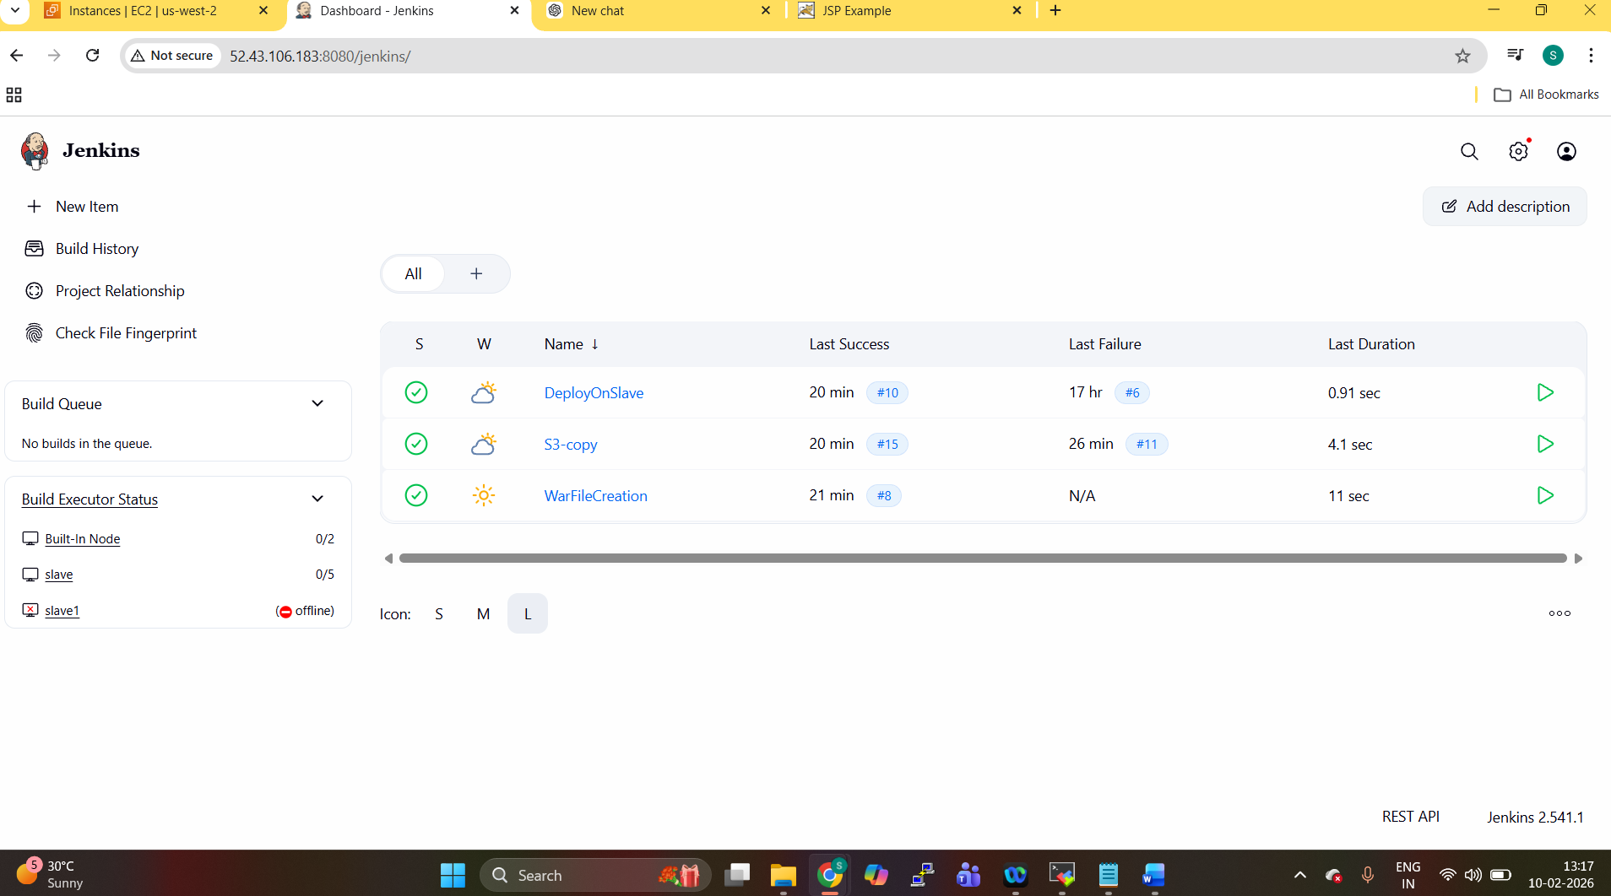

Created IAM role for aws s3 & applied to JM & slave machines for configuration.

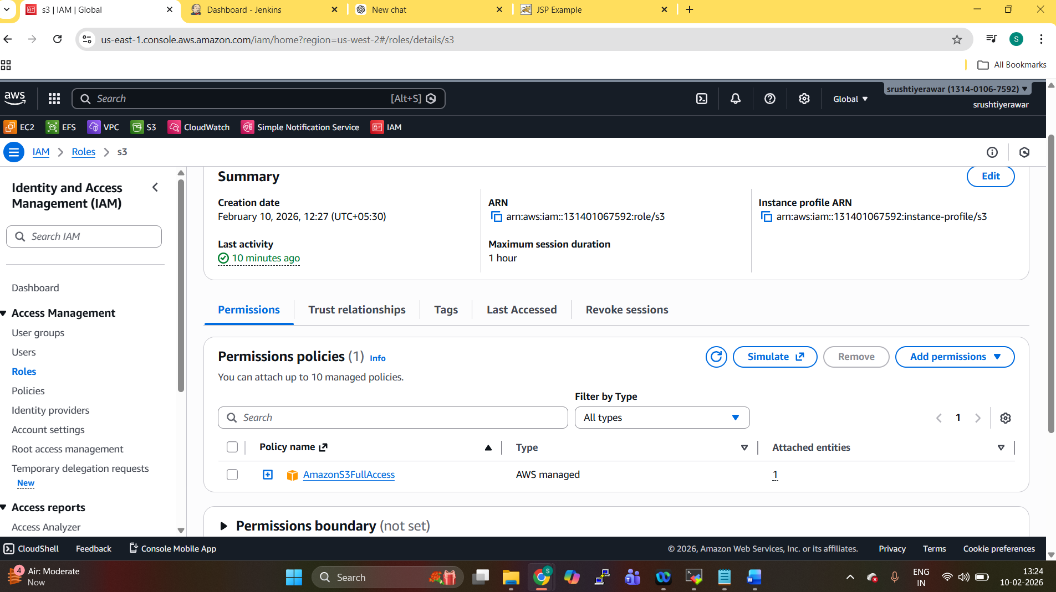

After build 1 start using post build actions executed the 2nd job .

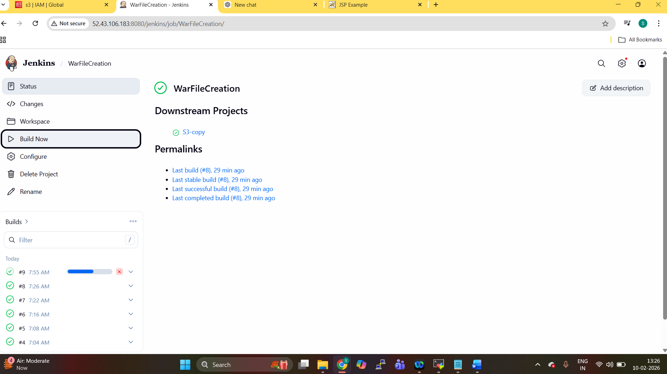

After 2nd job build executed post build 3rd job.
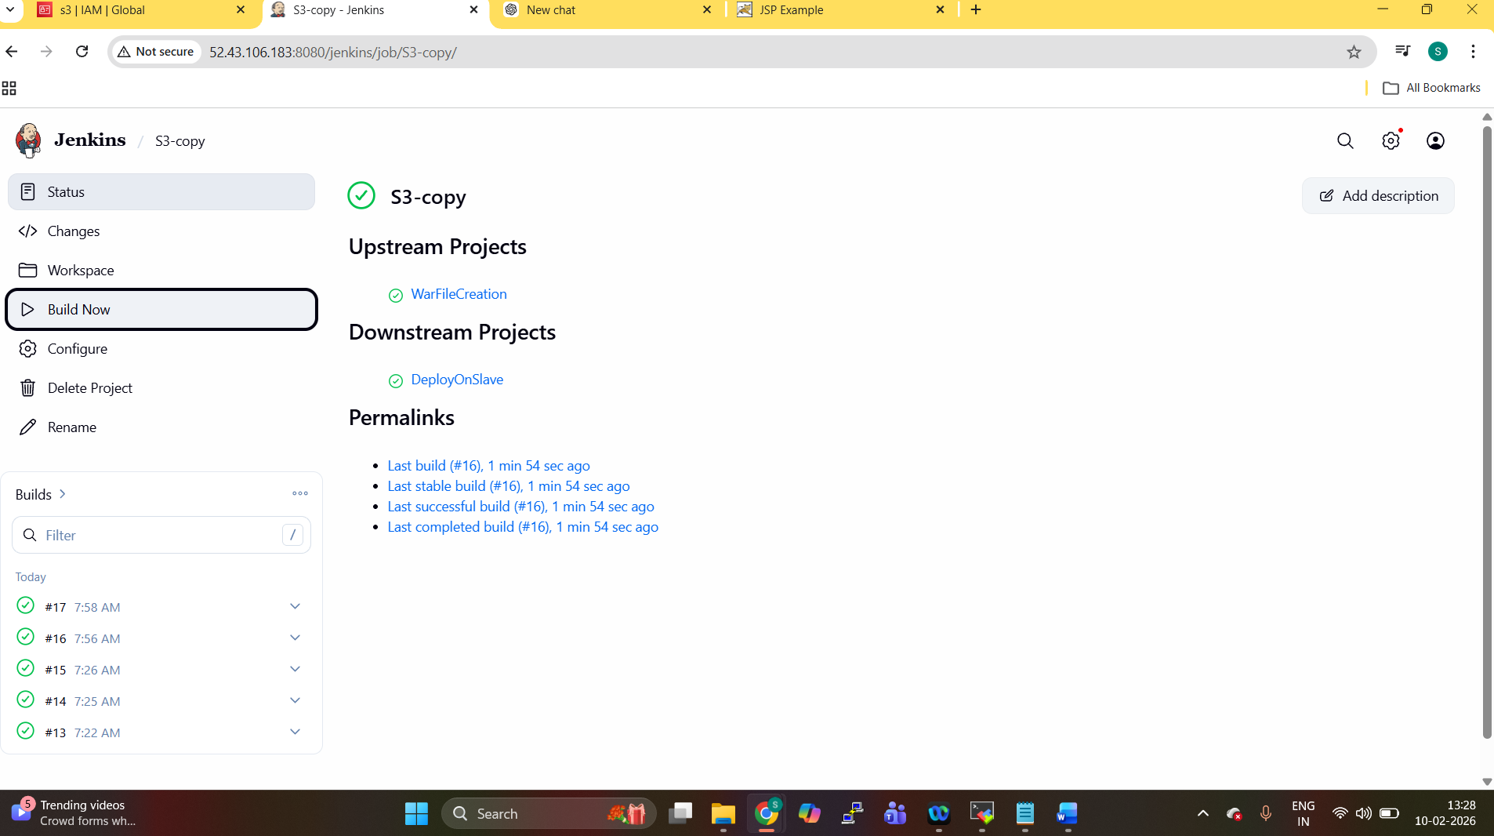

After 2nd job build 3rd job automatically run
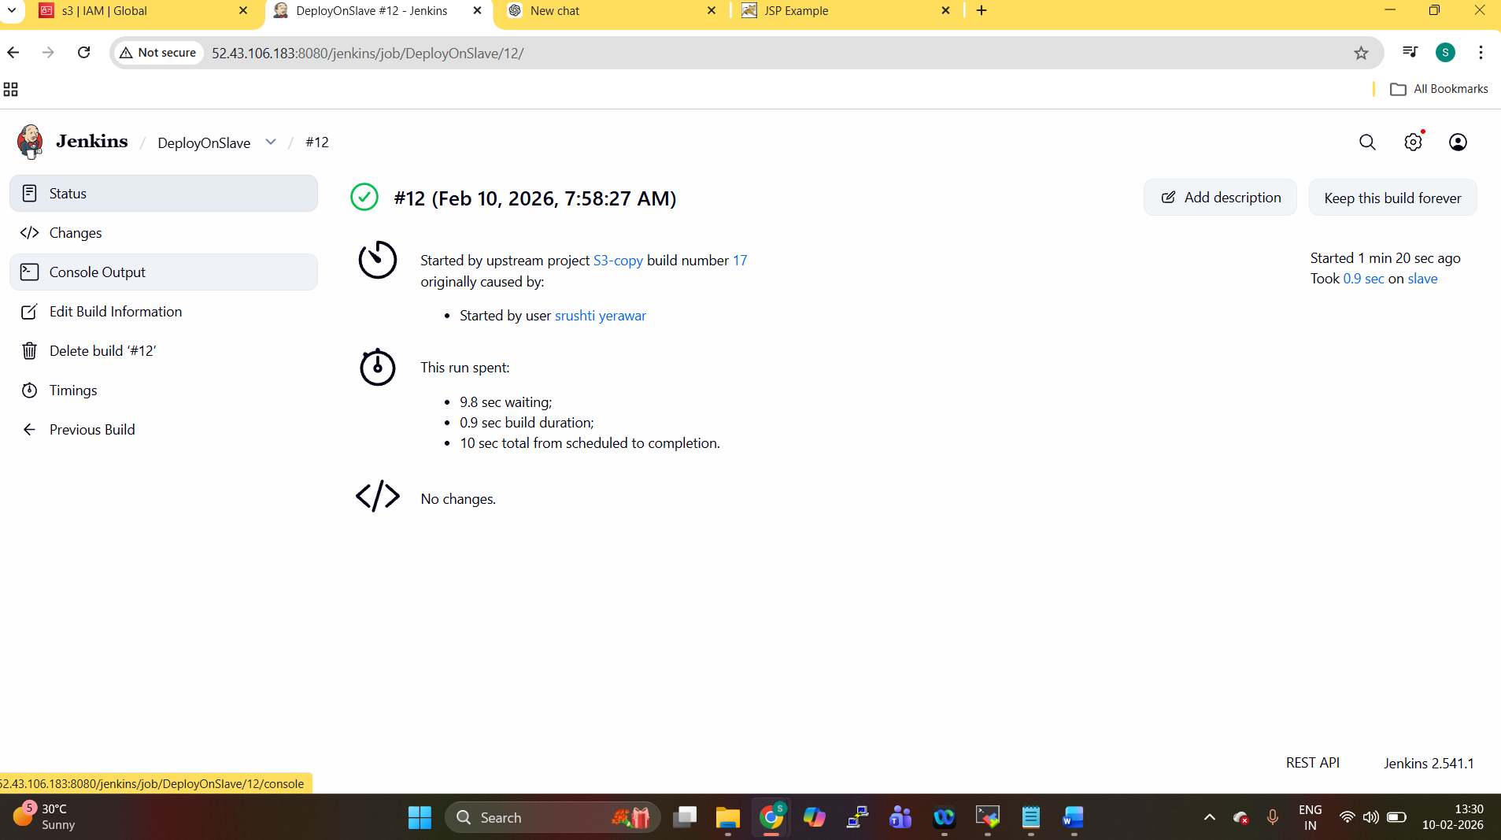

Website successfully deployed on slave machine & running.
