Created Jenkins Master and slave installed Git, Maven, tomcat, Java and Jenkins in JM and Java and tomcat git and maven on Slave machine

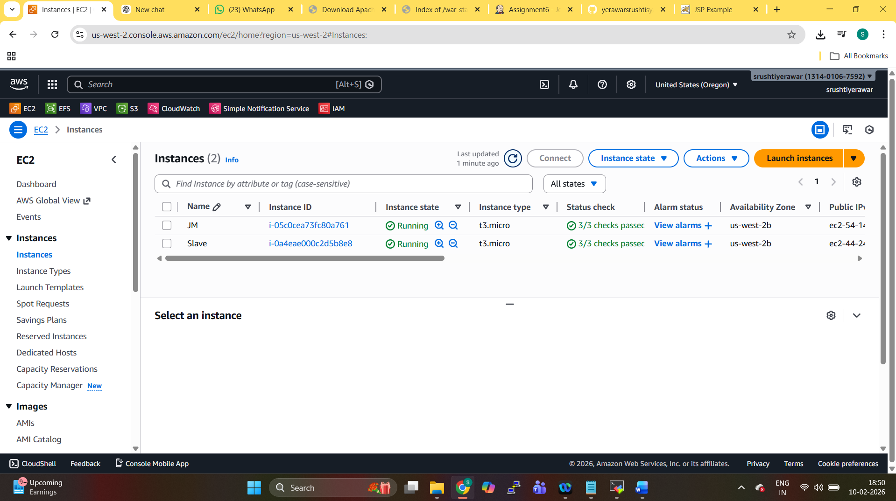

Created the job and Restrict where this project can be run. On slave machine
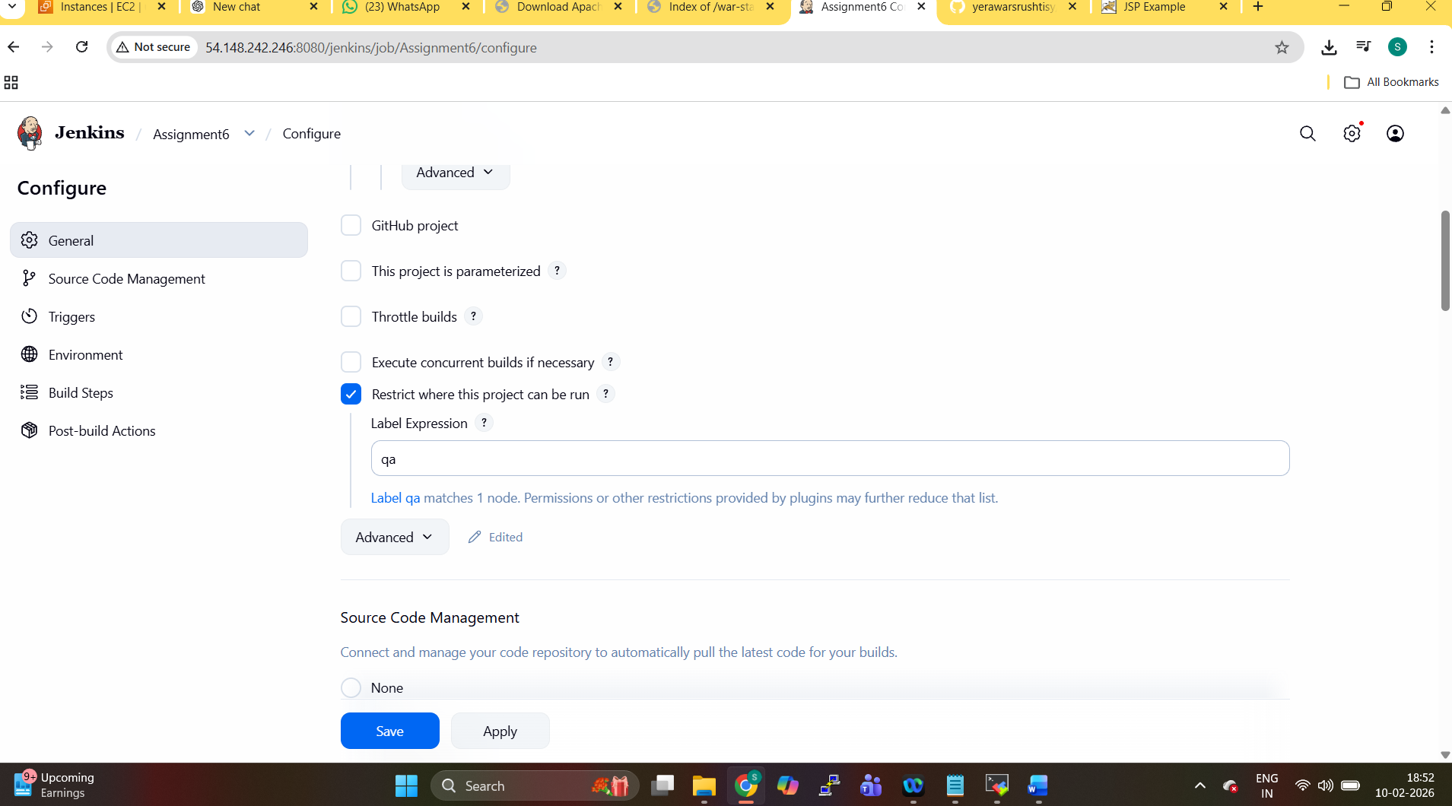

Added GIT repo
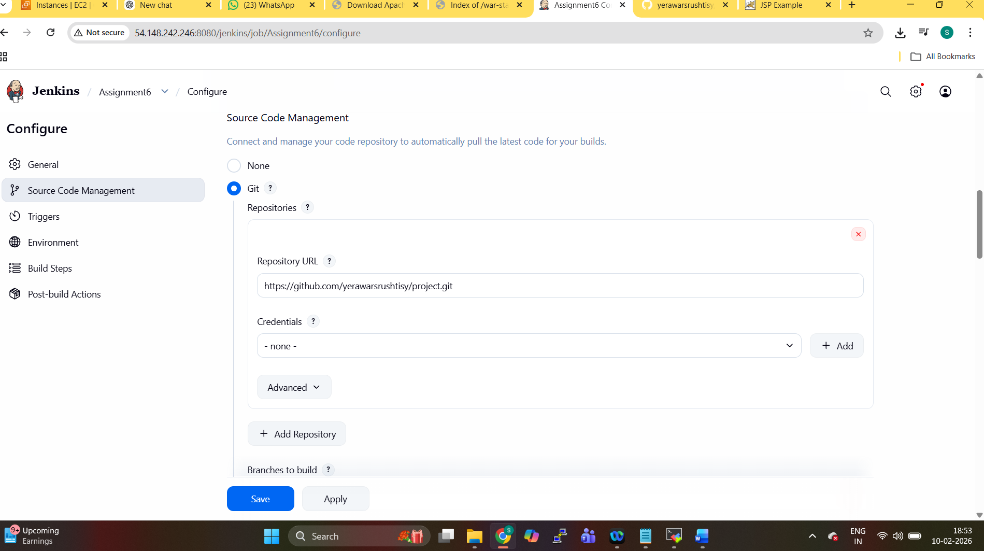

Invoke top-level Maven targets for Maven
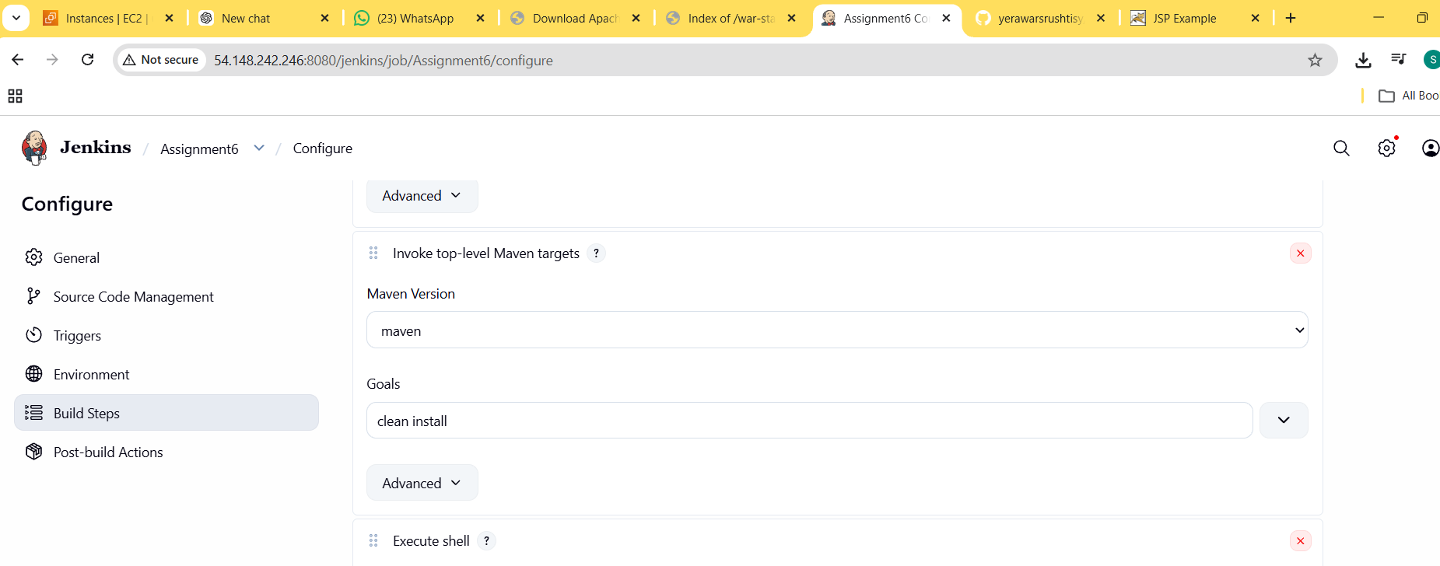

Copied the WAR file from folder to the webapps folder

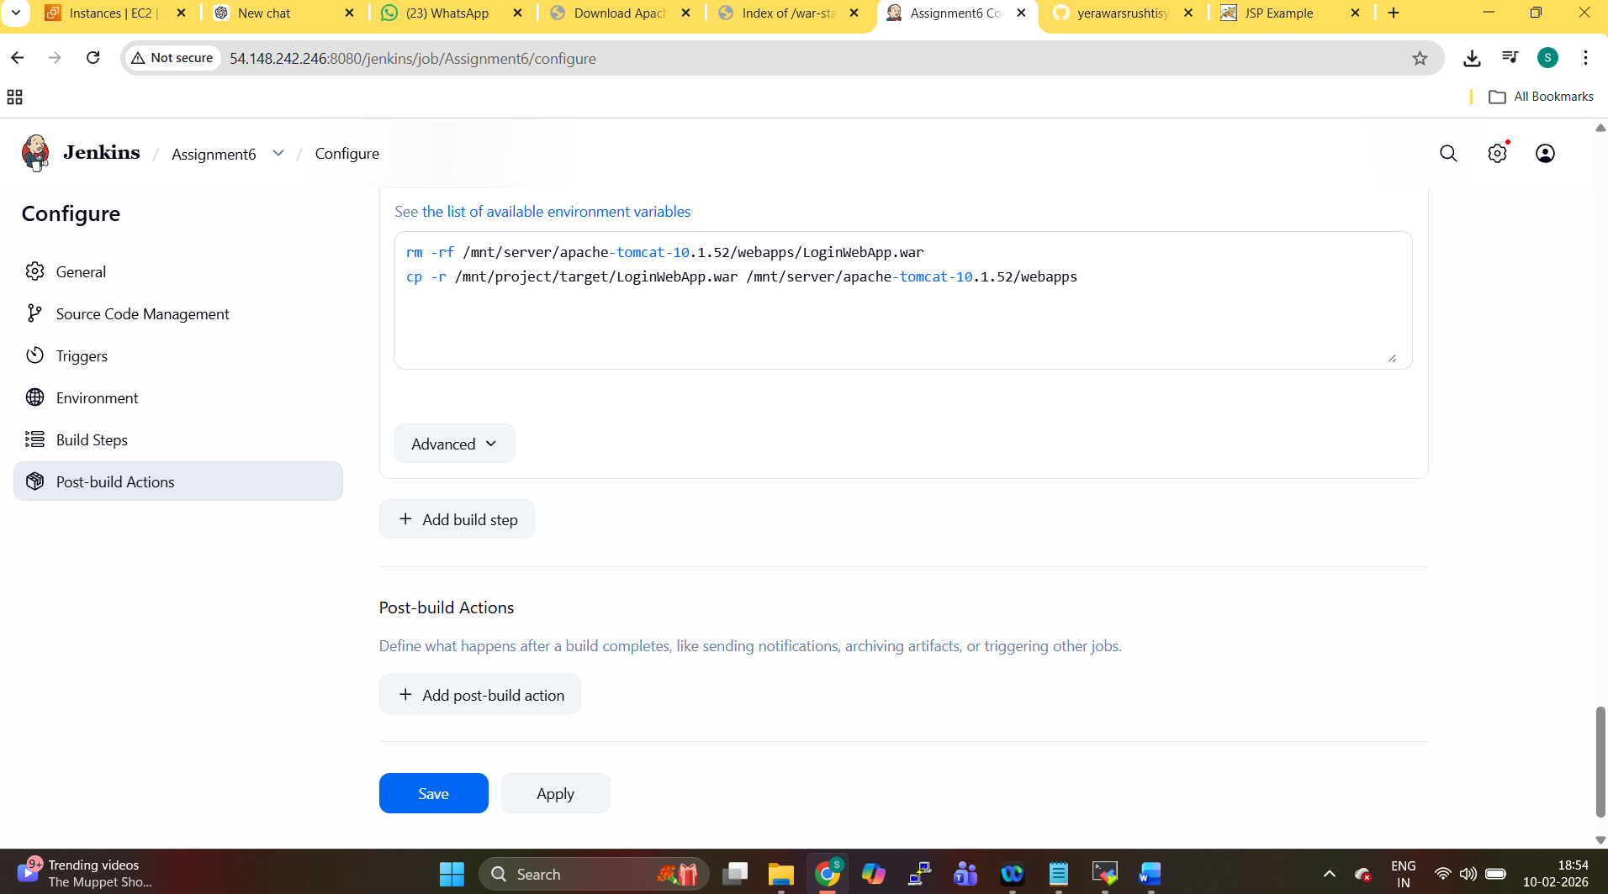

Website is running
