This is a snip of my script to backup all my users

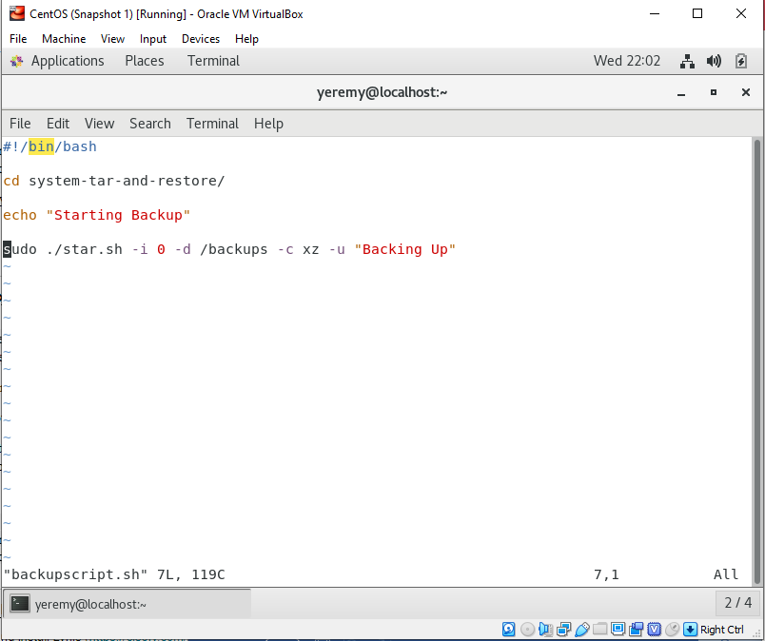

This is my cron job which is scheduled to run my script every single hour.

