This script will record all the attempted logins on my sever. This will create a text document and log everything in it.

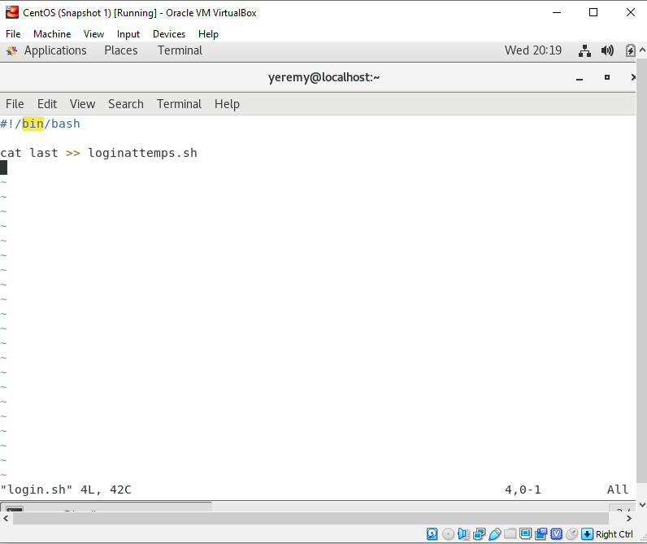

This command will monitor everything in the directory for my server.

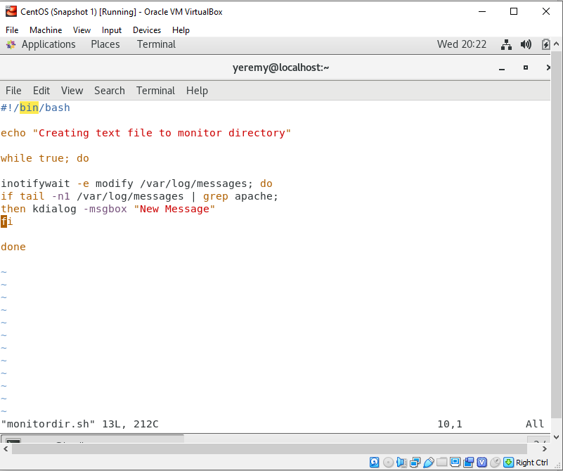

This script is to monitor any file changes or creations have been made. It will notify me,

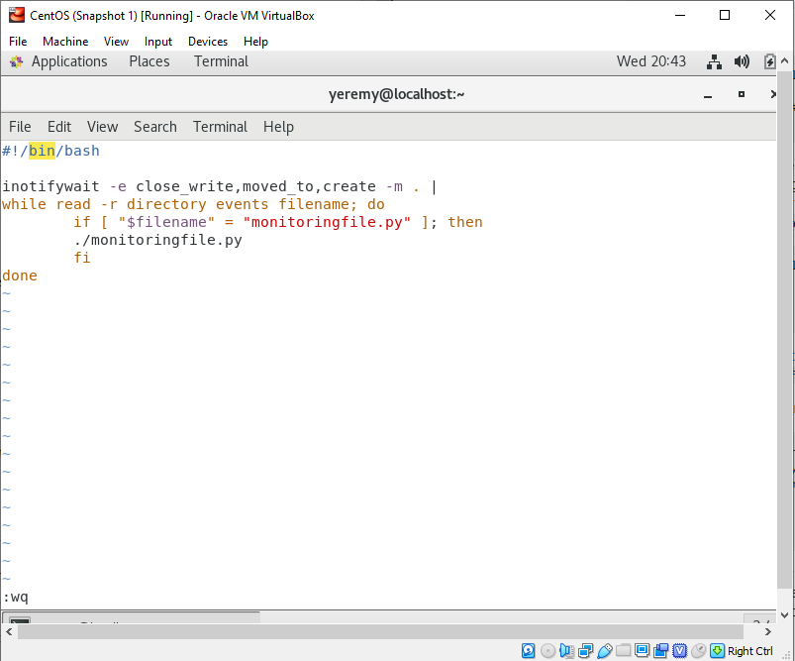

Websites I did research on:

<https://unix.stackexchange.com/questions/283868/bash-script-detecting-change-in-files-from-a-directory>