Lynis running on my CentOS server

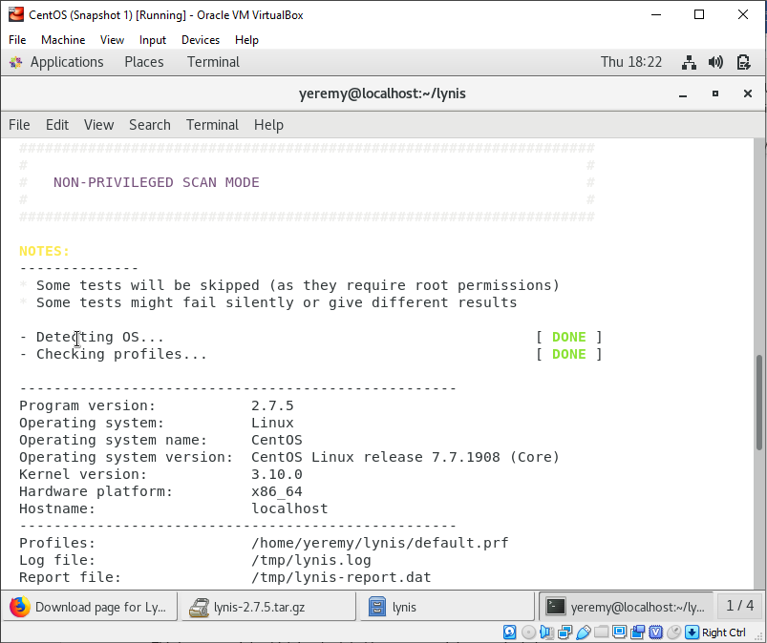

Lynis running on my Ubuntu server

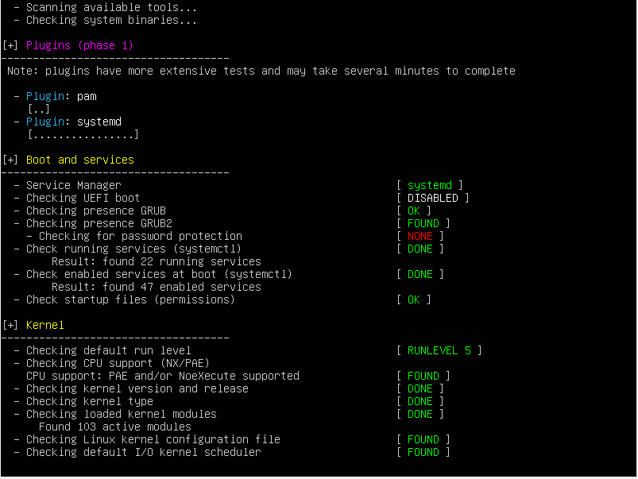

Script to monitor server

