This script will record all the attempted logins on my sever. This will create a text document and log everything in it.

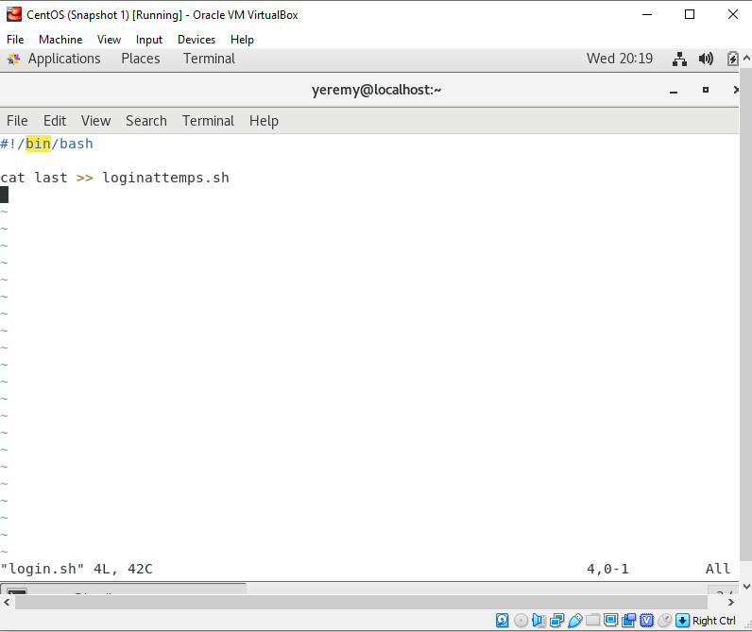

This command will monitor everything in the directory for my server.

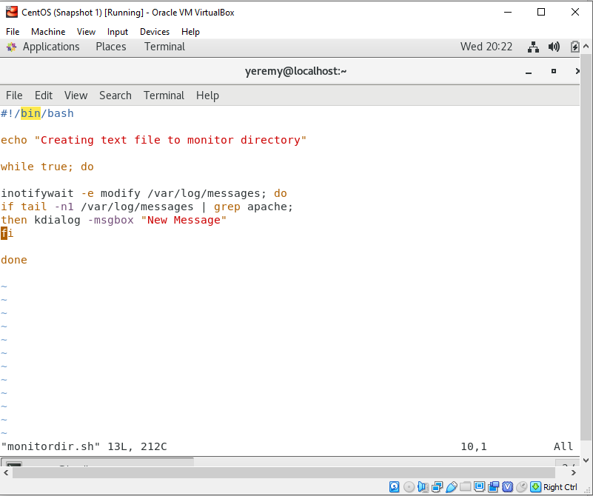

This script is to monitor any file changes or creations have been made. It will notify me,

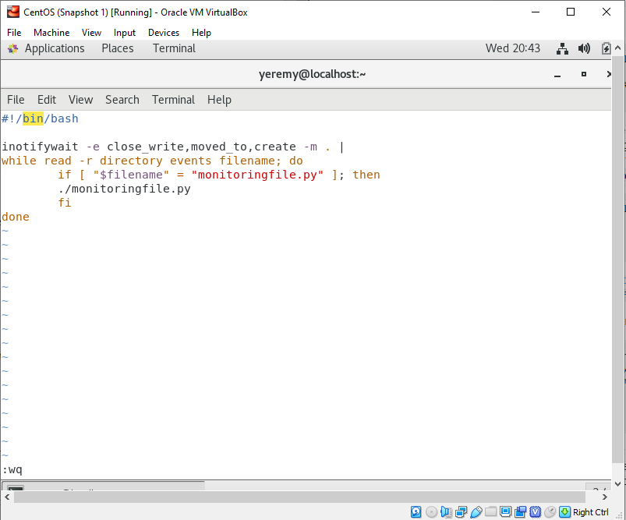

Websites I did research on:

<https://unix.stackexchange.com/questions/283868/bash-script-detecting-change-in-files-from-a-directory>

This is a snip of my script to backup all my users

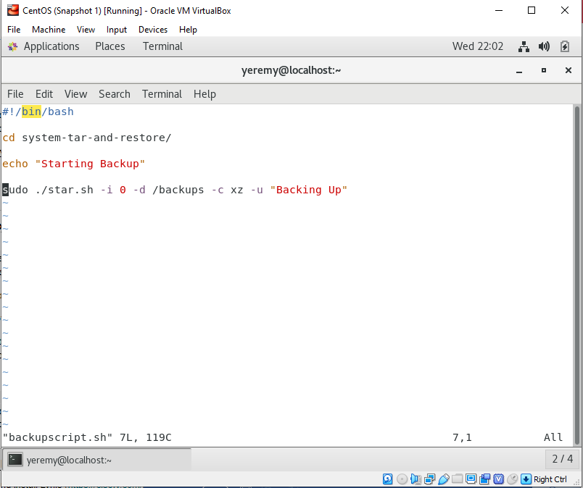

This is my cron job which is scheduled to run my script every single hour.

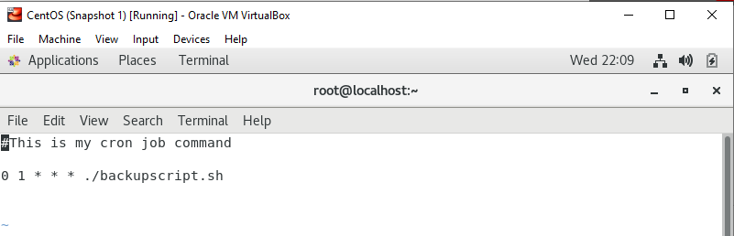

**CentOS Emergency mode instructions:**

**In order to start the CentOS system in emergency mode you must press “e” during boot up of system. This will bring up the boot configuration menu so we can adjust the boot settings. We will configure the end of the line after “rhgb quiet”. After this sentence we will enter “system.unit=\emergency.target”. This will allow you to set the startup to emergency mode within your CentOS machine. The final step will be exiting the boot configuration by pressing “Ctrl+x” which will restart the system.**

**Ubuntu Emergency mode instructions:**

**Once the bootup of the system has started in the menu to select an OS entry press “e”. Use the right arrow to reach the end of the sentence which ends with “maybe-ubiquity”. Please insert the following: “system.unit=rescue.target”. Once this is at the end of the sentence you may press F10 to exit the menu. You should boot up with the minimal settings for this configuration. Once this has been achieved you will notice you are now in emergency mode.**