Apple II Twitter Display

Document version 0.1, 13-October-2010, Chris Yerga ([yergacheffe@atomsandelectrons.com](mailto:yergacheffe@atomsandelectrons.com))

# Introduction

This document describes how to duplicate the Apple 2 Twitter display I showed at Maker Faire Bay Area 2010 and documented on my blog at <http://www.atomsandelectrons.com/blog/post/Apple-t.aspx>. The project was hacked together quickly to get it functional, but there has been interest from others who want to duplicate it. The intent of this release is to provide the software and documentation necessary for others to replicate this and carry it forward.

# Design Overview

The high-level design is shown in the following diagram:

**Twitter**

PC running TweetWall .Net App

HTTP REST calls to Twitter API

**Apple II**

Custom protocol over an FTDI USB->Serial cable

Connected to joystick port

The design intentionally has very minimal code running on the Apple II, to keep things simple. The project is called the Apple II Twitter Display because that’s all the Apple II is doing – being a display. The actual Twitter client is running on a PC that queries the Twitter API via HTTP. This code retrieves the text of the tweet and the avatar bitmap for the user, it then converts the bitmap to Apple II graphics format (both LORES and HIRES) and pushes the converted image to the Apple II.

There are 3 major components to the project that you will need: The interface cable, the Apple II software and the PC software.

# Interface Cable

The one piece of specialized equipment you’ll need, aside from a working Apple II, is a USB FTDI TTL-232 cable. This is a USB cable that plugs into a PC and allows the PC to control signals sent to the Apple II’s button inputs. These cables are available from a variety of electronics hobbyist sources for around US$20

* Adafruit: <http://www.adafruit.com/index.php?main_page=product_info&cPath=18&products_id=70>
* Sparkfun: <http://www.sparkfun.com/commerce/product_info.php?products_id=9718>
* RobotShop: <http://www.robotshop.com/ftdi-usb-to-ttl-serial-cable-5v.html>

You will need to wire this cable up to the joystick input port. The Apple II has a 16-pin DIP socket on the motherboard that exposes these signals. I used wire jumpers of the sort used for breadboards to connect between the FTDI cable and the joystick socket in the Apple II. The connections we need to make are as follows:

|  |  |  |
| --- | --- | --- |
| Apple II Game Port | FTDI Cable | Purpose |
| GND (Pin 8) | Black Wire (GND) | Ground |
| SW0 (Pin 2) | Orange Wire (TX) | Data from PC->Apple II |
| SW1 (Pin 3) | Yellow Wire (RX) | SPI Clock |
| SW2 (Pin 4) | Green Wire (RTS) | Attn/Framing |

The location of the game port connector on the Apple II motherboard is shown here:

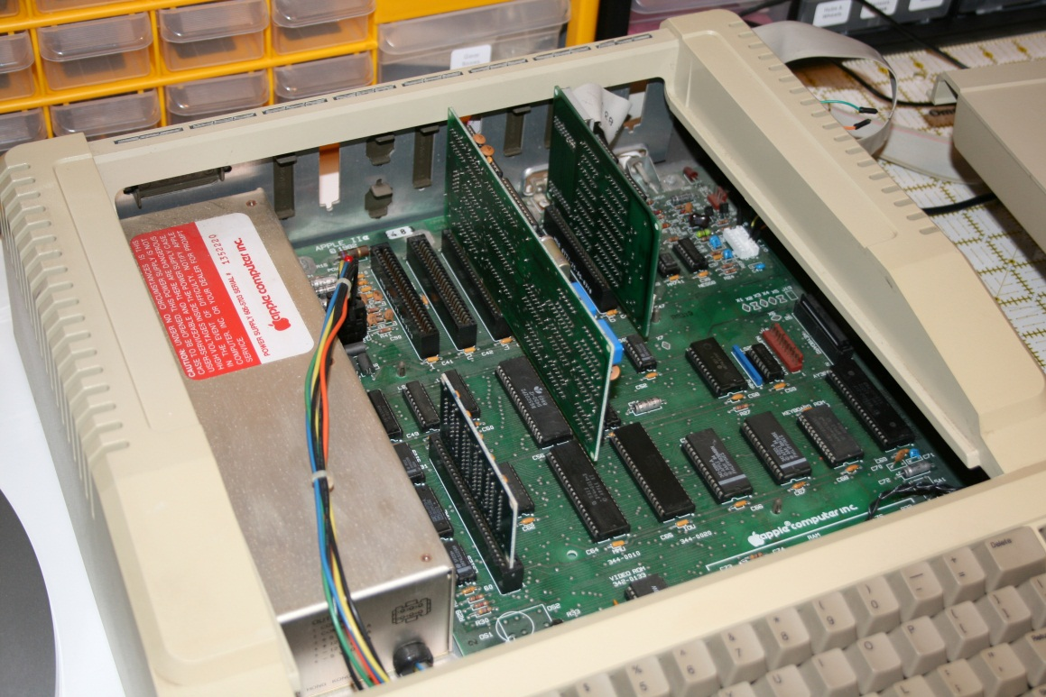

A close-up detail showing the wires connected:

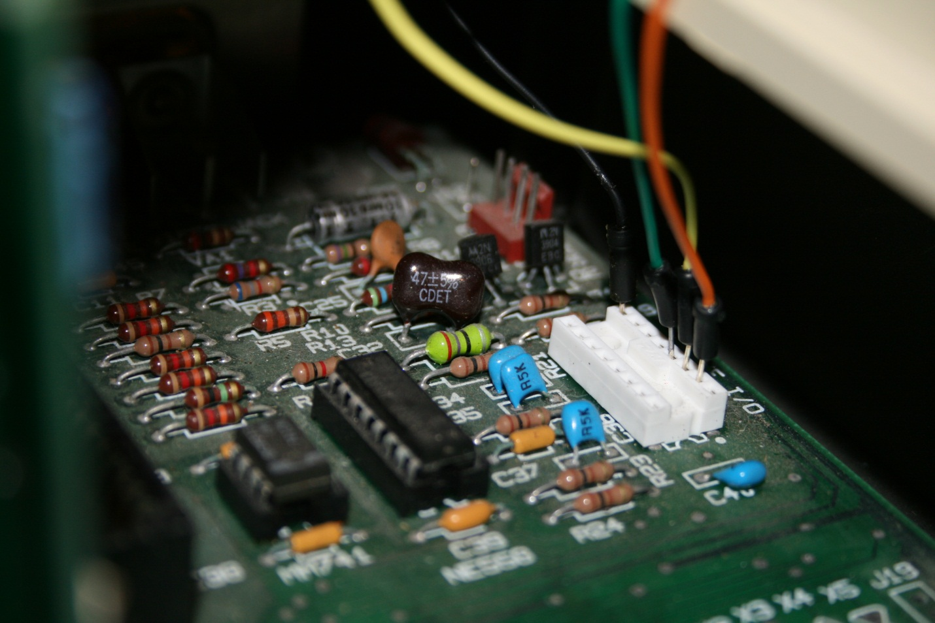

And the other end of the colored jumper wires plugged into the FTDI cable:

